Stories about Ḥuqúqu'lláh

extracted from

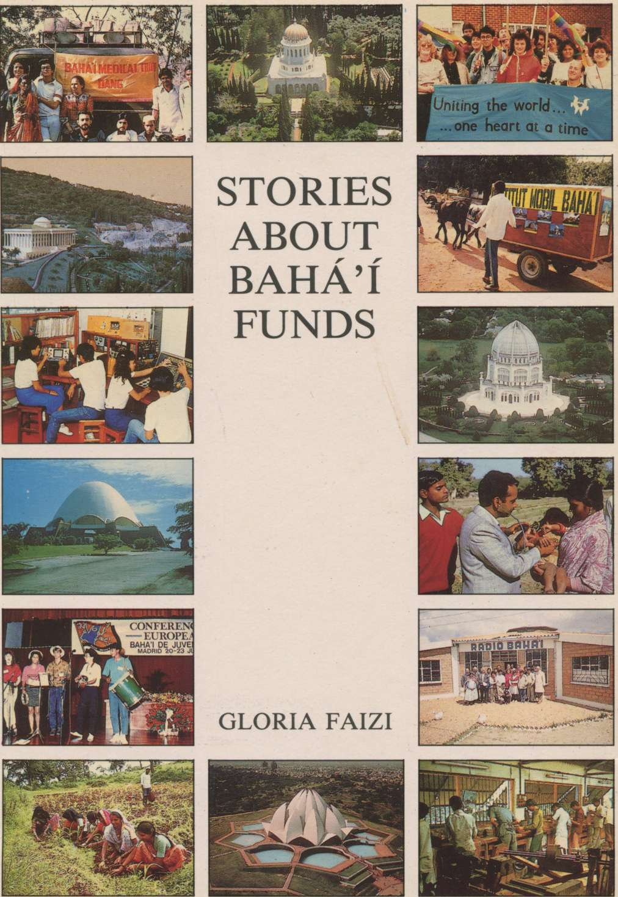

Stories about Ḥuqúqu'lláh

extracted from

Stories About Bahá'í Funds

retold by Gloria Faizi

BAHÁ'Í PUBLISHING TRUST, P.O. BOX 19, NEW DELH1-1

1

Ḥájí Amín was the first Trustee of Ḥuqúqu'lláh. He spent much of his life travelling between Írán and the Holy Land during the days of Bahá'u'lláh and 'Abdu'l-Bahá. At a time when roads were unsafe, and travelling was done mostly on foot, Ḥájí Amín would go from town to town and village to village in Írán, collecting Ḥuqúqu'lláh and other donations which he took to the Holy Land.

Ḥájí Amín was known to deprive himself of everything he possibly could in order to add a little more money to the sum he took with him from Írán. His food usually consisted of dry bread, which he carried wherever he went, and a little yogurt. He would dilute the yogurt with water, making what Persians call dúgh, and would break the dry bread in it. But he put so little yogurt in the water that ' Ḥájí Amín's dúgh' became a tradition among the Bahá'ís in Írán. This simple food he often shared with others as he travelled through the country. Many a time, when he was invited to stay for a meal at the home of a Bahá'í, he would persuade the hosts to partake of his dúgh and bread and give the money they would have spent on their food for him to take to the Holy Land.

All the Bahá'ís in Írán loved and respected Ḥájí Amín, and many wonderful stories are told about his sincerity and devotion. Once, when he was about to set off for the Holy Land, a very poor woman gave him a small coin to take with him. Ḥájí Amín thanked her and put it in his pocket. As soon as he arrived at the home of 'Abdu'l-Bahá, he presented to Him the donations he had collected, as he always did. The Master would usually thank him and praise him for his untiring labours. Ḥájí Amín's integrity was not to be questioned, and he had never made a mistake in his calculations. Indeed, it was not difficult for him to keep his accounts as he never had any money of his own.

This time, however, to his utter astonishment, when 'Abdu'l-Bahá was presented with the money, He looked at Ḥájí Amín kindly and said something was missing from the amount. Ḥájí Amín left the Master's presence with much sadness, unable to understand what could have happened. He went to his room in tears and prostrated himself in prayer. As he did so, he felt a hard piece of metal under his knee. It was the small coin the poor woman had given him to take to the Holy Land as he was leaving. The coin had slipped through a hole in his pocket into the lining of his long coat.

Ḥájí Amín immediately took the coin and went to 'Abdu'l-Bahá. The Master showered His praises on him. He kissed the coin and said this was worth more than all the other donations because it had been given with the greatest sacrifice.

2

Najafábád is a village near Iṣfahán, in Írán, where there have been Bahá'ís since the early days of the Faith. At that time, most of the believers in this village were prosperous farmers with almond orchards.

Not many villagers in Írán could read and write in those days, and it was difficult for the village Bahá'ís to calculate their Ḥuqúqu'lláh. Some of the believers in Najafábád, however, had worked out a system for themselves: every nineteenth tree in their orchards was marked for Ḥuqúqu'lláh. When the almonds were ready to be picked, the nuts on the marked trees would be picked and sold separately. This money was then sent to the Holy Land as Ḥuqúqu'lláh.

They would also tie cords round some of the branches of trees which were heavily laden with nuts to mark them for other Bahá'í Funds.

3

To demand the Ḥuqúq is in no wise permissible. This command was revealed in the Book of God for various necessary matters ordained by God to be dependent upon material means. Therefore, if someone, with utmost pleasure and gladness, nay with insistence, wishest to partake of this blessing, thou mayest accept. Otherwise, acceptance is not permissible.
Bahá'u'lláh

4

Mr. Músá Banání was a well-to-do businessman before he pioneered to Africa and was appointed a Hand of the Cause of God. Kamál, who worked with him, recalled an interesting incident of his life in Ṭihrán.

Mr. Banání decided to sell a very valuable property in one of the best localities of the capital, and two men came to see him about it. They were told the price and they said they were interested in buying the place but did not have enough cash in hand. They requested Mr. Banání not to sell the property to anyone else for one month, during which time they hoped to arrange for the money. Their request was accepted and Mr. Banání made a note of the date saying that, if they were not able to buy the place by that day, he would offer it to someone else. This agreement was verbal and nothing was put down on paper.

Some time passed and nothing further was heard from the men. Then one day another person came to buy the property. Mr. Banání told him of his promise to the first customers, but the man said he was prepared to offer twice the amount the others were going to pay, and that he had brought the entire sum of money with him. Kamál became quite excited and was eager to see Mr. Banání accept the deal, reasoning that such a great opportunity should not be lost. He argued that, had the first customers been serious about buying the property, they would have contacted the owner once again. But Mr. Banání said he could not break his promise. If they did not show up by the end of the one month they had agreed upon, then he would be free to sell his property to someone else.

The customer went away disappointed but came back on the very day the month was ended. Kamál received him eagerly, expecting Mr. Banání to start signing the property deeds. "But the day is not yet over", said Mr. Banání. "The men may turn up any moment. We must wait till sunset."

The customer left once again but did not return to the city. Mr. Banání's house was in a suburb of Ṭihrán, and the man waited around the place till the evening when he could come back. Mr. Banání then said to Kamál, "I think you should ring up the men and find out what they have decided to do. It is possible that they may have forgotten the date." Kamál telephoned and received their answer. They were sorry they could not arrange for the money.

The deeds were now signed, the property sold, and the money received. By the time the customer had left it was quite late, but Mr. Banání said to Kamál, "Please go and hire a carriage to take us to the city." "This time of night?" asked Kamál in surprise. "It will be past midnight by the time we reach the city." Mr. Banání said, "I have to go to Varqá's house and pay the Ḥuqúqu'lláh for the money I have just received." "But you can surely pay the Ḥuqúqu'lláh in the morning", said Kamál. Mr. Banání looked at him seriously. "Can you give me a guarantee that I shall not die during the night?" Kamál, a good Bahá'í himself, was rather shaken by this remark. "I shall fetch the carriage immediately", he said.

5

Take heed, O people, lest ye deprive yourselves of this great bounty. We have prescribed this law unto you while We are wholly independent of you and of all that are in the heavens and on the earth. Indeed there lie concealed in this command, mysteries and benefits which are beyond the comprehension of anyone save God, the All-Knowing, the All-Informed. Say, through this injunction God desireth to purify your possessions and enable you to draw nigh unto such stations as none can attain, except those whom God may please. Verily, He is the Generous, the Gracious, the Bountiful.
Bahá'u'lláh

6

A Deputy Trustee of Ḥuqúqu'lláh in India had explained the importance of contributing to this Fund when she was visiting some village Bahá'ís. One of the villagers, a farmer, wrote to her later, enclosing a money order for Ḥuqúqu'lláh which was quite a substantial sum of money, considering his financial circumstances.

He had also given a detailed account of all the money he had received that year for everything he grew on his farm: rice, onions, potatoes, etc. The amount he had sent for Ḥuqúqu'lláh was, in reality, 19% of all his earnings that year instead of 19% of his savings.

All that this generous soul now wanted to know was whether it was permissible for him to deduct the cost of the money order from what he set aside for Ḥuqúqu'lláh.

7

The severe persecution of Jews in X— engulfed many of the Bahá'ís in that country who came from Jewish background. Among them was David, a well-to-do businessman who was confined to a prison cell without any trial. From time to time, however, the secret police, who accused him of spying for Israel, questioned him about it and, of course, always received the same answer: David was a Bahá'í, not a Jew, and his religion forbade him to meddle in politics.

After three months in prison, David was summoned to the office of the director of police to be told that his case had been referred to higher authorities who had been advised to give him the death sentence.

David returned to his cell in a state of shock and utter grief. Suddenly, he remembered a quotation from Bahá'u'lláh:

Well is it with him who ascendeth unto God, without any obligations to Ḥuqúqu'lláh and to His servants.
Bahá’u’lláh

David's mood changed and a sense of detachment and extreme tranquillity pervaded his soul as he recollected that he had paid his Ḥuqúqu'lláh to the last penny.

The rest of this story does not pertain to the Funds but, as the reader may be anxious to know what happened to David, the narrative will be continued:

Four months later, the director of police called David to his office once again and offered him a deal. Many other Jews, David was told, had paid the director a sum of money and been released from prison. He could do the same; otherwise, he was warned, he would be "kept in prison for two hundred years without trial." To this David replied, "I entered this prison by the Will of God, and I shall leave it by His Will." "Are you crazy?!" cried the director as he ordered him back to his cell.

David had three reasons for not accepting the proposal offered to him. First of all, he wanted to prove to the authorities that he was a real Bahá'í. Secondly, he knew that if he paid to get out of prison, the other Bahá'ís there, especially the youth who could not afford to pay, would have no chance of ever being released; and thirdly, he felt that, as a Bahá'í, he should not pay a bribe but rely on the help of God.

Ten months after David had been arrested, the policy of the government changed and the president set up a committee to investigate the cases of thousands of people who had been imprisoned without trial. David was one of them, and that same director of police was ordered to release him.

8

E. K. was a great scholar and a wonderful Bahá'í. The National Spiritual Assembly of Írán had requested him to devote all his time to the Faith, so his days were spent in writing many useful books and in deepening Bahá'ís, especially the youth. As he had no income of his own, he accepted a very modest monthly allowance from the National Fund.

One of his students, Káẓim, who would often go to his house to help him in his work, noticed that his teacher never touched the allowance which came from the National Office until he had returned nineteen percent of it as Ḥuqúqu'lláh. Káẓim was surprised because he knew that his teacher had no other income, and the allowance he received was barely sufficient for his necessary expenses, so one day he asked about it. He said to his teacher, "You have repeatedly explained to us the laws pertaining to Ḥuqúqu'lláh. You have said that giving Ḥuqúqu'lláh is only binding on those who have savings. How is it, then, that you, yourself, give part of your money for Ḥuqúqu'lláh each month when I know how little you have to live on?" "My son", replied his teacher, "do you suppose that the amount I keep for myself is mine? That, too, rightfully belongs to God. It is His money that I am spending and the little I give back to Him is only to appease my own conscience."

Káẓim realized that true lovers are not bound by the standards of the wise. The measure of their sacrifice has no limitations.

9

The minimum amount subject to Ḥuqúqu'lláh is reached when one's possessions are worth the number of Váḥid (19); that is, whenever one owneth 19 mithqáls of gold, or acquireth possessions attaining this value, after having deducted therefrom the yearly expenses, the Ḥuqúq becometh applicable and its payment is obligatory.
Bahá'u'lláh

10

These notes were received by one of the Trustees of Ḥuqúqu'lláh:

"We want to thank you for increasing our love and understanding of the law of Ḥuqúqu'lláh…. We have been counting the days and our small wealth until it reached the nineteen mithqáls. By a series of recent miracles, we have made it at last.

"Please accept our first Ḥuqúqu'lláh payment with our warmest love."

11

"This Riḍván will be forever the happiest day of my life. This is the beginning of the law of Ḥuqúqu'lláh! Now I understand the passages in the Writings about paradise even in this world. There is nothing—no worldly event nor circumstance—which could ever take what has been placed in my heart at this Riḍván.

"This first contribution to Ḥuqúqu'lláh is offered with the utmost joy, freedom and desire for it to be acceptable. Bahá'u'lláh knows this is true. I have prayed for this day. My parents are in the eternal world and were not Bahá'ís; my husband is not a Bahá'í, nor is anyone in our family except our children. Now at least the fruit of a small portion of my parent's labours in this world, which I inherited, can be used for true paradise—the Oneness of Mankind and the Institution embodying that truth."

12

If one spontaneously offereth Ḥuqúq with the utmost joy and radiance it will be acceptable, and not otherwise. The benefit of such deeds reverteth unto the individuals themselves.
Bahá'u'lláh

Ḥuqúqu'lláh, the Right of God, No. 9
The law of Ḥuqúqu'lláh
Ḥuqúqu'lláh, the Right of God, No. 10
Ḥuqúqu'lláh, the Right of God, No. 22
Ḥuqúqu'lláh, the Right of God, No. 18
Ḥuqúqu'lláh, the Right of God, No. 27

