Cover
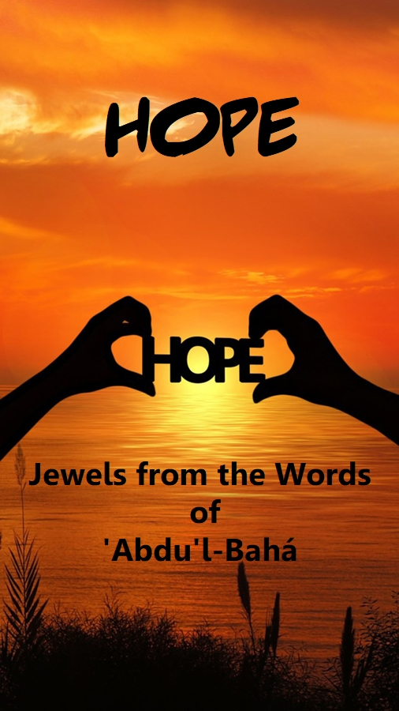

Title Page

HOPE

Jewels
from the Words of
‘Abdu’l-Bahá

This Compilation
is based on the following publications

© 1996 Bahá’í Publishing Trust UK
and 2004 edition published by Bahá’í Publications Australia

Translated into Thai language April 2020

Quotes and references updated from
https://www.bahai.org/library/authoritative-texts/
for passages from

Gleanings from the Writings of Bahá’u’lláh
Selections from the Writings of ‘Abdu’l‑Bahá
The Secret of Divine Civilization
The Promulgation of Universal Peace
Paris Talks

Official Bahá'í World Website in
English and other languages

Bahá'í Faith

Contents

Cover 1
Title Page 2
Contents 3
Words of Bahá’u’lláh 4
Words of ‘Abdu’l-Bahá 5
About ‘Abdu’l-Bahá 11

Words
of
Bahá’u’lláh

If ye be aware of a certain truth,
if ye possess a jewel,
of which others are deprived,
share it with them in a language
of utmost kindliness
and goodwill.

Words of ‘Abdu’l-Bahá

1
Never lose thy trust in God. Be thou ever hopeful, for the bounties of God never cease to flow upon man. If viewed from one perspective they seem to decrease, but from another they are full and complete. Man is under all conditions immersed in a sea of God’s blessings. Therefore, be thou not hopeless under any circumstances, but rather be firm in thy hope.

2
Do not wonder at the mercy and bounty of God. Consider thou how one spark sets on fire a great forest. Therefore, there is great hope, and the favour and grace of the Almighty is limitless.

3
Let us then trust in the bounty and bestowal of God. Let us be exhilarated with the divine breath, illumined and exalted by the heavenly glad tidings. God has ever dealt with man in mercy and kindness. He Who conferred the divine spirit in former times is abundantly able and capable at all times and periods to grant the same bestowals. Therefore, let us be hopeful. The God Who gave to the world formerly will do so now and in the future. God Who breathed the breath of the Holy Spirit upon His servants will breathe it upon them now and hereafter. There is no cessation to His bounty. The Divine Spirit is penetrating from eternity to eternity, for it is the bounty of God, and the bounty of God is eternal.

4
The bestowals of God which are manifest in all phenomenal life are sometimes hidden by intervening veils of mental and mortal vision which render man spiritually blind and incapable, but when those scales are removed and the veils rent asunder, then the great signs of God will become visible, and he will witness the eternal light filling the world. The bestowals of God are all and always manifest. The promises of heaven are ever present.

5
Let us pray to God that the breath of the Holy Spirit may again give hope and refreshment to the people, awakening in them a desire to do the Will of God. May heart and soul be vivified in every man: so will they all rejoice in a new birth.

6
Rely upon God. Trust in Him. Praise Him, and call Him continually to mind. He verily turneth trouble into ease, and sorrow into solace, and toil into utter peace. He verily hath dominion over all things.

7
O ye loved ones of God! Know ye that the world is even as a mirage rising over the sands, that the thirsty mistaketh for water. The wine of this world is but a vapor in the desert, its pity and compassion but toil and trouble, the repose it proffereth only weariness and sorrow. Abandon it to those who belong to it, and turn your faces unto the Kingdom of your Lord the All-Merciful, that His grace and bounty may cast their dawning splendors over you, and a heavenly table may be sent down for you, and your Lord may bless you, and shower His riches upon you to gladden your bosoms and fill your hearts with bliss, to attract your minds, and cleanse your souls, and console your eyes.

8
Turn your faces away from the contemplation of your own finite selves and fix your eyes upon the Everlasting Radiance; then will your souls receive in full measure the Divine Power of the Spirit and the Blessings of the Infinite Bounty.
9
When a drop draws help from the ocean, it is an ocean itself, and a little seed through the outpouring of rain, the favour of the sun, and the soul-refreshing breeze will become a tree with the utmost freshness, full of leaves, blossoms and fruits. Therefore do not consider thy capacity and merit, but rely upon the infinite Bounty and trust to His Highness the Almighty.

10
Pray that your hearts may be cut from yourselves and from the world, that you may be confirmed by the Holy spirit and filled with the fire of the love of God... impossible to you if you have faith.

11
Today, humanity is bowed down with trouble, sorrow and grief, no one escapes; the world is wet with tears; but, thank God, the remedy is at our doors. Let us turn our hearts away from the world of matter and live in the spiritual world! It alone can give us freedom! If we are hemmed in by difficulties we have only to call upon God, and by His great Mercy we shall be helped.

12
When our thoughts are filled with the bitterness of this world, let us turn our eyes to the sweetness of God’s compassion and He will send us heavenly calm! If we are imprisoned in the material world, our spirit can soar into the Heavens and we shall be free indeed!

13
Do not take into consideration your own aptitudes and capacities, but fix your gaze on the consummate bounty, the divine bestowal and the power of the Holy Spirit—the power that converteth the drop into a sea and the star into a sun.

14
Look ye not upon the present, fix your gaze upon the times to come. In the beginning, how small is the seed, yet in the end it is a mighty tree. Look ye not upon the seed, look ye upon the tree, and its blossoms, and its leaves and its fruits.

15
Chaos and confusion are daily increasing in the world. They will attain such intensity as to render the frame of mankind unable to bear them. Then will men be awakened and become aware that religion is the impregnable stronghold and the manifest light of the world, and its laws, exhortations and teachings, the source of life on earth.

16
Consider the days of Christ, when none but a small band followed Him; then observe what a mighty tree that seed became, behold ye its fruitage. And now shall come to pass even greater things than these, for this is the summons of the Lord of Hosts, this is the trumpet-call of the living Lord, this is the anthem of world peace, this is the standard of righteousness and trust and understanding raised up among all the variegated peoples of the globe; this is the splendor of the Sun of Truth, this is the holiness of the spirit of God Himself.

17
Rest thou assured that in this era of the spirit, the Kingdom of Peace will raise up its tabernacle on the summits of the world, and the commandments of the Prince of Peace will so dominate the arteries and nerves of every people as to draw into His sheltering shade all the nations on earth. From springs of love and truth and unity will the true Shepherd give His sheep to drink.

18
Let us pray to God that He will exhilarate our spirits so we may behold the descent of His bounties, illumine our eyes to witness His great guidance and attune our ears to enjoy the celestial melodies of the heavenly Word. This is our greatest hope. This is our ultimate purpose.

19
O ye friends of God! Show ye an endeavour that all the nations and communities of the world, even the enemies, put their trust, assurance and hope in you; that if a person falls into errors for a hundred-thousand times he may yet turn his face to you, hopeful that you will forgive his sins; for he must not become hopeless, neither grieved nor despondent.

20
Do not allow your minds to dwell on the present, but with eyes of faith look into the future, for in truth the Spirit of God is working in your midst.

21
Be hopeful of the mercy of the Lord of Creation, whose grace is infinite and the sea of whose gift is boundless.

22
Mortal charm shall fade away, roses shall give way to thorns, and beauty and youth shall live their day and be no more. But that which eternally endureth is the Beauty of the True One, for its splendor perisheth not and its glory lasteth forever; its charm is all-powerful and its attraction infinite. Well is it then with that countenance that reflecteth the splendor of the Light of the Beloved One!

23
Love and obey your Heavenly Father, and rest assured that Divine help is yours. Verily I say unto you that you shall indeed conquer the world!

Only have faith, patience and courage—this is but the beginning, but surely you will succeed, for God is with you!

24
When calamity striketh, be ye patient and composed. However afflictive your sufferings may be, stay ye undisturbed, and with perfect confidence in the abounding grace of God, brave ye the tempest of tribulations and fiery ordeals.

25
Wherefore must the loved ones of God, laboriously, with the waters of their striving, tend and nourish and foster this tree of hope. In whatsoever land they dwell, let them with a whole heart befriend and be companions to those who are either close to them, or far removed. Let them, with qualities like unto those of heaven, promote the institutions and the religion of God. Let them never lose heart, never be despondent, never feel afflicted. The more antagonism they meet, the more let them show their own good faith; the more torments and calamities they have to face, the more generously let them pass round the bounteous cup. Such is the spirit which will become the life of the world, such is the spreading light at its heart…

26
O my Lord and my Hope! Help Thou Thy loved ones to be steadfast in Thy mighty Covenant, to remain faithful to Thy manifest Cause, and to carry out the commandments Thou didst set down for them in Thy Book of Splendors; that they may become banners of guidance and lamps of the Company above, wellsprings of Thine infinite wisdom, and stars that lead aright, as they shine down from the supernal sky.

Verily art Thou the Invincible, the Almighty, the All-Powerful.

About ‘Abdu’l-Bahá
(1844-1921)

‘Abdu’l-Bahá, known to his followers as ‘The Master', is one of the most revered spiritual figures of our time. His life and teachings are today a source of inspiration to millions of people throughout the world. ‘Abdu’l-Bahá was the eldest son of Bahá’u’lláh, founder of the Bahá'í Faith, who taught that the world is entering a stage when the unity and harmony of all peoples will be established and the essential oneness of all religions will become recognised.

‘Abdu’l-Bahá’s life was dedicated to the service of humanity and the promotion of his father’s great mission. He is regarded as the perfect exemplar of the noble virtues and spiritual qualities which, Bahá’u’lláh taught, it is our purpose in life to acquire. When still a young child of tender years he was condemned, with his father, to a lifetime of bitter persecution, exile and imprisonment by the religious and civil authorities of his day. Despite the cruelty and suffering inflicted upon him, ‘Abdu’l-Bahá’s great love and compassion for the downtrodden and oppressed earned him the title ‘Father of the Poor’ and his wisdom and reputation drew countless pilgrims from four continents to the prison city of ‘Akká in the Holy Land, where he was incarcerated.

Upon his release from captivity in 1908, and despite his advanced years and failing health, ‘Abdu’l-Bahá embarked on a series of epic journeys to spread the Bahá’í teachings in the West. His message of hope and vision of universal peace challenges the traditional prejudices and rivalries of nation, race, class and religion, and transcends the barriers of time and place, encouraging us all to walk the spiritual path with practical feet.

Gleanings from the Writings of Bahá’u’lláh: www.bahai.org/r/722589456
Selections from the Writings of ‘Abdu’l‑Bahá: www.bahai.org/r/783627948
Tablets of ‘Abdu’l-Bahá ʻAbbás, vol. Ill, comp. Albert R. Windust (Chicago: Bahá'í Publishing Society, 1916), pp. 639-40.
The Promulgation of Universal Peace: www.bahai.org/r/828551904
The Promulgation of Universal Peace: www.bahai.org/r/018271400
Paris Talks: www.bahai.org/r/876614133
Selections from the Writings of ‘Abdu’l‑Bahá: www.bahai.org/r/086400364
Selections from the Writings of ‘Abdu’l‑Bahá: www.bahai.org/r/990701734
Paris Talks: www.bahai.org/r/410823766
Japan Will Turn Ablaze: Tablets of ‘Abdu’l-Bahá, Letters of Shoghi Effendi and Historical Notes about Japan (Osaka: Bahá'í Publishing Trust, 1974), p.20.
Cited in May Maxwell, An Early Pilgrimage (Oxford: George Ronald Publisher, 1976 ed.), pp. 39-40.
Paris Talks: www.bahai.org/r/235834623
Paris Talks: www.bahai.org/r/292573874
Selections from the Writings of ‘Abdu’l‑Bahá: www.bahai.org/r/980677178
Selections from the Writings of ‘Abdu’l‑Bahá: www.bahai.org/r/666956498
10 February 1980 – To the dear Iranian believers resident in other countries throughout the world: www.bahai.org/r/755514067
Selections from the Writings of ‘Abdu’l‑Bahá: www.bahai.org/r/666956498
Selections from the Writings of ‘Abdu’l‑Bahá: www.bahai.org/r/831680439
The Promulgation of Universal Peace: www.bahai.org/r/866249500
Tablets of ‘Abdu’l-Bahá ʻAbbás, vol. 11, comp. Albert R. Windust (Chicago: Bahá'í Publishing Society, 1915), p. 436.
Paris Talks: www.bahai.org/r/469193559
Tablets of ‘Abdu’l-Bahá ʻAbbás, vol. 1, comp. Albert R. Windust (Chicago: Bahá'í Publishing Society, 1909), p. 169.
Selections from the Writings of ‘Abdu’l‑Bahá: www.bahai.org/r/256948997
Paris Talks: www.bahai.org/r/973283130
Selections from the Writings of ‘Abdu’l‑Bahá: www.bahai.org/r/058847057
Selections from the Writings of ‘Abdu’l‑Bahá: www.bahai.org/r/030361494
Selections from the Writings of ‘Abdu’l‑Bahá: www.bahai.org/r/395989671

