Cover

Title page

The Trusted Ones of God : The Local Spiritual Assembly

Bahá'í Publishing Trust, Wilmette, Illinois 60091 U.S.A.

Copyright ©1972 by the National Spiritual Assembly of the Bahá’í’s of the United States of America- All rights reserved -Printed in U.S.A.

Downloaded from Bahá'í Works to be used in conjunction with its Thai translation. Some modifications made to bring it up-to-date with the Badi Calendar.

Contents

Cover 1
Title page 2
Contents 3
1 Bahá’u’lláh has brought God’s plan for world peace 4
2 In every city a Spiritual Assembly must be formed 5
3 All Spiritual Assemblies are aided by the Spirit of God 6
4 Spiritual Assemblies are elected once a year 7
5 No nominations and no discussion of names are permitted 8
6 Bahá’í's vote after prayer and thought 9
7 The nine with the most votes are elected 10
8 The Spiritual Assembly is in charge of all Bahá'í affairs 11
9 Spiritual Assemblies, not individuals, make decisions 12
10 The Spiritual Assembly has many duties 13
11 The Assembly keeps order and unity and obedience to the laws of God amongst the believers 14
12 All problems and disputes go before the Spiritual Assembly 15
13 The Assembly members must forget their own likes and dislikes 16
14 Consultation is essential 17
15 They must show forth love and harmony 18
16 With prayer and courtesy they must seek the truth 19
17 A majority Vote must prevail 20
18 Spiritual Assemblies pray before consulting 21
19 The Assembly must act with love and justice 22
20 The Assembly must humbly serve the community 23
21 All Bahá’í's must trust and obey their Assembly 24
22 We are building a New World Order 25

1
Bahá’u’lláh has brought God’s plan for world peace

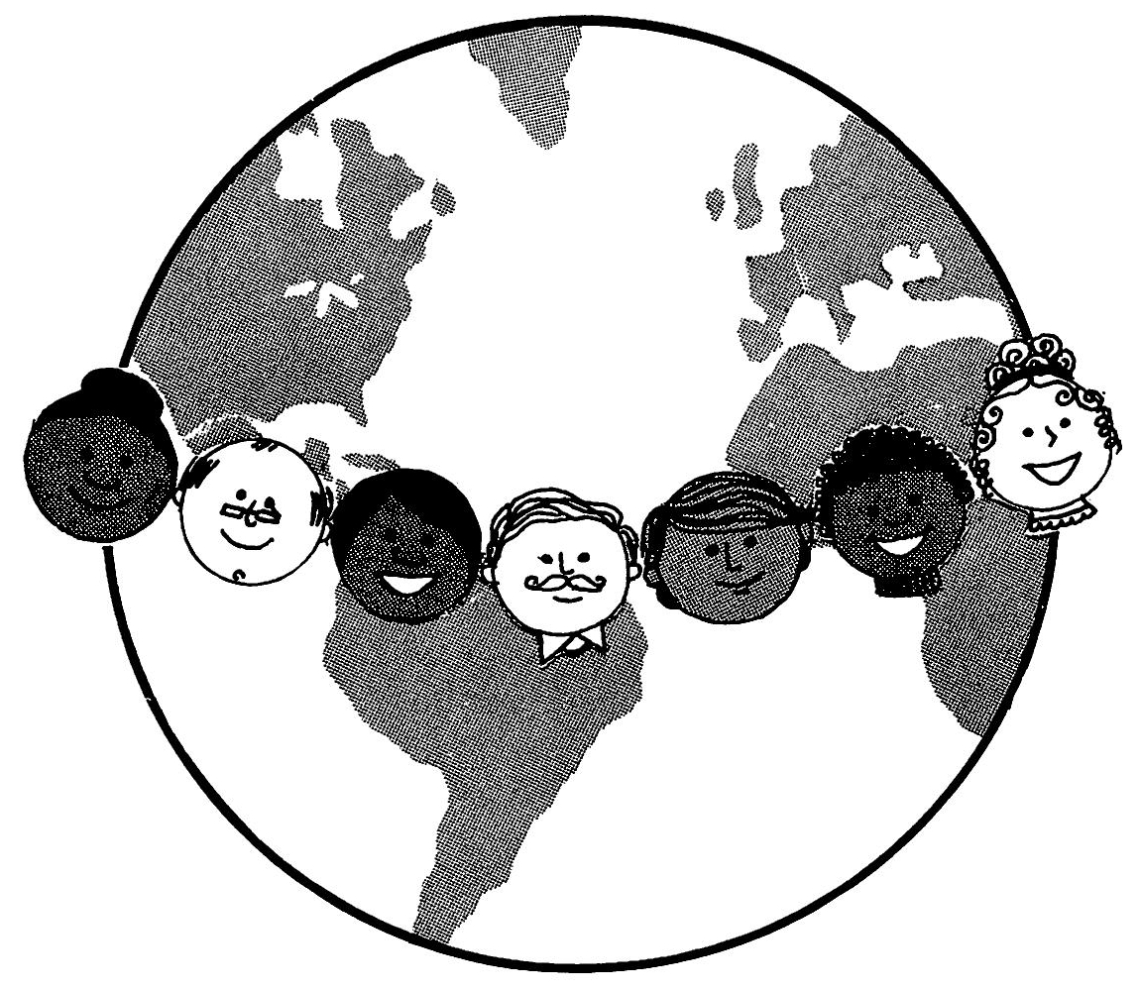

Bahá’u’lláh is the Manifestation of God for this age. He has brought a new Message from God to guide all of mankind. Bahá’u’lláh was sent to teach all men how to build the Kingdom of God on earth. He has come to unite all of the peoples and nations of the world under a reign of justice and peace. He has given us God’s plan for world unity.

There are no priests or ministers or clergy of any kind in the Bahá’í' Faith. Wherever there are nine or more adult Bahá’í's in one locality, a Local Spiritual Assembly is established to take care of the affairs of the Bahá’í Faith in that area. This Local Spiritual Assembly is a council of nine Bahá’í’s elected according to the plan of Bahá’u’lláh.

2
In every city a Spiritual Assembly must be formed

“The Lord hath ordained,” Bahá’u’lláh reveals, “that in every city a House of Justice be established wherein shall gather counsellors to the number of Baha (9)…. It behooveth them to be the trusted ones of the Merciful among men and to regard themselves as the guardians appointed of God for all that dwell on earth.”

It is of the greatest importance that, in accordance with the command of Bahá’u’lláh, in every city, town or village where there are nine or more adult Bahá’í's, a Local Spiritual Assembly be established.

3
All Spiritual Assemblies are aided by the Spirit of God

One of the healing remedies that Bahá’u’lláh has given to this sick world is the Local Spiritual Assembly (which in the future will be known as the Local House of Justice). It is to this divine institution that all Bahá’í's should turn for help and guidance. The Local Spiritual Assembly should become the centre of Bahá’í' Community life in every locality.

‘Abdu’l-Bahá says: “These Spiritual Assemblies are aided by the Spirit of God…. These Spiritual Assemblies are shining lamps and heavenly gardens, from which the fragrances of holiness are diffused over all regions, and the lights of knowledge are shed abroad over all created things. From them the spirit of life streameth in every direction.”

4
Spiritual Assemblies are elected once a year

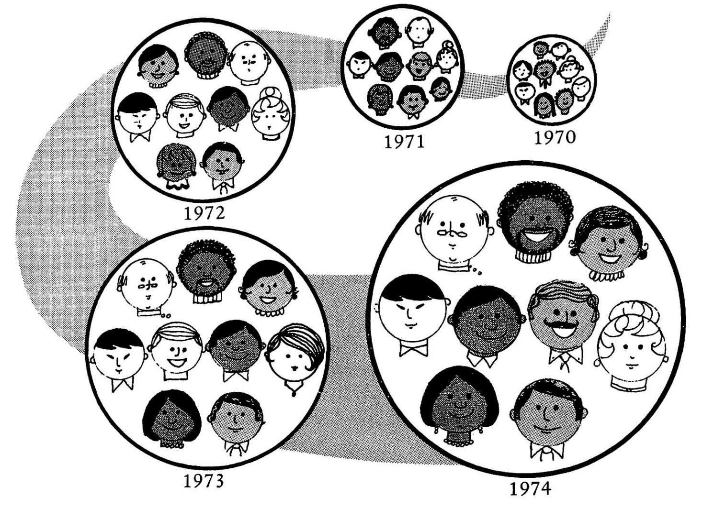

All Local Spiritual Assemblies must be elected once a year on the first day of the Riḍván Festival (between sunset on April 20th (or April 21st) and sunset on April 21st (or April 22nd). On this day all the Bahá’í's of the community come together for the election. They say prayers for God’s guidance and protection. Then, in an atmosphere of silent meditation, each adult Bahá’í' casts his vote.

Shoghi Effendi writes that “… every declared believer of 21 years and above, far from standing aloof and assuming an indifferent or independent attitude, should regard it his sacred duty to take part conscientiously and diligently, in the election . . . of his own local Assembly.”

5
No nominations and no discussion of names are permitted

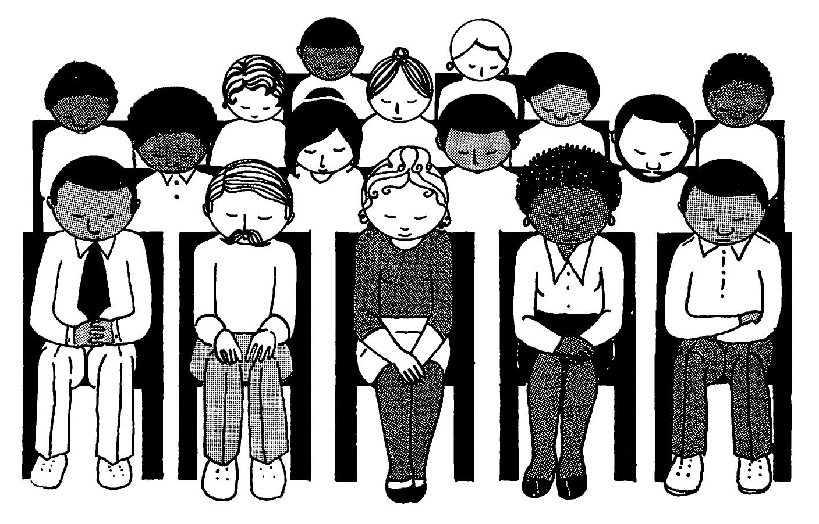

Nominating candidates and campaigning for their election are not permitted in the Bahá’í Faith. Any adult Bahá’í' (21 years or older) in good standing in the community can be elected to the Local Spiritual Assembly. Before the election there is no discussion of names or personalities among the Bahá’í’s because this causes misunderstandings and differences to arise. No Bahá’í' should ever tell another Bahá’í' how he should vote or try to influence his opinion.

Shoghi Effendi states that Bahá’í's should “…consider without the least trace of passion and prejudice, and irrespective of any material consideration, the names of only those who can best combine the necessary qualities of unquestioned loyalty, of selfless devotion, of a well—trained mind, of recognized ability and mature experience.”

6
Bahá’í's vote after prayer and thought

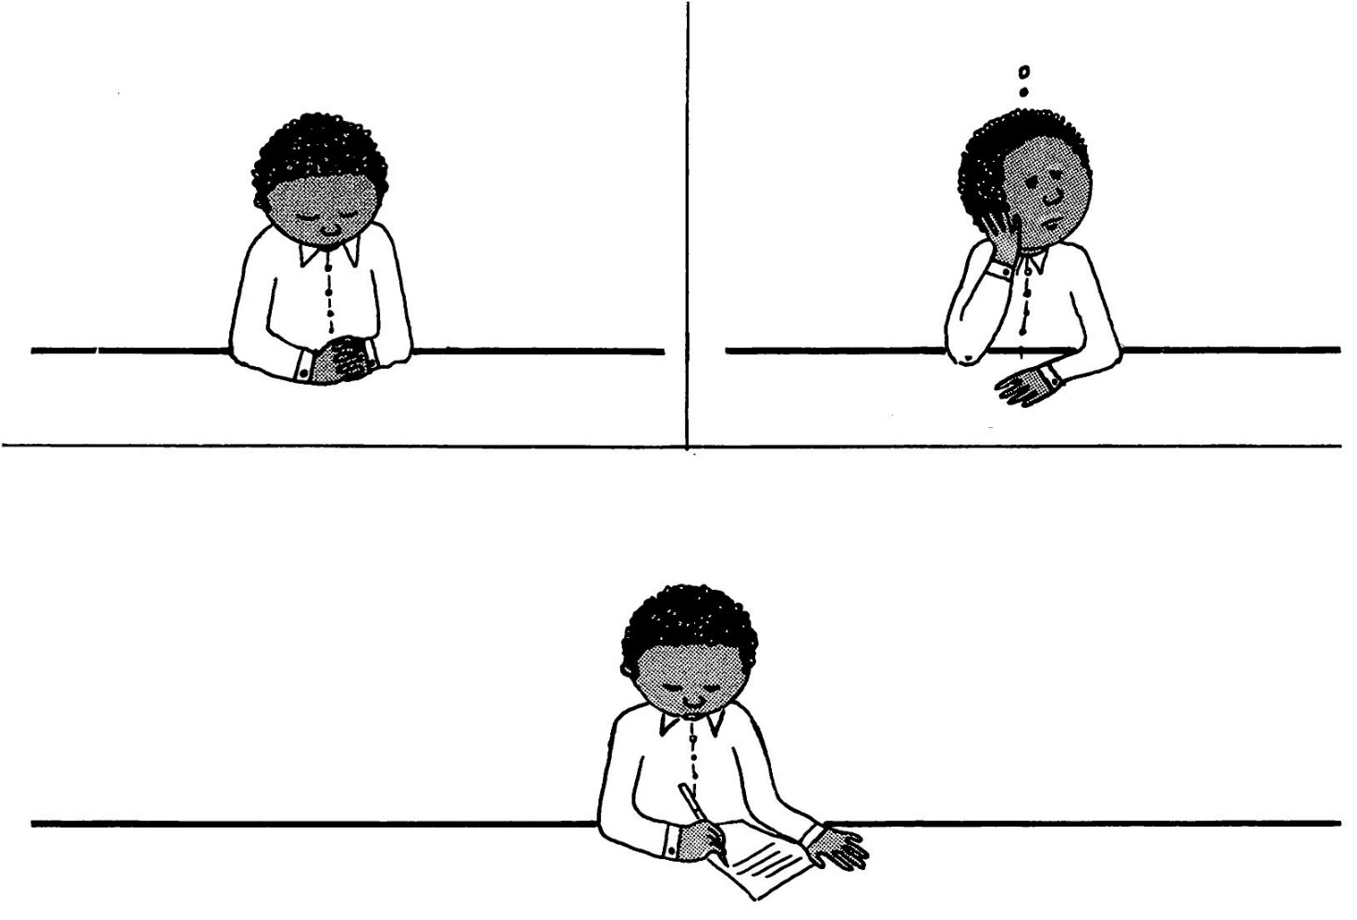

All through the year each Bahá’í' should mix freely with the believers in his community and get to know them. At the annual election the Bahá’í's gather together. Ballots are passed out and, after prayer and serious thought, everyone writes on his ballot the names of nine adult Bahá’í’s, no more and no less. This is done by secret ballot so that no one knows how another voted. The ballots are then collected and counted.

Every Bahá’í' should take part in the election of his Local Assembly. If he is unable to attend the annual election for some reason, he can send his ballot along with someone else or mail it in.

7
The nine with the most votes are elected

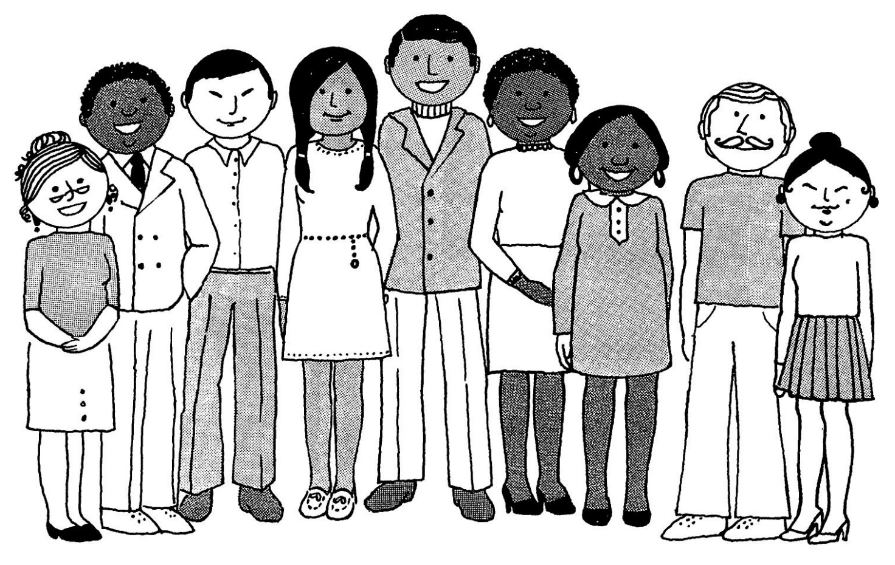

When the ballots are counted, the nine adult Bahá’í's in the community who receive the most votes become the Local Spiritual Assembly for one year.

Shoghi Effendi explains that “…every Assembly elected in that rarefied atmosphere of selflessness and detachment is, in truth, appointed of God, that its verdict is truly inspired, that one and all should submit to its decision unreservedly and with cheerfulness.”

Moreover, in a letter written on his behalf, we are reminded: “Bahá’u’lláh has given the promise that in every Assembly where unity and harmony prevail, there His glorious spirit will not only be present, but will animate, sustain and guide all the friends in all their deliberations.”

8
The Spiritual Assembly is in charge of all Bahá'í affairs

The Local Spiritual Assembly is in charge of all Bahá’í' affairs within its locality. This means that all matters which affect the Cause within that area should be referred to the Assembly.

‘Abdu’l-Bahá states: “It is incumbent upon every one not to take any step without consulting the Spiritual Assembly, and they must assuredly obey with heart and soul its bidding and be submissive unto it, that things may be properly ordered and well arranged. Otherwise every person will act independently and after his own judgment, will follow his own desire, and do harm to the Cause.”

9
Spiritual Assemblies, not individuals, make decisions

It is to the Local Spiritual Assembly itself that all Bahá’í's must turn. It is only the Assembly as a whole that can make decisions for the Bahá’í' Community; individual members of the Assembly do not have the right to do this.

In a letter written on Shoghi Effendi’s behalf, it is stated that “… there is a distinction of fundamental importance which should always be remembered in this connection, and this is between the spiritual assembly as an institution, and the persons who comprise it. These [the members of the Assembly] are by no means supposed to be perfect, nor can they be considered as being inherently superior to the rest of their fellow believers.”

10
The Spiritual Assembly has many duties

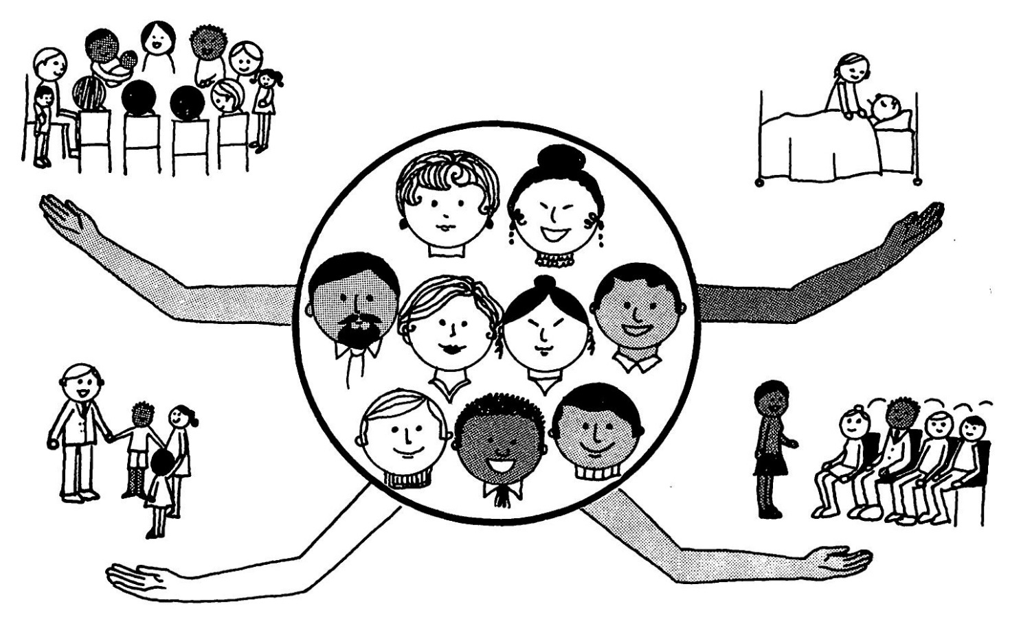

Bahá’u’lláh teaches us that when a Local Spiritual Assembly comes together to consult, teaching the Cause of God must be considered the most important matter before it. Ways and means of teaching new Bahá’í's more about the Faith and bringing the Message to new souls must be the principal topics of discussion.

But the Assembly also has other important duties and responsibilities. It must protect the Cause from the attacks of its enemies. It must promote love, fellowship and unity among all of the Bahá’í's in its community. It must do as much as possible to help the poor, the sick, the disabled, the orphan and the widow. The Assembly must also promote the education of Bahá’í children and youth and arrange for regular meetings of the Bahá’í's—the Feasts and Holy Days, as well as other meetings.

11
The Assembly keeps order and unity and obedience to
the laws of God amongst the believers

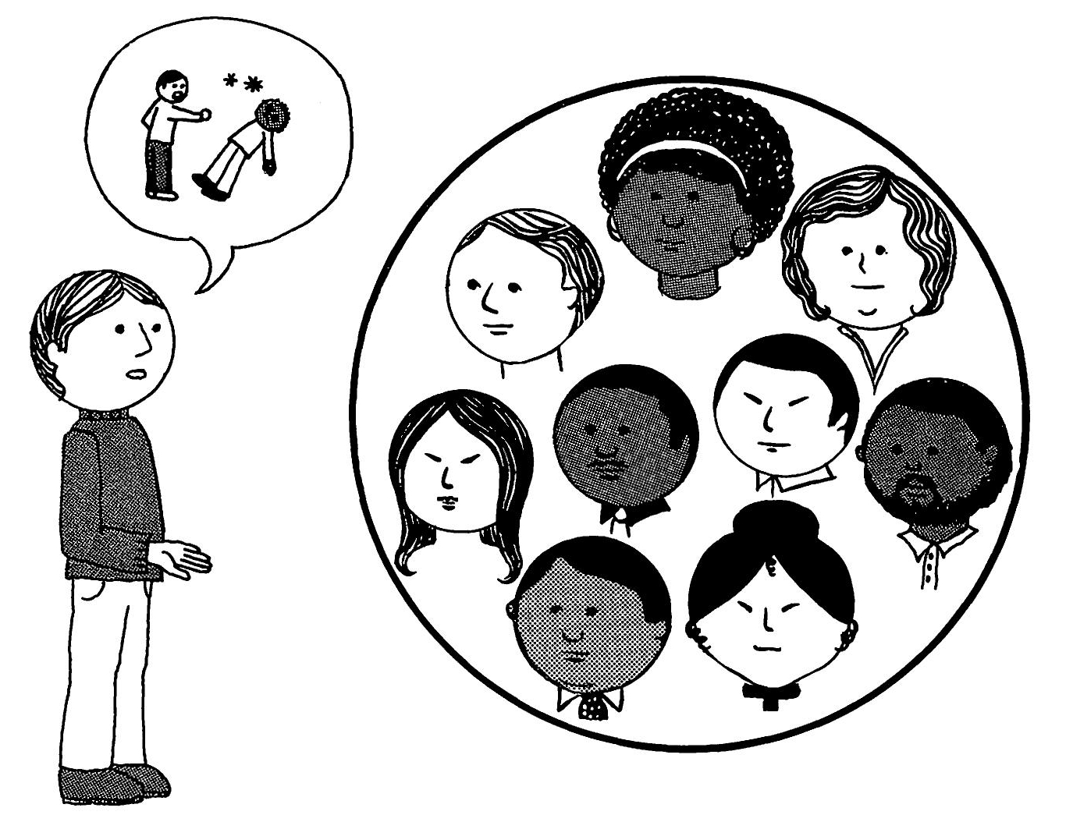

If any Bahá’í' is having a personal problem that he cannot solve by himself, or if he has a dispute with another Bahá’í' that cannot be worked out, he should go directly to his Local Spiritual Assembly for help—like a child would go to its parents.

Likewise, if someone feels that another Bahá’í is acting in such a way as to harm the Cause, he should not discuss it with others, but should bring the matter to his Local Spiritual Assembly. Shoghi Effendi, directed his secretary to state that: “These bodies have the sacred obligation to help, advise, protect and guide the believers in every way within their power when appealed to—indeed they were established just for the purpose of keeping order and unity and obedience to the law of God amongst the believers.”

12
All problems and disputes go before the Spiritual Assembly

All problems and disputes that arise in the Bahá’í' Community should be put before the Local Spiritual Assembly for action.

Shoghi Effendi instructed his secretary to write that: “Any person can refer a matter to the Assembly for consultation whether the other person wishes to or not. In matters which affect the Cause the Assembly should, if it deems it necessary, intervene even if both sides do not want it to, because the whole purpose of the Assemblies is to protect the Faith, the Communities, and the individual Bahá’í' as well.”

13
The Assembly members must forget their own likes and dislikes

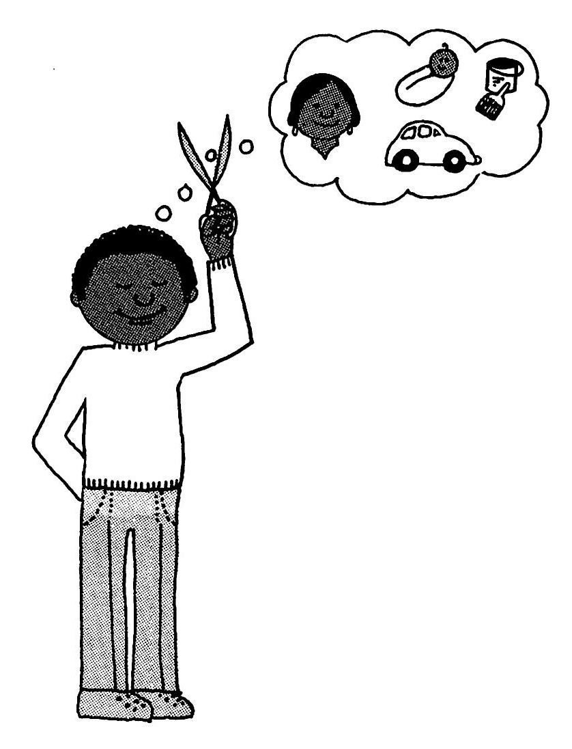

Every Local Spiritual Assembly must make its decisions by means of consultation. When an Assembly comes together for consultation, every member present must freely and openly express his views without fear of what others may think. But he must do this with the greatest courtesy and love so as not to offend anyone. The members of the Assembly must learn to forget personalities and overcome the urge to take sides and fight over different opinions.

“The members of these Assemblies, on their part,” Shoghi Effendi tells us, “must disregard utterly their own likes and dislikes, their personal interests and inclinations, and concentrate their minds upon those measures that will conduce to the welfare and happiness of the Bahá’í' Community and promote the common weal.”

14
Consultation is essential

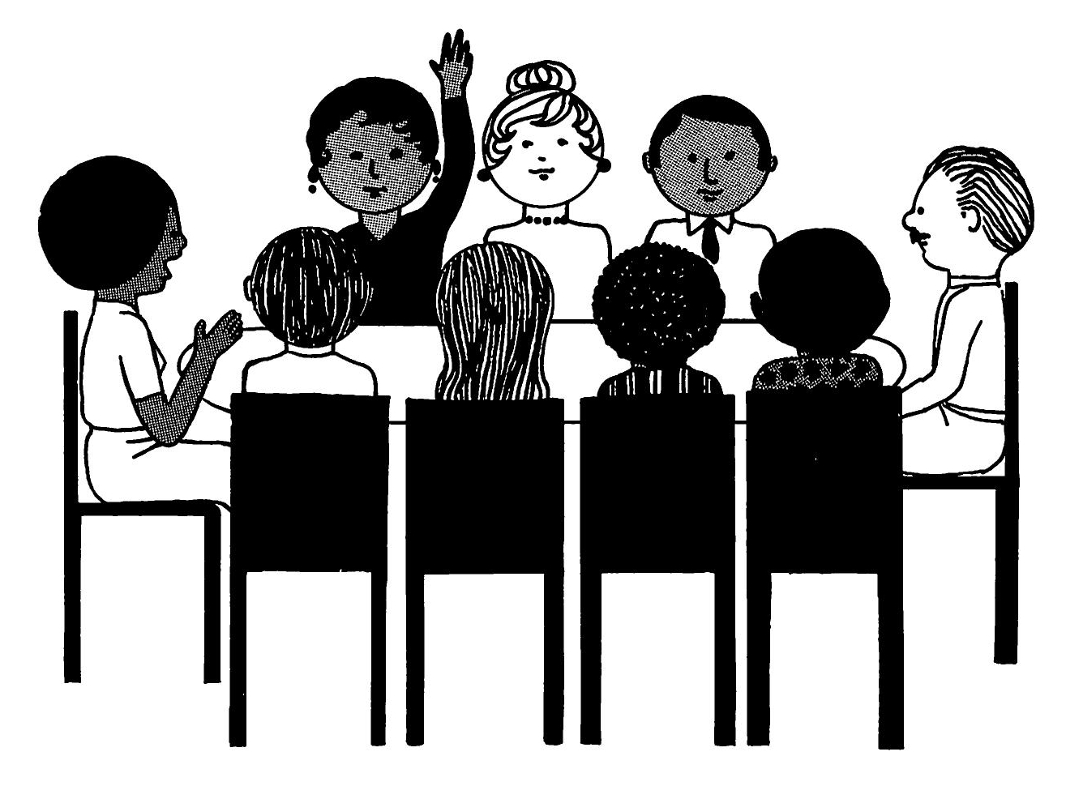

‘Abdu’l-Bahá has explained that: “In this day, assemblies of consultation are of the greatest importance and a vital necessity. Obedience unto them is essential and obligatory. The members thereof must take counsel together in such wise that no occasion for ill-feeling or discord may arise. This can be attained when every member expresseth with absolute freedom his own opinion and setteth forth his argument. Should any one oppose, he must on no account feel hurt for not until matters are fully discussed can the right way be revealed. The shining spark of truth cometh forth only after the clash of differing opinions. If after discussion, a decision be carried unanimously well and good; but if, the Lord forbid, differences of opinion should arise, a majority of voices must prevail."

15
They must show forth love and harmony

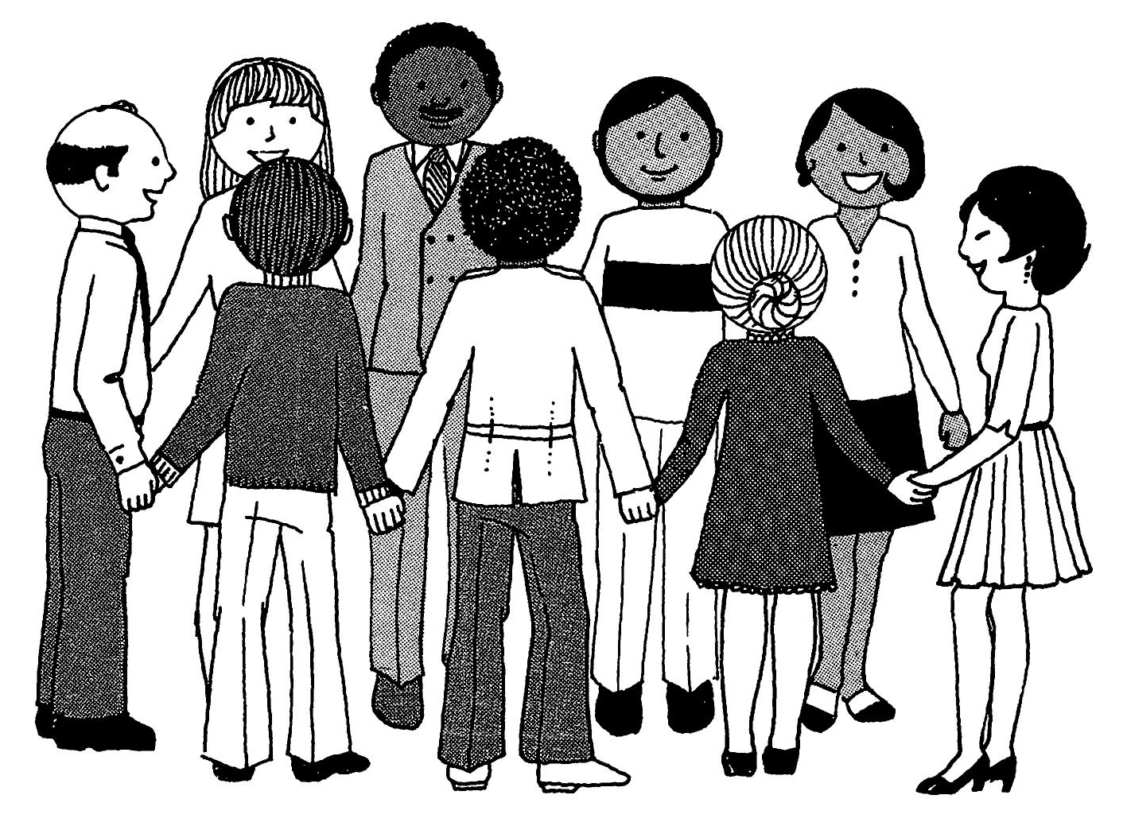

Regarding consultation, ‘Abdu’l-Bahá states:

“The first condition is absolute love and harmony amongst the members of the assembly. They must be wholly free from estrangement and must manifest in themselves the Unity of God, for they are the waves of one sea, the drops of one river, the stars of one heaven, the rays of one sun, the trees of one orchard, the flowers of one garden. Should harmony of thought and absolute unity be non-existent, that gathering shall be dispersed and that assembly be brought to naught.”

16
With prayer and courtesy they must seek the truth

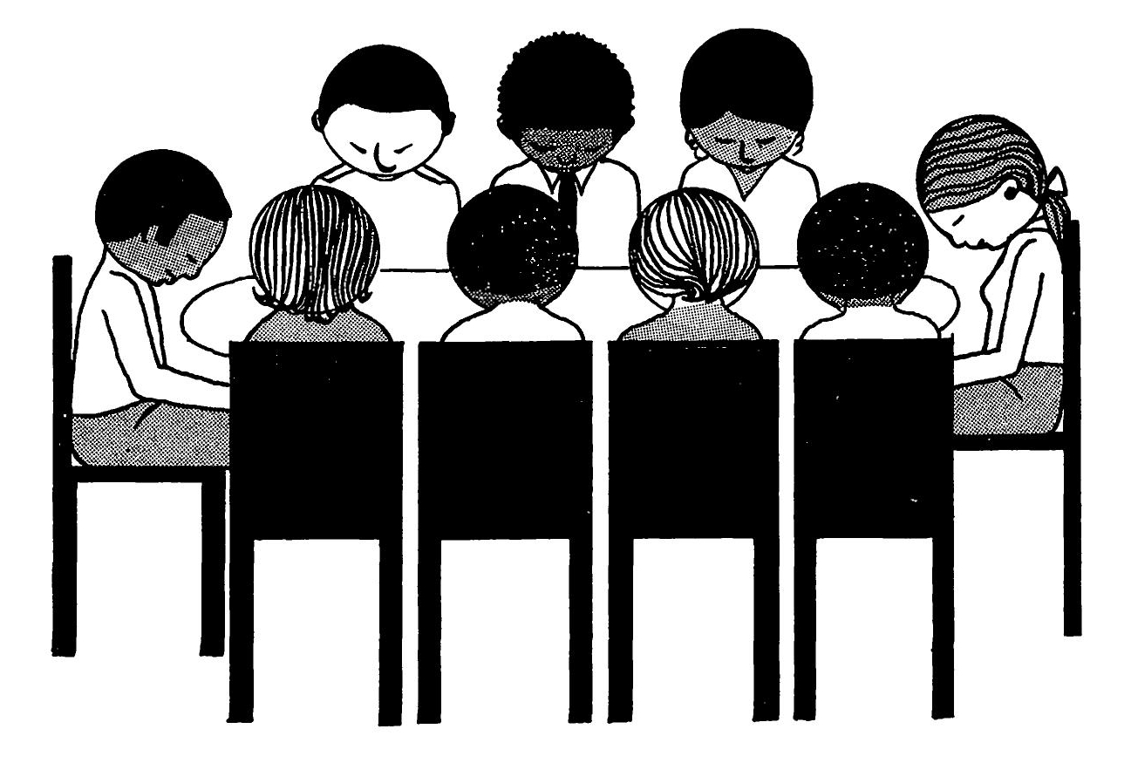

‘Abdu’l-Bahá continues:

“The second condition: They must when coming together turn their faces to the Kingdom on High and ask aid from the Realm of Glory. They must then proceed with the utmost devotion, courtesy, dignity, care and moderation to express their views. They must in every matter search out the truth and not insist upon their own opinion, for stubbornness and persistence in one’s views will lead ultimately to discord and wrangling and the truth will remain hidden. The honoured members must with all freedom express their own thoughts, and it is in no wise permissible for one to belittle the thought of another, nay, he must with moderation set forth the truth, and should differences of opinion arise a majority of voices must prevail, and all must obey and submit to the majority…. In short, whatsoever thing is arranged in harmony and with love and purity of motive, its result is light, and should the least trace of estrangement prevail the result shall be darkness upon darkness.”

17
A majority vote must prevail

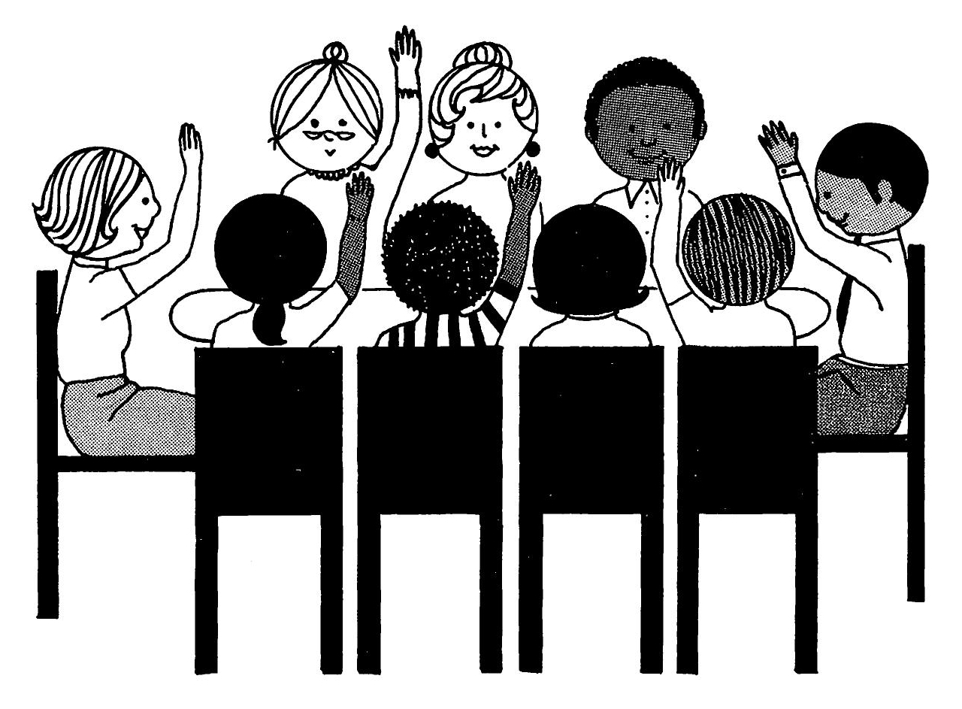

After the Local Spiritual Assembly has fully consulted on a matter and taken a vote and come to a decision, all of the members of the Assembly must submit to the decision of the majority. All of the Bahá’ís of the community must then cheerfully and wholeheartedly abide by that decision.

In a letter written on Shoghi Effendi’s behalf, it is explained that: “The Assembly may make a mistake, but, as the Master [‘Abdu’l-Bahá] pointed out, if the Community does not abide by its decisions, or the individual Bahá’í', the result is worse…. He tells us God will right the wrongs done. We must have confidence in this and obey our Assemblies.”

18
Spiritual Assemblies pray before consulting

Prayer for Spiritual Assemblies:

“O God! my God! We are servants of Thine that have turned with devotion to Thy holy face, that have detached ourselves from all beside Thee in this glorious Day. We have gathered in this spiritual assembly, united in our views and thoughts, with our purposes harmonized to exalt Thy Word amidst mankind. O Lord, our God! Make us the signs of Thy divine guidance, the standards of Thine exalted Faith amongst men, servants to Thy mighty Covenant, O Thou our Lord Most High, manifestations of Thy divine unity in Thine Abhá Kingdom, and resplendent stars shining upon all regions. Lord! Aid us to become seas surging with the billows of Thy wondrous grace, streams flowing from Thine all-glorious heights, goodly fruits upon the tree of Thy heavenly Cause, trees waving through the breezes of Thy bounty in Thy celestial vineyard. O God! Make our souls dependent upon the verses of Thy divine unity, our hearts cheered with the outpourings of Thy grace, that we may unite even as the waves of one sea and become merged together as the rays of Thine effulgent light; that our thoughts, our views, our feelings may become as one reality, manifesting the spirit of union throughout the world. Thou art the Gracious, the Bountiful, the Bestower, the Almighty, the Merciful, the Compassionate.”
Abdu’l-Bahá

19
The Assembly must act with love and justice

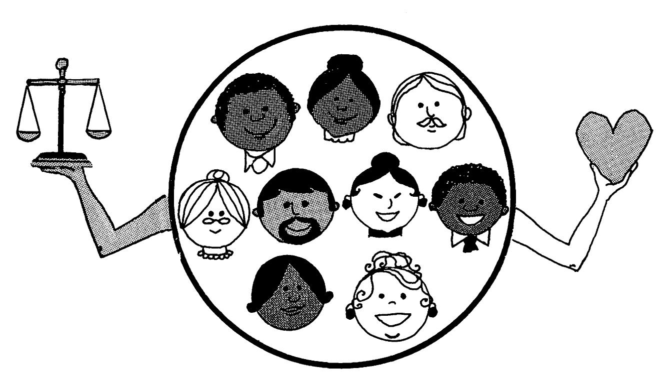

It is stated in a letter written on Shoghi Effendi’s behalf that:

“The administrators of the Faith of God must be like unto shepherds. Their aim should be to dispel all the doubts, misunderstandings and harmful differences which may arise in the community of the believers. And this they can adequately achieve provided they are motivated by a true sense of love for their fellow-brethren coupled with a firm determination to act with justice in all the cases which are submitted to them for their consideration.”

20
The Assembly must humbly serve the community

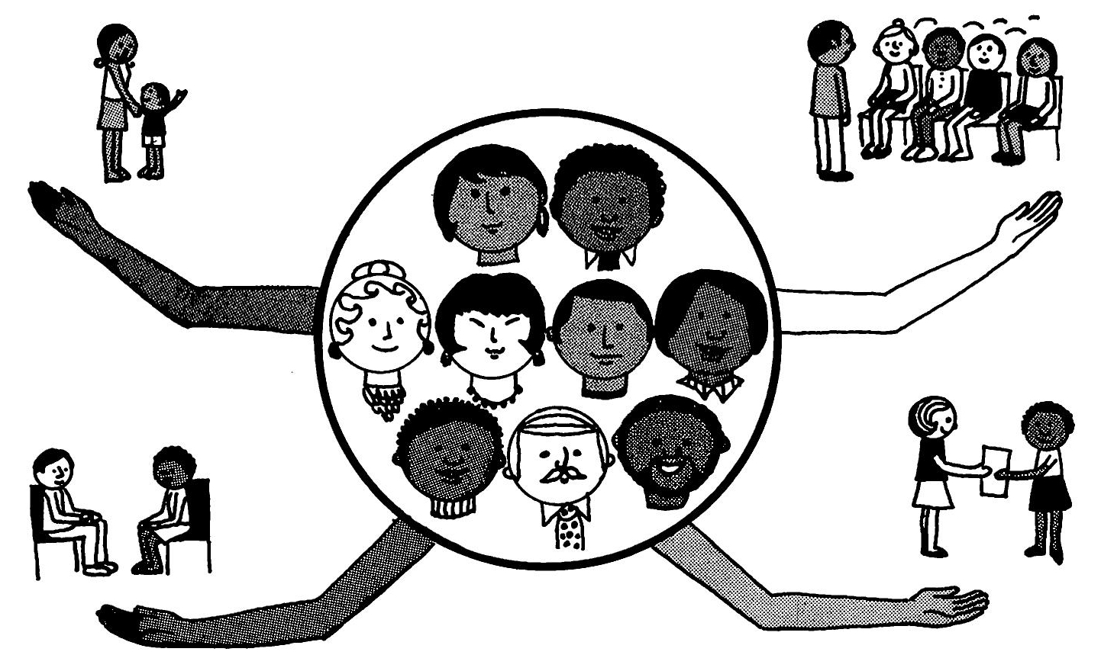

The members of a Local Spiritual Assembly should be humble and modest and should always keep an open mind and maintain a high sense of justice and duty. They should, within wise limits, take the friends into their confidence, share their plans and problems with them, and seek their advice.

Shoghi Effendi directed his secretary to state that: “The local assemblies should inspire confidence in the individual believers, and these in their turn should express their readiness to fully abide by the decisions and directions of the local assembly: the two must learn to co-operate, and to realize that only through such a co-operation can the institutions of the Cause effectively and permanently function. While obedience to the local assembly should be unqualified and whole-hearted, yet that body should enforce its directions in such a way as to avoid giving the impression that it is animated by dictatorial motives. The spirit of the Cause is one of mutual cooperation, and not that of a dictatorship.”

21
All Bahá’í's must trust and obey their Assembly

Bahá’í's everywhere must learn to trust their Local Assemblies and to turn to them for advice and help as soon as they are needed. The Assembly, on its part, must be concerned and watchful and truly feel responsible for the welfare of every Bahá’í' and for the community as a whole.

Shoghi Effendi authorized his secretary to write: “The believers should learn to turn more often to their assemblies for advice and help and at an earlier date, and the Assemblies, on the other hand, should act with more vigilance and a greater sense of community responsibility towards every situation that may damage the prestige of the Faith in the eyes of the public.”

22
We are building a New World Order

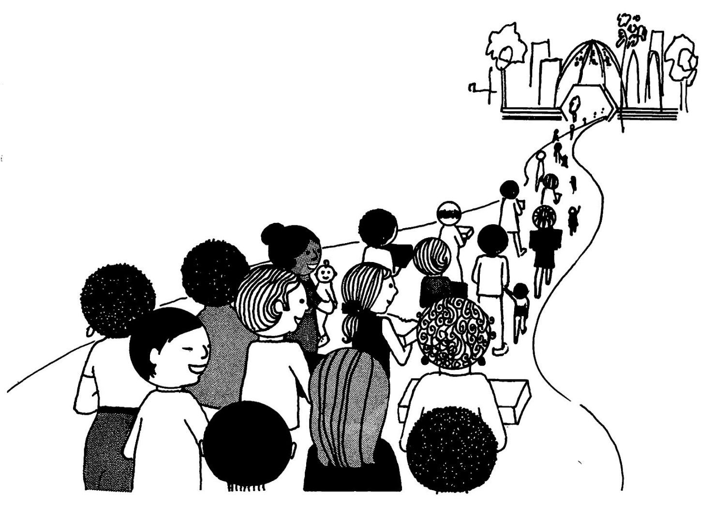

In another letter written on Shoghi Effendi’s behalf, it is stated that:

“This Cause is a Cause which God has revealed to humanity as a whole. It is designed to benefit the entire human race, and the only way it can do this is to re-form the community life of mankind, as well as seeking to regenerate the individual. The Bahá’í administration is only the first shaping of what in future will come to be the social life and laws of community living. As yet the believers are only first beginning to grasp and practice it properly. So we must have patience if at times it seems a little self conscious and rigid in its workings. It is because we are learning something very difficult but very wonderful—how to live together as a community of Bahá’í's, according to the glorious teachings.”

All references used in this booklet are taken from The Local Spiritual Assembly (compiled by the Universal House of Justice, August 1970). The September 2017 revision of this compilation can be downloaded here

Prepared by the National Teaching Committee. Illustrations: Miss Dale Robison

Downloaded from Bahá'í Works to be used in conjunction with its translation into Thai. Some modifications made to bring it up-to-date with the Badi Calendar.

Tools

This page was last edited on 23 October 2016, at 23:15.

Privacy policy

About Bahaiworks

Disclaimers

