Cover

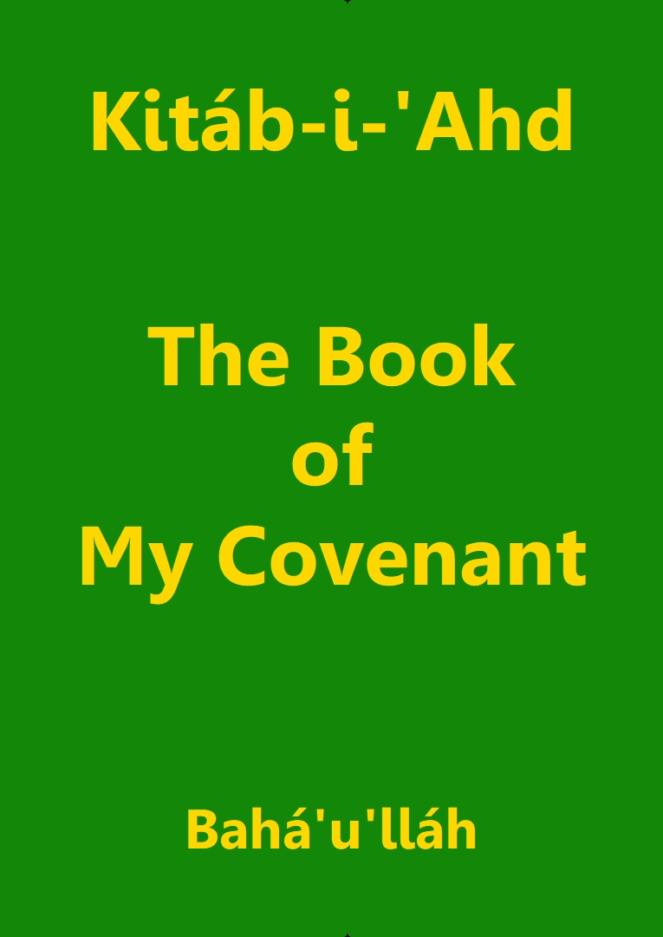

Title Page

Kitáb-i-‘Ahd

The Book
of
My Covenant

Bahá’u’lláh

Download English language version
from the Bahá'í World Centre

Bahá'í Faith

Note: Some minor changes made to the Bahá'í World Centre to match the Thai translation.

Kitáb-i-‘Ahd
(The Book of My Covenant)

ALTHOUGH the Realm of Glory hath none of the vanities of the world, yet within the treasury of trust and resignation We have bequeathed to Our heirs an excellent and priceless Heritage. Earthly treasures We have not bequeathed, nor have We added such cares as they entail. By God! In earthly riches fear is hidden and peril is concealed. Consider ye and call to mind that which the All-Merciful hath revealed in the Qur’án: “Woe betide every slanderer and defamer, him that layeth up riches and counteth them.” Fleeting are the riches of the world; all that perisheth and changeth is not, and hath never been, worthy of attention, except to a recognized measure.

The aim of this Wronged One in sustaining woes and tribulations, in revealing the Holy Verses and in demonstrating proofs hath been naught but to quench the flame of hate and enmity, that the horizon of the hearts of men may be illumined with the light of concord and attain real peace and tranquillity. From the dawning-place of the divine Tablet the daystar of this utterance shineth resplendent, and it behooveth everyone to fix his gaze upon it: We exhort you, O peoples of the world, to observe that which will elevate your station. Hold fast to the fear of God and firmly adhere to what is right. Verily I say, the tongue is for mentioning what is good, defile it not with unseemly talk. God hath forgiven what is past. Henceforward everyone should utter that which is meet and seemly, and should refrain from slander, abuse and whatever causeth sadness in men. Lofty is the station of man! Not long ago this exalted Word streamed forth from the treasury of Our Pen of Glory: Great and blessed is this Day—the Day in which all that lay latent in man hath been and will be made manifest. Lofty is the station of man, were he to hold fast to righteousness and truth and to remain firm and steadfast in the Cause. In the eyes of the All-Merciful a true man appeareth even as a firmament; its sun and moon are his sight and hearing, and his shining and resplendent character its stars. His is the loftiest station, and his influence educateth the world of being.

Every receptive soul who hath in this Day inhaled the fragrance of His garment and hath, with a pure heart, set his face towards the all-glorious Horizon is reckoned among the people of Bahá in the Crimson Book. Grasp ye, in My Name, the chalice of My loving-kindness, drink then your fill in My glorious and wondrous remembrance.

O ye that dwell on earth! The religion of God is for love and unity; make it not the cause of enmity or dissension. In the eyes of men of insight and the beholders of the Most Sublime Vision, whatsoever are the effective means for safeguarding and promoting the happiness and welfare of the children of men have already been revealed by the Pen of Glory. But the foolish ones of the earth, being nurtured in evil passions and desires, have remained heedless of the consummate wisdom of Him Who is, in truth, the All-Wise, while their words and deeds are prompted by idle fancies and vain imaginings.

O ye the loved ones and the trustees of God! Kings are the manifestations of the power, and the daysprings of the might and riches, of God. Pray ye on their behalf. He hath invested them with the rulership of the earth and hath singled out the hearts of men as His Own domain.

Conflict and contention are categorically forbidden in His Book. This is a decree of God in this Most Great Revelation. It is divinely preserved from annulment and is invested by Him with the splendour of His confirmation. Verily He is the All-Knowing, the All-Wise.

It is incumbent upon everyone to aid those daysprings of authority and sources of command who are adorned with the ornament of equity and justice. Blessed are the rulers and the learned among the people of Bahá. They are My trustees among My servants and the manifestations of My commandments amidst My people. Upon them rest My glory, My blessings and My grace which have pervaded the world of being. In this connection the utterances revealed in the Kitáb-i-Aqdas are such that from the horizon of their words the light of divine grace shineth luminous and resplendent.

O ye My Branches! A mighty force, a consummate power lieth concealed in the world of being. Fix your gaze upon it and upon its unifying influence, and not upon the differences which appear from it.

The Will of the divine Testator is this: It is incumbent upon the Aghsán, the Afnán and My Kindred to turn, one and all, their faces towards the Most Mighty Branch. Consider that which We have revealed in Our Most Holy Book: “When the ocean of My presence hath ebbed and the Book of My Revelation is ended, turn your faces towards Him Whom God hath purposed, Who hath branched from this Ancient Root.” The object of this sacred verse is none except the Most Mighty Branch [‘Abdu’l-Bahá]. Thus have We graciously revealed unto you Our potent Will, and I am verily the Gracious, the All-Bountiful. Verily God hath ordained the station of the Greater Branch [Muḥammad ‘Alí] to be beneath that of the Most Great Branch [‘Abdu’l-Bahá]. He is in truth the Ordainer, the All-Wise. We have chosen “the Greater” after “the Most Great,” as decreed by Him Who is the All-Knowing, the All-Informed.

It is enjoined upon everyone to manifest love towards the Aghsán, but God hath not granted them any right to the property of others.

O ye My Aghsán, My Afnán and My Kindred! We exhort you to fear God, to perform praiseworthy deeds and to do that which is meet and seemly and serveth to exalt your station. Verily I say, fear of God is the greatest commander that can render the Cause of God victorious, and the hosts which best befit this commander have ever been and are an upright character and pure and goodly deeds.

Say: O servants! Let not the means of order be made the cause of confusion and the instrument of union an occasion for discord. We fain would hope that the people of Bahá may be guided by the blessed words: “Say: all things are of God.” This exalted utterance is like unto water for quenching the fire of hate and enmity which smoldereth within the hearts and breasts of men. By this single utterance contending peoples and kindreds will attain the light of true unity. Verily He speaketh the truth and leadeth the way. He is the All-Powerful, the Exalted, the Gracious.

It is incumbent upon everyone to show courtesy to, and have regard for the Aghsán, that thereby the Cause of God may be glorified and His Word exalted. This injunction hath time and again been mentioned and recorded in the Holy Writ. Well is it with him who is enabled to achieve that which the Ordainer, the Ancient of Days hath prescribed for him. Ye are bidden moreover to respect the members of the Holy Household, the Afnán and the kindred. We further admonish you to serve all nations and to strive for the betterment of the world.

That which is conducive to the regeneration of the world and the salvation of the peoples and kindreds of the earth hath been sent down from the heaven of the utterance of Him Who is the Desire of the world. Give ye a hearing ear to the counsels of the Pen of Glory. Better is this for you than all that is on the earth. Unto this beareth witness My glorious and wondrous Book.

