Cover

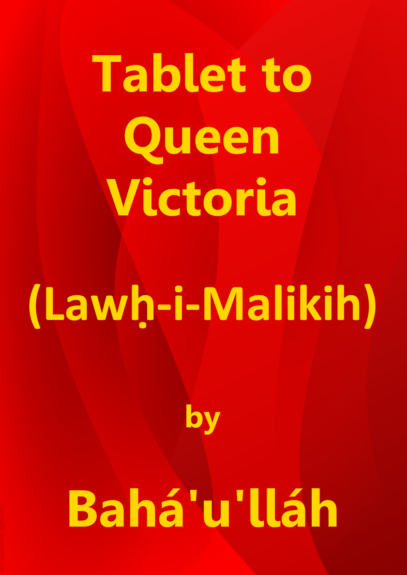

Title Page

Tablet to
Queen Victoria
(Lawḥ-i-Malikih)

by

Bahá’u’lláh

Download English language version
from the Bahá'í World Centre

Bahá'í Faith

This document has been downloaded from the Bahá’í Reference Library. You are free to use its content subject to the terms of use found at www.bahai.org/legal

Note: Some minor changes have been made to the Bahá'í World Centre download to mirror the November 2020 provisional Thai translation.

Table of Contents

Cover 1
Title Page 2
Table of Contents 3
Tablet to Queen Victoria (Lawḥ-i-Malikih) 4
Note on the Translation 10
Key to Passages Translated by Shoghi Effendi 10

Tablet to Queen Victoria
(Lawḥ-i-Malikih)

1
O Queen in London! Incline thine ear unto the voice of thy Lord, the Lord of all mankind, calling from the Divine Lote-Tree: Verily, no God is there but Me, the Almighty, the All-Wise! Cast away all that is on earth, and attire the head of thy kingdom with the crown of the remembrance of thy Lord, the All-Glorious. He, in truth, hath come unto the world in His most great glory, and all that hath been mentioned in the Gospel hath been fulfilled. The land of Syria hath been honoured by the footsteps of its Lord, the Lord of all men, and north and south are both inebriated with the wine of His presence. Blessed is the man that hath inhaled the fragrance of the Most Merciful, and turned unto the Dawning-Place of His Beauty, in this resplendent Dawn. The Mosque of Aqṣá vibrateth through the breezes of its Lord, the All-Glorious, whilst Baṭḥá trembleth at the voice of God, the Exalted, the Most High. Whereupon every single stone of them celebrateth the praise of the Lord, through this Great Name.

2
Lay aside thy desire, and set then thine heart towards thy Lord, the Ancient of Days. We make mention of thee for the sake of God, and desire that thy name may be exalted through thy remembrance of God, the Creator of earth and heaven. He, verily, is witness unto that which I say. We have been informed that thou hast forbidden the trading in slaves, both men and women. This, verily, is what God hath enjoined in this wondrous Revelation. God hath, truly, destined a reward for thee, because of this. He, verily, will pay the doer of good his due recompense, wert thou to follow what hath been sent unto thee by Him Who is the All-Knowing, the All-Informed. As to him who turneth aside, and swelleth with pride, after the clear tokens have come unto him from the Revealer of signs, his work shall God bring to naught. He, in truth, hath power over all things. Man’s actions are acceptable after his having recognized (the Manifestation). He that turneth aside from the True One is indeed the most veiled amongst His creatures. Thus hath it been decreed by Him Who is the Almighty, the Most Powerful.

3
We have also heard that thou hast entrusted the reins of counsel into the hands of the representatives of the people. Thou, indeed, hast done well, for thereby the foundations of the edifice of thine affairs will be strengthened, and the hearts of all that are beneath thy shadow, whether high or low, will be tranquillized. It behoveth them, however, to be trustworthy among His servants, and to regard themselves as the representatives of all that dwell on earth. This is what counselleth them, in this Tablet, He Who is the Ruler, the All-Wise. And if any one of them directeth himself towards the Assembly, let him turn his eyes unto the Supreme Horizon, and say: “O my God! I ask Thee, by Thy most glorious Name, to aid me in that which will cause the affairs of Thy servants to prosper, and Thy cities to flourish. Thou, indeed, hast power over all things!” Blessed is he that entereth the Assembly for the sake of God, and judgeth between men with pure justice. He, indeed, is of the blissful.

4
O ye the elected representatives of the people in every land! Take ye counsel together, and let your concern be only for that which profiteth mankind and bettereth the condition thereof, if ye be of them that scan heedfully. Regard the world as the human body which, though at its creation whole and perfect, hath been afflicted, through various causes, with grave disorders and maladies. Not for one day did it gain ease, nay its sickness waxed more severe, as it fell under the treatment of ignorant physicians, who gave full rein to their personal desires and have erred grievously. And if, at one time, through the care of an able physician, a member of that body was healed, the rest remained afflicted as before. Thus informeth you the All-Knowing, the All-Wise.

5
We behold it, in this day, at the mercy of rulers so drunk with pride that they cannot discern clearly their own best advantage, much less recognize a Revelation so bewildering and challenging as this. And whenever any one of them hath striven to improve its condition, his motive hath been his own gain, whether confessedly so or not; and the unworthiness of this motive hath limited his power to heal or cure.

6
That which the Lord hath ordained as the sovereign remedy and mightiest instrument for the healing of all the world is the union of all its peoples in one universal Cause, one common Faith. This can in no wise be achieved except through the power of a skilled, an all-powerful and inspired Physician. This, verily, is the truth, and all else naught but error. Each time that Most Mighty Instrument hath come, and that Light shone forth from the Ancient Dayspring, He was withheld by ignorant physicians who, even as clouds, interposed themselves between Him and the world. It failed, therefore, to recover, and its sickness hath persisted until this day. They indeed were powerless to protect it, or to effect a cure, whilst He Who hath been the Manifestation of Power amongst men was withheld from achieving His purpose, by reason of what the hands of the ignorant physicians have wrought.

7
Consider these days in which He Who is the Ancient Beauty hath come in the Most Great Name, that He may quicken the world and unite its peoples. They, however, rose up against Him with sharpened swords, and committed that which caused the Faithful Spirit to lament, until in the end they imprisoned Him in the most desolate of cities, and broke the grasp of the faithful upon the hem of His robe. Were anyone to tell them: “The World Reformer is come”, they would answer and say: “Indeed it is proven that He is a fomenter of discord!”, and this notwithstanding that they have never associated with Him, and have perceived that He did not seek, for one moment, to protect Himself. At all times He was at the mercy of the wicked doers. At one time they cast Him into prison, at another they banished Him, and at yet another hurried Him from land to land. Thus have they pronounced judgement against Us, and God, truly, is aware of what I say. Such men are reckoned by God among the most ignorant of His creatures. They cut off their own limbs and perceive it not; they deprive themselves of that which is best for them, and know it not. They are even as a young child who can distinguish neither the mischief-maker from the reformer nor the wicked from the righteous. We behold them in this Day wrapt in a palpable veil.

8
O ye rulers of the earth! Wherefore have ye clouded the radiance of the Sun, and caused it to cease from shining? Hearken unto the counsel given you by the Pen of the Most High, that haply both ye and the poor may attain unto tranquillity and peace. We beseech God to assist the kings of the earth to establish peace on earth. He, verily, doth what He willeth.

9
O kings of the earth! We see you increasing every year your expenditures, and laying the burden thereof on your subjects. This, verily, is wholly and grossly unjust. Fear the sighs and tears of this Wronged One, and lay not excessive burdens on your peoples. Do not rob them to rear palaces for yourselves; nay rather choose for them that which ye choose for yourselves. Thus We unfold to your eyes that which profiteth you, if ye but perceive. Your people are your treasures. Beware lest your rule violate the commandments of God, and ye deliver your wards to the hands of the robber. By them ye rule, by their means ye subsist, by their aid ye conquer. Yet, how disdainfully ye look upon them! How strange, how very strange!

10
Now that ye have refused the Most Great Peace, hold ye fast unto this, the Lesser Peace, that haply ye may in some degree better your own condition and that of your dependents.

11
O rulers of the earth! Be reconciled among yourselves, that ye may need no more armaments save in a measure to safeguard your territories and dominions. Beware lest ye disregard the counsel of the All-Knowing, the Faithful.

12
Be united, O kings of the earth, for thereby will the tempest of discord be stilled amongst you, and your peoples find rest, if ye be of them that comprehend. Should any one among you take up arms against another, rise ye all against him, for this is naught but manifest justice. Thus did We exhort you in the Tablet sent down aforetime, and We admonish you once again to follow that which hath been revealed by Him Who is the Almighty, the All-Wise. Should anyone seek refuge with you, extend unto him your protection and betray him not. Thus doth the Pen of the Most High counsel you, as bidden by Him Who is the All-Knowing, the All-Informed.

13
Beware lest ye act as did the King of Islám when We came unto him at his bidding. His ministers pronounced judgement against Us with such injustice that all creation lamented and the hearts of those who are nigh unto God were consumed. The winds of self and passion move them as they will, and We found them all bereft of constancy. They are, indeed, of those that are far astray.

14
Rein in Thy pen, O Pen of the Ancient of Days, and leave them to themselves, for they are immersed in their idle fancies. Make Thou mention of the Queen, that she may turn with a pure heart unto the scene of transcendent glory, may withhold not her eyes from gazing toward her Lord, the Supreme Ordainer, and may become acquainted with that which hath been revealed in the Books and Tablets by the Creator of all mankind, He through Whom the sun hath been darkened and the moon eclipsed, and through Whom the Call hath been raised betwixt earth and heaven.

15
Turn thou unto God and say: O my Sovereign Lord! I am but a vassal of Thine, and Thou art, in truth, the King of kings. I have lifted my suppliant hands unto the heaven of Thy grace and Thy bounties. Send down, then, upon me from the clouds of Thy generosity that which will rid me of all save Thee, and draw me nigh unto Thyself. I beseech Thee, O my Lord, by Thy name, which Thou hast made the king of names and the manifestation of Thyself to all who are in heaven and on earth, to rend asunder the veils that have intervened between me and my recognition of the Dawning-Place of Thy signs and the Dayspring of Thy Revelation. Thou art, verily, the Almighty, the All-Powerful, the All-Bounteous. Deprive me not, O my Lord, of the fragrances of the Robe of Thy mercy in Thy days, and write down for me that which Thou hast written down for Thy handmaidens who have believed in Thee and in Thy signs, and have recognized Thee, and set their hearts towards the horizon of Thy Cause. Thou art truly the Lord of the worlds and of those who show mercy the Most Merciful. Assist me, then, O my God, to remember Thee amongst Thy handmaidens, and to aid Thy Cause in Thy lands. Accept, then, that which hath escaped me when the light of Thy countenance shone forth. Thou, indeed, hast power over all things. Glory be to Thee, O Thou in Whose hand is the kingdom of the heavens and of the earth.

(The Summons of the Lord of Hosts)
www.bahai.org/r/990284655

Note on the Translation

Wherever possible, translations made by Shoghi Effendi have been incorporated in the present volume…. The committees and individuals appointed to prepare the translations faced the challenge of rendering the balance of the Text in a manner at once faithful to the meaning of the original and consistent with the exalted English style established by the Guardian for the translation of Bahá’u’lláh’s matchless utterance.

Key to Passages Translated by Shoghi Effendi

1–3 | “O Queen in London … the Ruler, the All-Wise.” | Shoghi Effendi. The Promised Day Is Come, Revealed to the Pope.
3 | “And if any one of them … of the blissful.” | Bahá’u’lláh. Epistle to the Son of the Wolf.
4–6 | “O ye the elected … all else naught but error.” | Bahá’u’lláh. Gleanings from the Writings of Bahá’u’lláh, CXX.
6–7 | “Each time that Most Mighty … what I say.” | Bahá’u’lláh. Epistle to the Son of the Wolf.
8–12 | “O ye rulers … naught but manifest justice.” | Bahá’u’lláh. Gleanings from the Writings of Bahá’u’lláh, CXIX.
15 | “Turn thou unto God … heavens and of the earth.” | Shoghi Effendi. The Promised Day Is Come, Revealed to the Pope.

The Mosque of Aqsa is in old city of Jerusalem, Israel, and is the third most Holy Place for the Muslims after Mecca and Medina in Saudi Arabia. Muslims believe that Muhammad was transported from the Great Mosque of Mecca to al-Aqsa during the Night Journey, and from there He ascended to Heaven. The Mosque is on a hill called the Temple Mount which is the most Holy Place for the Jews and where the Jews turn towards in prayer. The Jews believe that the third and final Temple will be built there when the Messiah comes. The old city of Jerusalem is where Christians believe that Jesus preached and healed in the second Jewish Temple, was tried, crucified, buried, resurrected and ascended to Heaven.
Mecca, Saudi Arabia.
The Súriy-i-Mulúk (Tablet to the Kings).
The Sulṭán of Turkey.

