Cover
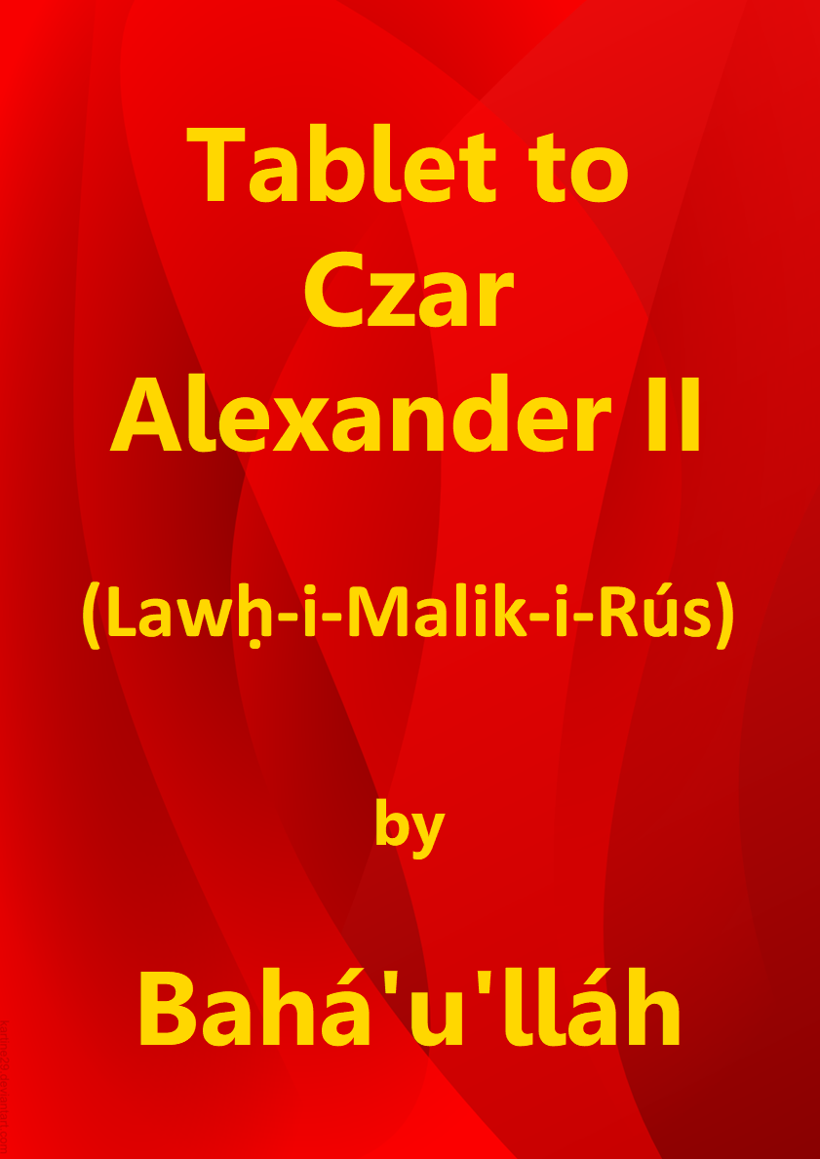

Title Page

Tablet to
Czar Alexander II
(Lawḥ-i-Malik-i-Rús)

by

Bahá’u’lláh

Download English language version
from the Bahá'í World Centre

Bahá'í Faith

This document has been downloaded from the Bahá’í Reference Library. You are free to use its content subject to the terms of use found at www.bahai.org/legal

Note: Some minor changes have been made to the Bahá'í World Centre download to mirror the November 2020 provisional Thai translation.

Table of Contents

Cover 1
Title Page 2
Table of Contents 3
Tablet to Czar Alexander II (Lawḥ-i-Malik-i-Rús) 4
Note on the Translation 8
Key to Passages Translated by Shoghi Effendi 8

Tablet to Czar Alexander II
(Lawḥ-i-Malik-i-Rús)

1
O Czar of Russia! Incline thine ear unto the voice of God, the King, the Holy, and turn thou unto Paradise, the Spot wherein abideth He Who, among the Concourse on high, beareth the most excellent titles, and Who, in the kingdom of creation, is called by the name of God, the Effulgent, the All-Glorious. Beware lest thy desire deter thee from turning towards the face of thy Lord, the Compassionate, the Most Merciful. We, verily, have heard the thing for which thou didst supplicate thy Lord, whilst secretly communing with Him. Wherefore, the breeze of My loving-kindness wafted forth, and the sea of My mercy surged, and We answered thee in truth. Thy Lord, verily, is the All-Knowing, the All-Wise. Whilst I lay chained and fettered in the prison, one of thy ministers extended Me his aid. Wherefore hath God ordained for thee a station which the knowledge of none can comprehend except His knowledge. Beware lest thou barter away this sublime station. Thy Lord, verily, doeth what He willeth. What He pleaseth will God abrogate or confirm, and with Him is the knowledge of all things in a Guarded Tablet.

2
Beware lest thy sovereignty withhold thee from Him Who is the Supreme Sovereign. He, verily, is come with His Kingdom, and all the atoms cry aloud: “Lo! The Lord is come in His great majesty!” He Who is the Father is come, and the Son, in the holy vale, crieth out: “Here am I, here am I, O Lord, My God!”, whilst Sinai circleth round the House, and the Burning Bush calleth aloud: “The All-Bounteous is come mounted upon the clouds! Blessed is he that draweth nigh unto Him, and woe betide them that are far away.”

3
Arise thou amongst men in the name of this all-compelling Cause, and summon, then, the nations unto God, the Exalted, the Great. Be thou not of them who called upon God by one of His names, but who, when He Who is the Object of all names appeared, denied Him and turned aside from Him, and, in the end, pronounced sentence against Him with manifest injustice. Consider and call thou to mind the days whereon the Spirit of God appeared, and Herod gave judgement against Him. God, however, aided Him with the hosts of the unseen, and protected Him with truth, and sent Him down unto another land, according to His promise. He, verily, ordaineth what He pleaseth. Thy Lord truly preserveth whom He willeth, be he in the midst of the seas, or in the maw of the serpent, or beneath the sword of the oppressor.

4
Blessed be the king whom the veils of glory have not deterred from turning unto the Dayspring of beauty and who hath forsaken his all in his desire to obtain the things of God. He, indeed, is accounted in the sight of God as the most excellent of men, and is extolled by the inmates of Paradise and them that circle morn and eve round the Throne on high.

5
Again I say: Hearken unto My voice that calleth from My prison, that it may acquaint thee with the things that have befallen My Beauty, at the hands of them that are the manifestations of My glory, and that thou mayest perceive how great hath been My patience, notwithstanding My might, and how immense My forbearance, notwithstanding My power. By My life! Couldst thou but know the things sent down by My Pen, and discover the treasures of My Cause, and the pearls of My mysteries which lie hid in the seas of My names and in the goblets of My words, thou wouldst, in thy love for My name, and in thy longing for My glorious and sublime Kingdom, lay down thy life in My path. Know thou that though My body be beneath the swords of My foes, and My limbs be beset with incalculable afflictions, yet My spirit is filled with a gladness with which all the joys of the earth can never compare.

6
Set thine heart towards Him Who is the Point of adoration for the world, and say: “O peoples of the earth! Have ye denied the One in Whose path He Who came with the truth, bearing the announcement of your Lord, the Exalted, the Great, suffered martyrdom?” Say: This is an Announcement whereat the hearts of the Prophets and Messengers have rejoiced. This is the One Whom the heart of the world remembereth, and is promised in the Books of God, the Mighty, the All-Wise. The hands of the Messengers were, in their desire to meet Me, upraised towards God, the Mighty, the Glorified. Unto this testifieth that which hath been sent down in the sacred Scriptures by Him Who is the Lord of might and power.

7
Some lamented in their separation from Me, others endured hardships in My path, and still others laid down their lives for the sake of My Beauty, could ye but know it. Say: I, verily, have not sought to extol Mine own Self, but rather God Himself, were ye to judge fairly. Naught can be seen in Me except God and His Cause, could ye but perceive it. I am the One Whom the tongue of Isaiah hath extolled, the One with Whose name both the Torah and the Evangel were adorned. Thus hath it been decreed in the Scriptures of thy Lord, the Most Merciful. He, verily, hath borne witness unto Me, as I bear witness unto Him. And God testifieth to the truth of My words.

8
Say: The Books have been sent down for naught but My remembrance. Whosoever is receptive to their call shall perceive therefrom the sweet fragrances of My name and My praise; and he who hath unstopped the ear of his inmost heart shall hear from every word thereof: “The True One is come! He indeed is the beloved of the worlds!”

9
It is for the sake of God alone that My tongue counselleth you and that My pen moveth to make mention of you, for neither can the malice and denial of all who dwell on earth harm Me, nor the allegiance of the entire creation profit Me. We, verily, exhort you unto that which We were commanded, and desire naught from you except that ye draw nigh unto what shall profit you in both this world and the world to come. Say: Will ye slay Him Who summoneth you unto life everlasting? Fear ye God, and follow not every contumacious oppressor.

10
O proud ones of the earth! Do ye believe yourselves to be abiding in palaces whilst He Who is the King of Revelation resideth in the most desolate of abodes? Nay, by My life! In tombs do ye dwell, could ye but perceive it. Verily, he who faileth, in these days, to be stirred by the breeze of God is accounted among the dead in the sight of Him Who is the Lord of all names and attributes. Arise, then, from the tombs of self and desire and turn unto the Kingdom of God, the Possessor of the Throne on high and of earth below, that ye may behold that which ye were promised aforetime by your Lord, the All-Knowing.

11
Think ye that the things ye possess shall profit you? Soon others will possess them and ye will return unto the dust with none to help or succour you. What advantage is there in a life that can be overtaken by death, or in an existence that is doomed to extinction, or in a prosperity that is subject to change? Cast away the things that ye possess and set your faces toward the favours of God which have been sent down in this wondrous Name.

12
Thus doth the Pen of the Most High warble unto thee its melodies by the leave of thy Lord, the All-Glorious. When thou hast heard and recited them, say: “Praise be unto Thee, O Lord of all the worlds, inasmuch as Thou hast made mention of me through the tongue of Him Who is the Manifestation of Thy Self at a time when He was confined in the Most Great Prison, that the whole world might attain unto true liberty.”

13
Blessed be the king whose sovereignty hath withheld him not from his Sovereign, and who hath turned unto God with his heart. He, verily, is accounted of those that have attained unto that which God, the Mighty, the All-Wise, hath willed. Erelong will such a one find himself numbered with the monarchs of the realms of the Kingdom. Thy Lord is, in truth, potent over all things. He giveth what He willeth to whomsoever He willeth, and withholdeth what He pleaseth from whomsoever He willeth. He, verily, is the All-Powerful, the Almighty.

(The Summons of the Lord of Hosts)
www.bahai.org/r/668132924

Note on the Translation

Wherever possible, translations made by Shoghi Effendi have been incorporated in the present volume…. The committees and individuals appointed to prepare the translations faced the challenge of rendering the balance of the Text in a manner at once faithful to the meaning of the original and consistent with the exalted English style established by the Guardian for the translation of Bahá’u’lláh’s matchless utterance.

Key to Passages Translated by Shoghi Effendi

1 | “O Czar of Russia … barter away this sublime station.” | Shoghi Effendi. The Promised Day Is Come, Revealed to the Pope.
2–3 | “Beware lest thy sovereignty … sword of the oppressor.” | Shoghi Effendi. The Promised Day Is Come, Revealed to the Pope.
5–6 | “Again I say … the Mighty, the Glorified.” | Shoghi Effendi. The Promised Day Is Come, Revealed to the Pope.
7 | “Some lamented … Evangel were adorned.” | Shoghi Effendi. The Promised Day Is Come, Revealed to the Pope.
13 | “Blessed be the king … the All-Powerful, the Almighty.” | Shoghi Effendi. The Promised Day Is Come, Revealed to the Pope.

