Cover

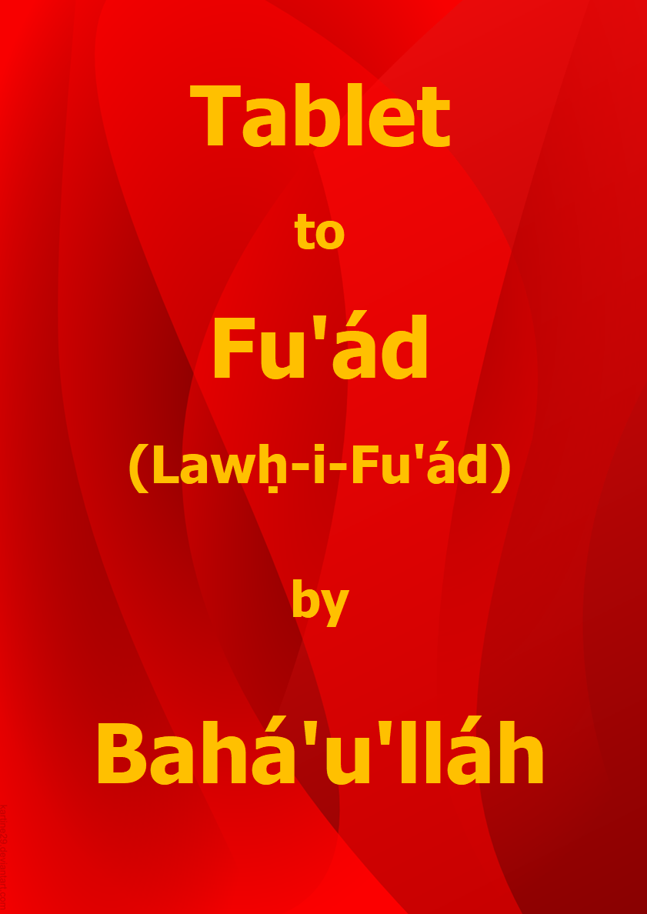

Title Page

Tablet to
Fu’ád
(Lawḥ-i-Fu’ád)

by

Bahá’u’lláh

Download English language version
from the Bahá'í World Centre

Bahá'í Faith

This document has been downloaded from Lawḥ-i-Fu’ád (from the Summons of the Lord of Hosts). You are free to use its content subject to the terms of use found at www.bahai.org/legal

Note: Some minor changes have been made to the Bahá'í World Centre download to mirror the April 2021 provisional Thai translation.

Table of Contents

Cover 1
Title Page 2
Table of Contents 3
Tablet to Náṣiri’d-Dín Sháh (Lawḥ-i-Sulṭán) 4
Note on the Translation 8
Key to Passages Translated by Shoghi Effendi 8

Tablet to Fu’ád
(Lawḥ-i-Fu’ád)

HE IS THE MOST HOLY, THE MOST GLORIOUS!

1
Káf. Ẓá’. [] We call unto thee from beyond the sea of grandeur, upon the crimson land, above the horizon of tribulation. Verily, no God is there save Him, the Almighty, the Most Generous. Walk thou steadfastly in My Cause and follow not the ways of those who, upon attaining unto the object of their desire, denied God, the Lord of Lords. Erelong shall He lay hold upon them in His wrath, and He, verily, is the All-Powerful, the All-Subduing.

2
Know thou that, through the power of His sovereign might, God hath seized him who was the foremost amongst them that passed judgement against Us. When he saw his torment approaching, he fled to Paris to seek recourse to physicians.

3
“Is there none to help me?” he asked.

4
He was smitten upon the mouth and told: “There is no escape!” []

5
And when he turned towards the angel of wrath, he well-nigh expired from fear. “I have a house full of riches,” he pleaded. “I have a palace on the Bosphorus, beneath which the rivers flow.”

6.
The angel replied: “No ransom shall be accepted from thee on this day, even shouldst thou offer up all things visible and invisible. Hearest thou not the sighs of the kindred of God, whom thou didst cast into prison without proof or testimony? Thy deed hath provoked the lamentation of the inmates of Paradise, and of those who circle morn and eve round the Throne on high. The wrath of thy Lord hath descended upon thee, and stern is He in His chastisement!” []

7.
He made reply: “I held command over the people, and here is the mandate of my authority.”

8.
“Hold thy peace, O denier of the Day of Judgement!” []

9.
He implored: “Is no respite possible so that I may send for my family?”

10.
“Far from it, O disbeliever in the verses of God!”

11.
Thereupon the keepers of the fathomless abyss called unto him: “The gates of Hell have opened wide to receive thee, O thou who hast turned away from thy Lord, the Unconstrained! Repair unto its fire, for it yearneth after thee. Hast thou forgotten, O rejected one, when thou wert the Nimrod of the age, how thy tyranny eclipsed the very cruelties of Pharaoh, the Lord of the Stakes? [] By God! Thine iniquity hath rent asunder the veil of sanctity and caused the pillars of heaven to tremble. Where canst thou find refuge now? Who shall protect thee from the dreadful scourge of thy Lord, the All-Compelling? There is no haven for thee in this Day, O ungodly doubter!” Whereupon the agony of death seized him and he saw no more. Thus did We lay hold on him in Our wrathful anger, and severe is thy Lord in His punishment.

12.
Then an angel from the right hand of the Throne summoned him: “Behold the angel of affliction. Is there any place to flee to save hell, wherein the heart [] boileth?” And the angel of chastisement received his spirit, and a voice proclaimed: “Enter the bottomless pit which hath been promised in the Book, and whose existence thou didst day and night deny!”

13.
Soon will We dismiss the one who was like unto him [], and will lay hold on their Chief who ruleth the land [], and I, verily, am the Almighty, the All-Compelling. Be thou steadfast in the Cause of God and extol thy Lord morn and eve. Suffer not the light of thy soul to be quenched by the calumnies of the one who was so blinded by Our bestowals as to turn away from God, the Lord of all names. He inspireth his devoted followers even as the Evil One prompteth his own. Erelong shalt thou behold him in evident loss both in this world and in the world to come. He, indeed, is among those whom an afflictive torment doth await. He dispatched an epistle to someone in that land, a writ of the workers of iniquity, in which he mocked God and recorded that which filled all created things with dismay. Say: Canst thou find anyone to protect thee when the wrath of God, the All-Powerful, the Unconstrained, is visited upon thee?

14.
Thus have We informed thee of that which lieth concealed within the hearts of men. Verily, thy Lord is the Almighty, the All-Knowing. Arise for the triumph of this Cause, and gather together My loved ones. Help them to see the truth in this Day when the feet of men have slipped. Say: It behoveth every true believer to assist his Lord. He, verily, is your helper, while the people have no one to turn to in this Day.

15.
Then We seized Mihdí, [] to whom We had promised divine chastisement in Our Books and Scriptures. When Our awful majesty encompassed him, he entreated: “May I not retrace my steps?”

16.
A voice exclaimed: “Woe betide thee, O disbeliever in the Day of Resurrection! This is the nethermost fire, and its flames have been made to blaze for thee. Thou didst forsake all righteous deeds in thy vain and futile life, and now thou hast none to shield thee from God. Thou art indeed he who caused all hearts to be consumed and the Holy Spirit to lament.”

17.
He pleaded: “Is there yet no refuge for me?”

18.
“Nay, by my Lord, even shouldst thou seek recourse to every possible means!”

19.
Thereupon he cried out in such distress as to cause the people of the graves to tremble, and was seized by the Hand of invincible power. A voice then proclaimed: “Return unto the seat of wrath in the fire of hell; wretched and evil be thine abode!”

20.
Thus did We lay hold on him as We laid hold on those who preceded him. Behold their houses which We have left to the spiders, and take heed, O ye who are endued with understanding! He it is who opposed God, and for whom the verses of wrath were revealed in the Book. Blessed is he who readeth it and pondereth its contents, for a goodly end doth in truth await him.

21.
Thus have We recounted unto thee the tale of the evil-doers, that thine eyes may be solaced. As for thee, there lieth in store naught but a blissful end.

* * * * *

Note on the Translation

Wherever possible, translations made by Shoghi Effendi have been incorporated in the present volume…. The committees and individuals appointed to prepare the translations faced the challenge of rendering the balance of the Text in a manner at once faithful to the meaning of the original and consistent with the exalted English style established by the Guardian for the translation of Bahá’u’lláh’s matchless utterance.

* * * * *

Key to Passages Translated by Shoghi Effendi

13 | “Soon will We dismiss … the All-Compelling.” | Shoghi Effendi. The Promised Day Is Come, What of Turkey and Persia?.

* * * * *

[] The Lawḥ-i-Fu’ád was addressed to Shaykh Káẓim-i-Samandar of Qazvín, one of the apostles of Bahá’u’lláh. Its subject, the former Ottoman statesman Fu’ád Páshá, died in France in 1869. The letter names Káf and Ẓá refer to the K and Ẓ of Káẓim.
[] cf. Qur’án 38:3.
[] cf. Qur’án 13:13.
[] cf. Qur’án 40:32.
[] cf. Qur’án 38:12, 89:10.
[] “Heart” translates fu’ád, the given name of the Ottoman minister.
[] ‘Álí Páshá
[] Sulṭán ‘Abdu’l-‘Azíz.
[] Mírzá Mihdíy-i-Rashtí, a judge in Constantinople and supporter of Mírzá Yaḥyá.

