Cover

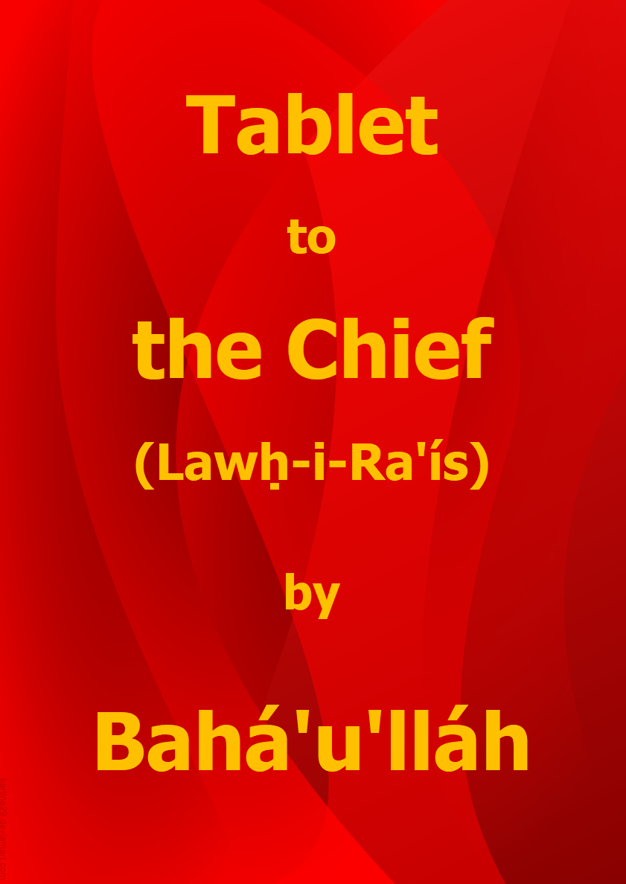

Title Page

Tablet
to
the Chief
(Lawḥ-i-Ra’ís)

by

Bahá’u’lláh

Download English language version
from the Bahá'í World Centre

Bahá'í Faith

This document has been downloaded from the Bahá’í Reference Library. You are free to use its content subject to the terms of use found at www.bahai.org/legal

Note: Some minor changes have been made to the Bahá'í World Centre download to mirror the April 2021 provisional Thai translation.

Table of Contents

Cover 1
Title Page 2
Table of Contents 3
Tablet to the Chief (Lawḥ-i-Ra’ís) 4
Note on the Translation 13
Key to Passages Translated by Shoghi Effendi 13

Tablet to the Chief
(Lawḥ-i-Ra’ís)

HE IS IN HIS OWN RIGHT THE SUPREME RULER!

1.
The Pen of the Most High proclaimed: O thou who hast imagined thyself to be the most exalted of men and who hast regarded as the lowliest of all creatures this divine Youth, through Whom the eyes of the Concourse on high have been illumined and made radiant! This Youth hath sought nothing from thee or from such as are like unto thee, inasmuch as from time immemorial, whenever the Manifestations of the All-Merciful and the Exponents of His unfading glory have stepped out of the Realm of eternity into this mortal world and revealed themselves to revive the dead, men such as thee have considered these sanctified Souls and Temples of Divine Oneness, upon Whom must needs depend the rehabilitation of the peoples of the earth, to be stirrers of mischief and worthy of blame. These men, verily, have all returned unto dust. Thou, too, shalt erelong take abode therein and find thyself in grievous loss.

2.
Even if this Lifegiver and World Reformer be in thine estimation guilty of sedition and strife, what crime could have been committed by a group of women, children, and suckling mothers that they should be thus afflicted with the scourge of thine anger and wrath? No faith or religion hath ever held children responsible. The Pen of divine Command hath exempted them, yet the fire of thy tyranny and oppression encompasseth all. If thou bearest allegiance to any faith or religion, then thou shouldst know that, according to all the heavenly Books and all the divinely inspired and weighty Scriptures, children are not to be held accountable. Aside from this, not even those who disbelieve in God have perpetrated such unseemly acts. Since from every thing an effect becometh manifest, a fact that none can deny save those who are bereft of reason and understanding, it is certain that the sighs of these children and the cries of these wronged ones will have their due consequence.

3.
Ye have plundered and unjustly despoiled a group of people who have never rebelled in your domains, nor disobeyed your government, but rather kept to themselves and engaged day and night in the remembrance of God. Later, when the order was issued to banish this Youth, all were filled with dismay. The officials in charge of My expulsion declared, however: “These others have not been charged with any offence and have not been expelled by the government. Should they desire to accompany you, no one will oppose them.” These hapless souls therefore paid their own expenses, forsook all their possessions, and, contenting themselves with Our presence and placing their whole trust in God, journeyed once again with Him until the fortress of ‘Akká became the prison of Bahá.

4.
Upon our arrival, we were surrounded by guards and confined together, men and women, young and old alike, in the army barracks. The first night all were deprived of either food or drink, for the sentries were guarding the gate of the barracks and permitted no one to leave. No one gave a thought to the plight of these wronged ones. They even begged for water, and were refused.

5.
Time hath passed, and we all remain confined in these barracks, notwithstanding that during the five years we dwelt in Adrianople, all its inhabitants, whether learned or ignorant, rich or poor, bore witness to the purity and sanctity of these servants. At the time this Youth was departing from Adrianople, one of the loved ones of God attempted to take his own life, so unbearable to him was the sight of this Wronged One in the hands of His oppressors. During the journey we were thrice compelled to change ships, and it is evident how much the children suffered as a result. Upon disembarking, four of the believers were separated and prevented from accompanying Us. As this Youth was leaving, one of the four, named ‘Abdu’l-Ghaffár, cast himself into the sea, and no one knoweth what befell him thereafter.

6.
All this is but a drop in the ocean of the wrongs that have been inflicted upon Us, and still ye are not satisfied! The officials enforce every day a new decree, and no end is in sight to their tyranny. Night and day they conceive new schemes. They have assigned each prisoner, from the government storehouse, a daily allowance of three loaves of bread that no one can eat. From the foundation of the world until the present day a cruelty such as this hath neither been seen nor heard of.

7.
By the righteousness of Him Who hath caused Bahá to speak forth before all that are in heaven and all that are on earth! Ye have neither rank nor mention among them that have offered up their souls, their bodies and their substance for the love of God, the All-Powerful, the All-Compelling, the Almighty. A handful of clay is greater in the sight of God than all your dominion and your sovereignty, and all your might and your fortune. Should it be His wish, He would scatter you in dust. Soon will He seize you in His wrathful anger, and sedition will be stirred up in your midst, and your dominions will be disrupted. Then will ye bewail and lament, and will find none to help or succour you.

8.
In making mention of these matters, it is not Our purpose to rouse you from your slumber, since the fury of God’s wrath hath so encompassed you that ye shall never take heed. Nor is it Our intention to recount the iniquities visited upon these pure and blessed souls, for they have been so intoxicated with the wine of the All-Merciful and are so carried away with the inebriating effect of the living waters of His loving providence that even were they to suffer all the cruelties of the world for His sake, they would remain content and yield thanks unto Him. These souls have never held, nor shall they ever hold, any grievance. Nay, their blood continually imploreth and beseecheth the Lord of the worlds that it might be spilt upon the dust in His path, and their heads yearn to be borne aloft on spears for the sake of the Beloved of hearts and souls.

9.
Several times calamities have overtaken you, and yet ye failed utterly to take heed. One of them was the conflagration which devoured most of the City with the flames of justice, and concerning which many poems were written, stating that no such fire had ever been witnessed. And yet, ye waxed more heedless. Plague, likewise, broke out, and ye still failed to give heed! Be expectant, however, for the wrath of God is ready to overtake you. Erelong will ye behold that which hath been sent down from the Pen of My command.

10.
Have ye fondly imagined your glory to be imperishable and your dominion to be everlasting? Nay, by Him Who is the All-Merciful! Neither will your glory last, nor will Mine abasement endure. Such abasement, in the estimation of a true man, is the pride of every glory.

11.
When I was still a child and had not yet attained the age of maturity, My father made arrangements in Ṭihrán for the marriage of one of My older brothers, and as is customary in that city, the festivities lasted for seven days and seven nights. On the last day it was announced that the play “Sháh Sulṭán Salím” would be presented. A large number of princes, dignitaries, and notables of the capital gathered for the occasion. I was sitting in one of the upper rooms of the building and observing the scene. Presently a tent was pitched in the courtyard, and before long some small human-like figures, each appearing to be no more than about a hand’s span in height, were seen to emerge from it and raise the call: “His Majesty is coming! Arrange the seats at once!” Other figures then came forth, some of whom were seen to be engaged in sweeping, others in sprinkling water, and thereafter another, who was announced as the chief town crier, raised his call and bade the people assemble for an audience with the king. Next, several groups of figures made their appearance and took their places, the first attired in hats and sashes after the Persian fashion, the second wielding battleaxes, and the third comprising a number of footmen and executioners carrying bastinados. Finally there appeared, arrayed in regal majesty and crowned with a royal diadem, a kingly figure, bearing himself with the utmost haughtiness and grandeur, at turns advancing and pausing in his progress, who proceeded with great solemnity, poise and dignity to seat himself upon his throne.

12.
At that moment a volley of shots was fired, a fanfare of trumpets was sounded, and king and tent were enveloped in a pall of smoke. When it had cleared, the king, ensconced upon his throne, was seen surrounded by a suite of ministers, princes, and dignitaries of state who, having taken their places, were standing at attention in his presence. A captured thief was then brought before the king, who gave the order that the offender should be beheaded. Without a moment’s delay the chief executioner cut off the thief’s head, whence a blood-like liquid came forth. After this the king held audience with his court, during which intelligence was received that a rebellion had broken out on a certain frontier. Thereupon the king reviewed his troops and despatched several regiments supported by artillery to quell the uprising. A few moments later cannons were heard booming from behind the tent, and it was announced that a battle had been engaged.

13.
This Youth regarded the scene with great amazement. When the royal audience was ended, the curtain was drawn, and, after some twenty minutes, a man emerged from behind the tent carrying a box under his arm.

14.
“What is this box,” I asked him, “and what was the nature of this display?”

15.
“All this lavish display and these elaborate devices,” he replied, “the king, the princes, and the ministers, their pomp and glory, their might and power, everything you saw, are now contained within this box.”

16.
I swear by My Lord Who, through a single word of His Mouth, hath brought into being all created things! Ever since that day, all the trappings of the world have seemed in the eyes of this Youth akin to that same spectacle. They have never been, nor will they ever be, of any weight and consequence, be it to the extent of a grain of mustard seed. How greatly I marvelled that men should pride themselves upon such vanities, whilst those possessed of insight, ere they witness any evidence of human glory, perceive with certainty the inevitability of its waning. “Never have I looked upon any thing save that I have seen extinction before it; and God, verily, is a sufficient witness!”

17.
It behoveth everyone to traverse this brief span of life with sincerity and fairness. Should one fail to attain unto the recognition of Him Who is the Eternal Truth, let him at least conduct himself with reason and justice. Erelong these outward trappings, these visible treasures, these earthly vanities, these arrayed armies, these adorned vestures, these proud and overweening souls, all shall pass into the confines of the grave, as though into that box. In the eyes of those possessed of insight, all this conflict, contention and vainglory hath ever been, and will ever be, like unto the play and pastimes of children. Take heed, and be not of them that see and yet deny.

18.
Our call concerneth not this Youth and the loved ones of God, for they are already sore-tried and imprisoned and expect nothing from men such as thee. Our purpose is that thou mayest lift up thy head from the couch of heedlessness, shake off the slumber of negligence, and cease to oppose unjustly the servants of God. So long as thy power and ascendancy endure, strive to alleviate the suffering of the oppressed. Shouldst thou judge with fairness and observe with the eye of discernment the conflicts and pursuits of this transient world, thou wouldst readily acknowledge that they are even as the play which We have described.

19.
Hearken unto the words of the one true God and pride thyself not in the things of this world. What hath become of those like unto thee who falsely claimed lordship on earth, who sought to quench the light of God in His land and to destroy the foundation of His mighty edifice in His cities? Where are they to be seen now? Be fair in thy judgement and return unto God, that perchance He might cancel the trespasses of thy vain life. Alas, We know that thou shalt never attain unto this, for such is thy cruelty that it hath made hell to blaze and the Spirit to lament, and hath caused the pillars of the Throne to shake and the hearts of the faithful to tremble.

20.
O peoples of the earth! Incline your inner ears to the call of this Wronged One and pause to reflect upon the story that We have recounted. Perchance ye may not be consumed by the fire of self and passion, nor allow the vain and worthless objects of this nether world to withhold you from Him Who is the Eternal Truth. Glory and abasement, riches and poverty, tranquillity and tribulation, all will pass away, and all the peoples of the earth will erelong be laid to rest in their tombs. It behoveth therefore every man of insight to fix his gaze upon the goal of eternity, that perchance by the grace of Him Who is the Ancient King he may attain unto the immortal Kingdom and abide beneath the shade of the Tree of His Revelation.

21.
Though this world be fraught with deception and deceit, yet it continually warneth all men of their impending extinction. The death of the father proclaimeth to the son that he, too, shall pass away. Would that the inhabitants of the world who have amassed riches for themselves and have strayed far from the True One might know who will eventually lay hand on their treasures; but, by the life of Bahá, no one knoweth this save God, exalted be His glory.

22.
The poet Saná’í, may God’s mercy rest upon him, hath said: “Take heed, O ye whose unseemly conduct hath darkened your faces! Take heed, O ye whose beards have been whitened by age!” Alas, most of the people are fast asleep. They are even as the man who, in his drunkenness, became attracted to a dog, took it in his embrace, and made it his plaything, and who, when the morn of discernment dawned and the light of the sun enveloped the horizon, realized that the object of his affection was but a dog. Then, filled with shame and remorse, he repaired to his abode.

23.
Think not that thou hast abased this Youth or prevailed over Him. The least of creatures ruleth over thee, and yet thou perceivest not. The lowliest and most abject of all things holdeth sway over thee, and that is none other than self and passion, which have ever been reprehensible. Were it not for God’s consummate wisdom, thou wouldst have been able to plainly behold thine own helplessness and that of all who dwell on earth. Our abasement is indeed the glory of His Cause, could ye but understand.

24.
This Youth hath ever been disinclined to breathe a word contrary to courtesy, for courtesy is Our raiment, wherewith We have adorned the temples of Our well-favoured servants. Otherwise, some of the deeds that ye believe to be concealed would have been divulged in this Tablet.

25.
O exponent of might and power! These young children and these poor ones in God did not need to be accompanied by officers and soldiers. Upon our arrival in Gallipoli, a major by the name of ‘Umar came into Our presence. God is well aware of what he said. After some exchanges in which his own innocence and thy guilt were mentioned, We declared: “From the outset, a gathering should have been convened at which the learned men of this age could have met with this Youth in order to determine what offence these servants have committed. But now the matter hath gone beyond such considerations, and, according to thine own assertion, thou art charged with incarcerating Us in the most desolate of cities. There is a matter, which, if thou findest it possible, I request thee to submit to His Majesty the Sulṭán, that for ten minutes this Youth be enabled to meet him, so that he may demand whatsoever he deemeth as a sufficient testimony and regardeth as proof of the veracity of Him Who is the Truth. Should God enable Him to produce it, let him, then, release these wronged ones, and leave them to themselves.”

26.
He promised to transmit this message, and to give Us his reply. We received, however, no news from him. Although it becometh not Him Who is the Truth to present Himself before any person, inasmuch as all have been created to obey Him, yet in view of the condition of these little children and the large number of women so far removed from their friends and countries, We have acquiesced in this matter. In spite of this nothing hath resulted. ‘Umar himself is alive and accessible. Inquire from him, that the truth may be made known unto you.

27.
Most of Our companions now lie sick in this prison, and none knoweth what befell Us, except God, the Almighty, the All-Knowing. In the days following Our arrival, two of these servants hastened to the realms above. For an entire day the guards insisted that, until they were paid for the shrouds and burial, those blessed bodies could not be removed, although no one had requested any help from them. At that time we were devoid of earthly means, and pleaded that they leave the matter unto us and allow those present to carry the bodies, but they refused. Finally, a carpet was taken to the bazaar to be sold, and the sum obtained was delivered to the guards. Later, it was learned that they had merely dug a shallow grave into which they had placed both blessed bodies, although they had taken twice the amount required for shrouds and burial.

28.
The pen is powerless to depict and the tongue faileth to describe the trials which We have suffered. Yet sweeter than honey to Me is the bitterness of such tribulations. Would that at every instant all the afflictions of the world could, in the path of God and for the sake of His love, be visited upon this evanescent Soul Who is immersed in the ocean of divine knowledge!

29.
We implore God for patience and forbearance, inasmuch as thou art but a feeble creature and bereft of comprehension. Wert thou to awaken and inhale the fragrance of the breezes that waft from the retreats of eternity, thou wouldst readily abandon all that thou dost possess and in which thou dost rejoice, and choose to abide in one of the dilapidated rooms of this Most Great Prison. Beseech God to grant thee such mature understanding as to enable thee to distinguish praiseworthy actions from those which merit blame. Peace be upon him who followeth the way of guidance!

* * * * *

Note on the Translation

Wherever possible, translations made by Shoghi Effendi have been incorporated in the present volume…. The committees and individuals appointed to prepare the translations faced the challenge of rendering the balance of the Text in a manner at once faithful to the meaning of the original and consistent with the exalted English style established by the Guardian for the translation of Bahá’u’lláh’s matchless utterance.

* * * * *

Key to Passages Translated by Shoghi Effendi

Para | Passage | Source
6 | “From the foundation of the world … nor heard of.” | Shoghi Effendi. God Passes By, Chapter XI.
7 | “Soon will He seize you … none to help or succour you.” | Shoghi Effendi. The Promised Day Is Come, What of Turkey and Persia?.
9 | “Several times calamities … the Pen of My command.” | Shoghi Effendi. The Promised Day Is Come, What of Turkey and Persia?.
25–26 | “There is a matter … may be made known unto you.” | Shoghi Effendi. The Promised Day Is Come, God's Vicar on Earth.

* * * * *

This second Tablet of Bahá’u’lláh addressing ‘Álí Páshá was revealed in Persian shortly after Bahá’u’lláh’s arrival and confinement in ‘Akká.
For an account of this incident see God Passes By, Chapter X, paragraph beginning “On the morning of the 2nd of Jamádíyu’l-Avval 1285 A.H…”.
A probable reference to the fire of Hocapaşa, which destroyed a large part of the city of Constantinople in 1865.

