Cover

Note from VBS (28Jan22): This is a work in progress and needs proofing

Pioneering Recollections

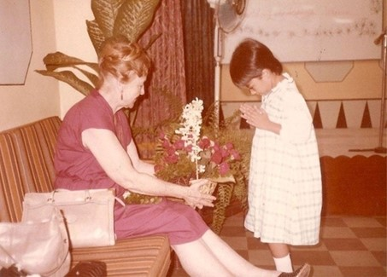
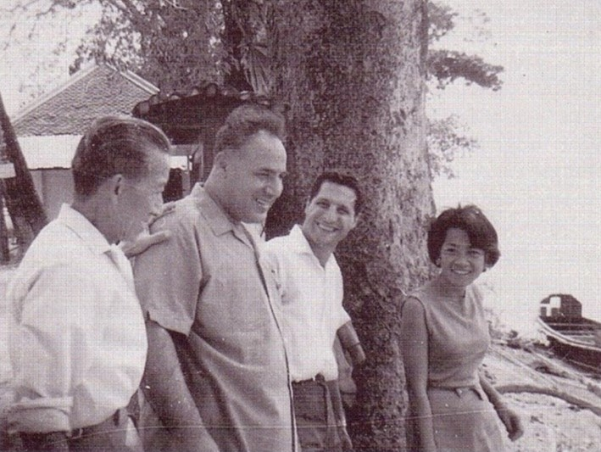

Historical information about the development
of the Bahá’í Faith in Thailand

compiled by

Sukhum Abhasakun (Fazlollah Faridian)

Pioneering Recollections

PART ONE:
Collection of Historical Data

Foreword

This historical data collection of Pioneering Recollections has been prepared for the Bahá’í archives. It can be used by Bahá’í historians and people who have a general interest in the history of the Bahá’í Faith in Thailand. It can also be further expounded and developed into a History of the Bahá'í Faith in Thailand.

Table of Contents

Cover 1
Pioneering Recollections 2
PART ONE: Collection of Historical Data 2
Foreword 2
Table of Contents 2
Original Table of Contents 6
Mandate from the Universal House of Justice and Spiritual Assembly of the Bahá’ís of Thailand 9
Apology/Disclaimer 10
Acknowledgments 10
The first Bahá’í teacher to visit Thailand 12
Jamal Effendi 12
Vasily Eroshenko 14
Instructions from ‘Abdu’l-Bahá 15
Instructions from Shoghi Effendi 16
Instructions from Shoghi Effendi 16
Instructions from Shoghi Effendi 16
Jamshed Sabet 17
First Bahá’í group established in Thailand 18
Anwer Cadir 18
Heshmatullah Ta’eed 20
Banu Hassan & Marjorie Lighthall 22
Charles Duncan 23
Kali Chaudari & his family 26
Beulah Heather Stuart 26
Caroline Lawrence 27
Dempsy & Adriene Morgan 28
Arden Thur & Bill Smitts 28
Proclamation, Translation and Publications 29
First Believer in Thailand 31
Mr Pramote 31
First Bahá’í Centre 32
First Local Spiritual Assembly 33
First Bahá’í Burial 34
First Thai Bahá’í Pioneer 35
First Observance of World Religion Day in Thailand 35
Jai Gopal Jand’s Recollections 36
Shirin Fozdar’s Recollection 36
First NSA of Bahá’ís of Thailand in the presence of Amatu'l-Bahá Rúḥíyyih Khánum 38
Firaydun Mithaq’s recollections of Mrs Shirin Fozdar 41
Shirin Fozdar’s passing 44
John Fozdar’s appreciation 44
Universal House of Justice’s Condolences 45
Bahá’í Administrative Committee of Thailand 47
PART TWO: Recollections of Hands of the Cause by early pioneers 49
Zikrullah Khadem 49
Taráz'u'lláh Samandarí 50
Enoch Olinga 50
Rúḥíyyih Khánum 52
Bangkok 52
Yasothon 60
Thai Bahá'í pioneer married in Cambodia 61
Hatyai address 61
Raḥmatu'lláh Muhájir Hand of the Cause of God, Knight of Bahá’u’lláh 77
Iran Furútan Muhájir’s memories of Dr Muhájir 80
Vicente Samaniego’s Recollections 87
Firaydun Mithaq’s Recollections 87
Collis Featherston 88
Contribution of the members of the Continental Board of Counsellors in Asia to Thailand 94
Yankee Leong and South Thailand Border Teaching 98
Yan Kee Leong Teaching Trips in Thailand 100
Songkhla 102
Songkla Summer School 103
School with a difference 103
Official Opening 104
Programme Highlights 105
How it should be done 105
The Enlightened Priest 106
Priest to Layman 107
Other Sessions 107
Cultural Evening 108
Increasing Tribute to Workers 109
Progress Report 109
Letter from Universal House of Justice 110
Border Teaching Committee of South Thailand 111
Aranyaprathet and Refugee Camps 112
Ranong 117
First Local Spiritual Assembly of Ranong 117
Letter of National Spiritual Assembly to Counsellor Payman 118
Chiangmai 119
Stories of Some Thai Believers Who Accepted the Faith 120
The Wongsopa family 120
Mr Lertchai Chaumrattanakul 126
Dr Utairat Chaumrattanakul (née Ek-ampai) 127
Buakham (Chanchai) Baran 128
Appendix 134
PART THREE: Faridian’s Recollections 134
Short biography of the compiler 134
Santitham Witthayakhom School 142
Arunrat Vithayakhom School in 1964 142
Taráz'u'lláh Samandarí’s 1966 visit 148
The 1st National Spiritual Assembly of Laos 152
Teaching Along the Mekong River 153
Recollection of Compiler’s Kenya travel teaching trip 162
Report of Compiler to the NSA of Kenya 165
Compiler’s return to Thailand 167
Appointment to Auxiliary Board 167
Nongkhai Activities 169
First Visit to Nongkhai 169
Instructions from NSA 169
Nongkhai Bahá’í Centre 172
Teaching Activities in Nongkhai 172
Travel Teacher Miss Alice Ang 174
CBC Fozdar letter to compiler (7 January 1992) 179
ITC letter to Counsellor Shantha Sundram (23 September 1991) 180
Compiler’s Cable to CBC with cc: NSA 180
ITC letter to Dr Jabbar Eidelkhani (18 October 1992) 181
Teaching Student Monks 183
Teaching experience at The Buddhist College in Nongkhai 184
Mekong Project report from Firaydun dated to the Compiler (16 Aug 1992) 191
CBC letter from Dr Edelkhani to Faridian w/cc to NSA Thailand & Laos (13 Jul 1992) 194
Mekong Teaching Project: A Report 199
CBC letter to Compiler 200
The END 210

Original Table of Contents

Section Heading Page No.

(Part 1)

Forward 1
Email from Spiritual Assembly of the Bahá’ís of Thailand 4
Apology 5
Acknowledgments 6
The First Bahá’í Teacher to Visit Thailand 7
Vasily Eroshenko 9
Instructions from ‘Abdu’l-Bahá’ 10
Instructions from Shoghi Effendi 11
Mr Jamshed Sabet 11
Mr C.P.M. Anwer Cadir 13
Dr Heshmat Ta’eed 15
Mrs Banu Hassan and Mrs Marjorie Lighthall 16
Mr Charles Duncan 17
Mr Kali Chaudari and his family 19
Mrs Beulah Heather Stuart 19
Ms. Caroline Lawrence 20
Mr and Mrs Dempsey Morgan 21
Ms. Arden Thur and Mr Bill Smitts 21
Proclamation, Translation and Publications 22
The First Believer in Thailand 24
The First Bahá’í Centre 24
Formation of the First Local Spiritual Assembly 26
First Bahá’í Burial 27
First Thai Bahá’í Pioneer 27
The First Observance of World Religion Day in Thailand 28
Recollections of Mr Jai Gopal Jand 28
Recollections of Mrs Shirin Fozdar 29
The First National Spiritual Assembly of the Bahá’ís of Thailand 31
Recollection of Counsellor Firaydun Mithaq about Mrs Shirin Fozdar 33
Passing of Mrs Shirin Fozdar 35
Message of Condolence from Universal House of Justice 36
Formation of Bahá’í Administrative Committee of Thailand 37
(Part 2)
Recollection of Early Pioneers about Hands of the Cause

39
Memories about Dr Muhájir by Mrs Iran Furútan Muhájir 61

Recollection from Counselor Vicente Samaniego 68
Recollection written by Counselor Firaydun Mithaq 68
Contribution of the Continental Board of Counsellors to Thailand 75
Songkhla Summer School 82
Aranyaprathet 90
The First LSA of Ranong 96
Chiang Mai 97
Stories of Some Thai Believers Who Accepted the Faith 99

Compiler’s Recollection 109
Santitham Witthayakhom School 115
Visit of Hands of the Cause Taráz'u'lláh Samandari 121
The First National Spiritual Assembly of the Bahá’ís of Laos 124
Teaching along the Mekong River 126
First Visit to Nongkhai 140
Nongkhai Bahá’í Centre 142
Teaching Activities in Nongkhai 142
The Buddhist College in Nongkhai 152

(Part 3)

Mandate from the Universal House of Justice
and Spiritual Assembly of the Bahá’ís of Thailand[]

To: Mr Sukhum Abhasakun

Dear Bahá'í Friend,

Our Assembly has received a letter from the Universal House of Justice clarifying their views on compiling historical information about the development of the Faith in Thailand and their encouragement to you to do so.

Likewise, our Assembly would like to ask you to continue your work and to assemble such historical data that can be further developed into a history of the Faith in Thailand.

Our Assembly is posting a notification on the email list thai-bahais to inform the friends of your project and to encourage their cooperation.

With loving Bahá'í greetings,

Spiritual Assembly of the Bahá'ís of Thailand
Victor Greenspoon, Secretary

Apology/Disclaimer

The details of these pioneering recollections have been taken from magazines, newsletters, letters, the compiler’s personal interviews, personal recollections, correspondence with early pioneers, Bahá'í travelling teachers and the compiler’s own revised notes which he has been collecting in over forty years of pioneering and travelling teaching in Thailand, Laos and Africa.

The compiler believes that there are many more pioneers, travel teachers and Thai co-workers whose names and services have not been mentioned in this compilation here. This is due the compiler’s his inability to find the records of their services and to the limitation of his memory, for which he offers his sincere apologies. He hopes that future Bahá’í historians will be able to gather more information about these heroes and heroines of the Faith and make mention of their sacrifices while serving the Cause during these early days.

Acknowledgments

The compiler of these Pioneering Recollections wishes to express his deepest gratitude to the Beloved Hand of the Cause of God, Dr A. M. Varqá[], former member of the Continental Board of Counsellors in Asia, Mr Vicente Samaniego[],[], the Spiritual Assembly of the Bahá’ís of Laos[], the Spiritual Assembly of the Bahá’ís of Thailand[],[] and Mr Charles Duncan[] all of whom have been very supportive in compiling these pioneering recollections. Without their support and encouragement this compilation could never have been completed.

The compiler also would like to thank the following people: the late Mrs B.A. Cadir, Mr Charles Duncan, Dr Heshmat Ta’eed, Mrs Banu Hassan, the late Mrs Shirin Fozdar, Mr Jamshed Fozdar and Dr Firaydun Mithaq (Missaghian) for offering their contributions.

I am especially indebted to Dr Eugene Jones, Mr Peter McAlpine, Mrs Sammi Nagaratnam[], and Mr Mohajir Satanam for proofreading these recollections.

Finally, I am deeply grateful to my daughter Mrs Alisa Das (Abhasakun) for her encouragement and support.

The first Bahá’í teacher to visit Thailand

Jamal Effendi

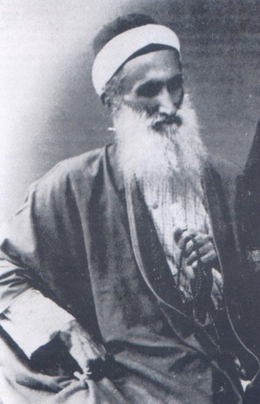
Jamal Effendi

The Bahá’í Faith was first propagated in Siam during the Reign of H.M. King Chulalongkorn[Rama V] by “Jamal Effendi[who] was the son of Isa Khan, a wealthy and influential man. ‘Abdu’l-Bahá said that “from childhood he had high ambition and noble aims, and he was honour and aspiration personified. He moved to Ṭihrán, hoping to achieve an important position in government circles. There he learned about the Faith and became a devoted and enthusiastic believer, dedicating his life to the service of the Cause.... In 1888 Jamal Effendi set out for Akká in the Holy Land and was with Bahá'u'lláh only a short time, however. On March 20, 1888 Jamal Effendi sailed back to India travelling places he had not visited previously, such as Burma, Java, and Siam (now Thailand.)”[]

“Jamál Effendi and Rúmí sailed on to Thailand, together with Bashír, the younger Bugis boy, and Mas'úd, a black servant boy. The French consul- general welcomed them and arranged for them to stay in a government guesthouse near the royal palace. Rúmí writes that they had arrived at a time when the mother of King Chulalongkorn (reigned 1868-1910) had just died. But it must have been another royal death that had just occurred, since Queen Debisinindra (Princess Rampoey), the mother of the king, had died in 1861. The king was in mourning and was seeing no visitors. After staying a month or so, the two men returned without having met the king but having spoken of the Bahá'í teachings to Iranian Shi`is who were settled there and to Sayyid `Alí Yamání and other prominent Muslims.[] They returned to Singapore and then back to Rangoon. In another account, Rúmí also mentions that they taught the Bahá'í Faith in Malaya.[] It may, however, be that he was counting Singapore as being part of Malaya.”[]

“…In some of the letters that Siyyid Mustafa Rumi had written, he mentioned a few countries that had been visited by Jamal Effendi; among these were Ceylon, Punjab, Burma, Malaya, Siam, Java and the islands of Celebes and Bali.

After this teaching trip, Jamal Effendi and Siyyid Mustafa Rumi returned to Singapore. Jamal Effendi remained in Singapore while Siyyid Mustaffa Rumi went to Rangoon to purchase some gifts to be given to the King of Siam on their next planned visit. When Siyyid Mustaffa Rumi returned to Singapore, both of them left for Siam to meet the King: however, at that time of their arrival, King Chulalongkorn’s mother had just died. The king was in mourning and refused to see any Visitor. After staying in Thailand for a month or so, they went back to Singapore. From Singapore they returned to Rangoon.”[]

Vasily Eroshenko

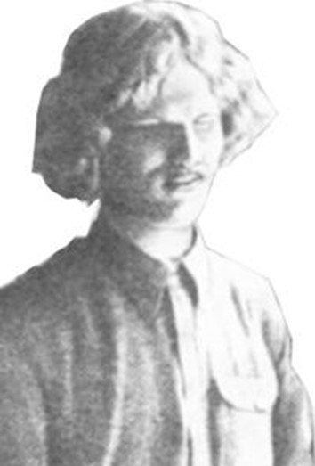
Vasily Eroshenko
(1890-1952)

In the summer of 1916, Mr Eroshenko left Tokyo to go to Siam. I had read him the book Some Answered Questions and he was very enthusiastic about it and asked to take the book with him on his travels. As he sailed from Japan many prayers were said for this brave young man. 11 of Boston wrote me: “At the next meeting of the friends here and at Green Acre we will have special prayers for Mr Eroshenko, blind brother on his way to Siam. You say he goes alone but he goes with God, and one is a majority in the service of God.”

From Bangkok, Siam, I received a letter from Mr Eroshenko who had passed through some trying experiences on his way, but was assisted by the Unseen Hand. He wrote: “Among the Russians are many Hebrews. I often visit one of these families. Two girls are interested in religion. I told them of the Bahá’í. They listened with great interest excitedly and wholly unexpectedly asked me, “Tell me is Christ on this earth?” I replied, ‘Bahá’ís say that he is.’ ‘But you personally, do you believed?’ I felt that she wished Christ might be here, but I replied, ‘I study the question.’ Now she is reading Some Answered Questions.”

Through Mr Eroshenko this girl wrote to me: “I am Jewish by creed, and have tried my utmost to get into a more deep investigation of the creeds of the world but how I regret that I cannot succeed as there are so many. I have studied with careful scrutiny the Buddhist religion, but was not satisfied until Mr Eroshenko lent me a book called Some Answered Questions, which has made an impression by its simple and true creed. I shall not go farther, but would ask you to forward me any periodicals and an edition of Some Answered Questions, and I shall try to help you in teaching in this part of the sphere . . . I am only 17 years and one month . . . I regret to be unable to help Mr Eroshenko in his efforts, for I do not hold any power. But I admire his noble effort to educate the blind here . . . I am sure his efforts would be greatly cherished by the One Above as his would be success . . .”

I wrote this dear young sister and sent her a prayer from ‘Abdu’l-Bahá. In reply I received a beautiful letter from her. She had experienced great help through the prayer, but her mother opposed the Cause and destroyed all her Bahá’í literature.

In Rangoon, Burma, some of the dear Bahá’ís welcomed Mr Eroshenko. There he told students in the school for the blind of the Bahá’í teachings and shared with them the book Some Answered Questions which they greatly appreciated. They were delighted with the teachings, especially because the Bahá’í Faith did not condemn the Buddhist religion, which was the faith of their forefathers, and into which they were born.[]

Instructions from ‘Abdu’l-Bahá

“Likewise, if some teachers go to other islands and other parts, such as the continent of Australia, New Zealand, Tasmania, also to Japan, Asiatic Russia, Korea, French Indochina, Siam, Straits Settlements, India, Ceylon and Afghanistan, most great result will be forthcoming…”[]

Instructions from Shoghi Effendi

NUMBER COUNTRIES OPENED FAITH BAHÁ’U’LLÁH APPROACHING HUNDRED PROMPT RESPONSE VALIANT INDIAN BELIEVERS REGARDING CEYLON PROMPTS ME APPEAL DISPATCH VOLUNTEERS SIAM INDONESIA THEREBY HASTENING GLORIOUS CONSUMMATION ABHA REWARDINESTIMABLE.
SHOGHI[]

Instructions from Shoghi Effendi

To the National Spiritual Assembly of the Bahá’ís of India, Burma and Pakistan:

…The News that from Calcutta two souls have volunteered to go forth as pioneers to Siam and Indonesia greatly pleased him.[]

Instructions from Shoghi Effendi

To the National Spiritual Assembly of the Bahá’ís of India, Burma and Pakistan:

“…The great historic enterprise launched by them in recent years in the neighbouring territories of Ceylon, Siam, Indonesia and the Malayan peninsula – a vast and highly meritorious undertaking still in its initial stage of development, and conferring a great and imperishable lustre on its valiant initiators…”[]

Jamshed Sabet

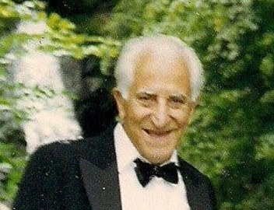
Jamshed Sabet

“In 1948 the National Spiritual Assembly of India sent Mr Jamshed Sabet an Iranian to Bangkok”[].

“In the second half of the 20th century, the first believer to arrive in Thailand for the purpose of teaching the Faith, reached Bangkok in mid-1951 and his name was Jamshi[e]d Sabet. He arrived from India, but, due to difficulties with the Immigration authorities of Thailand, was unable to stay long and finally returned to India at the end of 1951.”[]

“Mr Jamshed Sabet left India in the early fifties and he was last reported in the U.S.A. We do not have his present address. Mr Jamshed Sabet responded to the call of the National Assembly during its four-and-a-half-year plan to pioneer to Thailand. The beloved Guardian was also informed about it, but due to unavoidable circumstances he could[not] continue his pioneering services over there and probably stayed in Thailand for about three to four months”[]

First Bahá’í group established in Thailand

Anwer Cadir

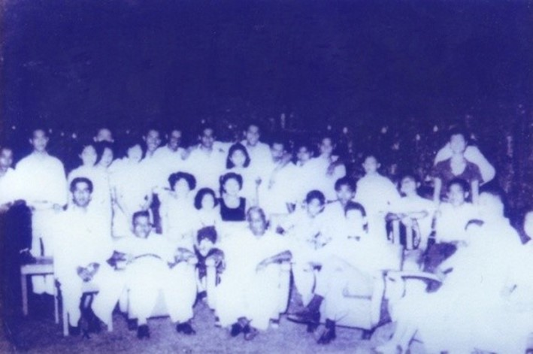
Mr C.P.M. Anwer Cadir seated first from left.
He established the first Bahá’í group in Thailand.

“The Guardian is very happy indeed to learn that you are established in Siam, and that you are busily engaged in the teaching work, and that you already have a group established.”[]

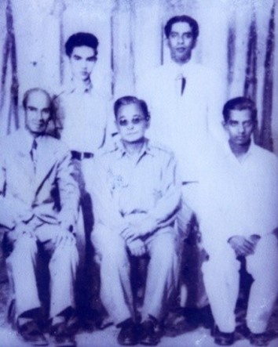
Mr Pramote seated in the centre,
Mr Anwer Cadir standing on the right

“Later Mr Anwer Cadir from Ceylon volunteered to pioneer to Thailand. The National Spiritual Assembly of India assisted him to do so in 1950. He stayed for nearly three years when he left the country to attend the Intercontinental Conference in 1953. During his stay he succeeded in bringing one Mr Pramote into the Faith.”[]

“Anver Cadir arrived in Bangkok in early 1953 and he, too, got into problems, with the local authorities first and subsequently with the Immigration Department and had to leave in September 1953 from where he attended the Inter-continental Conference in New Delhi in October 1953. During his stay in Bangkok he was able to confirm a Mr Pramote into the Faith as the first Thai Bahá’í”.[]

“As far as I know, the first pioneer to Thailand was from Ceylon and his name was Anwer Kadir. After being there a year, his visa expired and he had to leave.”[]

“This is what Mr Anwer told me after he arrived from Thailand on a short visit to Burma. He told[said] on the 3rd day after his arrival in Bangkok as there was nothing to do he went to a cinema hall to see a movie. There, to his surprise, as the movie started with Warner Brothers News screen and the picture of ‘Abdu’l-Bahá was screened with some words[like] “Unity of Mankind”. These lines are not very sure, some principles like that.) So at the break he went back to the hotel to get some Bahá’í leaflets, and stood outside the cinema and after the movie was over he started distributing the leaflets on the Bahá’í Faith. Once it was over he went back to the room were[where] he was staying and prayed, thanking God for the chance he was given.

“Then came a knock on the door, where 2 CID officers came and arrested him for distributing the Bahá’í leaflets and told him to bring all his papers with him. He was then kept under house arrest for 3 days, with no telephone calls or no visitors…”

“After the investigations were over, he was released, and then he got an appointment as an English Tutor to Thailand’s Royal Family. Over this period he met two Buddhist Monks; had Public Meetings; and Mr Anwer has given the beloved Faith to the Royal Family too. These were some unforgettable events in his life….

“Know[Now] he was able to do his Bahá’í teaching work freely, and gropes[groups] were form[ed] and LSAs and so on….

“He left Thailand by the last plane. That was due to the political up hovel[upheaval][].”[]

Heshmatullah Ta’eed

“In 1955 Dr Heshmatullah Ta’eed and his family came as pioneers but soon proceeded to Laos.”[]

“In March 1954, Dr H. Ta’eed arrived in Bangkok on a W.H.O. scholarship to study for one year. Soon afterward, he was sent on official duty to Chiangmai in northern Thailand and spent some months there. Upon returning to Bangkok he contacted Mr Pramote and also began to have the “Twelve Principles” translated into Thai and published. Later on he had another pamphlet, “Basic Facts of the Bahá’í Faith” translated into Thai and published. Mr Carl Scherer visited Dr Ta’eed in Sept. 1954, and Jamshed Fozdar visited him in November that same year and again with Mrs Fozdar in April 1955, when they also met Mr Pramote. At that time Jamshed tried to help Dr Ta’eed obtain employment with one of the foreign agencies, as Dr Ta’eed’s scholarship was due to be terminated and his continued stay in Thailand depended on his getting a job. These efforts, however, were not successful and Dr Ta’eed was soon made to leave Thailand for Laos.”[]

“In March 1954 by bus, train and finally plane, I moved with great difficulty to Thailand and reached there in May 1954. There were many problems including those of language, food, and sickness. My English was limited and very few people could speak it at all and thus I tried to learn the local language. Unfortunately it was a tonal language and I failed.

“During the year I did however manage to achieve a radio interview, an article in the newspaper and to make contact with Tanya Anaparitra who later joined the Faith. At that time Thailand had one Bahá’í in Pramote who was a very kind and gentle soul who later died of TB. Tanya kindly translated two Bahá’í pamphlets which pleased the Guardian.

“After thirteen months, as my visa could not be extended, and with advice from Mr Fozdar, I moved to Laos.”[]

Banu Hassan & Marjorie Lighthall

“Sometime during all of this (my memory of the chronological order of things is not quite exact) Banu Hassan and Marjorie Lighthall passed through Bangkok on their way to Laos.”[]

“…I arrived in Laos in Sept. 1957, having been a Bahá’í for only a year or so and not really prepared to go out pioneering but as Banu’s parents wouldn’t give permission for her to go without a companion I came along. Neither of us knew Laotian or French and could not have supported ourselves nor really communicated with the local people.”[]

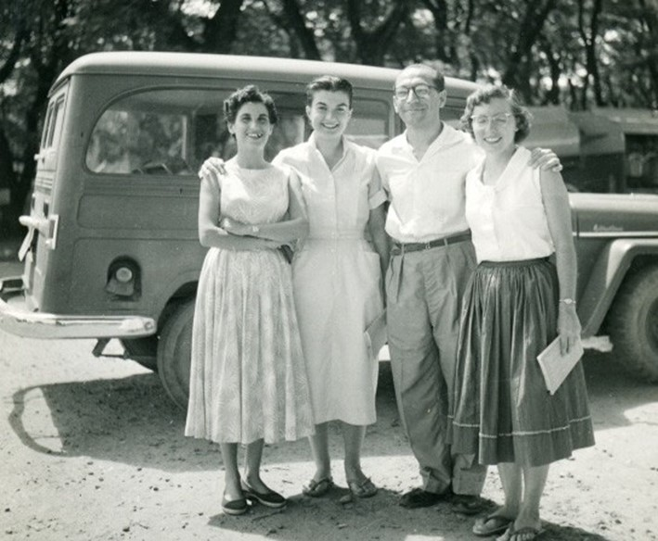
L-R: Mrs Ta’eed, Mrs Banu Hassan, Dr Ta’eed, & Mrs Marjorie Lighthall Fozdar, pioneers in Thailand and Laos

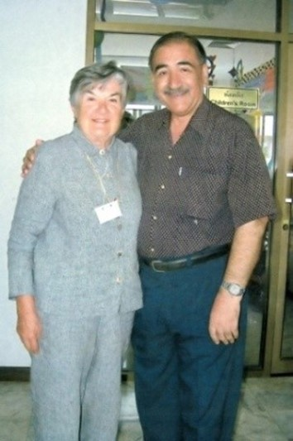
Mrs Banu Hassan with Mr Faridian on
her visit to Thailand in Nov 2005

Charles Duncan

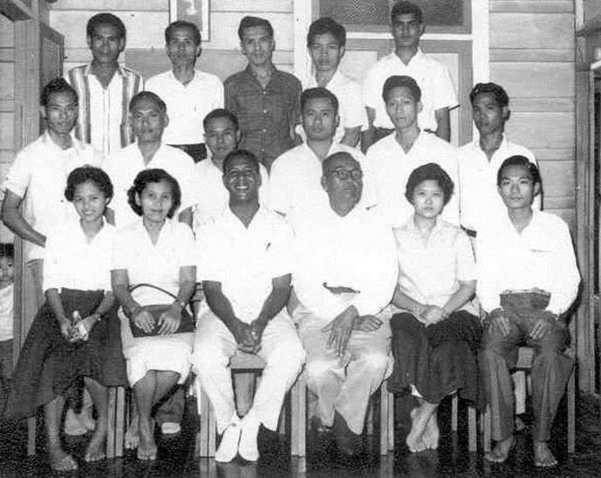
Fireside in Thonburi circa 1959: Back row: Mr Yua (Kamron) Phropluk extreme left. Front row: Mrs Prapai 2nd from left, Mr Charles Duncan 3rd from left.

Mr Charles Duncan went to Thailand in 1955. As a U.S. citizen he did not have any difficulty in settling in Thailand. He was supported financially by both Mr Jamshed Fozdar and Dr Ta’eed until he was able to secure a job as an English teacher. He pioneered in Bangkok and Dhonburi[]. In 1959, Charles left Thailand to help teaching work in Laos, following the advice of Mr Jamshed Fozdar, but returned to Thailand six months later on the advice of Hand of the Cause, Dr Muhájir. He pioneered then in Ubol and Songkhla. He left Thailand in 1964 having served here for eight years”.[]

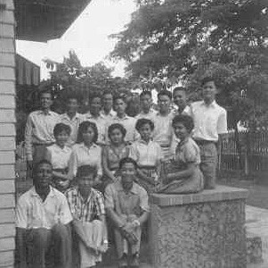
Bangkok Bahá’í Centre, Fireside: Mr Phaiboon (organiser of groups): back row extreme right. Charles Duncan: bottom left.

“Mr Charles Duncan an American arrived from Brunei in 1956. At a Regional Teaching conference at Singapore in August that year[1955], Jamshed[Fozdar] suggested to Mr Charles Duncan, then a pioneer in Brunei, that he should enter Thailand which was without pioneers and that Charles being a U.S. citizen would have no difficulty in entering Thailand and settling there. Charles Duncan, after asking the Guardian’s permission and receiving it, left Brunei on Oct. 20, 1955 and arrived in Bangkok on Oct. 22. He was helped financially by both Jamshed and Dr Ta’eed until he was able to secure a job teaching English. He was also able to secure a permanent visa quite easily. Charles met Mr Pramote and in February 1956, Dr Ta’eed visited him when he went to fetch Mrs Ta’eed and his two children who had arrived in Bangkok from Iran. Charles succeeded in having yet another Bahá’í pamphlet translated and published in Thai. In Nov. 1956, he attended the four-country Regional Teaching Conference in Saigon where the friends suggested that he find a proper centre for the Faith in Bangkok. Upon his return he was soon successful in renting a good centre and in March 1957, he was visited by Mr Jamshed Fozdar and Miss Arden Thur who were able to meet with him and Mr Pramote and some friends who were interested in the Faith”.[]

Kali Chaudari & his family

“After a while, Kali Chaudari and his family, who had been pioneering in Cambodia, moved to Thailand. He stayed at the Bahá’í Centre until he got a place of his own”.[]

Beulah Heather Stuart

“In 1957, we received a letter from the N.S.A. of the United States that Beaulah Stuart (she had changed her name to Heather, however) would come to Thailand for a while. We later received a letter from her saying that she was coming. Then on the Day of the Covenant, 1957, shortly after the passing of our Beloved Guardian, Shoghi Effendi, she suddenly appeared at the Bahá’í Centre. Her arrival was a turning point for the Faith in Thailand.

“She brought a new kind of enthusiasm and confidence with her. She also had lots of stories to tell us about her experiences in Swaziland, Africa. She had been told to come to Bangkok by Shoghi Effendi. She spoke at our firesides on Sundays and met many people. Then one day when I came home from work, she told me that David Lee, one of the men who had been coming to our firesides for months, had decided to become a Bahá’í. Shortly after him was one of the students at A.U.A. (an English Language Centre) and then a student from Thammasart University. They were Charote and Boon Lert respectively. Having shown Chaudari and me that it was possible to get Bahá’ís from among the Thais, she decided to leave. We had been warned before that she did not usually stay long in any one place and she had told us herself that Shoghi Effendi had written her saying that he hoped that she would long continue her fruitful wanderings for the Faith. She left in January or February 1958.”[]

Caroline Lawrence

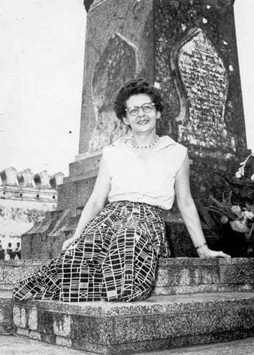
Miss Caroline Lawrence

“In 1958 Caroline Lawrence arrived in Thailand. We remained friends until she died in 1990 in Japan. She stayed in Thailand for about eight years. She came to pioneer in Laos, but after going there, and looking around and also finding that Banu Hassan and Marjorie Lighthall were newly arrived there, she decided to come back to Thailand to pioneer. After staying at the Bahá’í Centre a few weeks, she got a job at Chulalongkorn University as an English Professor. She kept her job the entire time she was in Thailand. She helped out greatly with the firesides at the Bahá’í Centre in Bangkok. Her new job provided her with a very nice house, which was easy to reach.

Her house was open to the Bahá’ís and was used as the Bahá’í Centre in Bangkok when Mr Duncan moved to Dhonburi”.[]

Dempsy & Adriene Morgan

“Then came Mr And Mrs Dempsey Morgan in 1958 and they worked very hard for the progress of the Faith. They left in 1961 for Vietnam.”[]

“Dempsy and Adriene Morgan came to Thailand quite a bit later. Dempsey got a job teaching at the International School. It is not clear in my mind where this wonderful couple fits in chronologically, but I remember that they were in Bangkok for quite a time and then they decided to go to Cambodia. While in Cambodia they met Chester Lee, a Chinese Bahá’í who (I think) was raised in Cambodia. For some reason that I am not sure of, Chester was arrested in Phnom Penh. When Dempsey heard that Chester was in jail, he went down to the police station and said “Was Chester Lee arrested because he is a Bahá’í?” When he received an affirmative answer he said “Well, I am a Bahá’í, too. Put me in jail as well.” And they did. When word got to the American Embassy there that an American was in jail, they went to the police station and bailed him out. Then they ordered him to leave Cambodia at once. So he and Adrienne came back to Bangkok. One day, I was walking downtown when I saw Adrienne walking toward me. I was so astonished that I couldn’t speak. I just stopped walking and pointed at her. They had just returned and hadn’t notified us yet.”[]

Arden Thur & Bill Smitts

“I was still living on Phahonyodhin Road when Arden Thur and Bill Smitts came as travel teachers. They came at the same time but they didn’t come together. Arden Thur found Thongchai and Uthai, two young men who became our next declarants.”[]

Proclamation, Translation and Publications

“During the year[1954] I did however manage to achieve a radio interview, an article in the paper and make contact with[Miss] Tanya Anaparitra who later joined the Faith…Tanya kindly translated two Bahá’í pamphlets which pleased the Guardian.”[]

“Dr Ta’eed occasionally came down to Bangkok[from Laos]. On one of his trips he introduced me to Ms. Dhanya (Tanya) who had translated a[nother] Bahá’í pamphlet into Thai. Dr Ta’eed suggested that Dhanya and I translate an additional pamphlet. This was the beginning of a long friendship between Dhanya and me. After we finished the pamphlet, Dhanya read the “proofs”. One of the architecture students at the ‘Y”[YMCA] designed a cover in three colours and the pamphlet was printed. Dr Ta’eed paid the expenses. The pamphlet was called What is Bahá’í? In the meantime I had started to study Thai. My first teacher was Phaiboon. He developed very rapidly into a good teacher. Later on, he taught other foreigners and earned quite a good living for himself while he was still a student at Thammasart University. I continued Thai at a missionary school. I studied an hour a day. The full course was for four or five hours a day. It was a good school run on really sound linguistic principles. I learned to read, write and speak Thai. Besides the basic conversation book, I read the fourth grad[e] books on Buddhism and local industries that were used in the Thai schools, and the Gospel of St. John.

“At Dr Ta’eed’s suggestion and expense, Dhanya and I began to work together on a translation of J. E. Esselmont’s book Bahá’u’lláh and the New Era into Thai. During the week, Dhanya spent her free time translating. Then on Sunday mornings, she would come to my house and we would go over what she had translated. Sometimes she had phrases translated two or three ways and I could help her to choose the most suitable one. We had a translation of the Old and New Testaments in Thai as well as some Buddhist books.

“All of this was very exciting for a book-lover like me. The translation of Esselmont took us three years. After we had translated the first five chapters we knew that it was going to be a very slow job, having taken us a year already. At about that time I was introduced to a man who was translating the Koran into Thai. He had published two volumes of it and was publishing more volumes as he translated them. I bought what he had published to use as a guide for our translation. Then it occurred to me that we could publish Esselmont in instalments of five chapters a volume. This we did until finally the whole book was translated and published. We published it in three volumes of five chapters each until finally the whole book was translated and published. After that I worked with the help of different people on Paris Talks and Some Answered Questions by ‘Abdu’l-Bahá. Later we translated The Pattern of Bahá’í Life with the help of different people. We worked in the same way that Dhanya and I had worked.

“All during the time we worked on the translations together, Dhanya felt the power and beauty of the Writings, but she would not agree to become a Bahá’í because she said that she was a sinner. It was only after I had left Thailand that she decided to become a Bahá’í. I understand that later she served as secretary of the N.S.A”.[]

First Believer in Thailand

Mr Pramote

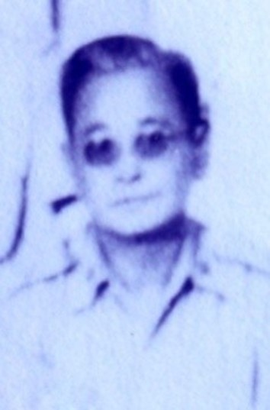
Mr Pramote

“Mr Pramote was the first person to become a Bahá’í in Thailand. But actually he was not a Thai. He was from Burma and he said he was a Karen. Karen is the name of a mountain tribe in central and southern Burma. He may have grown up in Thailand; certainly his wife and her family were Thai. He was introduced to the Faith by the second pioneer to Thailand named Anwer Cadir. Dr Ta’eed knew Mr Pramote and introduced him to me when he came back to Bangkok from Phuket. He seemed quite sincere in his belief. He was always available for 19-Day Feasts. He spoke excellent English and had read Esselmont in English.

“When I first arrived in Thailand Mr Pramote was on Phuket Island. After I had been in Bangkok for a couple of years, he returned to Bangkok because, he said, there was a lot of ozone in the air down there and it had a bad effect on his lungs. While he was in Bangkok, this lung trouble developed into tuberculosis, or it had been tuberculosis all the time and was finally diagnosed. He had to be hospitalized. Then it was complicated by diabetes. Finally he died.”[]

First Bahá’í Centre

“About a year later I got a job on the staff of the A.U.A. Language Centre. This increased my income considerably and gave me more free time. I rented a large house and we used that as the first Bahá’í Centre of Bangkok....

Not long after the Bahá’í Centre had opened, Phaiboon (my teacher of Thai) said that when he went to a Youth Camp in Japan, he was surprised and delighted by how all of the students took part in discussion groups. He wanted to have something like those discussion groups in Thailand and asked whether we could have them at the Bahá’í Centre. I, of course, was eager for the opportunity. This began a series of Sunday firesides where we discussed various modern social and religious questions. Phaiboon invited his fellow students from Thammasart. I also invited students from my classes. This lasted for a couple of years. Although there was always someone there to listen and to take part, no one declared. I spoke in English at the bulk of the firesides, but sometimes Bahá’ís were passing through Bangkok and they would speak. Phaiboon usually translated from English into Thai and if anyone asked questions in Thai, Phaiboon would translate them into English.”[]

I stayed at the YMCA on Sathorn Road. After getting a regular job teaching English at the A.U.A Bi-national centre, I moved to 33W (wau waen) Phahonyodhin Road near the Monument to Victory. We used that house as the Bahá’í Centre for Bangkok for quite some time. Sometimes people coming to Thailand to settle down stopped and stayed there until they found a place of their own. Sometimes travel teachers came and stayed until they were ready to move on”.[]

“In Nov. 1956, he[Charles Duncan] attended the four-country Regional Teaching Conference in Saigon where the friends suggested that he find a proper centre for the Faith in Bangkok. Upon his return he was soon successful in renting a good centre….”[]

First Local Spiritual Assembly

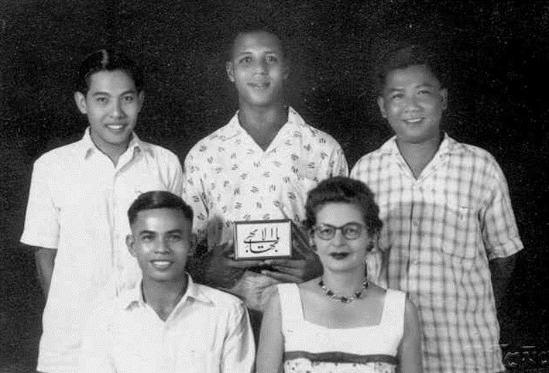
Five Members of the 1st LSA of Bangkok, 1958.
Back L-R: Mr Charote, Mr Charles Duncan, Mr David Lee
Front L-R: Mr Boonlert, Mrs Caroline Lawrence.

“With Caroline, Chaudari and his wife, Mr Pramote, the three new Bahá’ís[David Lee, Charote, Boonlert] and me, we had eight Bahá’ís. If only we could get one more by April 21st[1958] we could form an L.S.A. Our prayers were answered. About two days before Riḍván a student from A.U.A declared and we formed an Assembly… Soon afterwards, Thongchai and Uthai declared and I felt that the LSA would be able to function all right… so I moved to Dhonburi to open a new centre”.[]

First Bahá’í Burial

“The details of Mr Pramote’s burial are unpleasant. He had neglected to tell anyone in his family that he was a Bahá’í and so at his death when the Bahá’ís said that his remains should not be cremated, they were shocked. They said that since he was Thai, he should be placed in a wat[Thai Buddhist temple] for two days and prayers should be chanted by monks. The Bahá’ís agreed to that. The family agreed that if we could find a place to bury the remains at the end of that time they would consent. Somehow one of the Bahá’ís located the wat near Nonburi. When we got there with Mr Pramote’s wife, she screamed in rage when she saw where the coffin was to be placed. We did not know much about Buddhism, and did not realize that the place that we had paid for was the type that was usually used just as a temporary resting place and that the body would be taken out at a later date and burned. Mrs Pramote, however, recognized it and screamed that the Bahá’ís had tricked her. We were flabbergasted and made arrangements with the abbot to have the coffin buried and covered over with concrete with a headstone. This was done. I saw it myself and went out there several times to pray with other Bahá’ís. Mrs Promote was satisfied with the grave and went there by herself to pray and to leave flowers. So imagine my surprise when twenty years later Mr Vaughan Smith and I went out there together. We couldn’t find the grave or anyone who knew there had ever been one.”[]

First Thai Bahá’í Pioneer

“...Then I received word that Dr Mohajir would be in Vientiane. I rushed down to see him. He told me to return to Thailand. He suggested that we get one of the Thai Bahá’ís to go up to Luang Prabang in my place. So I went to Bangkok to see if I could find someone. I was very lucky. Sukkasem had just left the Buddhist monkhood, had become a Bahá’í and was jobless. He also spoke Laotian. He agreed to go to Luang Prabang and handle the Bahá’í work and earn a living teaching English. He was the first Thai Bahá’í pioneer...”[]

“The first Thai pioneer left on June 1, 1960 for Lung Prabang Laos”[]

First Observance of World Religion Day in Thailand

“…The English language daily The Bangkok World of 12 January 1960 announced that first observance of World Religion Day in Thailand would be held on Sunday 17 January 1960 at the Bahá’í Centre at 160 PhayaThai Rd. Bangkok, according to a report submitted to it by Mrs Caroline Lawrence the Secretary of the Local Spiritual Assembly of the Bahá’ís of Bangkok. No post-event news report was printed by that paper or in any other paper…”[]

Jai Gopal Jand’s Recollections

“Mr Jai Gopal Jand pioneered to Thailand on 23rd August 1962. He was invited to replace Miss Banu Hassan in Chiangmai who wanted to get married and return to America. After one month, after[the] arrival of Mr Jai Gopal Jand to Chiangmai, Banu left. Now the only source of income for him was from teaching English.

The first Local Spiritual Assembly of Chiangmai was formed in 1963. In the course of time, he met a young man called Suraphon, who after a time took Mr Jai Gopal Jand to his village. Through several visits a large number of people enrolled in Laam Luang Village and an LSA was formed in the same year.

Both Mr Jai Gopal Jand and Suraphon used to travel teach in adjoining areas and walked on foot for miles from house to house village to village and spoke at several schools. He left Chiangmai and was replaced by Marc and Jaleh Daughtey. Mr Jai Gopal Jand kept returning to Chiangmai and did a lot of teaching work with Marc.

In Bangkok he assisted Mrs Fozdar at the Bahá’í Centre and in travel teaching. In 1964 Mr Jai Gopal Jand got a job In Assumption School at Siracha. He was able to form[an] LSAs in Siracha and other localities on the eastern seaboard. He left Assumption in 1970. Mr Jai Gopal Jand married in India and his wife Savita declared soon after her arrival in Thailand. Savita and Mr Jai Gopal Jand served on the NSA as Secretary and Chairman respectively from 1970-1974. Savita left Thailand in September 1975 with their two sons Aroon and Michael, and Mr Jai Gopal Jand returned to India in 1977….-”

Shirin Fozdar’s Recollection

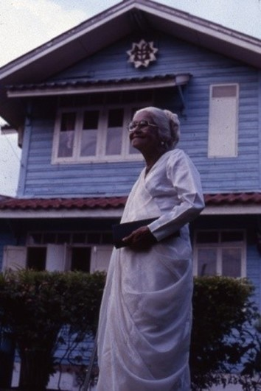
Mrs Shirin Fozdar

1961/1962
In March 1961, Mrs Shirin Fozdar pioneered to Thailand under instruction from the Hands of the Cause. Soon thereafter Mr Charles Duncan went to settle in Ubol and formed a Local Spiritual Assembly in 1962. The same year Mr Jai Gopal Jand arrived as pioneer from India. Miss Banu Hassan an American came as pioneer and she settled in Chiangmai and started the Bahá’í Centre.

There were two cousins Miss Zeenat Yeganegi and Fari Rahpayma who came to pioneer, but the former. After a few months, married Rodney Edwards a pioneer to Vietnam and went with him to Saigon. They were followed by Mr Marc Daugherty and Miss Jaleh Mow zoon. Within a couple of days of their arrival they were married in a Bahá’í ceremony and sent off to Ubol to look after the Bahá’í Centre since Mr Charles Duncan was proceeding to Songkhla to facilitate the departure of Banu Hassan who wished to get married. The Cause was taken for the first time to the tribal people the Mao tribe in the mountains of Chiangmai in 1961 by Mrs Shirin Fozdar and the first Meo was brought into the Faith that year.

1964
Thailand was under the Regional Spiritual Assembly of Southeast Asia but in 1964 the first National Spiritual Assembly of Thailand was formed since there were four Local Spiritual Assemblies in Bangkok, Ubol, Chiangmai and Songkhla. In 1964 the World Religions Day was organized and proved extremely successful. Over 1,000 people flocked to the Lumpini Hall where the lectures by various religious leaders were arranged. The Foreign Minister, Dr Thanat Khoman inaugurated the function.

During the following years many areas were opened to the Faith and the number of Local Spiritual Assemblies multiplied, Miss Dawn Edwards came to pioneer after the World conference in London and within a short time married a Thai Bahá’í Lawyer (Mr Sanya Polprasid). The Bahá’í marriages had already been recognized and this was the fourth Bahá’í marriage, at the Bahá’í Centre in Bangkok.

Mr Hushang Shayegh and Mr Faridian came from Iran as pioneers in 1964 and went to settle in Yasothon. Later a High School was obtained and Hushang was put in charge as supervisor. Mr Faridian married a Thai girl (Miss Chusiri Roobsoong[]),who turned out to be a good Bahá’í teacher. Faridian later pioneered to Laos with his wife.

In Riḍván 1964 the Regional Spiritual Assembly of Southeast Asia evolved to the formation of independent National Spiritual Assemblies of Thailand, Vietnam and Burma. The first national convention of Thailand was crowned with the presence of the Hand of the Cause of God Amatu'l-Bahá Rúḥíyyih Khánum and was further charmed with the presence of the Hand of the Cause of God Dr Mohajir in Bangkok. I, in the company of a local believer Mr Van-Tui from Laos rushed to Bangkok to witness the marvellous event.[]

First NSA of Bahá’ís of Thailand in the presence of Amatu'l-Bahá Rúḥíyyih Khánum

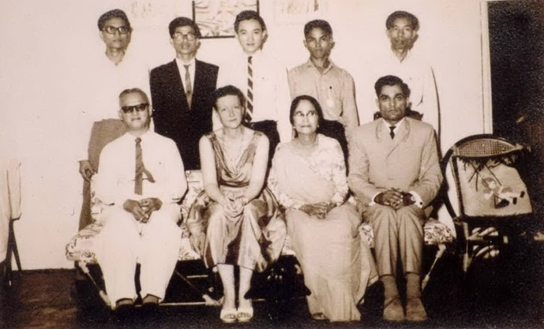
1st National Spiritual Assembly of the Bahá’ís of Thailand with Amatu'l-Bahá Rúḥíyyih Khánum seated 2nd from left

In 1964 the National Spiritual Assembly of the Bahá’ís of Thailand was established with the following members elected.

Mrs Shirin Fozdar | Chairperson
Mr Jai Gopal Jand | Vice Chairperson
Mr Swang Thongsuk | Secretary
Mr Tien Thai | Treasurer
Mr Ahkom | Member
Mr Pramook | Member
Mr Kirti | Member
Mr Vollop Ratanavibul | Member
Mr Ronda | Member

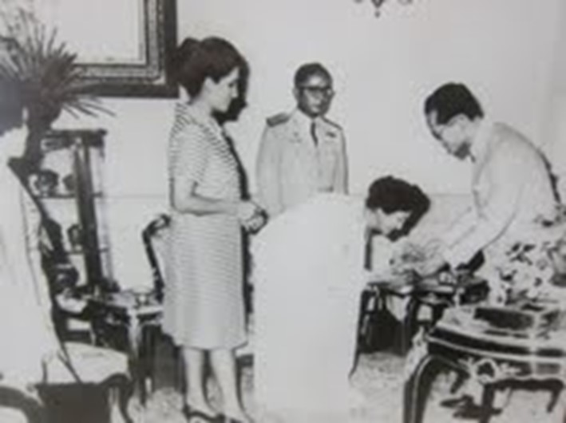
His Majesty Rama IX King Bhumibol Adulyadej of Thailand
receives Bahá’u’lláh’s Proclamation to the Kings

1967
The Cause is well known to the Ministers and important people and the King of Thailand was the first Monarch to give an appointment to the Bahá’ís to present His Majesty with the Proclamation Book in 1967.[The presentation of this historic document took place on 29 September 1967]

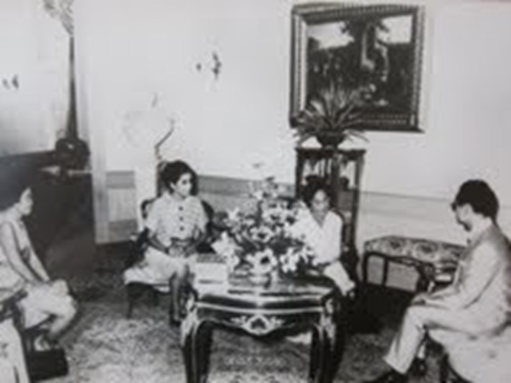
L to R: Mrs Dhanya Anapapitra, Secretary of Spiritual Assembly
of the Bahá’ís of Thailand; Mrs Parvati, Member of the Assembly;
Mrs Fozdar, His Majesty Rama IX King Bhumibol Adulyadej

This event was announced on radio and television and in newspapers. This publicity was given from the palace, and the Faith gained in prestige.

At present we have 55 Local Spiritual Assemblies and over 218 groups and centres. The Cause could progress more rapidly if it was incorporated and so we pray that the obstacles in our path may be removed.[]

Firaydun Mithaq’s recollections of Mrs Shirin Fozdar

“Mrs Shirin Fozdar was a very devoted believer who, despite her advanced age, had consecrated her life to the service of the Faith and had earned an eminent position in the establishment of the Faith in Thailand. In the sixties there were a few young pioneers from India, Sri Lanka and Persia in Thailand. Mrs Fozdar was like a mother to us young pioneers and we called her mommy. She was so enthusiastic in the fast expansion of the Faith that sometimes her enthusiasm made her take over and make the needed decision to move forward when the new infant believers or assemblies[failed] to respond actively.

We who were young and rather inflexible in those days did not appreciate this aspect of Mrs Fozdar and questioned her actions although we knew all along of the years[of] her ability and absolute devotion to the Faith and love for Bahá’u’lláh. She was kind to us, knew our simple hearts and overlooked our uneasy youthful behaviour.”[]

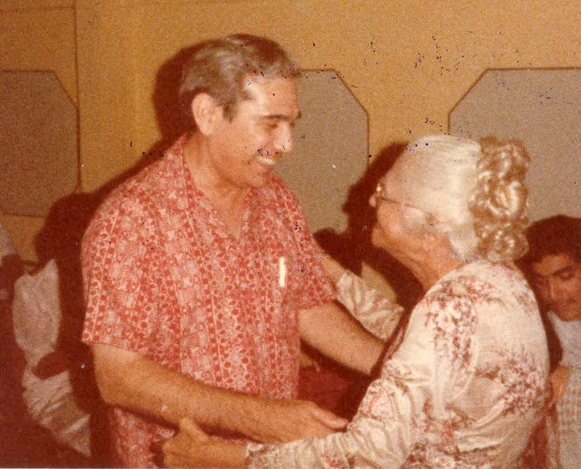
Dr John Fozdar with his mother Mrs Shirin Fozdar

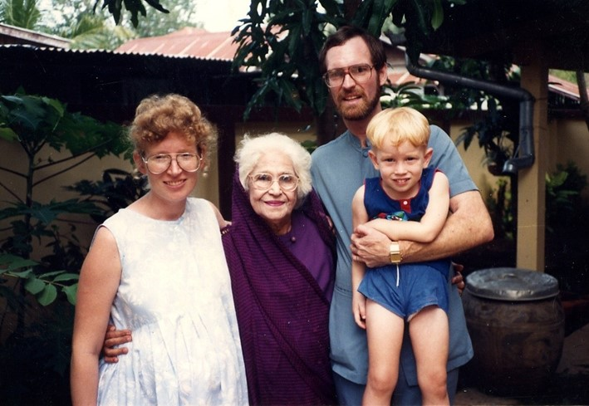
Diana, Tim, Scott Schaffter with Mrs Shirin Fozdar

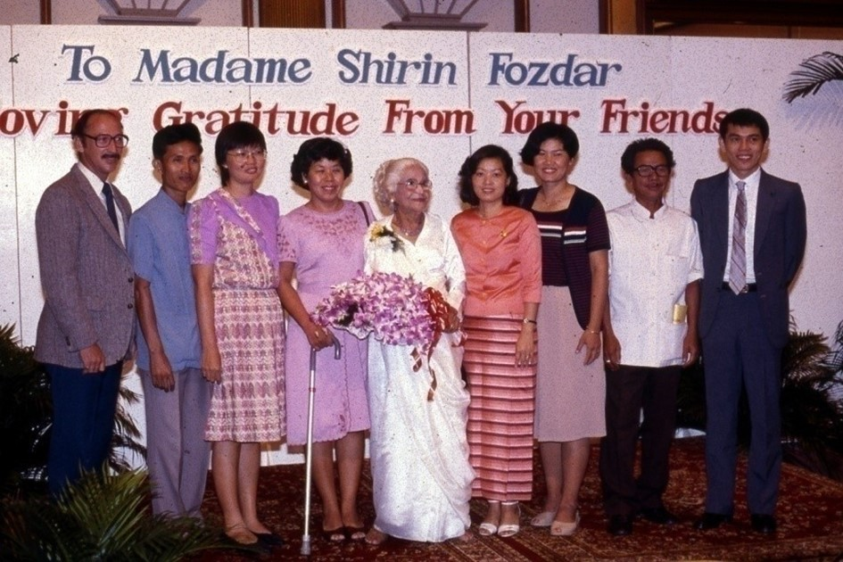Farewell party for Mrs Shirin Fozdar on the occasion of her returning to Singapore.
L-R: Victor[], Sawai[], Sunapa[]; Mrs Fozdar, Laddawan[], Pensri[], Mr Pim, Tawatchai[]

Shirin Fozdar’s passing

John Fozdar’s appreciation

“Thank you for your kind message of condolence on the passing of my late mother Mrs Shirin Fozdar.

She had been ailing for more than a year, but only in the last three months she began to sink rapidly. She knew that the end was not far off and often joked with friends if there was anything they wanted done on the other side.

She had had a very useful and active life and felt that she had done as much as she could. Her old body could not be expected to do more. Her mind was alert till before the end, but the body just could not take more.

She had learned to take her first steps by holding on to the gown of ‘Abdu’l-Bahá during, her first pilgrimage in 1906. This early guidance from the Master must have sustained he throughout her long life of dedicated service.

The National Spiritual Assembly of Singapore had made truly remarkable funeral arrangements. Their loving concern was apparent in all the arrangements. Our family can never thank them enough for their loving concern in their last farewell to one who had brought the Cause of God to their island nation.

I am sharing with you the message received from the Universal House of Justice…[]

Universal House of Justice’s Condolences

THE UNIVERSAL HOUSE OF JUSTICE
BAHÁ’Í WORLD CENTRE

TRANSMITTED BY FAX

To: | The Spiritual Assembly of the Bahá’ís of Singapore | Date: 3 February 1992

Fax Number: (65) 7475521

MESSAGE:

GRIEVD PASSING SHIRIN FOZDAR, DEDICATED MAIDERVANT BAHÁ’U’LLÁH, HER INDEFATIGABLE SPIRIT, ABIDING DEVOTION, PERSISTENT AUDACITY, UNTIRING EFFORTS SERVICE BELOVED CAUSE SPANNING OVER SEVEN DECADES IN FIELD TEACHING, PROCLAMATION, ADMINISTRATION, EMBRACING MANY COUNTRIES, PARTICULARY INDIAN SUBCONTINENT AND SOUTHEAST ASIA, HAVE EARNED HER WORTHY POSITION AMONG IMMORTAL FIGURES HISTORY FAITH FORMATIVE AND BAHÁ’Í DISPENSATIONS. HER ACTIVITIES INTERNATIONAL FIELDS, PARTICULARLY STATUS WOMEN, HAVE OPENED NEW DOORS REACHING HIGHER STRATA SOCIETY. TO LAST BREATH HER PRECIOUS LIFE SHE CONSCIOUSLY STROVE SERVICE FAITH. ADVISING NATIONAL ASSEMBLY INDIA HOLD BEFITING MEMORIAL GATHERING MOTHER TEMPLE SUBCONTINENT. URGING NATIONAL ASSEMBLIES SOUTHEAST ASIA LIKEWIES ARRANGE SUITABLE GATHERINGS AS ACKNOWLEDGEMENT HER GREAT ACHIEVEMENTS THAT REGION.

CONVEY LOVING SYMPATHY HER BELOVED CHILDREN FRIENDS. ASSURS ARDENT PRAYERS HOLY SHRINES BESEECHING BAHÁ’U’LLÁH SHOWE HER WITH BLESSINGS, ETERNAL REALM.

UNIVERSAL HOUSE OF JUSTICE

cc: International Teaching Centre
Board of Counsellors in Asia
Counsellor Zena Sorabjee
Counsellor John Fozdar

Bahá’í Administrative Committee of Thailand

Letter dated December 3, 1974 from the Universal House of Justice

Mr Chavalit Menjikul
Mrs Chusiri Faridian
Miss Duangkamol
Mr Victor Greenspoon
Mr F. Faridian

Dear Bahá’í Friends,

Because of irregularities in election, it has been decided that the present Bahá’í Spiritual Assembly of Thailand should be disbanded, effective immediately. In its stead, we have decided to appoint you as members of the Bahá’í Administrative Committee of Thailand and we request Mr Chavalit Manjikul to convene your first meeting.

Your functions consist in the administration of the affairs of the Bahá’í Community of Thailand with special attention to the carrying out of the teaching work, the winning of the goals of the five year plan, and the preparation of the friends of Thailand for the election of a new Spiritual Assembly for Thailand at Riḍván 1975. In the discharge of these functions you will have the active assistance of the Continental Board of Counsellors in South-eastern Asia; the election of delegates and the subsequent election of the members of the Assembly will be under their supervision. We will inform you of the number of delegates for your Convention as soon as we receive from you the number of Local Spiritual Assemblies in existence as of 1 December 1974.

The Spiritual Assembly of Thailand has been instructed to cooperate with your Committee by turning over its records and files and giving you any information you may need for the discharge of your functions. Please elect from your number such officers as you may need to carry out your duties, and henceforth maintain direct contact with the World Centre.

If there is anything you do not understand, or if you encounter any difficulties which you cannot resolve, please feel free to either contact the Counsellors or to write directly to us.

Be assured of our ardent and loving prayers at the Holy Shrines that Bahá’u’lláh may guide, assist and sustain you in the performance of your important work on behalf of His Cause.

With loving Bahá’í greetings

The Universal House of Justice

cc: The International Teaching Centre
Board of Counsellors in South-eastern Asia
Spiritual Assembly of Thailand

PART TWO:
Recollections of Hands of the Cause by early pioneers

Zikrullah Khadem

“While I still lived at the YMCA I received a visit from Hand of the Cause Mr Khadem. I was so embarrassed at receiving a visit from such a distinguished person that I am afraid I did not show him the suitable hospitality.”[]

“We also had visits from many Hands of the Cause. I have already mentioned Mr Khadem’s visit. Later we were visited by Hands of the Cause, Amatu'l-Bahá Rúḥíyyih Khánum, Agnes Alexander, Collis Featherstone, Enoch Olinga and Dr Muhájir. I am not sure whether Hand of the Cause, Mr Samandari, visited us or not. I think he did but I was in Ubol at the time.”[]

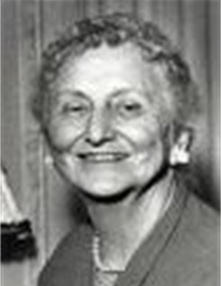 | 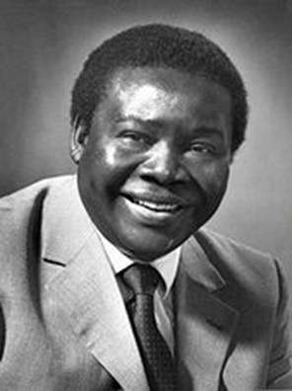 | 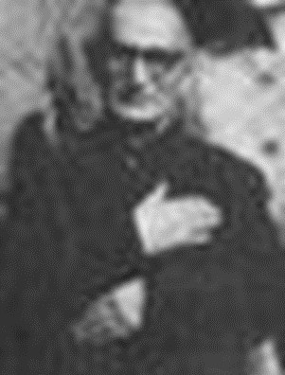
Miss Agnes Alexander | Mr Enoch Olinga | Mr Taráz'u'lláh Samandarí

Taráz'u'lláh Samandarí

“Due to the horrible conditions of the country[Laos] we left under the fire of bullets, as did all the Americans. We stayed for a few months in Bangkok where I was fortunate to have Mr Samandari (the Hand of the Cause) come to our home as I was translating on his behalf. He held Olinga’s hand in his hand (my youngest son). This child was also brought home from the hospital in the arms of Dr Muhájir (the Hand of the Cause) and to us this had great spiritual meaning”.[]

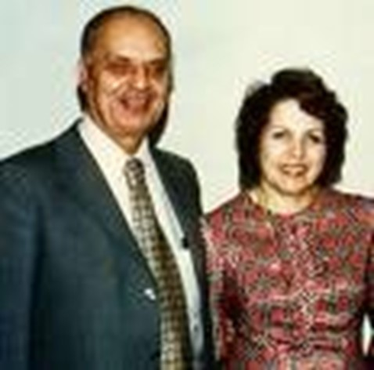 | 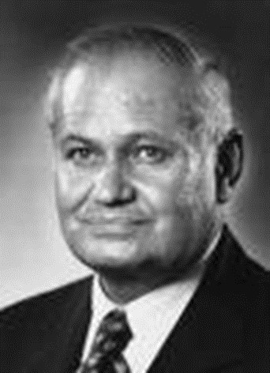
Mr Zikrullah Khadem  with wife Javadukht Khadem | Dr ʻAlí-Muhammad Varqá

Enoch Olinga

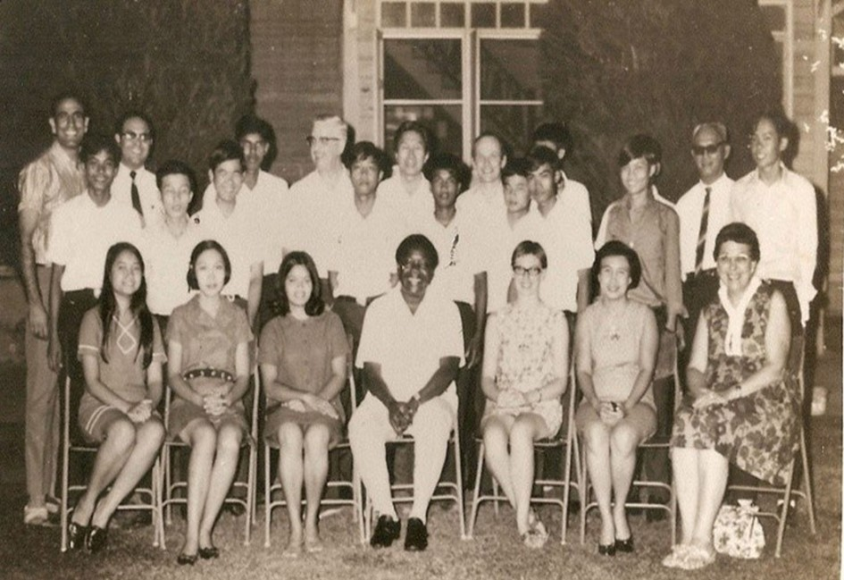
Bangkok Bahá'í Centre, ~ Jul 1970, Mr Enoch Olinga visiting
Standing L-R: Nasser[], Youth1 (Rachen), Chavalit[], Youth2 (George)[], Youth3 (Vinai), Perumal[], Mr Phillips[], unk, Sanya[], unk, Aldi[], 3 unk youth, Noi[], Tien[], unk
Sitting L-R: 3 new Bahá'í youth, Enoch, Avril[], Tanya[], Mrs Phillips[]

Rúḥíyyih Khánum

Bangkok

Bahá'í Centre, Lang Suan Rd, Bangkok,
Miss Sima welcoming Rúḥíyyih Khánum

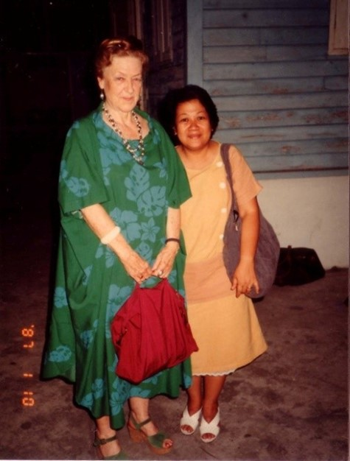 | 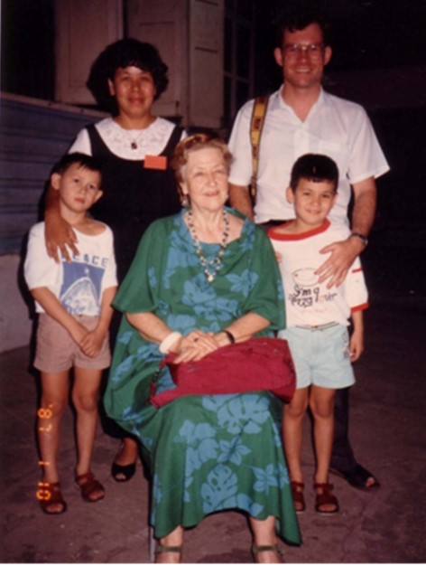
Rúḥíyyih Khánum with Chusiri | Sunantha[], Vaughan, Thep & Tee Smith
1987, Rúḥíyyih Khánum travelled to Thailand after inauguration of House of Worship in New Delhi.. Bahá'í Centre, Lang Suan Rd, Bangkok,.

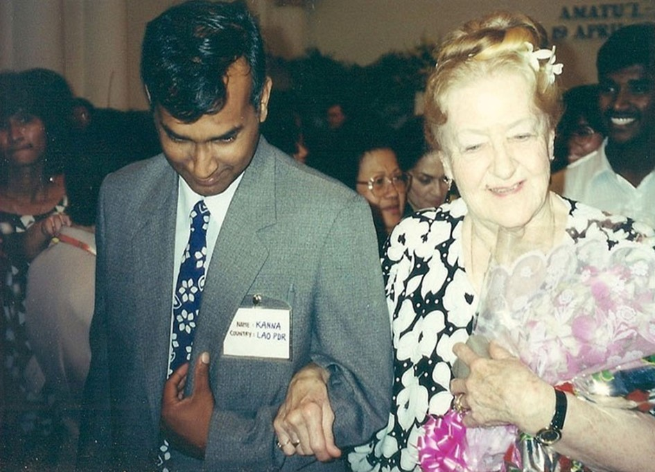
Bangkok, Conference, 1991, Rúḥíyyih Khánum with Kanna[].

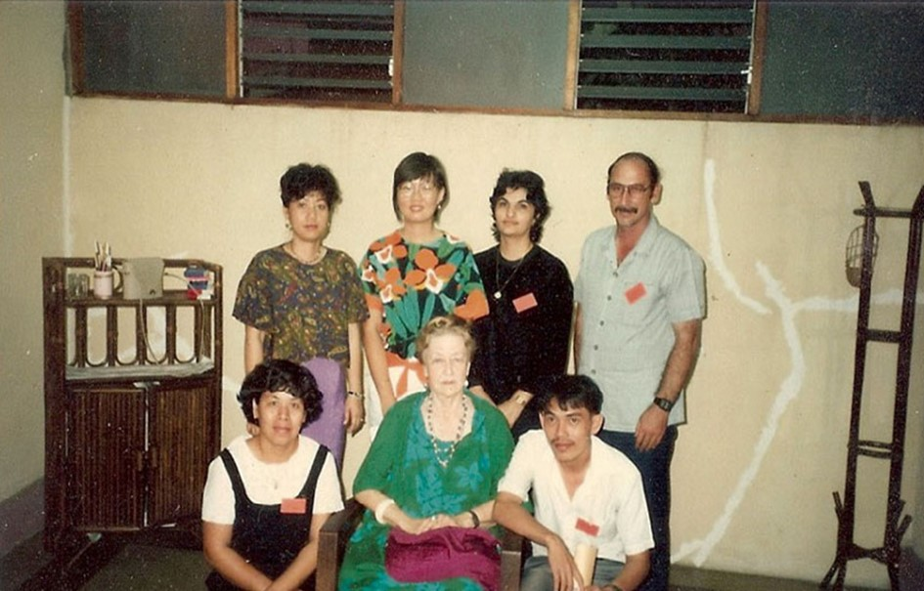
Bangkok Bahá'í Centre,
Back L-R: Laddawan, Sunapa, Maliheh[], Victor
Front L-R: Sunantha, Rúḥíyyih Khánum, Tawatchai

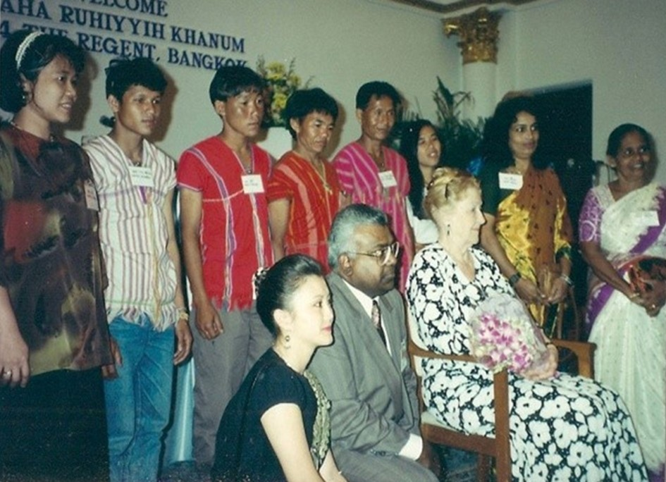
Bangkok, Regent Hotel, 1994. Standing: includes members Karen tribe from Omgoi, and Bahá’ís from Malaysia. Front: L-R: Dr Nardrudee, Elan[], Rúḥíyyih Khánum.

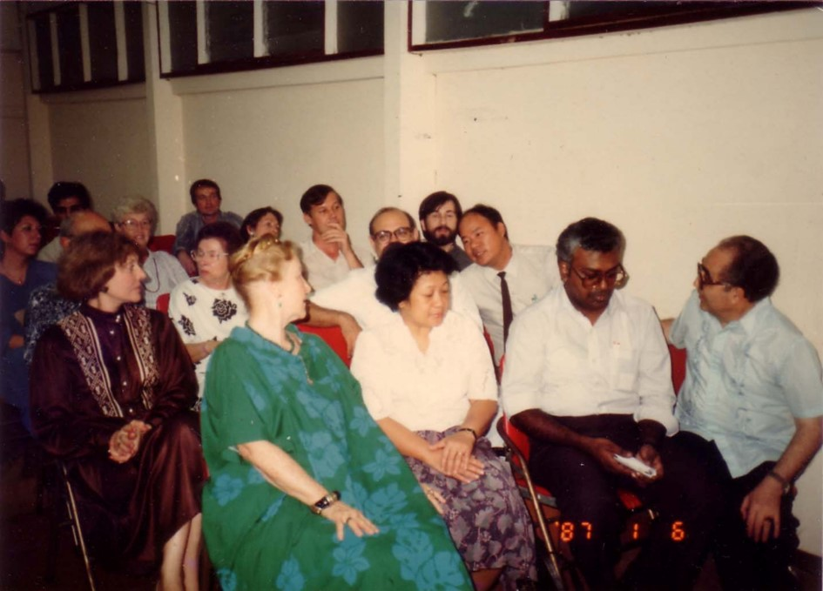
Bangkok Bahá'í Centre, 1987. Front L-R: Rúḥíyyih Khánum, Chusiri, Elan, Iraj Ayman. Behind L-R: Mrs Navidi, Hazel Neave, Tawin (Tony) & Helene Panalaks, Shirley Smith, Frank Mausley, Chavalit Manjikul, Peter Smith, Chanchai Rojchanakittisakul

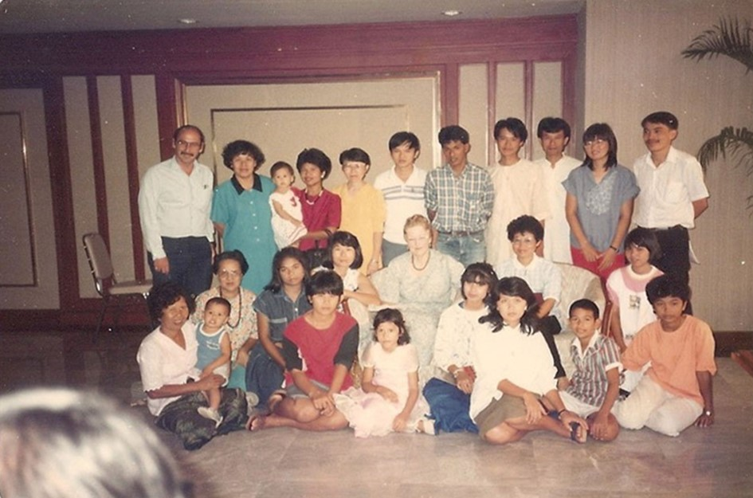
Incomplete need more names
Upper Row: Victor, Sunantha, Montha holding Sara, Waraporn[], Chaiwat Yaowapapong, 3x?, Sunapa, Tawatchai
Bottom Row: Suthita, Abha, Rúḥíyyih Khánum,
Front: Paul Greenspoon

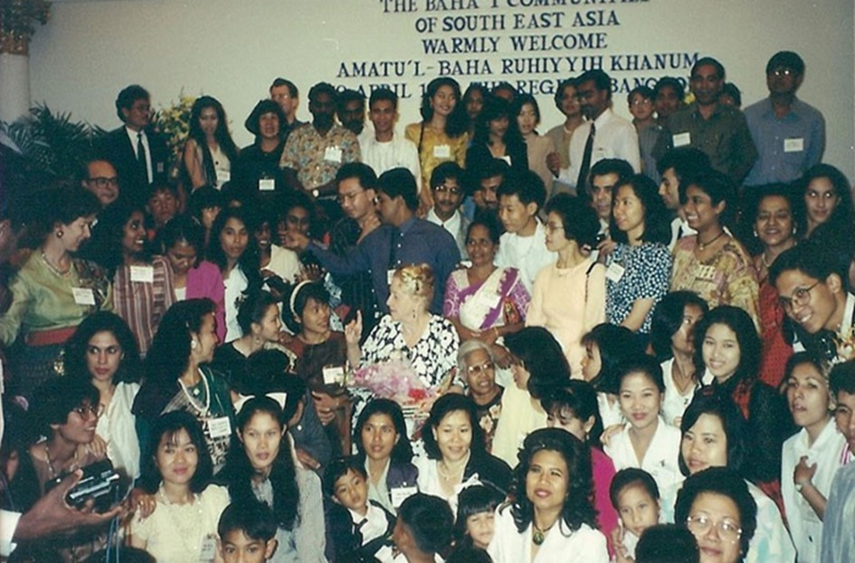
Regent Hotel, Bangkok, 1994. Rúḥíyyih Khánum with friends
from Thailand and Malaysia

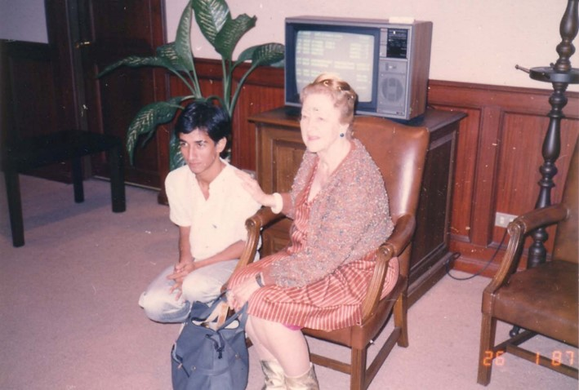
VIP room, Don Muang Airport, Bangkok, 1987. Rúḥíyyih Khánum and Roshan Abhasakun

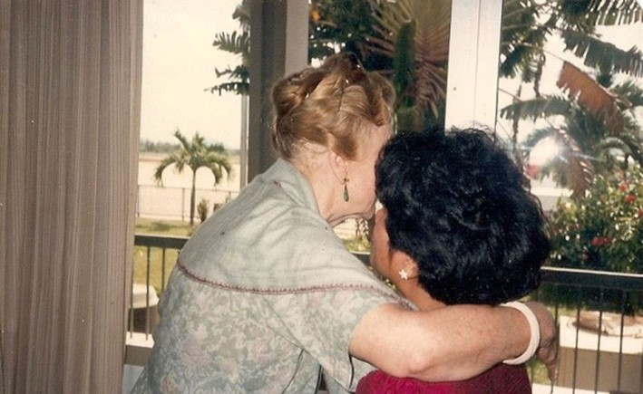
Rúḥíyyih Khánum with Montha Greenspoon

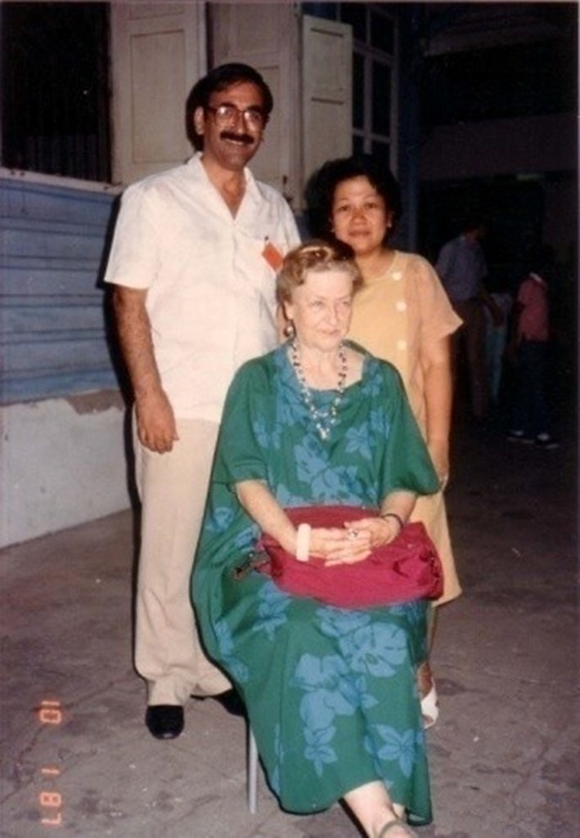
Bangkok Bahá’í Centre, 1987, Rúḥíyyih Khánum with Faridian & Chusiri

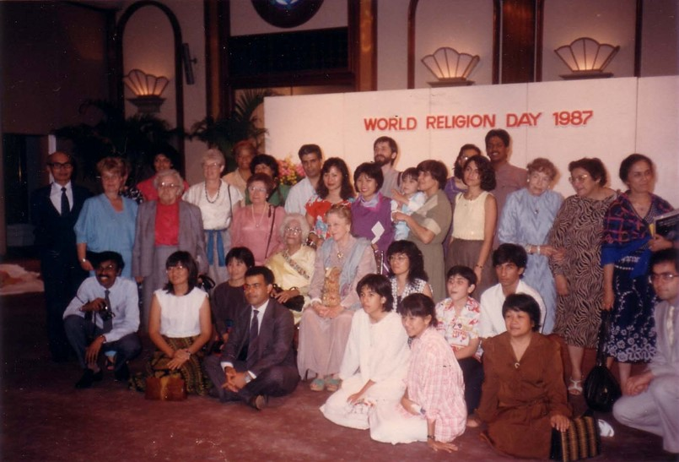
Bangkok, World Religion Day, 1987. Rúḥíyyih Khánum with Bahá’ís.

Yasothon

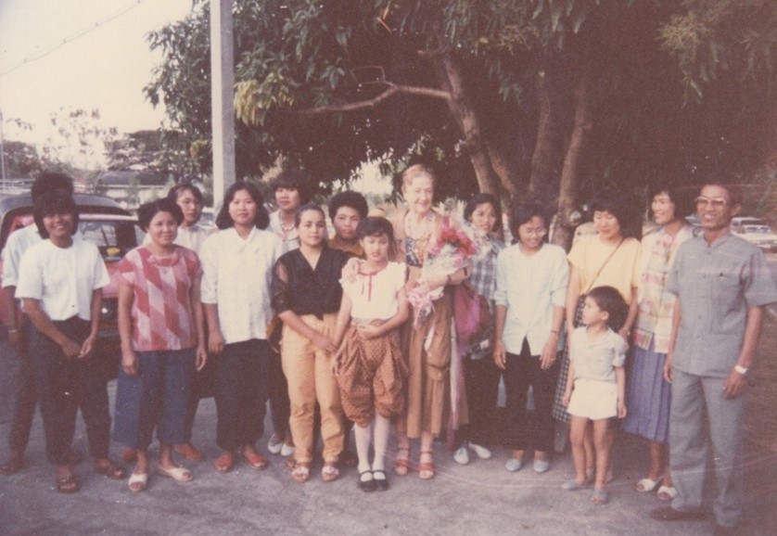
Yasothon. R-L: Sawai & Pensri, Nida & Panu Starrs, Mrs Pensri, Ms Tawan, Rúḥíyyih Khánum, Wi[].

Thai Bahá'í pioneer married in Cambodia

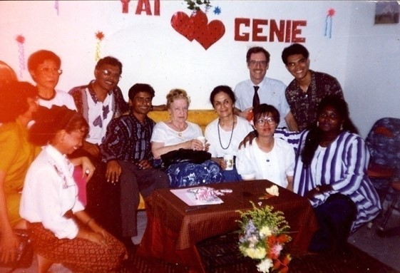
Bahá'í Centre, Phnom Penh, Cambodia, 1994: Rúḥíyyih Khánum witnessing Sunapa (Yai) Dechatattanon & Giovanie (Ginnie) de Leon’s wedding after election of 1st National Spiritual Assembly.

Hatyai address

Excerpts from the Address given by Hand of the Cause of God Amatu'l-Bahá Rúḥíyyih Khánum at JB Hotel, Hatyai, Thailand on 17 January, 1987.

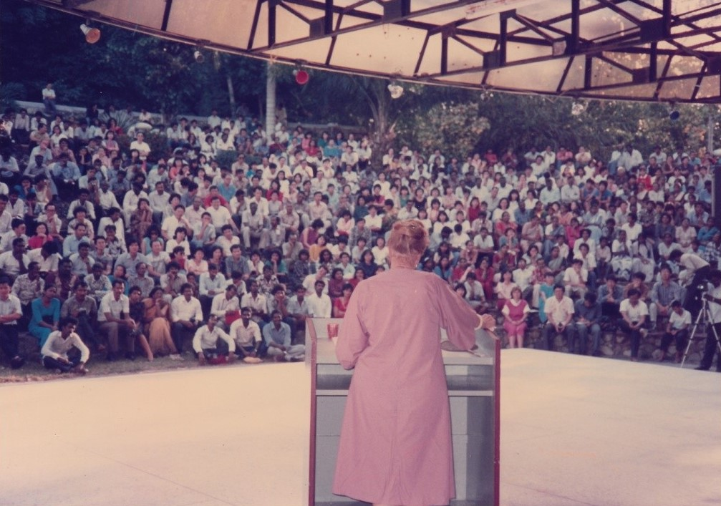

Everything has a History

“First of all, I want to say how very happy I am to be here and that everything has a history. My being here tonight has a very short history. The Malaysian National Spiritual Assembly, before the dedication of the Delhi Conference asked me, if after the Conference I would go to visit the Bahá’ís in Malaysia. As you know I’ve been there twice already and I wanted very much to go back. So I accepted. And then in Haifa we discussed it and we decided that because of the difficulties of teaching in Malaysia and the attitude of some elements against the Bahá’í Faith, that if I received any publicity in Delhi, then went immediately to Malaysia, they might identify me, you see, as being from the World Centre. So because of that, I gave up Malaysia and I was planning also to go to Indonesia where I have never been. And this plan was all made and I was very happy about it, very excited about going. At least I’ll be seeing the Bahá’ís in Indonesia. And then we consulted in Haifa and we decided, for[the] same reason, that it would be unwise. If it were 6 months after the Conference and the dedication in Delhi, it would have been alright-they would have forgotten about the whole thing; but just one or two weeks later was too close. So then I thought, well, I’m going all the way across the world and going to Delhi and it’s a pity to turn around and just go home. So why don’t I go and visit the Bahá’ís of Thailand? I have never visited any of the village areas or the secondary cities of Thailand. I’d only been, I think, this is my 5th visit to Bangkok-just coming and going on different trips – and I liked this idea very much and the Assembly of Thailand was consulted by Dr Iraj Ayman and it was decided and the plan was made and here I am; so that one of the happiest parts of this whole trip in Thailand is to be able to see so many of the Malaysian Bahá’ís here. And I hadn’t expected this – it makes me very happy, makes me very happy to also see some of the Bahá’ís from Singapore. Now if we don’t get too tired and it doesn’t get too confused, I have an idea. I thought that tonight before the meeting is ended, at least before I’m ended and go to bed, that we would try to have a picture of each of the groups – the Singapore Bahá’ís and separately the Malaysian Bahá’ís (applause…) and obviously the Thailand Bahá’ís and this would be a night and all of us together, and that would be a very good thing. I hope these people who are forever taking photographs have thought about taking a photograph of all of us together. Has anybody thought about that? They have? Alright, that’s fine.

Now, that[what] I was thinking about is this. You know, you are all Bahá’ís. And most of you are very active, devoted Bahá’ís. Some of you are very old Bahá’ís. Some of you may be new Bahá’ís but it doesn’t matter. And you know about the World Centre. You know about the wonderful House of Justice guiding the destiny of the Bahá’í world. You know about the International Teaching Centre. You know about the Continental Boards of Counsellors. You know about the Bahá’í administration and obviously you know a great deal about Bahá’í teachings. So why should I spend the short time that I have with you going again into this subject that all of us are so familiar with?

I don’t know how free the Bahá’ís[are] to teach in Malaysia – not very free from what I have heard from Dr Sundram, the Counsellor. Obviously you have to be very wise and very discreet; it’s not like many other countries. But as best you can, I know you are always teaching the Faith. The Bahá’ís in Singapore are free. Thank God, the Bahá’ís in Thailand are free to teach, and many of the Bahá’ís from Malaysia, I understand, are able to cross over into Thailand and to be active visiting different centres and perhaps doing some village teaching and mass teaching.

Village Teaching and Mass Teaching

So I felt that, it would be nice to do what I would like to do –[that] would be to give you some ideas that I have developed over the years on the subject of village teaching and mass teaching because my experience, in particular in Africa, is that the Malaysian Bahá’ís (the Thai Bahá’ís have not travelled that much) but the Malaysian Bahá’ís have travelled to many countries, particularly Africa and they have been, I’m the witness, wonderful wonderful pioneers and wonderful wonderful travelling teachers. Strangely enough, way down at the other end of the Pacific Ocean, the comparable, if you like, for this kind of pioneering and travel teaching, are the Philippine Bahá’ís. I don’t know why. I haven’t got time in life to sit around puzzling over things but I know that is true.

An Example of a Malaysian Pioneer in Africa

I give you an example that comes to my mind of a Malaysian pioneer in Africa. When Violette and I – Mrs Nakjavani were travelling 3 years and 10 months mostly in Africa, to 34 countries, 36,000 miles by Land Rover, we were in Swaziland for quite a number of weeks and when we were there, a Malaysian pioneer turned up. So he came to the National Assembly or the National Teaching Committee – whoever was delegated to meet him – and he said “Here I am – what do you want me to do?” So they told him they wanted him to go to such and such and such a village, small towns in Swaziland and teach! So this is a Malaysian. And I told this story all over the world. They give him some money – the local currency – they tell him what bus to take, they tell him the name of the town to go to and he goes! Just like that – he gets on the bus and off he goes to that place! And 3 weeks later, we[were] still in Swaziland, we had a conference. The Malaysian Bahá’í turns up with 10 new Bahá’ís that he has taught since he arrived 3 weeks earlier.

Now this is the standard as far as I can see of the Malaysian pioneers. And I have said all over the world I wish we had thousands of you to travel teach and to be pioneers…., Anyway, the point is that all Bahá’ís are needed for the teaching work and they are needed all over the world but if you have any spare Malaysian Bahá’ís that can still go out as pioneers or still go out and travel teach, I suggest that you think about doing so because it is a great great assistance to the Cause of God, (thank you), and will mean a great deal to the teaching work all over the world.

The People in Rural Districts

The people in rural districts seem to be still more receptive to the teaching of Bahá’u’lláh than the people in the Cities. You know, I personally am a city child. I was born in New York, because the hospital was there that I was born in (laughter…) and…, on 5th Avenue and I’m a real New Yorker. Very few people are New Yorkers nowadays, (who) are born on 5th Avenue. Anyway, I was brought up in Montreal, Canada which was at that time the biggest city in Canada (2 million population). And then I had spent a great deal of time in Rome, Paris in London and always in cities as Haifa is the second biggest city in Israel. So that my life had been up to the time when the Guardian passed away, entirely spent in cities. And I know nothing whatsoever about teaching villages – I never visited a village in my whole life until after the beloved Guardian passed away. Now I owe my understanding of village teaching to two people. One of them is Shirin Boman, you’ll remember, of India, who is one of the greatest mass teachers in the world and the other is Ali Nakjavani who was such a wonderful teacher of the masses in Uganda, Africa, and who, of course, instructed his wife and his wife is travelling with me. So this is the background of my knowledge of village teaching. And it has been a revelation to me, this whole experience in my life, of being privileged to go amongst villages. I’ve reached the point now where I personally hate civilization. I’ve had it, as we say. I can’t bear cities – I have to bear them – Haifa’s become a very big city and very polluted. This is where I live; this is where I have my work and so on… the World Centre. But I hate Cities and I hate civilization and all the time I remember the words of Shoghi Effendi when he said that a cancerous materialism was coming from the west, mainly from America. It’s the epitome of all that is the worst in civilization, is in North America, even more than Europe, and particularly in the United States. And the older I get the more I see the truth of these words of Shoghi Effendi. Now, you are all intelligent people. You have eyes and ears and you read the newspapers and you read articles and you see, undoubtedly, documentaries on T.V. so you know perfectly well[what] I’m talking about. Maybe you like cities still but I hate them. But the county, the countryside, the people in the countryside quite a different proposition. You’ll remember that ‘Abdu’l-Bahá, and Shoghi Effendi has quoted it so we know it is authoritative; ‘Abdu’l-Bahá said the city, He said Bahá’u’lláh said, the city is the home of the body but the country is the home of[the] soul. Now either we have to take the word of Bahá’u’lláh seriously, or we take only the words of Bahá’u’lláh that we like, you see. Everybody likes the word of Bahá’u’lláh about world peace and equality of man and woman and the universal language, science and religion must go hand in hand and all of these things. They are very wonderful, obviously, principles upon which the whole world’s society will be founded but they’re not particularly applicable to us. I can’t do anything about an International language. I can’t produce world peace. I have no prejudice against woman or man, so that’s alright. But all of these great-great universal principles are for society, for nations to adopt, for the development of a world order. But what I call the small print in the Bahá’í teachings we don’t often read and we don’t pay so much attention to. Now, in my vocabulary, my way of thinking, one of the small prints is that the city is the home of the body but the country is the home of the soul. However much, umm, shall I say, “degeneration” may be going on in village society all over the world, and it’s going on very rapidly, still, villages seem to have a more upright spirit, a more spiritual concept of life and a little bit better moral behaviour and a higher sense of religion than the people in the cities. So that to teach the masses of people that are not in these tremendous centres of civilization, I think, is one of the great challenges of this period in history-this is my own point of view, I can only tell you what I think. I don’t say I’m right, I don’t say I’m wrong-I’m only sharing with you my very firm convictions. I was reading the other day that by the end of this century, Mexico City will have 26 million people – I don’t know – you can’t even think in those terms. And Buenos Aires will have, I don’t know, 20 million. And Sao Paulo which is already a ghastly city will have, I don’t know, how many in the 20 millions and so on. This is as if this process of urbanization, the magnetic attraction of the cities, is growing stronger at the end of the 20th century. Now, if you analyse it, the thing that is producing it is materialism. You see, I have, as I said, travelled so much that I have seen things that the average person has never seen. And I have seen, for instance, the terrible slums of Africa. You go to Kinshasa, the capital of Zaire. When we were there, which is already, what, 1971 – 72, they had half a million people living in the slum surrounding the capital of Kinshasa; living in the mud – beggars. I see the same thing in Buenos Aires. I’ve seen it in Caracas in Venezuela. I’ve seen it all over the world, you see. It’s as if people were attracted to the city.

Cancerous Materialism

Shoghi Effendi spoke of is drawing the population to these tremendous centres of urban life. Why? Because they think that they will have running water – well, I don’t blame them for thinking that. They think that they will have flush toilets – that is not a bad idea. They think they will have an automobile and a television set and a good job, and money, and entertainment, and diversions. And this is the lodestone; this is the magnet that is taking the villagers out of the jungle, out of desert, out of the rural areas all over the world, to these deadly centres of civilization. And lately, I don’t even know, perhaps I shouldn’t say this out loud, but I’ve been thinking about it, you know, it’s not clear to us Bahá’ís, exactly what the future holds. We know that Bahá’u’lláh says – the unforeseen calamity. We know that Shoghi Effendi forecasts a terrible disaster, terrible suffering in the world, probably a world war.

The Protection of Nature, the Environment, and the Planet

Well, if you are interested the way I am in environment and in the protection of nature, and the protection of the environment, and the protection of the planet, which is extremely important for all of us, then you wonder how much more of what we human beings are creating – civilized human beings, not villagers, how much more the world can stand.[This is] because, gradually we are changing the atmosphere. We are changing the ionosphere, we are polluting the oceans. You see what I mean? You know this – I don’t want to waste time[going] into it but sometimes I think that it’s a race between us human beings and the destruction of the planet, that if God doesn’t do something to get rid of us as we are in the present form, “urban man”, if you like, materialistic man “par excellence”, then we would have gone to a degree of destruction of the planet, that for all we know, we won’t have any more[people] left anyway, because we will have destroyed, damaged very seriously the environment. But anyway, these are the kinds of thought that go through my mind. So then I was thinking that nature has a, I won’t say that nature has a conscious intelligence, but nature has a form of intelligence of her own. So nature combined, I suppose, with Almighty God, because nature is a handmaid of God, seems to be arranging that we would all congregate in these great urban centres and then we’ll have a nice atomic war and all the people will be killed because they’ll (be) located in one place. I can remember Shoghi Effendi – the Bahá’ís used to ask him, particularly the American Bahá’ís, the pilgrims they used to say, “what is the future, what does the future hold?” and he said, “well, if there’s another war, of course it holds unbelievable destruction.” So they said, “what should we do?” He gave (a) very interesting answer. He said, “Go to the ends of continents. Go as far away from the centres of civilization as you can get”.

If We had Another War

He said that if we had another war, the big dogs, as I call them, would go for each other, which of course is obvious. So what will they aim at? Population centres, financial centres, military centres, any kind of valuable source of national life or wealth in that country that is their enemy. So if there’s any hope for protection, it is to be[among the] small percent[who are] far away from these centres of civilization. I remember in Africa, sometimes the African students, when I gave talks in universities, they would get on the subject of colonialism. They would say, oh look how we have been treated and you white people came here and you did this, that, and other things. Well, alright, there’s a lot of truth in that but also we did a few good things but, never mind, we were the colonial powers and so on and so on. But I said, now you listen to me (I remember this was in Malawi – this young student was very militant.) I said, “Look, my friend, you’re young enough to be my grandson, you listen to me. A day may come when you’ll remember what I’m saying now. If we have another war, Malawi is a poor, undeveloped country, which is what you’re complaining about, and saying that we’re affluent in America and Europe, and look at your poverty and backwardness in Malawi. But nobody will drop an atom bomb on you because you’re not worth it financially” (laughter…) It’s true! It’s true – Just use your own mind. An atom bomb is a very expensive thing. And it’s very essential for annihilation of whatever it is you want to hit. Who is going to drop an atom bomb on a poor little developing country that has nothing? They won’t bomb them- they may get a little fallout but nobody’s going to hit them, you see.

So that one has to look, I think, at the whole planet in some kind of a light of what might be future development. I don’t see how any Bahá’í can ignore any thinking on this subject. And if what I’m saying has any value, then what it amounts to is this – that it is to the advantage of the future, to the advantage of the Bahá’í Faith and maybe to the advantage of the individual Bahá’í who arises to teach, to go far away from these centres of civilization and teach the masses while there is yet time. …….”

The Faith has made Tremendous Progress in Thailand

The Faith has made tremendous progress in Thailand. You have so many centres, where many years ago, even a few years ago, you had almost none! The Cause is advancing in Thailand. The Bahá’í community of Thailand is strong and devoted. It’s National Assembly and committees are active, but still, what is it compared to the people of the country? So, we have so much to do. We have such challenges facing us and we only have one life in which to work for Bahá’u’lláh because, whatever happens, we die. We hope we all die as good Bahá’ís, we hope we’ll be accepted by Bahá’u’lláh, we hope we’ll go to the Abha Kingdom. But, we’re not going to be able to do any more work here because that’s a different kind of a world. It hasn’t got any villages; it hasn’t got any world order to established, and so on.[It’s] quite a different proposition. So that this is our opportunity to create something that is of supreme value. I thought that I would give you, because I think that it would interest you, a few examples of ‘Abdu’l-Bahá in teaching.

The Bahá’ís should Copy the Method of ‘Abdu’l-Bahá

Shoghi Effendi used to always say the Bahá’ís should study the talks of ‘Abdu’l-Bahá. The Bahá’ís should copy the method of ‘Abdu’l-Bahá. Well if you study the travels of ‘Abdu’l-Bahá and His talks, they were exceedingly simple. First of all, He was so kind. Contrarily to the understanding of most Bahá’ís, ‘Abdu’l-Bahá never greeted anyone in the west with “Alláh-u-Abhá!”. Never, not once. He said, “How do you do, are you well, are you happy? This was His greeting to people. Now,[in]His talks, as I recall, reading many of them, He dealt with one or two subjects, maybe at most, three. In very simple language, often He said it a little bit this way, then a little bit that way, maybe one or two versions in the talk of the same subject, you see, which of course any teacher of children or school teacher knows is very good psychology to imprint it on the mind of the person that you are talking to. He never dealt with the whole business at once. It was intellectual because it was true.

But it wasn’t intellectual by the standards of some of the talks that I have heard. I remember some years ago, Violette and I were in, where were we? We were in India. And it came time to open the Bahá’í Temple in Germany. So, I was going to go on behalf of the house of Justice and open this new Temple and we went to Germany. I speak German quite fluently, and understand it even better. I heard one of the Bahá’ís who is a very old friend of mine, a brilliant Bahá’í, gave a public talk. It was marvellous, absolutely marvellous. He exposed this subject and that subject and the other subject and he did it with wonderful words and wonderful vocabulary and when this talk was finished and I left the hall, I couldn’t remember one single thing he said. It was like being put under a heavy shower, you see, so much had come on me at once, that I really had no idea what he said. He said everything, and he said it very beautifully but it didn’t remain. Now, ‘Abdu’l-Bahá didn’t teach that way. He said a few things, He said it very simply and it remained, because it’s easier for normal people’s minds to take in one or two things clearly than a hundred things…”

‘Abdu’l-Bahá’s Explanation of Ghosts

My mother was a very marvellous Bahá’í teacher and nearly everything I am and know is either from my mother or from Shoghi Effendi. Sometimes I wonder if I have any existence of my own at all. (Laughter...) but I remember my mother used to talk about ‘Abdu’l-Bahá’s explanation of ghosts. And as far as I’m concerned there’s no doubt that ghosts exist. The phenomena of ghosts exist. People in cities, young college graduates, if you like, maybe Ph.D.’s says that that’s all nonsense, you see, but it isn’t nonsense as they do exist. Now, the understanding I have, I’ll try to put it as clearly as I can, is that, when a person dies, his spirit is released from his body according to the Bahá’í teachings, and, as it says in the writings he is like a bird that is let out of a cage. This is the way I talk to the villagers but as far as I’m concerned, it’s the truth, so, the example is the bird[that] is let out of the cage and it wings its flight on high. The body dies, the spirit is released, the soul of human being wings its way to wherever it’s going and whatever God apportions to it. But, if you have ever had any experience of birds and I have seen this myself because I’ve had lots of pets and studied them. If a bird has always been in a cage, and you open the door of the cage, the bird does not want to go out. And it’s very interesting to observe – the bird cage is open – you even see that the bird comes and sits on the opening, and he’s afraid. He’s never been out of the cage, afraid to go out there, afraid to stretch his wings, he goes back in again. Often, you have to chase the bird out of the cage to get it to fly and get out of the cage. Now, this example is the attachment of the soul to this world. As I understand it, when a soul passes away, the proper thing, the spiritually natural thing for it to do is to be free, you see, to wing its way up on high. But, if it is attached very strongly to its environment or to some individual, say, a grandmother, very attached to her grandchildren, a man very attached to his farm, a woman very attached to her children and her home, in other words, a passionate attachment to the environment in which that person has lived, it’s like the bird that doesn’t want to leave the cage. And. The person is dead but it still is attached, it hasn’t flown away, whatever that means in the spiritual realm, we don’t know, but it hasn’t gone away. It’s still attached to this place that it lived, to this Earth, to its environment. So, ‘Abdu’l-Bahá said that when the atmosphere becomes (now this I heard from my mother that she heard Him say) when the atmosphere becomes clairvoyant and clairaudient, which were terms that were often used at the beginning of this century. Clairvoyant means a capacity of the atmosphere to reflect something, and clairaudient means the capacity of the atmosphere to reflect sound, you see. So then you get the phenomena of ghosts. The thoughts of the person (because we know from the writings that my mind, my personality is there after I die), so my thoughts, my personality are back where I was, and therefore if the conditions (don’t ask me what they are but they exist) , if the conditions are suitable my thought can be reflected. Sounds of my activity can be reflected. But, I’m not there – I’m not there – I’m dead. Now, if you explain this to villagers, it’s a tremendous relief to them. I used to say. Look, I have died and I have gone out of this hut, away, I’ve finished, but I don’t want to go away where I would become afraid or I love my home, and[am] very attached to my environment. So, I look back into the room and there’s a mirror here. This is where I can see myself and the mirror over there, you see, it’s the same principle. The mirror would be the clairvoyant or clairaudient quality of reflection. And I’m outside, I’m dead. I cannot go back into the hut, but I cannot go back into the house. I’ll never be able to go back – I’m dead. But, my thoughts go back, my interest, my attachment to that home, to my environment, whatever it is, it goes back, you see. And it’s reflected under certain circumstances. And then the villagers, one or two, sometimes the whole village, they actually see sometimes that person who is dead, they hear sounds associated with the activities of that person and they say they have come back. They are dead, but they are haunting us, and they are afraid. They say the spirit can work evil, all kinds of terrible things can happen to us – they are dead and now they are here, and they have power over us, you see, But, they have no power, any more than the reflection in the mirror has any power. It’s only a reflection. The reality is no longer there. And if you teach to villagers, some of this terrible superstitious fear of ghosts[will disappear.]

Don’t Say, “Ghosts don’t exist”

Don’t say ghosts don’t exist because villagers are intelligent enough to know that they do exist. Don’t deny the existence of phenomena that every people from the North Pole to the South form the East to the East believe exists. But, explain it in a way that will free them of the fear of it then,[as] we used to tell them in the villages, “alright, you have this haunting, you have this spirit that won’t go away, pray! Pray that the spirit will be released. Pray that the bird that is out of the cage will not try all the time to come back into the cage but will know that it is out, it can never go back, and it will fly, that it is free, that it will go away.” And, of course, invariably, this is what happens. And this is the exorcism of the Catholic Church, you see. The Catholics are very wise people, they know that this exists and they have a mass often in the place to exorcise this spirit that is attached to this world. Pray, pray by the power of the spirit and the power of prayer that this thing will be released from the chain of its attachment to this world and go to the other world where it is ready[to be] because it is dead. Well, you see, these are the things I think that the Bahá’ís could teach. I think you can teach this in Thailand. I think you can teach it if you have superstitious villagers in Malaysia. Certainly I could teach it all over Africa and other parts of the world because their beliefs are very profound and very strong. They have to understand these things. They have to understand, particularly, the protective mercy of God, the power of prayer, and the fact that the dead cannot affect us, but only their thoughts can seem…. (End of Tape 1, side 2.)

Superstition Based on Fear

…these sects that are arising, all kinds, based on physic phenomena, based on imagination, based on voodooism are based on fear. All these things are so tragic, you see, and one has to make a distinction between a spiritual belief, a thing that has a basis in reality, and just sheer superstition and imagination, coupled of course with a very great fear on this subject. So that these are some of the things I think that we can teach and it can have a great effect on the lives of other people, particularly here – Thailand where they have such a strong belief in spirits. The other day, I was having a meal in the Bahá’í school – Shirin Fozdar’s school in the north. We were having dinner with the teachers in that school. One of the teachers, a girl opposite me, a very nice girl, spoke good English, but not a Bahá’í, and there was a knife on the table and jokingly, I took the knife up, you know, and just went like that….a gesture. She looked at me, she said, “Aren’t you afraid that the spirits will push the knife against your throat?” I said “No, they can’t…I’m not afraid and they won’t do it.” But it showed where her mind went, you see. Now one of the things we can do to make people understand what is reality and what is imagination, what is foolishness and unnecessary fears and what may have a certain basis of fact…”

The Example of the Lamp

Another very good example for village teaching …it comes from sears, it is not original with me, but it is very useful because if you want to teach people what we mean by progressive Revelation, it is very hard to convey this thought in a very short period of time, particularly to people who don’t have such a sophisticated vocabulary as we have. But I find that in any case the hardest thing to convey even to highly educated people is the principle of progressive Revelation. But this is a system that Bill Sears developed in Africa for his village teachings. He is a wonderful writer and teacher. He gave the example of a ‘light’; I will use the microphone as a lamp. Bill used to use a hand torch or something like that. So I say to the friends. “You imagine this is a lamp – a light and you imagine that light was put in the world in the very beginning to give light to human beings by the Creator, and of course, this was the most valuable thing that the people had, because it gave light. They loved the light because it illumined them, guided them and they had this wonderful lamp. So after a period of the time one of the people came and said, “…that lamp is very unadorned, you see, it is a pity that the lamp should be so bare and I want to give an offering to the lamp.” So he came and he made a present to the lamp. After another period of time another man came and he said “well, that is not a very good offering. I will give something that is better than that. I can afford to give something much more valuable to the lamp.” So he gives another offering to the lamp and after a period of time someone else came along and said “This is cheap stuff I can give something much more valuable to the lamp than that.” Another person comes along and they say, “I’m important, I know what the light needs and I have the light. This is the light that is illuminating everything. I will give it another present which is much better.” And another person comes along and says, “That’s nothing…my gift is much better and more important.” Then another person comes along after a period of time and says, “That’s really nonsense, I can give a much more beautiful gift to the lamp.” So he gives his gift. Then another person comes along and he also decided that he could give his gift to the lamp – so he did! Now, in the meantime, of course, there’s no light because they have covered it all up. So people began to grumble. They say “what is the matter? Everything is dark in the world, there is no light, there is no guidance, there’s no illumination. Is this the way to treat us? He leaves us like this in darkness. What kind of a world has he given us – it has no light anymore.”[God] hears this ….for God uses our own terms to teach us….anyway He is the creator or anything you like to term Him to be. So He hears this on high, and He thinks this is very funny, because He says, “I know I put a lamp in that world and now they are saying there is no more light and no more guidance and nothing left to help them.” And He called one of His prophets again and He says, “Go down there and find out what’s the matter with those people on earth, because they are complaining all the time. They say there is no light but[just] a lamp in the world to light them.” So this one sent by God came into the world. Sure enough, there is no light, it is very dark. He looks around and he says, “There’s no light at all to illumine them!” Then He looked and He said, “What’s that?” and He takes all this junk off the light and there is the original lamp with the light of God shining in it. Now, who added the veils to the lamp? we did! We human beings….why did we add them?” That’s because we loved the light, not because we hated it, you see. Human beings gradually cover up the light, the light of their own religion, which is given to them by God…not because they hate it…but because each one thinks he can add something better to it, you see, priesthood, monks, interpretations, misguided philosophies, whatsoever…we just keep adding to the bright, shiny lamp of God and obscure it….the eternal light of God. So then He sends somebody to take all these unnecessary bandages off, and the light of God is shining again.

This is a very good example for villagers. Bahá’u’lláh had appeared in the world today because we human beings, whatever our religion, that we have covered up the light and it needed to be uncovered because we need clear, shiny light, we need proper guidance, we need help. Bahá’u’lláh has come and He has removed all these junky bandages and we have eternal light of divine guidance shining upon us.

Raḥmatu'lláh Muhájir
Hand of the Cause of God, Knight of Bahá’u’lláh

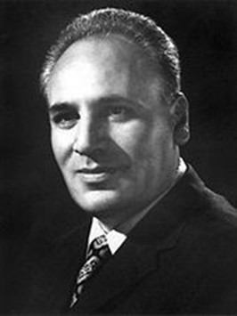
Dr Muhájir

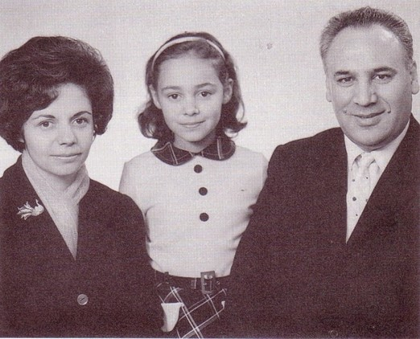
Mrs Iran Muhájir, daughter Gisu, Dr Muhájir

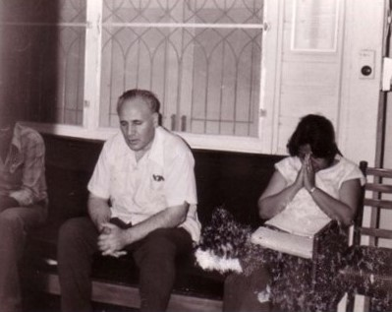
Bahá’í Centre, Lang Suan, Bangkok. Praying. L to R: Elan, Malaysian student pioneer; Dr Muhájir, Chusiri

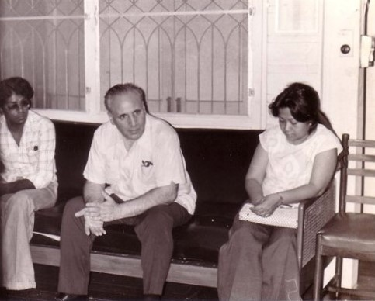
Bahá’í Centre, Lang Suan, Bangkok. L to R: Elan, student pioneer from Malaysia; Dr Muhájir and Chusiri.

“Dr Mohajir appeared after a couple of days[in 1958] and suggested I make trips around Thailand and be a kind of travelling teacher. The Morgans and Caroline would support me. I did make several trips. I went to Chiangmai, Ubol, Korat, Udorn, and Songkhla.”[]

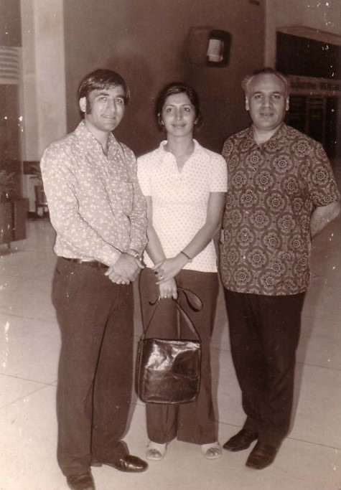
Don Muang Airport, Bangkok. L to R: Faridian, Camelia[], Dr Muhájir.

Iran Furútan Muhájir’s memories of Dr Muhájir

“On our way to the Mentawai Islands in 1954, we had stopped in Bangkok for a day and a night. In the ensuing years Raḥmat visited Thailand numerous times, yet he considered his real work there to have begun in 1973. The friends in Bangkok had been resistant to mass teaching for many years, and insisted on having a strong administrative base in Bangkok before contemplating bringing masses into the Faith.” Raḥmat wrote in his notes “I stayed in Thailand for two nights. I met the friends but it was not very useful. One of them said that they did not need a new plan but needed first to solve their problems. I left them to themselves at 10.30 p.m.”

Raḥmat encouraged the Iranian pioneers to leave Bangkok and settle in the interior, so that they could start teaching the refugees who had fled from the Vietnam War into Thailand. Kamal and Camelia Ma’ani, Naser and Maliheh Jafari answered his call and left Bangkok. Teaching among the refugees dovetailed into teaching the native people of Thailand.

Kamal had a motorcycle which he used for his travel teaching. Raḥmat would ride with him, and they would trek the dusty and potholed roads of Thailand to meet the Bahá’ís and teach in the Villages.

Mr and Mrs Jafari lived in Songkhla, 1,400 kilometres from Bangkok. Whenever Raḥmat visited Thailand it was for the sole purpose of seeing them. Their daughter (son) whom Raḥmat had named Carmel was two and half years old. Maliheh recalls that Naser had taught Carmel to address Raḥmat as Amo Ayadi – Uncle Hand of the Cause – which made Raḥmat very happy Maliheh Jafari remembers:

He stayed with us in our humble dwelling, for three days and three nights. Many friends came to the Feast and he was delighted with them. One day he showed us Gisu’s picture and said “I am not a good father. I left when she was Carmel’s height. Now look at her. And I am still away” The day he was leaving he asked us to sit with him and said “I want to tell you a little about children. Maliheh, you are alright, you are relaxed. Naser, you are too rough with your son. You should look at children as if they are tender flowers. If you are harsh with them they will wilt and spoil. You have to be very gentle. Whenever you forget this put your big hand against his tiny one and remember my words. Write on a big piece of paper Amu Ayadi and hang it on the wall. Anytime you are cross with him look at it and remember my words.” His frequent visits to Thailand were the consolation of our hearts at a time when our institutions were in their infancy. Anyone who heard he was in town would rush to his hotel. He would graciously invite everyone to his room and kindly and softly talk to the adults and give sweets to the children. At one time he would lead us on a teaching excursion to Lumpini Park and at another he would let us gather around him, and listen to our complaints and problems.

Once we had a teaching conference in a rose garden, at which Dr Muhájir arrived unannounced. The joy of the friends was unimaginable. On the way to the airport, passing through heavy traffic, in the hot, humid and suffocating, we had a glimpse of what he went through every time he visited us. At the airport, even if there was only a little time, he would take the friends to the coffee shop. There he would clear his briefcase, getting ready for the next stop.

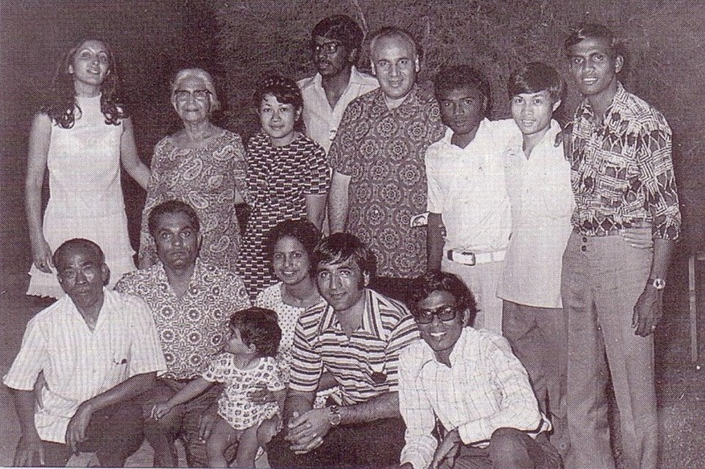
Rose Garden, Bangkok. Teaching Conference. Standing: L-R: Camelia, Shirin[], Chusiri, Elan, Dr Muhájir, Mr Govindan Gurusamy, Mr Noi, Kalai[]. Seated: L-R: Ajan Prasat, Mr Jai Gopal Jand, Mrs Savita & Mike Jand seated on her lap, Mr Faridian, Yoga[].

The post–Hong Kong conference, held in Port Dickson, Malaysia, in 1977 was another occasion for us to be with him. We travelled by train and car and were 54 hours on the way. I was pregnant with our second child. Three Hands of the Cause , Dr Muhájir, Mr Faizi and Mr Featherstone attended the conference. At recess, Malaysian friends gathered around them and I could not get through. As Dr Muhájir was passing through the crowed he saw me and invited me to his hotel to have lunch with him and Firaydun. We went to his room and he ordered lunch. He was unhappy with the way the conference was going. He expected so much more. His vision was always higher and vaster than the rest of us. He was going to meet with the Board members after lunch to discuss adding more goals.

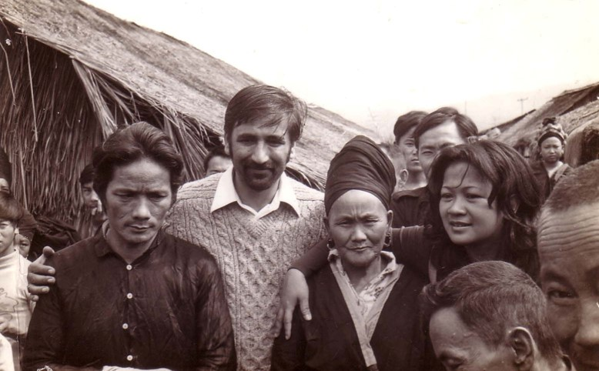
Mr Faridian & Chusiri with refugees from Laos.

He knew I was sharing a room with a few friends which had no air conditioning. After lunch he said. Smiling, “God loves his pioneers. While I go to the meeting, you stay here and rest. Enjoy the cool air and the privacy.”

On later trips Raḥmat would only stay in Bangkok for a few hours, then leave for the interior to spend time with the pioneers. Camelia Ma’ani remembers that on one occasion they heard he had arrived in Bangkok.

It was the Declaration of the Báb and we had planned celebration with our local Bahá’ís. The National Assembly also had arranged a lavish feast in Bangkok and we were certain that there was no way that we could have the Hand of the Cause with us. However, we sent an invitation to him. On the day of our celebration Dr Muhájir arrived. He stayed with us for two days, spent time with giving gifts to our children and chanted prayers for us before leaving. It was the last time we saw him.

His last trip to Thailand was in August 1978. The Jafari family had moved to Chiangmai, on the border with Laos. Raḥmat went there intending to stay for one night, but remained for four. During those days he visited some villages and gave a talk in the university. Maliheh writes, “…when he was leaving, my sadness was reflected in my face. He smiled and said, ‘Maliheh Khanum, don’t worry. You are a good girl, God loves you. He went to the airport, but came back, as there was no room on the plane. He said, ‘I don’t get to stay in my own home for four nights, but I stayed with you for four nights.’ ”

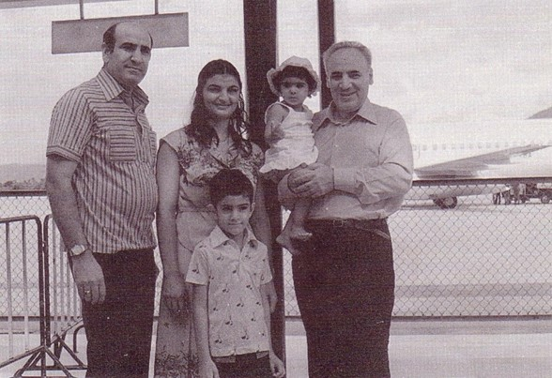
The Jafari family: Nasser, Maliheh, Carmel &
Golibang with Dr Muhájir.

That evening he shared some of the writings with us. One passage was about tests, and how everything was a test for everything else. He said, ‘at first when I read this passage whatever someone did to me. I said to myself, never mind he is a test for you. Later I realized that I was a test to others also. I am a bigger test as I am a Hand of the Cause. For everything I do people say, “Look, a Hand of the Cause did that” I am a test for them.

He left for Bangkok and we followed him. He met with the National Teaching Committee and advised them to interview the friends to see how they wanted to serve the Faith. When the committee members came out of the room, Dr Muhájir had left for the airport.

In his diary, Raḥmat noted, “On 1 August I went to Chiangmai and stayed for three days. I spoke in the university and the teacher-training college. They were both wonderful meetings. In Bangkok I met the National Spiritual Assembly and the Counsellors and discussed the teaching work. We formulated teaching plans for North, South and South-East Thailand. Vic Samaniego stayed on to help them with these plans. In Ching Mai I had a dream that I was in Rangoon and a Bahá’í teacher gave me a large amount of money and asked me to establish three mass teaching zones. After Thailand I went to Burma and after consultation with the National Assembly we made a few teaching programs. With the confirmation of Bahá’u’lláh they will pursue those plans.”[]

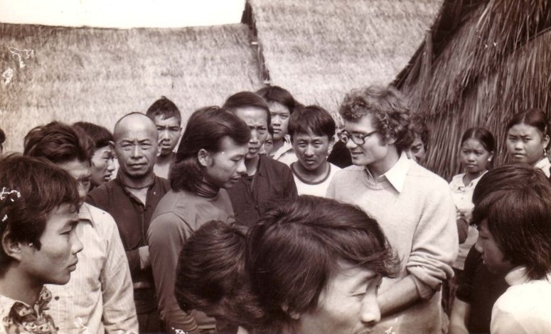
Vaughan Smith among Lao Hmong Bahá'í refugees.

Vicente Samaniego’s Recollections

“When you mentioned the beloved Hand Dr Muhájir, it made me miss him very much. He was truly a father to us all and pushed us into the field of sacrificial service. He continued to encourage each of us till the very end of his life. It is a great service that you rendered when there were so few in Thailand. Now, there are so many native Thais who are serving the Faith. They are the fruits of the sacrifice of the early pioneers....”[]

Firaydun Mithaq’s Recollections

“Dr Mohajir was a regular visitor to Thailand who usually came to Southeast Asia about once or twice a year and never passed through without meeting the friends and national assembly’s in Thailand and Laos. He constantly encouraged us with his special charm and genuine love which made us to arise to heights of service. He gave us the vision of the future and always supported his idea with the writings of the Faith and stories from ‘Abdu’l-Bahá and the early believers. We took his advice and suggestions seriously and were pleased to formulate them into plans and bring them to victory. He was not only our beloved Hand of the Cause of God, but our teacher, supporter and a loving friend. In him we saw the embodiment of the Bahá’í ideals which one would wish to understand and follow as portrayed in the writings of ‘Abdu’l-Bahá.

Once in the early seventies Dr Muhájir was sitting in the hall of the National Bahá’í centre in Bangkok talking informally to a group of assembled believers among whom were some National Assembly members, Auxiliary Board Members and others. He spoke of the importance of the border teaching project in the south where the Thai and the Malaysian believers were to cooperate in the promotion of the Faith in the South of Thailand. The project was lingering and needed boosting. He spoke of many possibilities that could help the project to gain momentum. Among which was the plan of obtaining a building for a teaching institute in Hatyai which could also serve as the Bahá’í Centre. (I usually did my best to be in Thailand whenever I knew of Dr Muhájir’s coming and spent my time around him until he would depart or I would go to Laos with him.) In that meeting he said we must purchase the building in Hatyai without further delay as prices were on the rise. He looked at me and said, “you do it.” In my mind I considered it done and soon afterward Dr Muhájir left. I consulted on the matter with Mr Faridian who later assumed the new name, Sukhum Abhasakun, and we decided to go down to Hatyai and see what could be done with the small amount of money that was allocated for this purpose. To make the story short we contacted the bank in Hatyai and sought a mortgage arrangement. Fortunately, the Bank had a new building left from the series of apartments which they had developed and put on the market. It was available to us. We looked at the place it was in, an excellent location near a main road in the town. Our money was sufficient to cover the initial necessary capital. We had the general approval of the National Assembly. Thus we made a small down payment and agreed to finalize the contract at a later date after final approval could be obtained from the National Assembly. The building was purchased in the name of the chairman of the Spiritual Assembly of the Bahá’ís of Hatyai[]

Collis Featherston

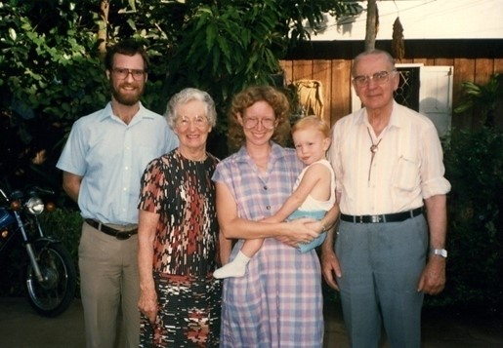
Aranyaprathet, 1990. Inauguration of 1st Bahá'í Centre.
L-R: Tim Schaffter, Mrs Featherstone, Diana & Scott Schaffter, Mr Featherstone.

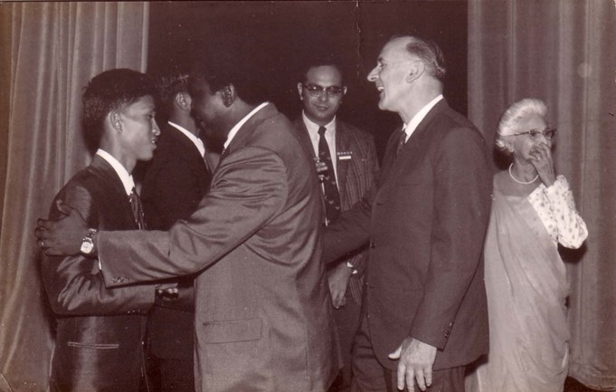
Oceanic Conference of the South China Seas, Singapore, Jan 1971. L-R: Sawai, Enoch Olinga, Chavalit Manjikul, Collis Featherstone, Shirin Fozdar.

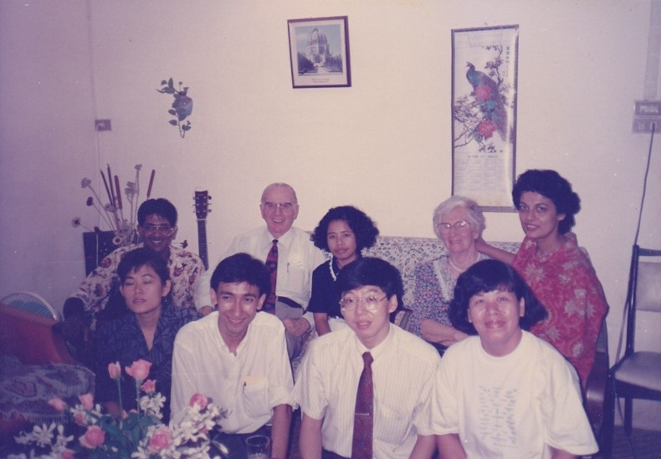
Faridians’ home, 1990.
Back: L-R: Nagen[], Mr Featherstone, Sulee[], Mrs Featherstone, Sammi.
Front: L-R: Somlak[], Badi[], Dr Chairat Saovaprut, Sunantha

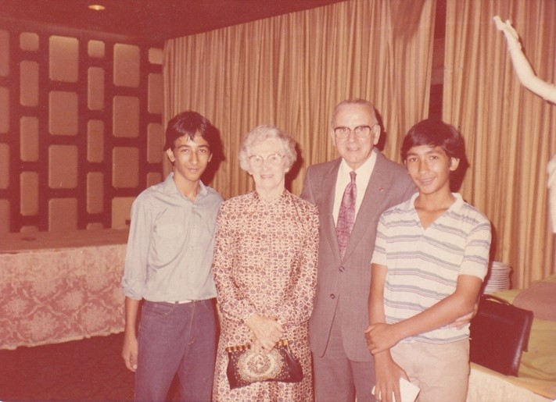
L-R: Mr Roshan Abhasakun, Mrs Madge Featherstone, Mr Collis Featherstone, Badi

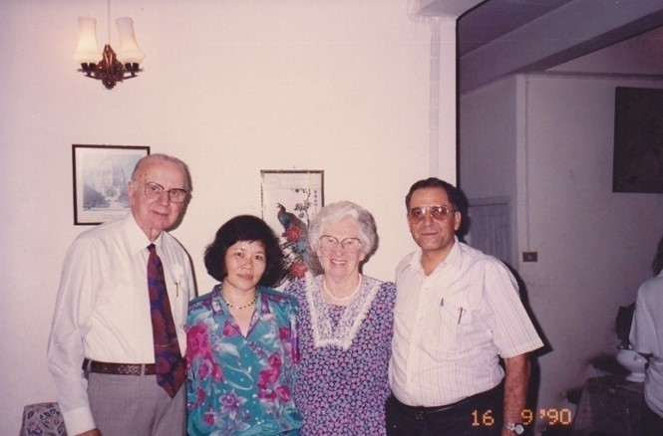
Faridians’ home, Bangkok, 1990. L-R: Mr Collis Featherstone, Mrs Meuangma Yaganegi, Mrs Madge Featherstone, Mr Faiz Yaganegi.

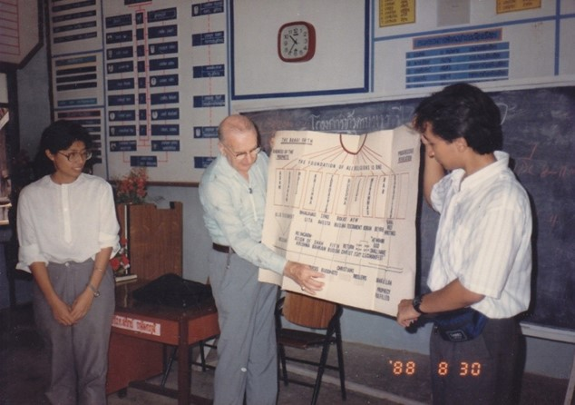
Yasothon, 1988. L-R: Mrs Siriporn Pillay, Mr Collis Featherstone, Badi

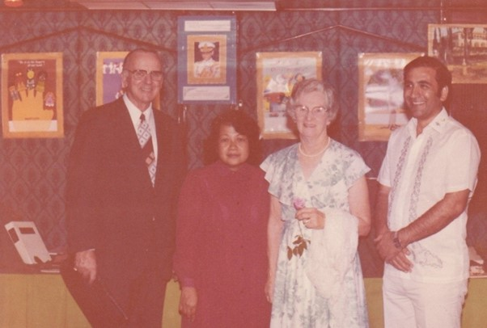
L-R: Mr Collis Featherstone, Chusiri, Mrs Madge Featherstone, Mr Fazlollah Faridian.

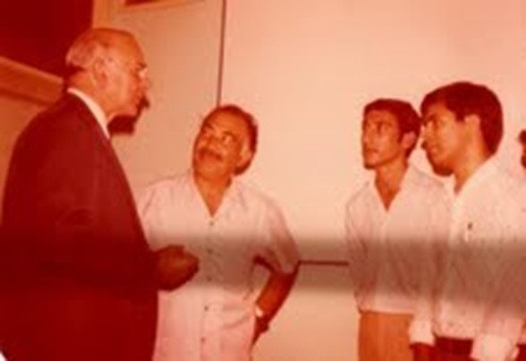
Bahá'í Centre, Lang Suan Rd, Bangkok. L-R: Collis Featherstone, Yazdanpoor, Sohrab Moattar, Firouz Anaraki

Contribution of the members of the Continental Board of Counsellors in Asia to Thailand

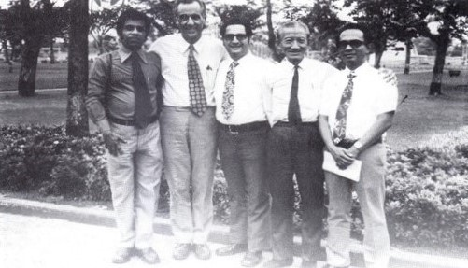
Manila, 1973: Meeting of Continental Board of Counsellors
for SE Asia. L-R: Chellie[], Payman[],
Firaydun, Yankee Leong, Vic

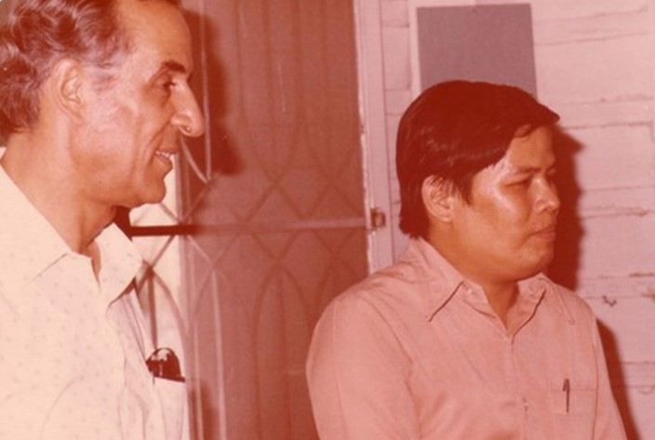
Bangkok Bahá'í Centre.
L-R: Counsellor Payman, Maha Boonsong[]

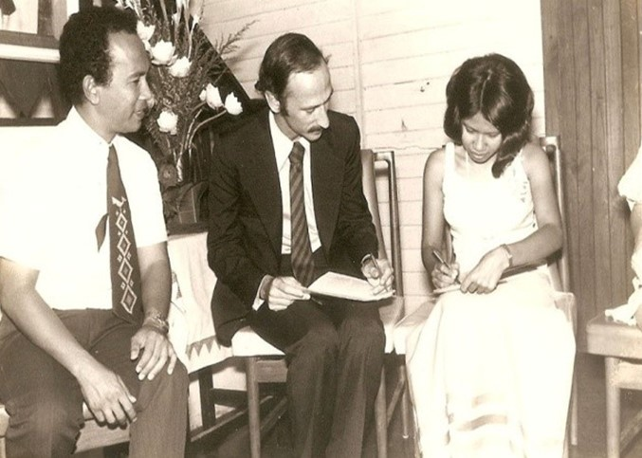
Bangkok Bahá'í Centre, June 7, 1975. Wedding of
Montha & Victor Greenspoon. Counsellor Vic on left.

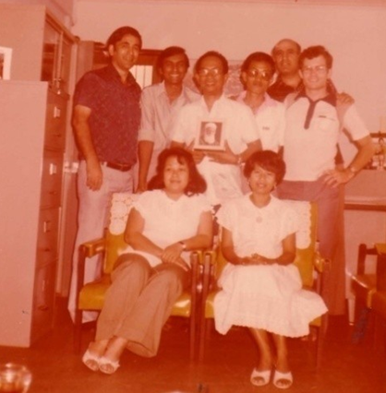
Bangkok Bahá'í Centre. ABMs meeting with Counsellor
Standing L-R: Faridian, Kanna, Vic, Sawai, Nasser, Vaughan.
Seated L-R: Chusiri, Montha.

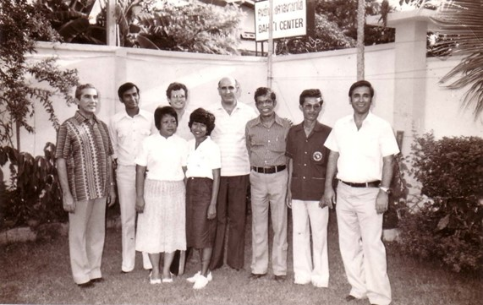
Bahá’í Centre, Bangkok. ABMs with Counsellors.
L-R: John Fozdar, Kanna, Chusiri, Vaughan, Montha, Nasser, Chellie, Sawai, Sukhum.

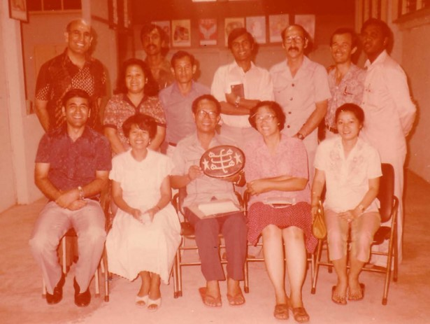
Bangkok Bahá’í Centre. Counsellor, ABMs & NSA members.
Standing L-R: Nasser, Chusiri, Jaya[], Boonkong[], Kanna, Victor, Mr Mark Starrs, Kalai. Seated L-R: Mr Sukhum Abhasakun, Mrs Montha Greenspoon, Mr Vicente Samaniego, Ms Thaworn Pirakittikun, Laddawan.

Yankee Leong and South Thailand Border Teaching

“From Alor Star it was less than a hundred miles to South Thailand, and it was the most natural thing for Uncle Leong to look across the Border to see how help could be rendered to our neighbour. Hand of the Cause Dr Muhájir was the guiding hand behind a plan for inter-country co-operation, and soon a south Thailand border committee was formed with Uncle Leong in the forefront, leading the friends of Alor Star to new horizon in Songkhla.[]

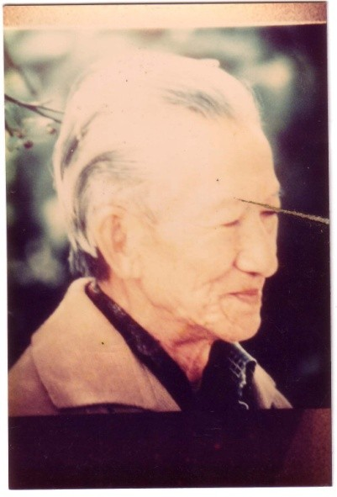 | 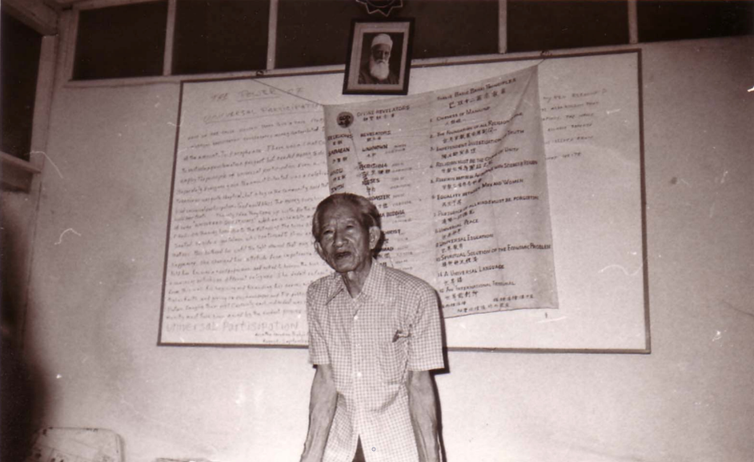
Counsellor Yankee Leong

“…I love Thailand and the opportunity of visiting all Bahá’í friends. Bahá’u’lláh has to be sincerely thanked for having showered His Bounteous Blessings and Guidance to assist Thailand Bahá’ís to accomplish the goals. Visiting Bahá’ís will instantly recognize Thailand’s tremendous advancement, and the spiritual growth. Local Bahá’ís may not realize this fact…The pioneers were also thanked. Without their endeavours and sacrifices many of the Bahá’í communities would not exist now.”[]

Counsellor Mr Yan Kee Leong travelled extensively in Thailand, Visiting Bahá’í Communities in deferent parts of Thailand. Sometimes he went from house to house visiting Bahá’í friends and their families. He had a teaching program focused on Administrative Institution’s, Progressive Revelation and a chart on the Guardian’s illustrations of clan, family, tribe, City-State, Country and the world. In his teaching he explain that the Bahá’í religion stresses one God, one religion and one humanity and our purpose is to work for love, unity, peace and justice. Today, Bahá’ís all over the world are traveling to convey to every corner of the world the message of Bahá’u’lláh which is the only remedy for this age.[]

“I[Mr Yankee Leong] was fortunate in Thailand to be able to have firesides and deepening sessions in Yasothon, Bangkok and Chiangmai and also to visit many other places where enquirers declared their faith in Bahá’u’lláh. I had visited one of these villages some two years ago and at that time half of the village became Bahá’í. During this visit all the residents were found at home and the entire village accepted the Faith.

“At another mountain village which was half a day’s walk distant we found a Thai chief who had taught himself to read and write Thai. The village also understood the northern Thai dialect so our translator was able to explain very clearly what the Bahá’í message was and the entire village also became Bahá’í. The women were very amused when I give each man an embrace of welcome.”[]

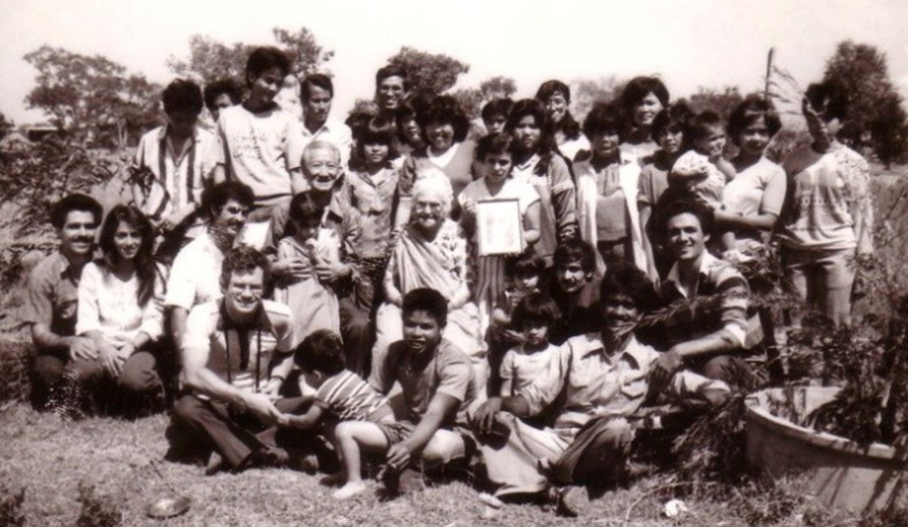
Yasothon. Yankee Leong & Shirin Fozdar with friends, including Ahdi, Boonkong, Sawai & Pensri, Foad Faridian, Nagen, Siriporn & Jan Pillay, Vaughan & Thep Smith, Mong Leng & Farzad,

“Yan Kee Leong first heard of the Faith from Mrs Shirin Fozdar and became a Bahá'í on December 19, 1953. He was the first Bahá'í in Malaya, (now known as Western Malaysia) and he took the Faith to countless numbers of his fellow Malaysians, including some of the indigenous tribes of that country. In 1968 the Universal House of Justice appointed him to the Continental Board of Counsellors for Southeast Asia. He was the first Counsellor of Chinese ancestry and he remained on that institution until his death in 1985.”[]

Yan Kee Leong Teaching Trips in Thailand

“Bahá’ís accompanied Mr Chavalit and myself to the Railway station[in Bangkok], and we left for Chinghai at 3 am. The cost of the fare was 75 Baht each. The distance is well over 800 kilometres. On arriving in Chiangmai, we tried to trace pioneer Miss Carmen, but failed. We then took accommodation in a hotel. Only on the next day were we able to locate Miss Carmen. Afterward we referred to the reference-list of Mark Dorothy to locate the other Bahá’ís. The record showed 100 in town and another 300 in the neighbouring village.

We were fortune enough to meet three of the outstanding Bahá’ís, Mr Suring Suthachi was attached as Superintendent of the Education Department. Recently he had obtained a Government scholarship to study in America for a period of 8 months. On his return he would be promoted to a higher rank. The NSA Secretary had written to Mark Dorothy in America to contact the above, and deepen him. So that on his return, he would be able to serve the Cause more actively”

“We further made plans to visit tribes to teach the Faith, so we hired a minivan, so that Miss Carmen, Mr Chavalit, Mr Insurvan, Mr Chalom Dong and myself[Mr Yankee Leong] could all travel together.”

“On reaching the first village, the chief not knowing us felt very suspicious. We were total strangers to them. It so happened that the son of the village-chief, Suephang Saegam, was a student of the same school where Mr Insuravan was teaching. So Mr Insurvan spoke to the boy, and he in turn translated what was being said to his father in the Mew Language. After explanation the chief became very friendly, and was prepared to listen to what we had to say. We told the chief, that we all were Bahá’ís, we spoke of the world religion and the prophet Bahá’u’lláh, we also introduced ourselves as Miss Carmen from the Philippines, Mr Insurvan from Thailand, Mr Chavalit from India and myself[Mr Yangkee Leong] from Malaysia. We explained to them that the Bahá’í religion stressed one God, one religion and one humanity and our purpose is to work for love, unity, peace and justice. I said that whichever village, town or country accepted the teachings of Bahá’u’lláh, the people had to foster love, peace and harmony. It was only in places where the great message was not accepted that animosity, and fighting prevailed. Today, Bahá’ís all over the world are travelling to every corner of the world proclaiming the message of Bahá’u’lláh which is the only remedy for this age. After the explanation, we told him that we wished to welcome him into our fold and asked him whether he was prepared to accept us[as] his brothers. The chief replied that he and his tribe will gladly accept Bahá’u’lláh. We then hugged and kissed them and offered Prayers for the blessing of this village. We also taught them to say Alláh-u-Abhá as a greeting. This village, comprising about 300 people, sent the son of the chief to accompany us to the next village, where there were 75 residents, and to another village where[there were] only 12 natives. In the last mountainous village the sister of Master Suephang Saegam was married to one of the residents. This mountain is known as Doypoi. On our return, I instructed Miss Carmen to visit this boy when opportunity permitted, and also to send photographs of the Greatest Name, and ‘Abdu’l-Bahá and other materials which might[be] required by the mountain Tribes we had visited. Miss Carmen had agreed to visit them again in two months time.”

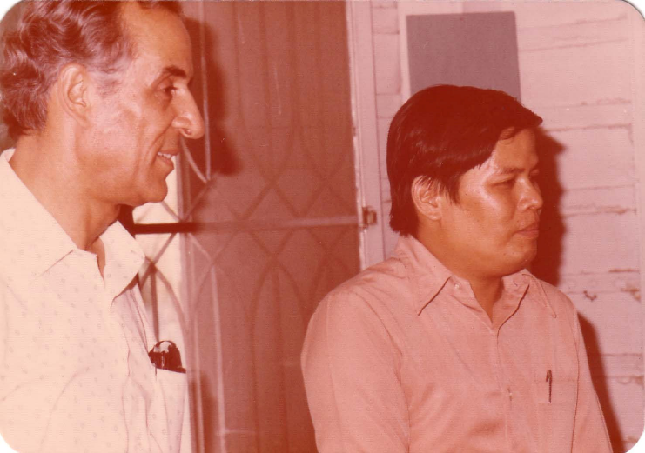
Bangkok Bahá'í Centre. Counsellor Payman & Maha Boonsong

Songkhla

“… Mr Nagaratnam, on behalf of the Border Committee gave a brief history of the development of the Faith in South Thailand recalling the part played by various Bahá’ís through the years. Mention was made of Banu Hassan. And also another early American Pioneer Charles Duncan. These friends sowed the first seeds of the Faith in South Thailand. Then later Hushang[Hushang Shayegh] came from Iran. He lived and worked with the local people having got a job as an English teacher in the Klubpet Suksa, a high school there. The first results began to show during this period, when the Headmaster, Mr Sammnuan Ngamsook, became a Bahá’í. Hushang established contact with the Alor Star community across the border, and a new era began when Malaysia started extension teaching in South Thailand.”

Songkla Summer School

“When the first exciting rumour trickled through the Thai-Malaysian border that this year’s Summer School may be held in Songkhla, the general reaction was “How wonderful, but can it be done? But the problems appeared so numerous, But the Thai-Malaysian Border committee, from whom the idea had sprung, went full speed ahead and got the approval of the National Spiritual Assemblies of both countries for this ambitious project.

By the 11th of August 1967, small groups in cars, taxis, buses and trains, began the short but troublesome journey across the border. Everyone had to present himself and his papers first at the Malaysian immigration, then the Malaysian Customs, then across no man’s land to the Thai immigration, the Thai customs and an additional police check post, For carefree Malaysian Bahá’ís, many of whom were accustomed to hitching a ride at the last minute to a Summer School in port Dickson or Malacca, this procedure involved that much pre-planning that it was a miracle how so many managed it! But when Summer School opened in Songkhla there they were – almost a hundred familiar faces of friends from every state of Malaysia, and a sprinkling of pioneers from abroad. Notably Firaydun from Laos and Harlan Lang and his wife Kim Lim with their infant son, Victor, from Marshall Islands. From Bangkok came Mrs Shirin Fozdar, chairman of the Thai National Spiritual Assembly, Miss April Edwards and Maha Boonsong, while the rest of the members were from South Thailand.

School with a difference

The venue chosen was the Hilton-style hotel the “Samila” situated on a picturesque stretch of coastline facing the South China Sea. Careful planning by the enthusiastic Border Committee resulted in a very comfortable situation. The elegant hall of the Samila was booked for all the meetings, and most guests were accommodated in this air-conditioned hotel with a private swimming pool which was made full use of by the friends. This was a Summer School with a difference in more ways than one! Bahá’ís accustomed to associating Summer Schools with Spartan youth camp facilities, now enjoyed these different conditions, which lent an added prestige to the Bahá’í name in a foreign country, (Everyone of course paid their own expenses).

On the evening before Summer School began, a meeting was held at the Town hall attended by a large number of Thai students eager to hear more about this new Faith that was constantly coming to their notice. Shantha Sundram, Fiyaydun Missaghian and Harlan Lang spoke briefly, after which many question were asked, especially with regard to the existence of God and the comparison of Buddhist teaching to other faiths.

Official Opening

Next morning, Summer School was officially opened by the Mayor of Songkhla who joined the Bahá’ís for breakfast at the Samila. The Mayor was very cordial, and said that from what he had heard of the teachings, it was certainly a wonderful Faith. He hoped that the Bahá’ís themselves would follow their religion strictly, for them the world would surely be a better place… (Food for thought). He then extended to the visitors from Malaysia and abroad, a very big Thai welcome to the city of Songkhla. As he concluded, the Bahá’ís started singing a new theme song which had been especially composed in Penang for proclamation. It was sung both in Malay and English and its catchy tune and words were quickly picked up by everybody who joined in heartily. The delighted Mayor was then given three cheers by the Bahá’ís and left in a very happy mood.

Programme Highlights

The school sessions began with Mr Tony Fernandez as principal, paying a tribute to the Spiritual Assembly of Songkhla and Haadyai and Thai-Malaysian Border Committee whose dedicated efforts had made this two – nation summer school possible. The programme, which had undergone a series of last minute changes, finally emerged to suit the needs of the very new Thai believers. Talks were given on the central figures of the Faith, with Lily Chinnial speaking dramatically on the Báb, Yankee Leong, with much fire, on Bahá’u’lláh, and Shirin Fozdar very movingly on ‘Abdu’l-Bahá. Dr Sundram give a brief talk on simple Bahá’í administration and procedure, ending up with the establishment of the new Bahá’í Information Services called for by the National Spiritual Assembly of Malaysia, There was a suggestion that perhaps Songkhla could develop into the Information Centre for all of southern Thailand.

How it should be done

The afternoon was devoted to a mock Nineteen Day Feast conducted by Mrs Betty Fernandez. Spiritual readings were selected with emphasis on teaching and Proclamation. The secretary’s report prepared by Bhaskaran, mentioned a few items of activity and a long list of jobs still undone! The youth report given by Ganesan was quite encouraging, reflecting the trend in some communities, while the Treasure’s report presented by Inbum Chinniah, cleverly contained a touching appeal for funds. “Suggestions from the community” were very appropriately directed to the border committee. It was a model 19 Day Feast from which every – one absorbed something.

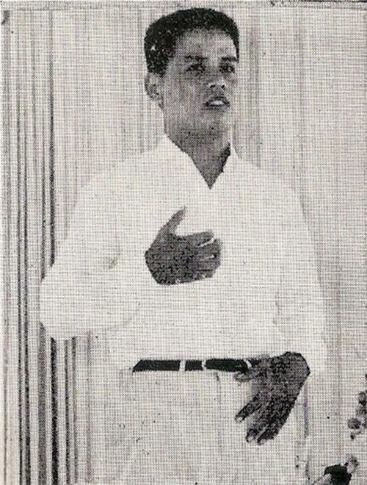
Maha Boonsong at Summer School

The Enlightened Priest

A highlight of the Summer school was the story of the first monk to become a Bahá’í this was told by Mrs Shirin Fozdar who proudly presented Maha Boonsong to the friends, and related the interesting steps which had led to his giving up the orthodox robes of a priest, and accepting the modern mantle of an active believer. She explained how this learned Buddhist monk, who had a degree in philosophy and a wide knowledge of comparative religions, had first come in contact with the Faith through Bahá’í travellers in Bangkok who had stayed in his monastery as guests, and talked to him of Bahá’u’lláh’s message. Maha Boonsong sought permission from his own Abbot for this job, but it was refused, possibly because the temple authorities did not want such close association with Bahá’ís, whose activities they were slowly becoming aware of. By now Maha Boon Song had understood enough of the Faith to realize that he would have to give up his priesthood if he was to be a follower of the returned Buddha. This was not an easy decision to make, as he had been a monk for fourteen years, having entered the monastery at the young impressionable age of thirteen. He prayed earnestly for guidance, and then took the bold step that has now earned him a place in the Bahá’í History of Thailand.

Priest to Layman

Thrilled by this story, the friends present asked Maha Boonsong to say a few words. He stood up with great diffidence, but once started, held his listener’s attention to the last word (The term “Maha” is a title conferred upon a priest when he has attained a certain scholastic level and corresponds to “Reverend”).

He spoke in English and translated his own talk rapidly into Thai as he went along, so that everyone could follow. He explained how his greatest difficulty had been to understand the ‘’God Theory’’ Of the Bahá’ís. The Buddhists of the Hinayana sect who dominate Thailand apparently do not believe in the existence of God such as we know Him, this one factor is normally a big stumbling block for most Buddhists, that very few get over it to extend their search. Maha Boon Song however was finally convinced that the ‘’First Cause” referred to in Buddhist theology, corresponds to this same all-knowing Almighty One. He confirmed his talk with thoughts on meditation, lust and ego, explained how difficult had been transition from priest to layman. His life had been such a sheltered one without all the mundane problems of finding his own food and lodging. In Thailand a priest was held in very high esteem by the laymen, but Boon Song declared with a smile, that it should really be the other way round, as the problems and temptation which the man in the street had to overcome were so tremendous, while the priest was protected from all this in his monastery. He touched on the spiritual teaching of Bahá’u’lláh and compared them with the teaching of Buddha, displaying a very deep understanding of the Bahá’í Writings.”

Other Sessions

Other sessions during the two day Summer School, included a talk on the “Role of women,” given by Lilly Ng who has done considerable work in the estates of Malaysia bringing more women into the forefront, Shirin Fozdar spoke on “God, Prophet and religion” in her usual brilliant manner. A panel was also arranged, with April Edwards, Harlan Lang and Shirin Fozdar, who were kept on their toes answering all types of questions from new and old Bahá’ís.

Cultural Evening

The young Community of Songkhla and Haadyai had gone to very great pains to arrange a special cultural programme for their first Summer School. Three teachers Miss Chamroonlak, Miss Salee and Miss Montana had between them trained the talented young pupils of their school in some Thai dances, which were done in colourful costumes to the beat of rhythmic drums and vocal music. The young performers were applauded by a very appreciative audience.

After the cultural dance ended, the drums still continued to beat their magic rhythm, and everyone was invited on the floor to do the Ramvong. Headmaster, teachers, pupils and visitors, all joined in. Soon the Thais were requesting that the visitors perform their dances. With a slight change of beat and a different tune, the Malaysian Rongteng took the place of the Siamese Ramvong. This mixed programme continued until late at night, with those who were not dancing keeping time, clapping hands or tapping feet. Music and song, and the merry laughter which filled the hall attracted the non – Bahá’í residents of the hotel. It was difficult for them to believe that the participants were members of a religious group who had come to Songkhla with a spiritual purpose! Haadyai is in fact well-known throughout Southeast Asia for its shady night clubs and dance halls which attract patrons from far and wide. It was thus a matter of great pride and amusement to the Bahá’ís that here was a group of people both young and old, who could enjoy themselves heartily, outside of the accepted way of entertainment in these parts…

Toward the end of the evening, April Edwards was invited to sing. The friends were so thrilled by her beautiful rendering of Bahá’í songs which were quite new to them, that she was not allowed to stop until every song was recorded on tape.

Increasing Tribute to Workers

Mr Nagaratnam also paid a glowing tribute to Mr Sammnuan who had been responsible for the greater part of the elaborate arrangements at the Samila Hotel, the Town Hall meeting, and the cultural programme. He also recorded appreciation of the efforts of committee members, Mr Kam Pan yong of Thailand. Mr Phung Woon Khing of Malaysia, and of course Auxiliary Board Member, Mr Leong Tai Chee.

Mr Sammnuan replied briefly and conveyed the thanks of South Thailand to the friends from the border, who had come with such spirit that the Thais have all been aroused to activity. He said it would take a little while for the Thais to understand the great significance of the Faith, but when they did, they would surly respond whole heartedly…”

Progress Report

The following day Mr Nagaratnam, on behalf of the Border Committee gave a brief history of the development of the Faith in South Thailand recalling the part played by various Bahá’ís through pit the years. Mention was made of Banu Hassan. And also another early American Pioneer Charles Duncan, These friends sowed the first seeds of the Faith in South Thailand. Then later Hushang[Hushang Shayegh] came from Iran and lived and worked with the local people having got a job as an English teacher in the Klubpet Suksa, a high school there. The first results began to show during this period, when the Head master, Mr Sammnuan Ngamsook became a Bahá’í. Hushang established contact with the Alor Star community across the border, and a new era began when Malaysia started extension teaching in South Thailand.

Letter from Universal House of Justice

“The devoted services of Mr Hushang Shayegh are greatly appreciated and we hope that he will soon return from his visit to Iran”[]
The Universal House of Justice

Inspector Rogers Samy Choong, an active Bahá’í of Perak was transferred to Songkhla on a police posting and helped a great deal. Then Dr Muhájir came into the picture. The pace quickened. He saw the future possibilities as Malaysians poured over the border with their contagious enthusiasm. A conference was arranged and a high powered Thai Malaysian Border Committee was formed with Auxiliary Board Member, Leong Tai Chee made responsible for the teaching programme.

Extension trips became more frequent, meetings more regular, prayer and patience began to show results. Declarations slowly tricked in, and at Riḍván the Local Spiritual Assembly of Songkhla was formed with Mr Sammnuan as the Chairman.

The first stage was over, and now with Mr Sabapathy presence a new era was beginning with the wheels of administration slowly being turned. (Sabapathy of Negri Sembilan had volunteered as pioneers to Laos, but had been detained temporarily in South Thailand.) Mr Nagaratnam paid a very big tribute to him for showing by example what was meant by the term “Bahá’í”. Saba had earned the respect and love of all the staff and the students of the Klubpet Suksa School where he was temporarily teaching. Regular deepening classes were being held and numbers were steadily that the close ties of Bahá’í love and unity which had been established between the two countries would be strengthened by a continuous exchange of visit…”

“… Nasser Jafari returned to Thailand with a beautiful wife from Iran and they have established a home in Songkhla which had once again become a lively centre. Nagaratnam and Ganesan from Alor Star, Kanniyah from Kemaman, East Coast of Malaysia, Faridian from Thailand and myself had a wonderful get-together with Nasser and Maliheh. We worked as a team for three days during which there were fifty-nine declarations in three new localities.

It has been great to serve Bahá’u’lláh in Thailand in spite of all our immigration problems, and we now look forward to India as our next most likely pioneering post.[]

Border Teaching Committee of South Thailand

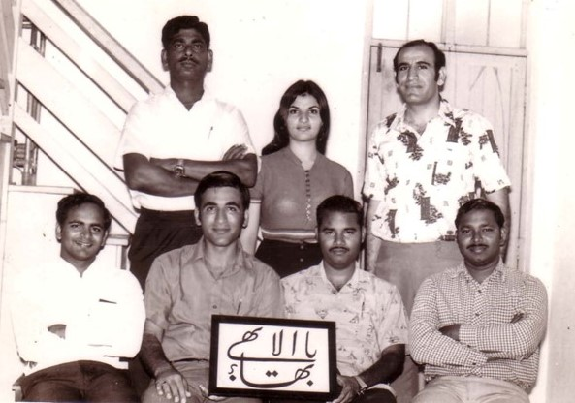
Standing: L-R: Nagaratnam, Maliheh, Nasser.
Seated: L-R: Mr Ganesan, Mr Faridian, Mr Kanniyah, Mr Sabapathy.

Aranyaprathet and Refugee Camps

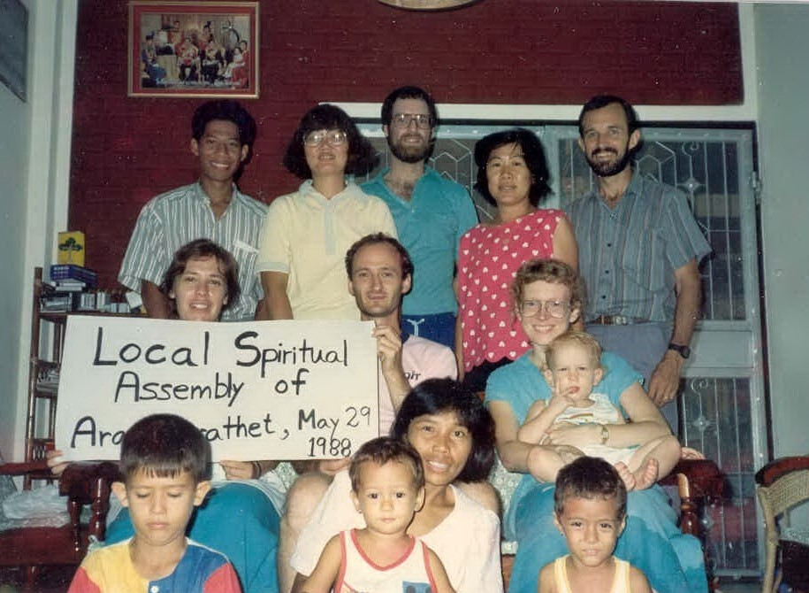
First Local Spiritual Assembly of Aranyaprathet (1992)
Back: L-R: Nawarat[], Sunapa, Tim Schaffter, Nida Starrs, Mark Starrs.
Middle: L-R: Barbara Swenson, David[], Diana & Scott Schaffter.
Bottom: L-R: Panu Starrs; Andrew, Lek[] & James Lyon.

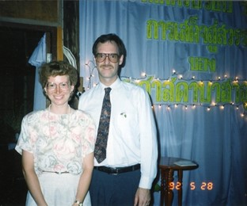
Diana & Tim Schaffter (1992)

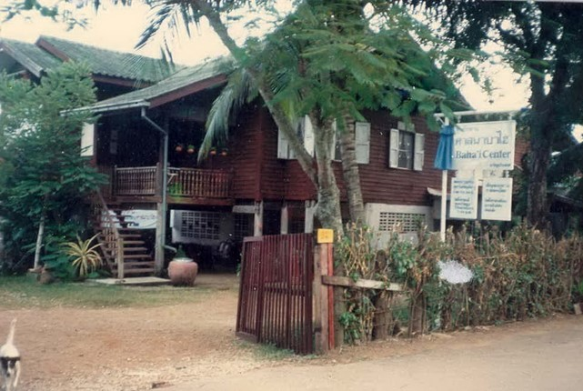
First Bahá’í Centre of Aranyaprathet
Inaugurated by Collis Featherstone (~1990)

Around 1990 Mrs Shirin Fozdar came to meet Princess Maha Chakri Sirindhorn who visited Aranyaprathet.

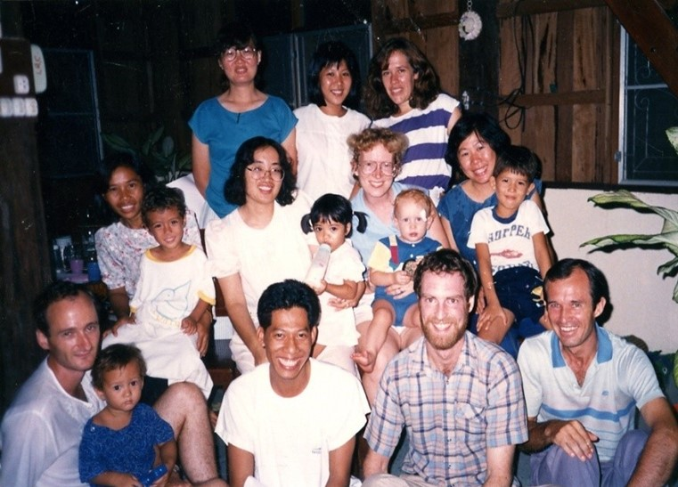
Pioneers of Aranyaprathet, Prachinburi, 1987
Back L-R: Sunapa, Sow Fun Wong, Barbara Goodwin (née Swenson).
Middle: L-R: Lek & James Lyon, Naiyana: (Nai) & Nicha Wongsopa, Diana & Scott Schaffter, Nida & Panu Starrs.
Front. L-R: David & Andrew Lyon, Nawarat, Tim Schaffter, Mark Starrs

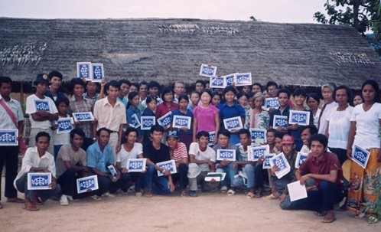
Baha'i Community in Dang Ruk Camp, Site 2 North, Thai-Cambodian Border, Sakaew Province: 1988: The Chinese/Vietnamese who returned to Site 2 from Khao-i-Dang taught the Faith to people in the Dang Ruk Camp. A few of the Baha'is from Khao-i-Dang are in this picture also.

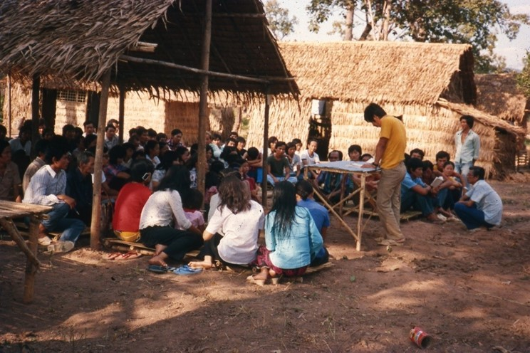
Vietnamese "Platform" Refugee Camp, Site 2 South, Thai-Cambodian Border, Sakaew Province: 1988: A large number of Chinese/Vietnamese Baha'is moved from Khao-I-Dang camp to Site 2. When the families were given bamboo to build their houses, each family donated some bamboo to build the Baha'i centre, under construction in the picture. The picture is of a Nineteen Day Feast.

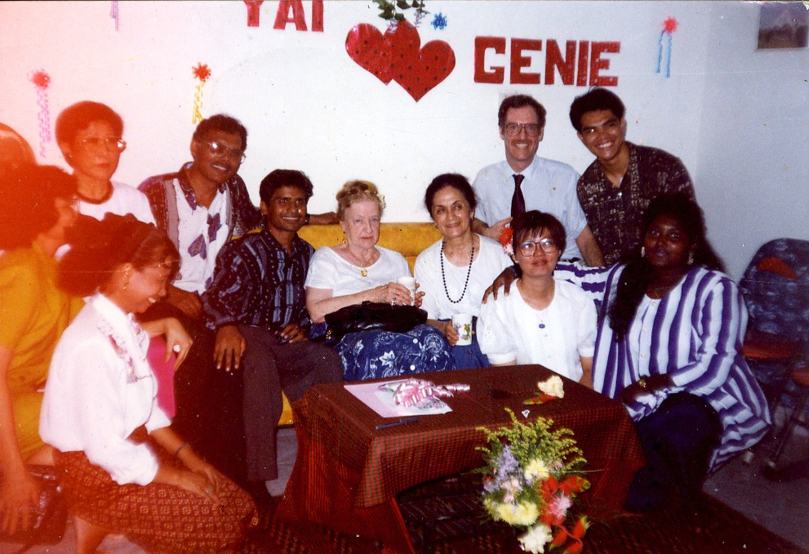
Duplicate: Move above one?
Bahá'í Centre, Phnom Penh, Cambodia, 1994: Rúḥíyyih Khánum witnessing Sunapa (Yai) Dechatattanon & Giovanie (Ginnie) de Leon’s wedding after election of 1st National Spiritual Assembly.

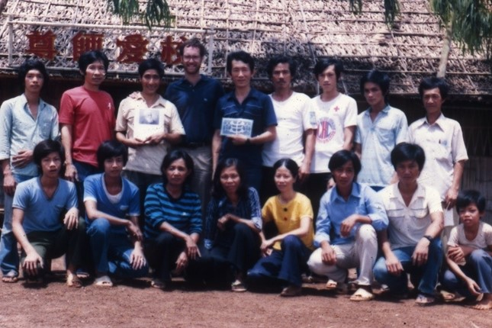
Chinese School, Khao-I-Dang Refugee Camp, Aranyaprathet, 1988.
All teachers became Bahá’ís. Tim Schaffter standing 4th from left

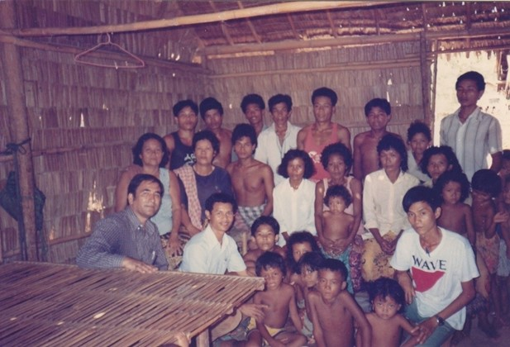
Cambodian refugee camp, Aranyaprathet.
Mr Faridian 1st on left.

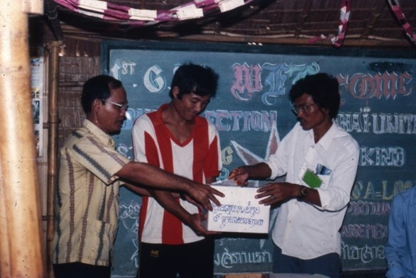
Khao-i-Dang refugee camp, Aranyaprathet. Bahá'í election.

Bahá’í Centre, Site 2 South Refugee Camp, 1991, Aranyaprathat

Ranong

First Local Spiritual Assembly of Ranong

“I am happy to inform you that another goal of the Universal House of Justice, Ranong province, has now been opened to the Faith with 4 declarations. They are as following:

- Mr Tulakom Yurak, a clerk in the Ranong Post office accepted the Faith as the first Bahá’í in Ranong.
- Mr Boonnak Wishidwong, working as the guard of the technical college.
- Mrs Nunwang Tensue, a nurse.
- Mr Sopon Tongsuban, a fisherman

All of these believers showed much interest to help in teaching the faith...”[]

The Local Spiritual Assembly of the Bahá’ís of Ranong was formed on November 8th, 1983.

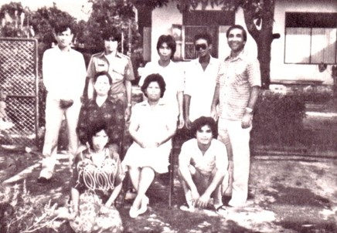
LSA of Ranong, November 8th 1983.
Mr Faridian standing on the right

Letter of National Spiritual Assembly to Counsellor Payman

“As you may know by now, an LSA in the town of the Ranong has been formed, in large part due to the devoted effort of ABM Faridian. Two travel teachers are still there and will shortly form a second Assembly in a village about 20 KMs, from the town. In addition to this, the LSA in the neighbouring province of Chumporn has now been strengthened by doubling the number of Bahá’ís to 22.

The Board of Counsellors seemed quite eager in having some event in Ranong which a few Burmese Bahá’ís could attend by slipping across the border. I was thinking an institute of 3-4 days could be arranged in Ranong to which the more capable new believers in the Chumporn and Ranong provinces could be brought and also a few Burmese. It could be done through the Board. ABM’s in Burma could be informed of place and date. Arranging something on a small but intensive scale may be more successful since Ranong is quite far from both Bangkok and Songkhla and the number of participants would not be too great.

This past weekend I drove up to Ranong with 3 members of the ATC and a few other friends to visit the two travel teachers attract a few of the new Bahá’ís and I joined in a day of activity. It was very thrilling to meet the chairman of the LSA of Ranong, Mr Sophone. He is 38 years old and is one of those special souls who were prepared to receive the Faith in a large measure. His spiritual understanding is great and he is actively teaching and bringing others into the Faith. He would be an excellent contact for any Burmese friends crossing into Thailand at Ranong since his English and his Burmese are quite adequate for good communication. You may wish to pass his name and address along to the Burmese friends, especially ABM Tin Soo Lin:

Mr Sophon Thongsuwan
260 Ruangrat Rd,
Muang District Ranong.

I hope that the Blessed Beauty continues to protect and preserve you in all your undertakings.[]

Chiangmai

The Bahá’ís of Chiangmai held a world Religion Day Conference in December, 1966 in Ching Mai City. I was fortunate to be there; the program included speeches by representatives of Buddhism, Islam, Christianity, Hinduism, Zoroastrianism and the Bahá’í Faith. The representative of Christian Faith declined the invitation and the Zoroastrian religion did not have a speaker. The chairman of the conference came to me a few minutes before the conference was to start. He said they had only three speakers namely Buddhism, Islam, and Bahá’í. He wanted to add the two missing speaker’s right then. He asked me if I could speak of the Zoroastrian Faith. My first reaction was that I could not accept this request since I had no preparation and my knowledge of the Zoroastrian Faith was quite limited. But the chairman insisted that since I was Persian and Zoroaster was from Persia it was the only choice under the circumstances so[I] had to make the speech. I was put on the spot. I only agreed to make the speech by introducing myself as a Bahá’í and talk about the New Age and describe the connection of Zoroastrianism to the Bahá’í Faith on the basis of the revealed prophesy. Luckily it did not turn out too badly. The Buddhism speech was made by a renowned monk who did a good job and spoke amicably centring his talk on the harmony of religions. On the contrary the Moslem speaker was very critical of all the other religions and did not pass the chance of attacking the Bahá’í Faith. The audience, which numbered around two hundred or so, was deeply touched by the Bahá’í presentation which focused of progressive revelation and the oneness of mankind. It was remarked that this event was the biggest proclamation of the Faith that had thus far been made in the Northwest of Thailand, opening the way for the speedy progress of the Faith in that region.[]

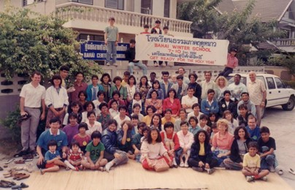
Bahá’í Winter School, Chiangmai 7-10 December 1991

Stories of Some Thai Believers Who Accepted the Faith

The Wongsopa family

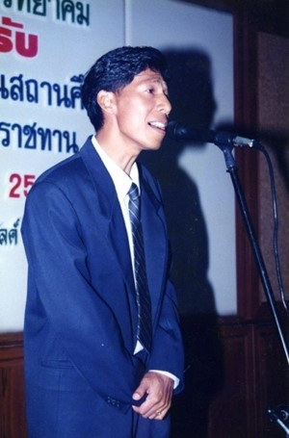
Mr Nawarat Wongsopa

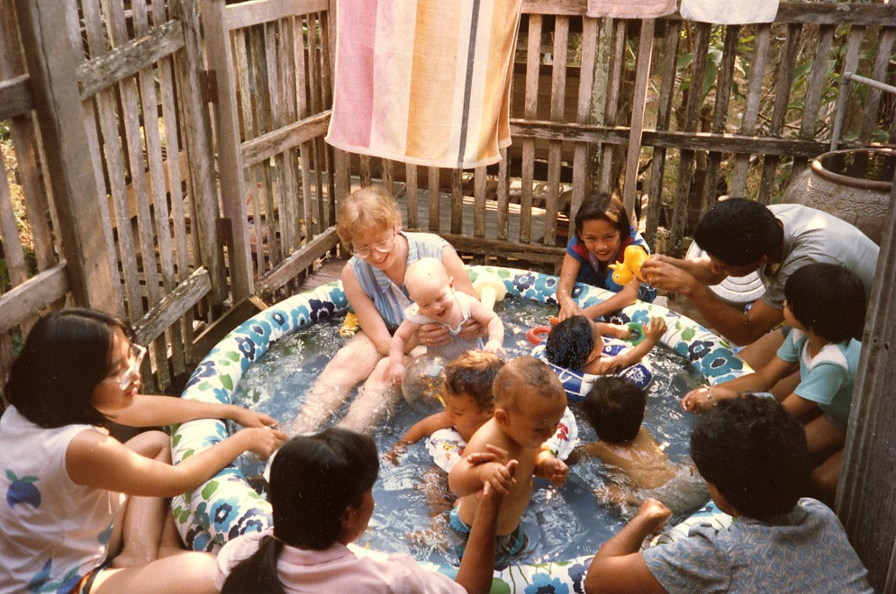
Aranyaprathet, 1987: Diana Schaffter hosted a play group
for parents & children to build bonds of friendship
Back L-R: Naiyana Wongsopa, Diana Schaffter, Scott Schaffter (baby), unk, Nawarat, Nin Nin Wongsopa (baby), Nicha Wongsopa.
Front L-R: unk, Lek Lyon, James Lyon (baby), Andrew Lyon (baby), unk baby.

As an ordinary Thai, I was quite slow in learning about life; it took me almost thirty years to find the Bahá’í Faith and to know Bahá’u’lláh, His Basic Teachings and to finally accept Him at last. I was born in 1959 in Chiangrai[in the] northern part of Thailand into a family of Buddhist background. My farther named me Naiyana which in Buddhist[Pali] means Eye or Vision. In my village of Wiangpapao there were already some people who were Bahá’ís by that time i.e. MahaSong But because I was just a child I did not know what Bahá’í was. Later, my farther sent me to study at Dara Academic, a Protestant Christian School. There, I could feel that I started to hear more about God and how we all should turn to follow Him and to Thank Him. Then I went to study further and graduated from Chiangmai University. I felt as if my life was being guided to go and find work in the International Field of Service; and right away I got a job as an ESL (English as a Second Language) Teacher at the Indochinese Refugee Camp in Panas Nikhom, Cholburi Province. There were some Bahá’ís who worked in that Refugee Camp like Mr Meharan. I did not know his last name though; but he was very polite and a really nice Iranian man and he was just a teacher like me. Later I heard that he went to resettle in Canada. And another Bahá’í named Mr David Apostle, an American man, was one of the best teacher trainers I ever had in my life. But still at that stage I did not hear enough of the story of the Bahá’í Faith.

But one of the most amazing things happened to me in that Camp. It was the first time I met Mr Nawarat who also came to work in that Refugee Camp in Panas Nikhom. He was a wonderful young man and he liked to play the guitar, sing and socializes with friends who came from different parts of the world. He was actually the one who was very impressed with the stories which Mr David Apostle had told, most of which were stories about the Bahá’í Faith and the teachings of Bahá’u’lláh. However, sadly, at the end of the year 1983 Mr Nawarat got a new job with the International Committee of the Red Cross (ICRC) and had to leave for his new post at the Thai-Cambodian border in Aranyaprathet in Prachinburi Province. However, not so long after that I too got a new job with CARE International and was able to follow him to Aranyaprathet. Two great things happened and completely changed my life. One was that I decided to get married with Mr Nawarat and secondly we happened to meet with a very wonderful, sincere and friendly Bahá’í Couple: Diana and Tim Shafter who came from Canada and who happened to come to work with the Refugees on the Border. When we had our first child Nicha; Tim and Diana also had their first child: Scott. However, our daughter Nicha got some health problem and she cried very loudly and upset most of our neighbours except the Shafter’s. Whenever, the neighbours complained or talked about our daughter, Tim and Diana always acted differently. They in fact always comforted us and prayed for us and instead of turning away from us, they invited us to their Fireside and we got a chance to meet with their Bahá’í friends. They were a husband and wife (traveling teachers) who came from Canada and a lady from Ireland who came to visit them. It was the first time we knew of Progressive Revelation and the evolution of humankind from infancy to adulthood, from clans to cities and from nations to an international order and to a one common world etc.

After that tea-party and The Bahá’í Fireside, Nawarat became deeply interested in the Faith, he kept praying all night with the brown prayer book he got from Tim. One day a few days before the observation of the Fast in 1988, Nawarat told me that he could not bear it anymore and he needed to find where the Bahá’í Centre was He then took me and Nicha to Bangkok and finally we found the Bahá’í Centre at Soi Langsuan. We decided to knock at the door (ring the bell) and Mr Cheuh (Boonyang’s husband) came and welcomed us into the house that served as the Bahá’í Centre. We were deeply impressed with that house and the environment. Immediately, in that living room, Nawarat had expressed to Mr Cheuh that he wished very much to join the Bahá’í Faith. It seemed that Mr Cheuh believd that Nawarat had no background in the Faith and seemed that we came from the street or out of the blue. So, Mr Cheuh took some time to explain to us about The Báb, Bahá’u’lláh, ‘Abdu’l-Bahá, Shogi Effendi, Hand of the Cause Rúḥíyyih Khánum and finally he explained to us about the Universal House of Justice. Nawarat’s heart was burning like fire, and could not stay patient or wait any longer. He then told Mr Cheuh straight away that he wish to become Bahá’í and asked him to show him how Mr Cheuh took a card and explained that once it was filled in, it means that we have accepted Bahá’u’lláh, The Báb and ‘Abdu’l-Bahá and that one is to abide by His Divine Teachings and His Bidding. He led Nawarat to the stairways to the upper floor where Mrs Sunantha Smith and Ms Tim-Sulee Kaewprasert and Ms Penrat Yaowapapong were. He announced to these aforementioned friends, “Khun Nawarat is already a new Bahá’í”. Nawarat paid his respects to each one present there like an ordinary Thai, using the “Wai” and saying “Sawaddee” to everyone there. Since Naiyana and Nicha had been waiting quite a long time already he asked to leave the Centre to return to the Borders.

From that day on, Nawarat started to observe the Fast and f I was very busy supporting him and we tried to live our Bahá’í lives while assisting Tim, Diana and Scott, along with Yai-Sunapa, Nida, Panu and Mark Stars, David Lion, Lek and their children James and Andrew. Thus, we were able to establish the First Local Spiritual Assembly of the Bahá’ís of Aranyaprathet and later the First Bahá’í Centre of Aranyaprathet which Hand of The Cause Collis Featherstone came to inaugurate. Then, around the year of 1990 Mrs Shirin Fozdar went to meet with Princess Sirinthorn Prathep Rattana Rajchsuda who happened to visit Aranyaprathet. It was really amazing and so wonderful to have opportunities to meet great believers like Hand Collis and Mrs Shirin Fozdar. Of course so many Bahá’í Friends came to visit our community in Aranyaprathet including Mr Chaovalit Munjikul, Mr Faridian Abhasakun, Mrs Choosiri Abhasakun, Mr Roshan Abhasakun, Mr Badi Abhasakun, Ms Michell Abhasakun, Mr Vaughan Smith, Ms Saufan, Ms Barbara Swensen, Ms Patty Murday and so many more including our parents and siblings who were quite surprised and worried about our becoming Bahá’ís. I too in around the year of 1990 was overwhelmed with the Bahá’í spirit and finally decided to declare as a Bahá’í after Nawarat. Later in 1992 we got another gift from God a new baby whom we named Nanapat (Ninnin) while we also applied to attend the Centenary of the Ascension of Bahá’u’lláh in the Holy Year of 1992 in the Holy Land in Israel. We needed to leave our children behind with our maids and close friends. We prayed very hard in the Holy Land and when we returned to Thailand we met with a Bahá’í from Canada, Mr Ken Cooper, at the Ambassador Hotel, Jomtien Pattaya where Nawarat was posted with a UN mission assigned to Air Movement Control Unit (MOVECON/UNTACT) which wa responsible for any UN movement through Donmuang Airport, Utapao Airport and Sattahip International Sea Port There was of a massive mobilization of approximately 25,000 UN Peace Keeping Force occurring for the General Election of the Cambodian Governmental Body. The important story was that Mr Ken Cooper was serving as the Administrator of Santitham Witthayakhom School[a Bahá’í school] for some time and we were quite surprised when we first met him and he expressed to us that God had sent us to help him. He gave us a loving hug like the Bahá’ís did a lot in those days, then he invited us to visit him and the School in Yasothon.

Without knowing the reason why, Nawarat’s heart felt strongly attracted to accept the invitation and he decided to go to Yasothon. This happened around the year 1992 after Mrs Shirin Fozdar passed away. We rented a car from Pattaya and drove to Yasothon. Once we arrived at the school we parked under the Twin Tamarind Trees and walked around. It was on a weekend and there was no school, no children around and Nawarat went to use the rest room(toilet. He could not use it because it was so untidy. He thought to himself and felt strongly that this school was really in need of help. We left the school and visited a few local Bahá’í Friends before returning home (actually we rented a room at the Bangkok Centre in Soi Lang Suan, we had been told that it was the room where Mrs Shirin Fozdar used to live). After visiting Yasothon, Nawarat said that he could not sleep well and his heart was telling him to stop working at the UN and go to Yasothon. We discussed this back and forth in our family and at the end of our deliberation he said either Yasothon or Cambodia is where we will go. Finally Nawarat won we decided then to leave Bangkok and go to Yasothon.

Although the school was undergoing a critical financial crisis and the number of students was quite low at around a hundred with about twenty staff, we gradually gathered our limited resources to develop the school starting all over once again. We did not have much training in school and education systems; except the experience we had with Tim and Diana back in Aranyaprathet where we used to assist with their Private Nursery School. Nawarat spent most of his time and energy on buildings and grounds work while I spent most of my time and energy on finance and office work. We later decided to announce to the parents a need to collect school fees and we came up with a standard rate. With the help of the School Board and the Foundation we were each encouraged to provide a good portion of time to spend in carin for the children and in teacher training. It took us more than 15 years to be able to learn through trial and error, including going through a lot of crises while gain some some victories. In our years of service, beginning in 1992 and lasting up to now in the year of 2009, we all have had the great bounty to experience some success, which has also brought our Bahá’í friends some joy and happiness. With deepest gratitude from the depth of our hearts!

Mr Lertchai Chaumrattanakul

“…Lertchai became Bahá’í through the introduction of his junior engineering student while he was studying at the University of Texas at Austin. In late 1991, his junior, Shoaleh Hedayati, invited him to join the Celebration of the Birth of the Báb, and later asked him to many firesides. He decided to fast in the following year (1992) while not yet a Bahá’í. He declared as a Bahá’í on the 9th day of Riḍván 1992. Then he finished his studies and went back to Thailand at the end of May at a time when Thailand was having political unrest (Black May). Lertchai saw the Faith as more reasonable and more practical for humanity……

He did not have any difficulties with his family since he was very independent, spending over 7 years abroad by himself for his education. He has lived a Bahá’í life since the time of his declaration. The most interesting episode in his life was when he visited the Holy Shrines during the 9-day pilgrimage in 2000.”[]

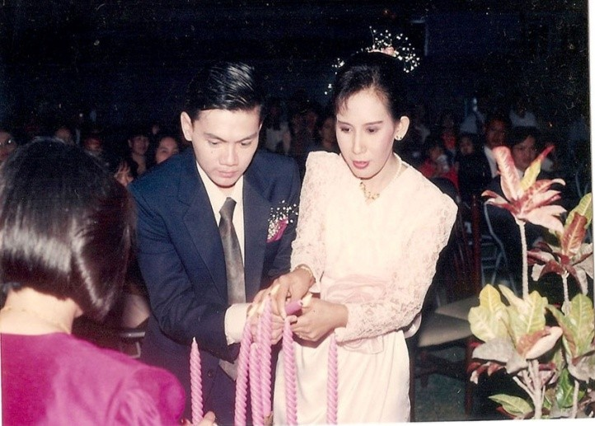
Wedding of Utairat & Lertchai

Dr Utairat Chaumrattanakul (née Ek-ampai)

“… I became Bahá’í during the Feast of Might in 1985 through Dr Nardrudee’s[] persistent persuasion. Before that for nearly about a year I had gone to many firesides and Bahá’í activities held mostly at the Jafaris’ house which was then a Bahá’í Centre of the Chiangmai community.

“The reason that I attended all those activities was because Nardrudee asked me to accompany her. She thought that if I accompanied her, I would be able to convince her not to easily accept what the Bahá’ís said. However, through the loving and caring hospitality of the Jafaris and thought the study of the Faith for nearly a year, both of us could not find any reason to deny the Truth of the Faith. Late in August 1985, Nardrudee attended the 19-day feast alone because I had to be on duty at the hospital. She came to my room at the dormitory the next morning and told that she had already signed the declaration card. From then on, she tried to persuade me to also sign a card which I did at the following Feast. My approach to the Faith during my first few years as a Bahá’í was very intellectual. It sounded very reasonable for all the problems. I did not feel any real spiritual connection with Bahá’u’lláh until I came across my own spiritual tests. I had a lot of problems to be solved in my family. I had to spend a lot of time and energy to convince my father that the Bahá’í Faith was a very good religion and the Bahá’ís are good and trustworthy. I started to have a stronger spiritual connection with the Faith more and more through prayers when I was in trouble and I was tested for so many times during my 5th and 6th years as a Bahá’í.

“The first exciting experience for me was when I had to be a translator for the Hand of the Cause, Amatu'l-Bahá Rúḥíyyih Khánum in 1988 when she visited Chiangmai after the Opening Ceremony of the Indian Temple.

“Afterwards, there were many other exciting moment in my Bahá’í life, but I can say that the most important one for me was when I went for the Commemoration of 100 years since Bahá’u’lláh’s Ascension in 1992. That was the first time for me to be able to prostrate myself at the Holy Threshold…..”[]

Buakham (Chanchai) Baran

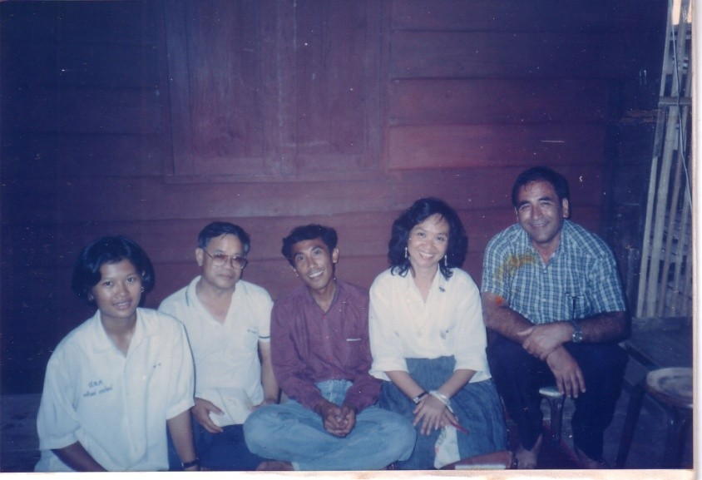
Nongkhai, house of Mr & Mrs Jalan. L-R: Miss Darin, Mr Jalan, Mr Pei, Mrs Chanchai and Mr Faridian

Notes from an interview of Buakham Baran (Chanchai) by Mr Faridian (Sukhum)

Question: How did you hear about Bahá'í Faith and how did it affect your life?

One blessed day in 1977, while I was waiting at a bus stop I unexpectedly met a radiant and enthusiastic person – Mrs Chusiri Faridian[]. Since that historical day my life’s destiny has changed.

She gave me a small pamphlet to read on the Bahá’í Faith and her friendship, which attracted me, I was moved to invite her to my village. After one week she came with a group of foreigners, Mrs Maliheh, Nasser and Ken Robinson to my village in Hangdong Nokyang (60km form Chaingmai). I was selling water melon and they came to help me to carry melons from the farm. I invited them to my humble home and we started a discussion about the Faith and then invited my neighbours and relatives to share the message. By the end of the day, miraculously my grandmother, parents, relatives and friends accepted the Faith, they were all taught that the promised 5th Maitreya Buddha has appeared and His name is Bahá’u’lláh. All Buddhists are waiting for Him and, our greatest wish is to be born during His Revelation and follow His teachings. This was the great announcement of His coming!

I was given the book - Bahá’u’lláh and the New Era to read, after reading about the exiles and the sufferings and torture of the Báb and Bahá’u’lláh by the authorities in Persia, I felt very angry, sad and sorrowful, and wondered why the learned men and rulers of Persia had tortured the Promised One of God. I felt the immediate urge to arise, to defend and teach His Cause, so that all the peoples of the world will know the Truth of His Revelation.

After 3 days, I requested that the Bahá’ís in Chiangmai come back to my village and promised to take them from house to house, to teach and proclaim the message. Since the village had a population of 1,000 people all of whom were my relatives, when we went door to door, they were surprised to see the happy foreigners (Maliheh, Joan, Ken and sister Chusiri).

Among those visited was Mr Thawee, who accepted the Faith and received a prayer book. (he later became the chairman of LSA and member of the teaching committee). I took Uncle Nasser to teach the Chief Monk in the temple. The monk had many questions and opposed me for accepting the Faith, he intended to burn the books but, luckily, I saw it thrown in the rubbish bin. I was very sad and angry, that he did not respect the coming of the 5th Buddha, though they were anxiously praying and waiting day and night for His coming. I lost my respect for them, though I had been a very strong devotee of the temple, going everyday with my grandma to wash and clean hundreds of plates, thinking it was a bounty and blessings to help the monks and the temple.

In December 1977 there came a big turning point, I decided to devote myself to the service of the Faith. I joined 2 other friends (Lot and Dee) to attend the 9 day Institute in Chaam, HuaHin. I met many members of the Faith who were coming together to study with Jenebe Caldwell from Alaska. He was a great facilitator. This is also where I met Kanna, who was serving as a pioneer and Auxiliary Board Member in Yasothone.

I also attended a Bahá’í Conference in Suwan Sampan, where nearly 100 Iranian fiends participated and donated a Van for teaching[].

After experiencing the 9-day spiritualization course, I was transformed into a new person and inspired to arise to serve wherever the team wished to go. It was decided that the teaching team would cover 8 provinces in the north - Chiangrai, Nan, Prae, Uthaidit, Maehongson, Lampang and Lampun.

In the team, I was blessed to be teaching along with great Bahá’í teachers like Counsellors Yankee Leong, Vic Samaniego and youths like Gobu, Yim, Boon and other friends in Thailand. Kanna was also part of the team. The teaching campaign was intensive; we use to pray two hours every morning both in the group and individually. Then we would go out to teach in teams of two. In the evenings we had firesides and teaching activities till late into the night.

The team had to move from one province to another. I was given the responsibility of asking permission from the Governors to teach in the villages. Often it was a difficult task for someone who just finished grade 4 and did not have much exposure to the world outside the village. (When I was a child I also was afraid to travel in a car and often walked long distances.) We also went to very difficult villages where we received much opposition. In one village we were stoned and had to stay inside the house. Another was in the Karen minority village of Amphur Pai in the mountains 11km high where our stable food was tamarind and rice for 15 days. Gobu, Tuk and Tawone was also in team. It was difficult to teach due to language differences and the fact that the people drink rice wine every day. However, we did not give up but disseminated the seed of Faith in the hearts of the people with the hope that one day it would grow.[]

After joining the Faith my life dramatically changed, because Bahá’u’lláh promised that “the source of all courage is promotion of the Word of God” and I was able to take on all the tasks given to me by the facilitator. I met Governors in all the provinces we visited and they gave us letters to permit the teaching activities, in spite of the fact that this was a period of leftist movement in the country.

My last task was to look after the finances of the teaching team in which duty Kanna was assigned to help me and Jenabe encouraged him to take good care of me since I had potential to be a teacher of the Faith. The teaching team lasted 3 months. Afterward the teaching team broke up and I had to go home broken hearted.

Still, I was hoping that one day I could visit other Bahá’í communities. So I wrote jokingly to Kanna in Yasothone to visit me during the Thai New Year. Surprisingly he came and found me in my village after walking 3 kms. He encouraged me to go on a teaching trip to the refugee camp in Ubol. After this I felt that we could be a new teaching team. I decided to get married in the same year in July 1978. Since then my passion to teach and serve the Faith has grown from strength to strength we moved, after 10 years in Yasothone, to Chiangmai, Bangkok, Phanat Nikhom, and Haadyai and in 1990 we had an opportunity to pioneer to Laos. In 1992, I was able to attain the desire of my heart and soul to throw myself down tearfully at the shrine of Bahá’u’lláh, to thank Him for all the bounties and opportunities bestowed on this humble handmaid. In the same year I was appointed as the Board member for Laos until 2002. In 1996 my husband and I were board members and invited to the opening of the International Teaching Centre (ITC) for the launching of the 5th Epoch of the Formative Age of the Cause of God.

I hope my humble story will inspire the next generation to detached themselves from the old beliefs of the past religions and “die to the earthly limitations and enter the eternal realm”.

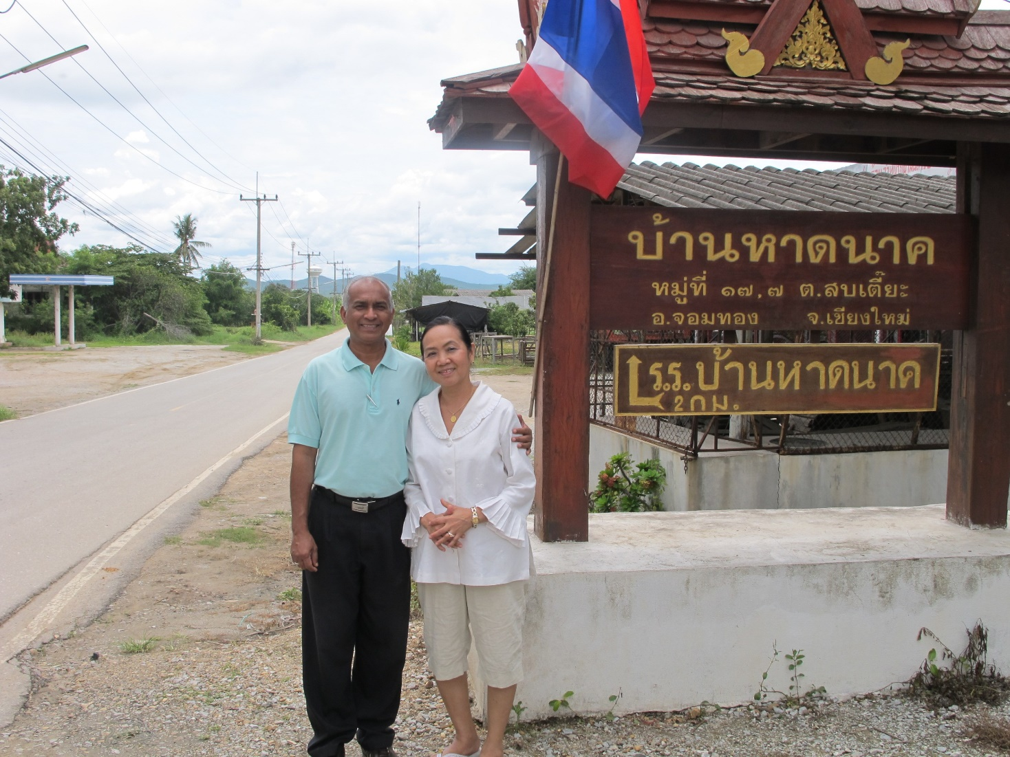
Kanna & Buakham (Chanchai) Baran
Chiangmai. Village where Chanchai became a Bahá'í

Appendix

PART THREE:
Faridian’s Recollections

Short biography of the compiler

While still very young, my father, Mr Mohammad Reza Faridian, lost his father, and he was entrusted to the care of his aunt whose husband was Imam Jomeh in the city of Zevarah in central Iran. An Imam is someone who leads the Friday prayers for Muslims.

When Mohammad Reza was a youth, he heard that the Promised One had appeared, and he ran happily to the Imam to give him the good news. But, instead of being delighted by this momentous piece of news, the Imam became very angry, and said that anyone who believed in the new religion would be subject to prosecution and even capital punishment.

Mohammad Reza wondered why the Imam did not investigate the truth, and why, without any reason, he was so much against this new religion, so he decided to investigate it for himself. But trying to find any information was extremely difficult to do. There was no library and no books existed about the Promised One. Worse still, anyone who kept the Writings of this new religion at home would be prosecuted immediately, and maybe worse would happen. As a result, Mohammad Reza was at a loss about how to find any information.

In spite of the dangers involved, my father made enquiries and found out that due to their fear of prosecution, the followers of this new religion would meet secretly and very quietly at about midnight in different locations in order not to be caught. My father spent many sleepless nights watching from the roadside with the hope that one night he would meet a member of this new religion.

One night, at around midnight, my father heard someone walking along Sid Road. He wondered where he was going so late in the night. Perhaps he was going to a meeting about the Promised One. So, without that person noticing, he followed him. The man arrived at a house, and it seemed that the host was expecting him because as soon as he reached the door the host opened it and the man went in.

But by the time Mohammad Reza reached the door, it was already closed, so he climbed over a wall and went into the house. He searched everywhere, but he did not see anyone. Where were they? Thinking that they must be in the basement, he went down into the basement where he saw a candle burning in the middle of the room. There he saw a man chanting some Holy Writings quietly

While the rest of the people listened, the Words of God touched his heart deeply.

As quietly and slowly as he had entered the house, he left the house and waited for the man to appear. When he saw the man, he approached him and told him that he was so glad to receive news that the Promised One had come, and said that he would like to investigate this new Faith.

Over the course of the following weeks and months the friendship and love between my father and the Bahá’ís grew stronger and stronger, and he became a defender of the Bahá’í friends in Zevarah.

One day, without notice, a group of people went to the mosque and asked the Imam, “What kind of Imam are you when members of your own family have become Cafer (outcast)?” The Imam told them that it was not true that anyone in his family had become a Cafer, but the people did not believe him.

Finally, the Imam ordered that Mohammad Reza be brought to the mosque. My father told me that hundreds of people were gathered in the mosque to hear what he had to say. When he arrived the people became silent. Then the Imam ordered them to bring my father to him.

The Imam told Mohammad Reza to tell the people what they had heard was not true. My father replied, “I don’t know what they have heard.’

The Imam replied, “They are saying that you have become a Bahá’í. Tell them that it is not true.” The Imam seemed to be shaking with fear of losing his position and income. As my father did not reply at once, the Imam shouted, “Tell these people that you are not a believer of this new religion.”

Then my father turned his face toward the people and said, “O people. The Promised One whom for a thousand years we have been awaiting, has indeed come, and his name is Bahá’u’lláh.” At that moment the Imam hit Reza on the head with his walking stick and told the people to kill him. He was now an outcast and everybody hit and kicked him until they felt sure that he must be dead.

Then they told the Imam that he was dead. Some of the people suggested burying him, but the Imam refused, saying that as he was not a true believer he should not be buried in a Muslim cemetery. He told them to take his body and throw it into the desert and let the animals eat it. The people did as they were told, and took the body of my father and threw it into the desert for animals to eat. They were now happy because they had fulfilled the instructions of the Imam, and because they believed they would receive a reward for participating in the killing of a non-believer.

My father was unconscious in the desert for three days and nights. When eventually he woke up he noticed what had happened to him. He could not return to the city and he didn’t know where to go. As he was contemplating his situation, he heard a caravan passing by, and asked if he could accompany it. The people agreed and the caravan took him to the city of Kashan, which at that time had, like every city, a caravanserai, just as cities nowadays have airports and bus or train stations.

The caravanserai was connected to the Bazaar, and there were a few commission agents to facilitate business between the caravan and the local merchants. Mirza Anayat was one of the Bahá’ís there, and he worked as a commission agent. He soon found out that my father was a Bahá’í and what had happened to him, and he introduced my father to the Bahá’í community in Kashan Province. In Kashan at this time there were already thousands of believers from Muslim, Jewish, and Zoroastrian backgrounds who believed Bahá’u’lláh was the Promised One of all religions, so my father was not alone.

He had a happy time in the Bahá’í community, and with the help of Mirza Anayat he became a merchant who bought goods from caravans and sold them in the local market. During this time, my father fell in love with Miss Besharat, who was Mirza Anayat’s daughter, and married her. My father had four sons, called Mohammad, Ehsan, Namat, Ehayat, and myself, Fazlollah. I am the youngest child in my family. I was born in Kashan on 30 Bahman 1319 Persian calendar, which is equivalent to 19 February, 1941.

In Kashan too, we were not free from prosecution. I remember that when I was seven years old my parents put me in the first grade at the only government school in the city. One day the manager of the school called me to his office and asked me what my parents’ religion was. I told him that my mother was a Bahá’í, that my father, who was a Muslim who had become a Bahá’í, and that I was born a Bahá’í.

The school manager turned red with anger. He pointed to the water tap and told me that the water tap was only for Muslims. He said that I was now an outcast and that I was not allowed to drink any school water. The taps had to be kept clean for Muslims to drink from. In the heat of Kashan with its desert wind I was now not allowed to drink any water. To add to this, it often happened that when I walked down the roads of Kashan some children remembered that I was a Bahá’í, and they threw stones at me while saying bad words about my beloved Faith.

At that time we had no water supply at home, and people stored water in the (Ab-an-bar) underground water reservoir, which was 1 kilometre from our house. To get our drinking water we had to go down approximately 70 steps below the ground and then go up 70 steps. On one occasion when one of my brothers went to fetch water, some people recognized that he was a Bahá’í. He ran away, fearing for his life, and they followed him. Eventually, he returned home without any water, and since we had no water, my mother said to me, “You are a small child and no one will recognize you. Please go and try to get some water.”

I went all the way and brought the water, but when I was near my house someone recognized me. He wanted to hit me, but when he saw that I was just a very small child, he took some dust from the roadside and put it into my water. I cried and I wanted to return home, but when I remembered that there was no water at home, I went back to get some more water, and this time I reached home with the water without incident.

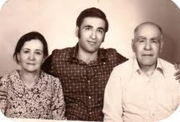
Ṭihrán, 1971. L-R: Mrs Besharat Faridian (my mother aged 72), Mr Fazlollah Faridian (the Compiler), Mr Mohammad Reza Faridian (my father aged 95)

I finished the first grade of primary school in Kashan. My parents then moved to Ṭihrán and I continued my studies there. One by one my family members went pioneering to different countries, and my desire to follow their example grew. In the beginning I wanted to go to the Arabian Peninsula, but then I received a letter from my very dear friends, Mr Bijan Bayzaee and Fridoun Misaghian, about how masses were coming into the Faith, and about how they were in need of manpower to teach them.

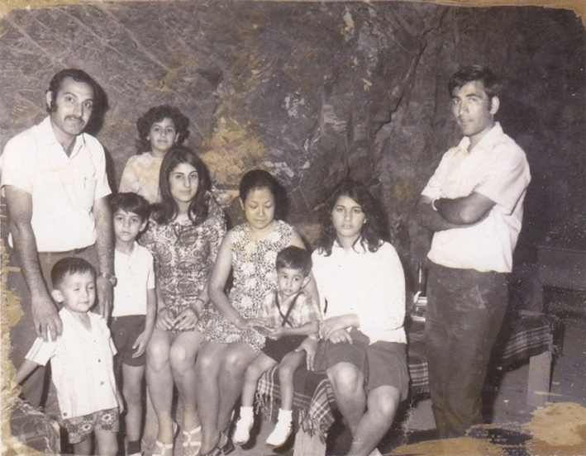
Ṭihrán, 1971. On left: Mr Hushang Shayegh. On right: the compiler.

I took the letter immediately and went to see my good friend, Mr Hushang Shayegh, to tell him that I was going to go pioneering in Laos. I asked him if he wanted to go with me. Hushang, his brothers and his father were Bahá’ís while his mother was a good Muslim. He told me that he had just finished his education, that he had started working for the Iranian oil refinery, and that his mother’s wish was for him to get married. Hushang was worried because he felt that maybe his mother would not agree with the idea and would not give consent for him to go pioneering, so he said he would have to consult with his family first before giving an answer.

Finally, he got permission from his family to go pioneering to Laos. When we were ready to go it was the beginning of April 1964. The Pioneering Committee for Asia in Ṭihrán told us that there was a 9-Year Plan from the Universal House of Justice, which would be announced on April 21st, the first day of Riḍván. They asked us to stay and then leave after the announcement of the 9- Year Plan, so we waited for two weeks until the Plan was announced.

We left immediately after the announcement of the 9-Year Plan of the Universal House of Justice. After a long and tiring journey from Ṭihrán by train and bus through Mashhad, Zahedan, Quetta, and Delhi, we finally flew from Calcutta to Bangkok. Mrs Shirin Fozdar kindly met us at Don Muang airport and took us to her house, which at that time served as a Bahá’í Centre. It was located at 311/8 Suriwong Road, Bangkok. We had to stop in Bangkok to prepare for going to Laos.

A few days after our arrival in Bangkok, Hand of the Cause Dr Mohajir arrived to consult with the newly formed National Spiritual Assembly. This beloved Hand of the Cause told us that he had consulted with the National Spiritual Assembly of the Bahá’ís of Thailand, and that the NSA felt that Thailand needed pioneers, so it had decided that both of us should serve as pioneers in Thailand. Dr Mohajir left the same day.

Dr Mohajir in his next trip to Bangkok came with Dr Sundram. I went to visit them in their hotel. After greetings, Dr Sundram started asking me questions and Dr Mohajir translated for him. Dr Sundram wondered what I could do here. Dr Mohajir told him I was a good pioneer, why? Because he is going to bury his born in Thailand.

Later on Mrs Shirin Fozdar asked us[the writer and Mr Hushang Shayegh] what we were planning to do to earn a living, and we replied that we had no idea. She said that it would be a good idea if we could have a chicken farm to earn a living as this would enable us to convey the message of Bahá’u’lláh to the Thais in the rural areas. We told her that we knew nothing about chicken farming. She said that the reason she had suggested chicken farming was that the NSA Secretary, Mr Sawaeng Thongsuk, who was from the North-East of Thailand, also went travel teaching sometimes. At that time he wanted to establish himself independently, and so he had studied agriculture. He wanted to have a chicken farm, but he had no capital. Mommy suggested that if we could put up the capital, she would be willing to help Sawaeng to start a chicken farm. At the same time we could teach the Faith in Yasothon in the North-East and in the surrounding area.

Hushang and I had very little money, so the three of us together could only buy approximately 70 chickens. Mrs Fozdar had an old Land Rover, and after everything was loaded into it there was actually almost no room at all left for passengers, but I managed to squeeze myself into the back.

The journey was a wonderful experience, which we spent it mainly looking at the sky. I felt somehow that the stars were speaking to me. I said to myself, “The Thai People became Buddhist because of their spiritual awareness, and this peace-loving people will soon be attracted to the beautiful Teachings of Bahá’u’lláh.”

The road was bordered by trees and everywhere there was greenery. The air was fresh, and a wonderful smell of leaves and flowers filled the air in many places. Finally, after a 24-hour journey along dusty roads, which included a few stops to repair the jeep, we reached Yasothon.

We spent the first few days very busily making cages for the chickens and getting to know our neighbours. At that time there were no foreigners in the area and everyone wanted to know what we were doing there, which made it easier for us to give the Message of Bahá’u’lláh to the people.

After one month, I got up one morning and I became very sad to see one of our chickens has died. I didn’t know what to do with it so I buried at the back of our garden. When Sawang came back I told him that how sad I was to see one of our chicken died. He immediately asked me where the chicken was. I told him that I had burried it. He said, “It seems that you are very rich since you bury the chicken” Then he dug the chicken out of the ground where I buried it and cooked it for dinner. He made a “Tom yam Gai” dish with it and it was very delicious.

Again after few days we were shocked to find that about twenty more chickens had died from disease. We had no knowledge of why they were dying. Within a few week most of our chickens had died, so we decided to give up on the chicken farm.

Santitham Witthayakhom School

Soon afterwards, Suwang got a job in Arunrat Vithayakhom School. It was the only high school in Yasothon at that time, and it was operating at a loss. Because of this, the owner of the school approached Suwang and suggested that Mrs Fozdar take over his school on a ten-year lease for which she only needed to pay 50,000 baht. He agreed not to interfere in its affairs.

Back then the only channel for the education of poor young men was through entrance into the Buddhist monkhood. Poor young women who could not enter the monkhood or live in the temples were deprived of education entirely. Mommy was very concerned about the education of poor young children, especially of poor young women. She realized that it was more important to educate women because they are the future mothers, and if they are educated, they can educate their children.

Arunrat Vithayakhom School in 1964

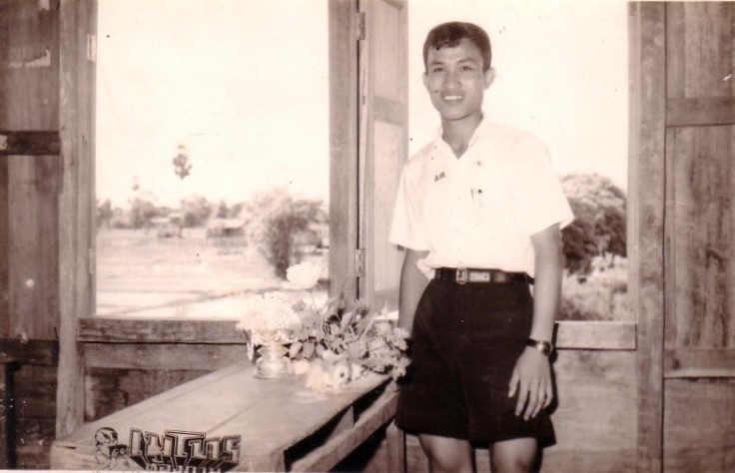
Yasothon, 1964, Mr. Suwai Thongsuk

Mr Suwai Thongsuk the brother of Suwang Thongsuk came to study in the Arunrat Vithayakhom School in 1964. After his graduation he became a teacher in Arunrat and he married one of the good Bahá’í teachers in Arunrat and for a long time both served the school and the Faith, Mr Suwai has served as a Local Spiritual Assembly member, an Auxiliary Board member and as a member of the National Spiritual Assembly of Thailand.

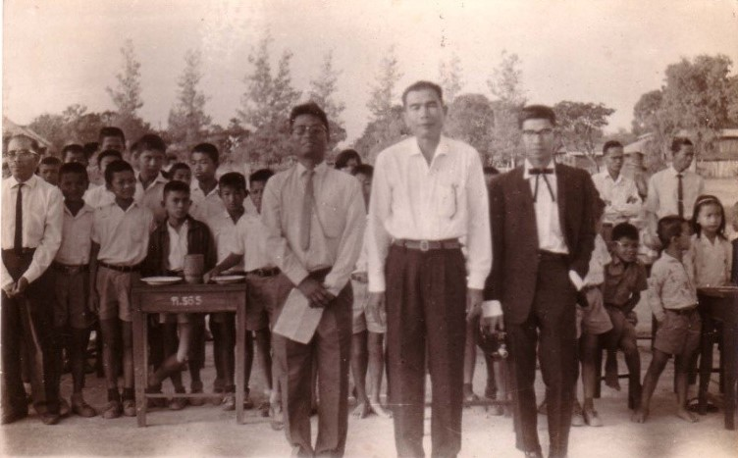
Arunrat Vithayakhom School, 1964,
Mr Suwang Thongsuk on the right

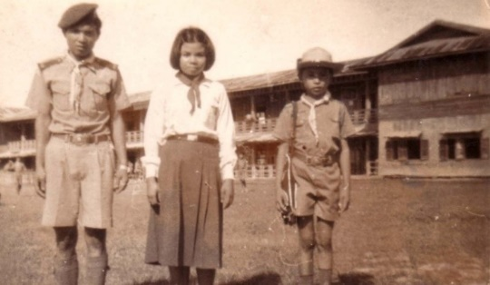
Arunrat Vithayakhom School, 1964

Mummy agreed to run the school on a contract for ten years. Mr Hushang Shayegh was appointed as the manager of the school and Suwang became one of the directors of the school. Soon Suwang brought his younger brother, Mr Suwai Thongsuk, to study at Arunrat and at the same time to help run the school.

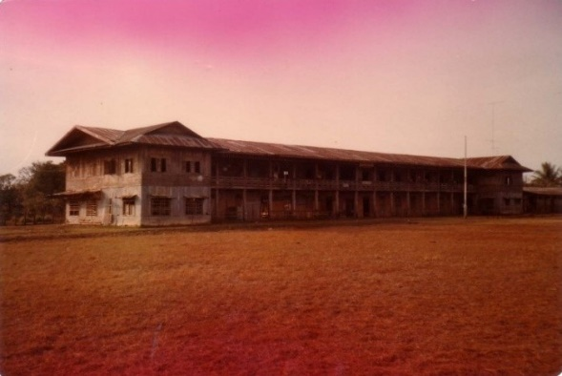
Arunrat Vithayakhom School, 1964

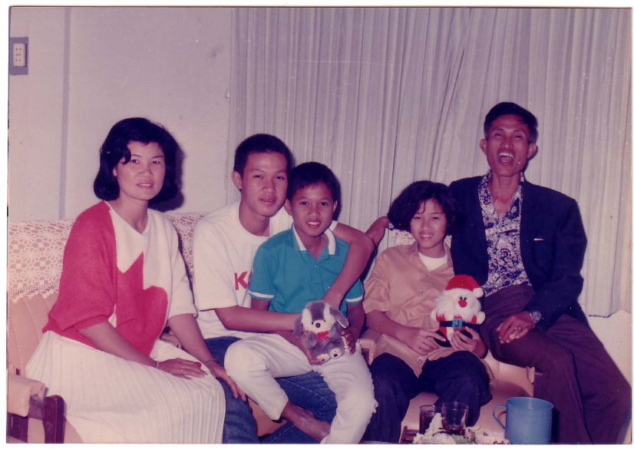
Thongsoot family. L-R: Pensi, Pam Phai, Pattanasak, Vilairatana, Sawai

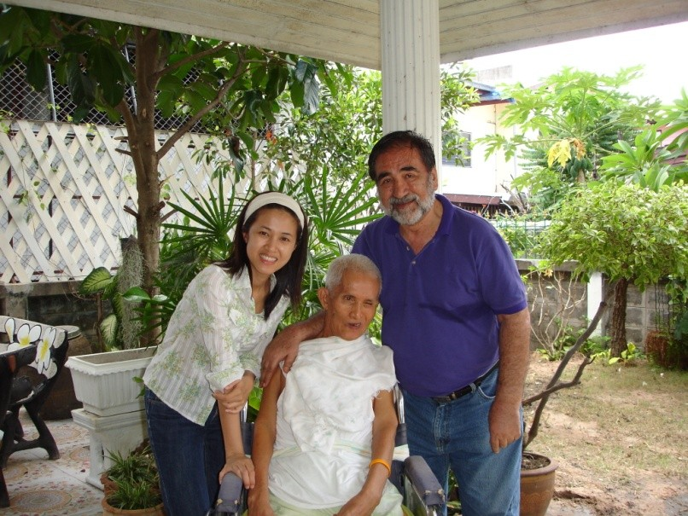
Yasothon, Thongsoot home, 2010. L-R: Wilairat, Sawai, Faridian

However, within two months, the owner returned to the school and started interfering in the management. He often arrived at the school drunk and disturbed the teachers and the staff. Mrs Fozdar wrote a letter to him reminding him of the agreement that he would not interfere in the running of the school; otherwise, he should return the money and take back the school. Immediately, after receiving Mrs Fozdar’s letter the owner took back control of the school and did not pay anything to Mrs Fozdar.

But one night, the owner of the school was drunk and involved in a road accident. He passed away and his sister became the new owner of the school.

She was a very good person and called Mrs Fozdar to apologize for what her brother had done, and expressed her eagerness to sell the school to Mrs Fozdar.

She arranged to transfer ownership to Mrs Fozdar for 80,000 Baht. As a foreigner she could not have the school in her name so it was transferred to the name of a Thai Bahá’í called Miss Dhanya Anapapitre.

Later on a large tract of land (12 rai) was purchased nearby, and the old wooden building of Arunrat was transferred to the new location. The construction of an additional building was begun under the auspices of the Bahá’í Foundation of Thailand in 1967.

After the chicken farm was closed, I was requested to travel teach in Khonken province in North-East Thailand, in order to open up the province. Later on, Hushang was requested to go to Banpai, a city 50 KMs from Khonken. In 1965 Hushang moved to Songkhla in southern Thailand.

By this time Suwang was again jobless, and Mommy suggested that Suwang and I go to Krirk College to improve our Thai and English language. Both of us started our classes, but soon Suwang got a job and so he left the college.

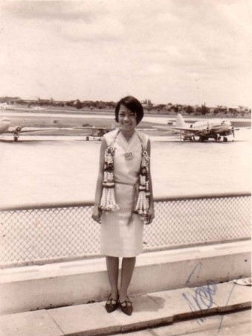
Miss Chusiri Roobsoong in 1965

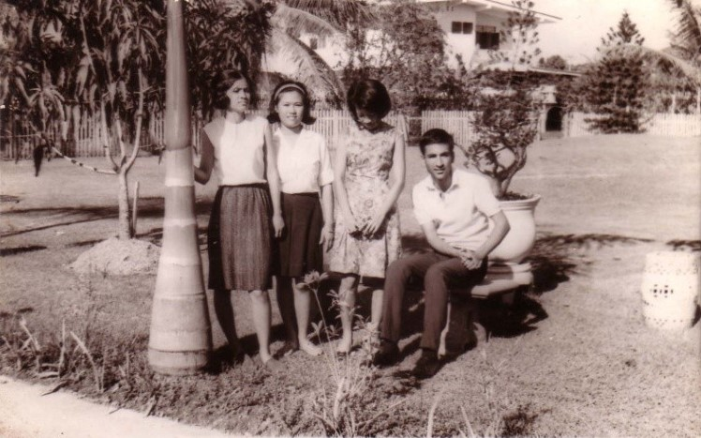
Bangkok, 1965. L-R: Miss Valai, Miss Get, Miss Chusiri & Mr Faridian

In Krirk College I met a student called Miss Chusiri Roobsoong for the first time. One day, when the regular teacher was absent, the college combined my class with another class. I sat next to Chusiri and said, “Hello”. We could not speak much in the class, but the next time I met her in the library I gave her one of the Bahá’í pamphlets. She looked at the pamphlet and repeated, “Bahá’í religion”. I replied, “Yes. If you are busy, you can keep it and read it at home.” She took it home and forgot about it. But after some time she found the pamphlet, read it carefully, and found the Bahá’í Teachings to be very interesting.

We met each other often, mainly in the college. When I talked to people about the Bahá’í Faith, she came over and sat very quietly while showing much interest. One day, I invited her to attend a fireside at the Bahá’í Centre on the following Saturday. When we reached the Bahá’í Centre that Saturday, there were a few monks attending the fireside, and Mrs Fozdar was answering their questions. Chusiri was amazed that the monks were satisfied with the Bahá’í answers regarding the existence of God. Mrs Fozdar said to the monks, “Buddha preached that every effect had a cause, but observed discreet silence about the First Cause. He implied that there was a Causeless Cause of all Causes, an Ultimate Reality, which we call God.”

After the fireside when everybody had left, Mrs Fozdar invited Chusiri into the sitting room for tea, and asked Chusiri if she had any more questions. She replied, “I have got some Bahá’í pamphlets from Faridian, and I have read them. I like the Bahá’í teachings and today I was very happy to see that the monks were satisfied with your answers.” Then Mrs Fozdar asked her what she was waiting for, and gave her a declaration card to sign and to declare her Faith in Bahá’u’lláh, which she did.

Chusiri turned out to be a very good teacher. It reminded me of when I went to get consent from my mother to go pioneering. She had told me that she wished that I would get married and go pioneering with my wife. I told her that I would go pioneering, and God willing, I would marry one of the active girls who declared her faith in Bahá’u’lláh so that we could serve together. I wrote to my parents to tell them about Chusiri. I said that Chusiri and I had decided to get married, and so we needed their blessing and a letter of consent.

Taráz'u'lláh Samandarí’s 1966 visit

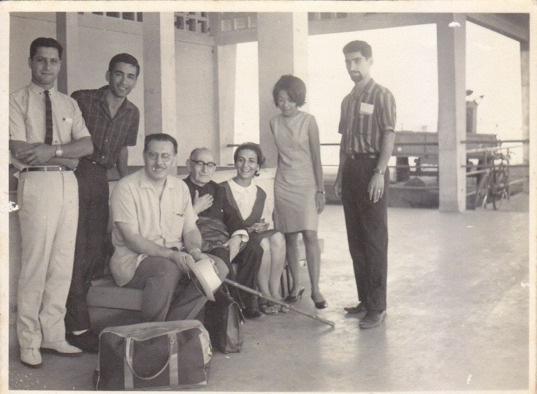
Lan Xagin Hotel, Vientiane Laos, October 1966
Standing L-R: Firaydun, Mr & Mrs Chusiri Faridian, Mr Bijan Bayzaee,
Seated L-R: Mehdi Samandari, Mr Taráz'u'lláh Samandari, Manijeh Khanom

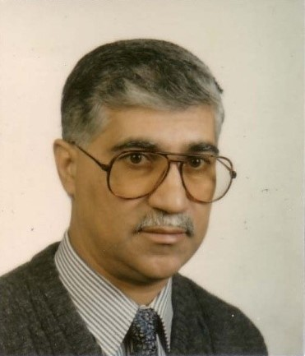
Mr Abolfazl (Bijan) Bayzaee pioneered in SE Asia from 1962-1968, was the youngest Auxiliary Board member appointed by Dr Muhájir for Laos, Thailand & Cambodia (1964-1968)

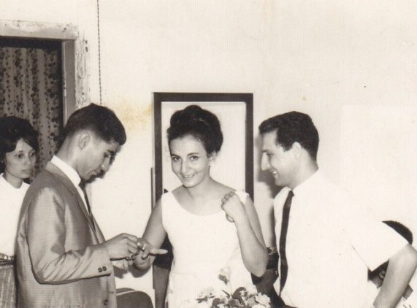
Vientiane, Laos, 1966. Wedding of Mr Bijan Bayzaee
& Manijeh Khanum, Firaydun on right

Before we could get married, however, events conspired to keep Chusiri and me apart. At that time the Bahá’í Faith in Laos was under the administrative responsibility of Thailand. It was Riḍván, 1966 when ABM Mr Bijan Bayzaee, Manijeh Bayzaee, and Firaydun asked me to go to Laos to help with the teaching for the election of the first National Spiritual Assembly of the Bahá’ís of Laos. After consultation with the Hand of the Cause Mr Harold Collis Featherstone, I moved to Laos, and with the help of Firaydun, I started working with USAID.

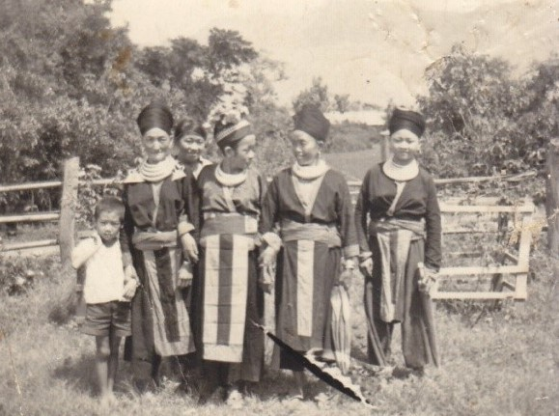
Sayaburi, Laos, 1966, Chusiri is 2nd from left,
on teaching trip with Yankee Leong

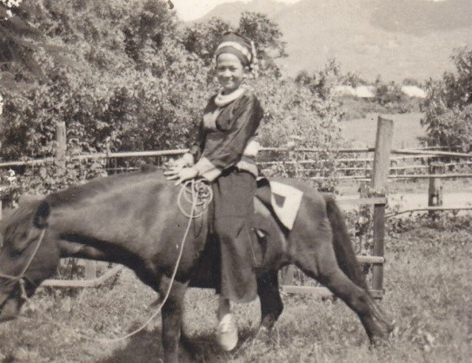
Sayaburi, Laos, 1966. Chusiri on a horse. She accompanied
Yankee Leong to Sayaburi as a translator on his teaching trip

While on his way to Vientiane Dr Mohajir stopped over in Bangkok to visit the friends there. He asked Chusiri how much she loved me. She replied, “Very much.” Dr Mohajir asked, “If Faridian died, what would you do?” She replied, “I will die with him.” When Dr Muhájir arrived in Vientiane he told me that he had met Chusiri and about what she had said. I was so happy, and I contacted my parents. They told me that a letter of consent had already been posted and that it was on the way.

ABM Bayzaee and Manijeh told me to let Chusiri go to Laos. They said that she could be their guest until we were married. I called Chusiri and told her that Mr and Mrs Bayzaee were inviting her to go to Vientiane and to stay with them temporarily until we had got married. She came to Vientiane and our engagement ceremony was held within a few days. Both ABM to the Hand of the Cause of God Dr Mohajir, Dr Soraya and Bijan Bayzaee were present at our engagement and the friends in Vientiane all kindly helped to make the ceremony a success.

After a few days Chusiri was able to get a job in an airline ticketing company, which was the sole agent of Trans World Airlines (TWA) in Laos. One weekend we travelled to Bangkok to visit the Bahá’í friends and our family. We went to the Bahá’í Centre, which at that time was at 77/1 Soi Langsuan.

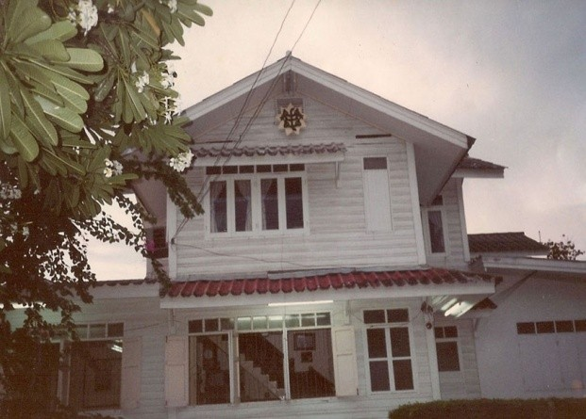
National Bahá’í Centre, Bangkok,
77/1 Lang Suan Rd, Soi 4

Mommy was on the second floor in a meeting with the NSA. She came down and told us that the letter of consent from my parents had arrived. She asked us if we would like to get married now as the NSA was present. We said that we would be delighted to do so, and that we felt honoured to be blessed by the presence of the nine members of the NSA. We got married.

The 1st National Spiritual Assembly of Laos

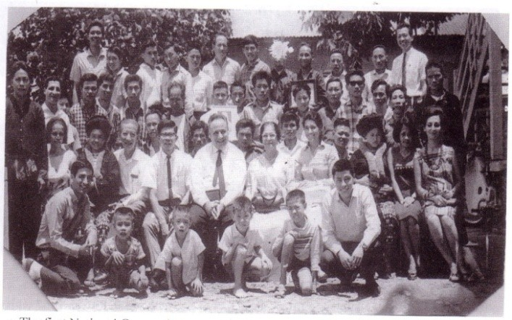
First National Convention of Laos held in Vientiane during Riḍván,1967

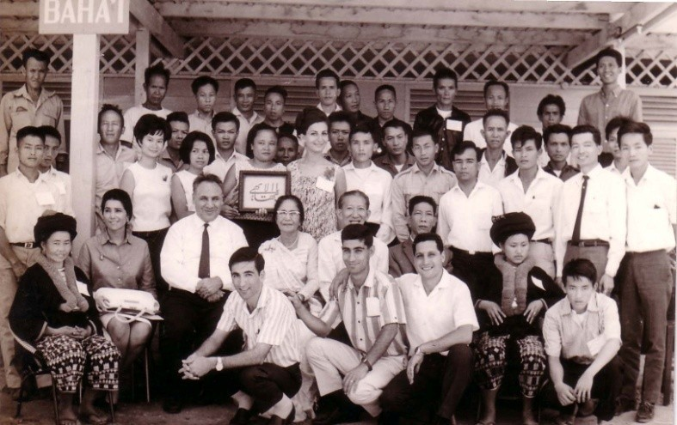
The first National Convention of the Bahá’ís of Laos was blessed with the presence of the representative of the Universal House of Justice, Hand of the Cause of God Dr R. Muhájir & Auxiliary Board members ABMs Mr Bayzaee & Mr Yan Kee Leong

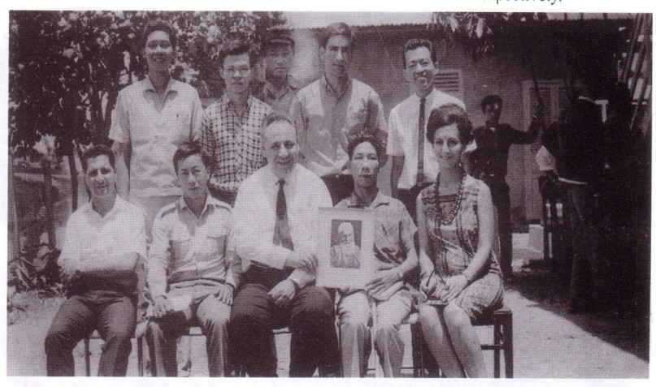
First National Spiritual Assembly of the Bahá’ís of Laos elected in Riḍván, 1967.
Standing R-L: Paul Antipolo, Khamsay, Noi Mujoo, Fazlollah Faridian, Chester Lee
Seated R-L: Firaydun, Khamsing, Dr Muhájir, Bun-Me, Manijeh Javid (Bayzaee)

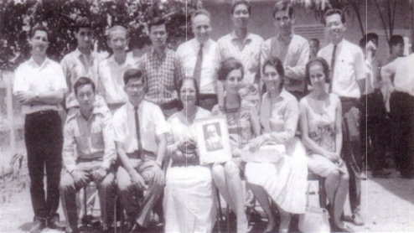
Standing L-R: Firaydun, Bayzaee, Yankee, Khamsay, Dr Muhájir, Paul Antipolo, Faridian, Chester Lee.
Seated L-R Khamsing, Suwang Thangsuk, Shirin Fozdar, Manijeh Javid (Bayzaee), Parvat Fozdar, Bahiya Sohili.
(Mr Suwang Thangsuk, Parvat Fozdar, & Shirin Fozdar were representatives of the NSA Thailand to the Convention.)

Teaching Along the Mekong River

Dr Muhájir encouraged pioneers to start teaching the Faith in the villages on both sides of the Mekong River, and he even suggested that we should purchase a boat for this purpose. He was the person who started this project. Dr Mohajir took Uncle Yankee Leong, Firaydun, and Chusiri Faridian to Thakek in the South of Laos, where there were many Bahá’í villages and Bahá’ís among the refugees. From there he crossed the Mekong River to Mukdahan on the Thai side to teach in the local Thai schools and colleges.

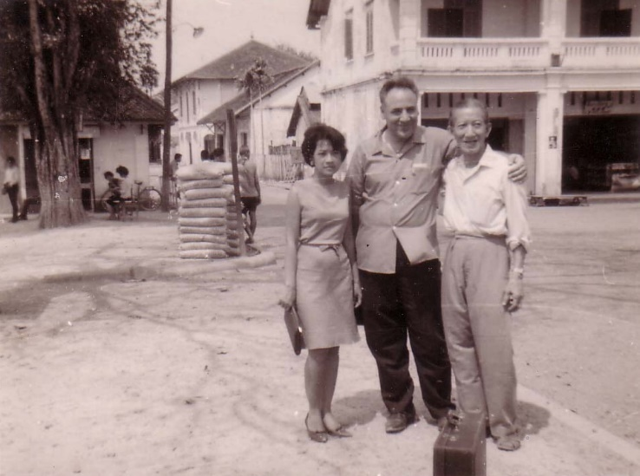 | 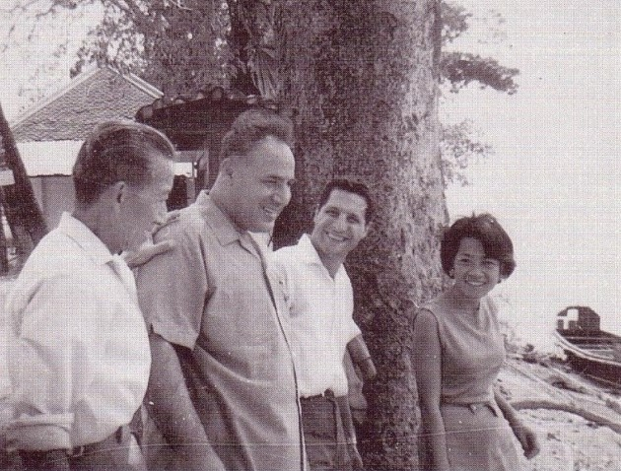
L-R: Chusiri, Dr Muhájir, Yankee | L-R: Yankee, Dr Muhájir, Firaydun, Chusiri

On his next trip, Dr Mohajir told me that with the sacrifice of Firaydun many villages in Thakek area had embraced the Faith, and that for a long time no one had visited those villages. He told me to go to the South and to try to find a job there, and then move to southern Laos. He said that when I was there I should visit those villages, and that I should not be satisfied with there being just a few Bahá’ís in each village because, for there to be unity in the village, the whole village or a majority of the people in the village needed to embrace the Faith.

I left my job with USAID and went to Thakek to look for a job. Thakek was a very small city surrounded by many villages and refugee houses, and was one of the receptive areas. I spent one month there enjoying visiting the villages, but I could not find a job, so I was forced to return to Vientiane. This time, Dr Muhájir’s advice was to apply for a job with an international agency in order to work in the South.

I was confident that there must be a way to move to the South with a job. I approached Air America and I got a job with the supply department. My job was to identify and supply aircraft parts for the engineers who assembled and repaired aircraft. After receiving training and some working experience I was put in charge of the supply department for the South of Laos.

I was stationed in the provincial capital of Suwanaket and I was provided a Jeep for my transportation. After one month Chusiri left her job as a ticketing agent for TWA and followed me to Suwanaket. We replaced pioneer Pol Antipolo, who was leaving Suwanaket. We rented a house and the first floor became our Bahá’í Centre. We placed a sign outside the entrance to the building in Lao and English outside that said, “Bahá’í Faith Suwanaket Centre”. We used the second floor for our living quarters. Soon Chusiri got a job with USIS as a local secretary and translator from Lao and Thai into English.

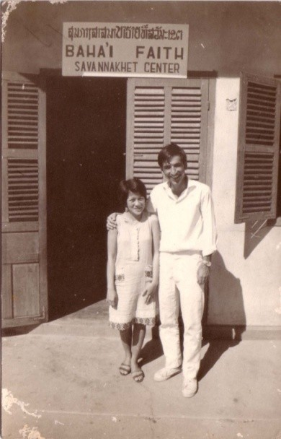
Chusiri & Faridian in Savanakhet

In Savanakhet, Pol earned his living by teaching English, and when he left he asked Chusiri to continue his English class. Back then teaching English was a good way to get contacts and to teach in the cities. Indeed, through Chusiri’s English classes many youth from diverse backgrounds - Laotian, Thai, Vietnamese, Chinese, and Khmer - embraced the Faith, and on April 2, 1968 the first Local Spiritual Assembly of the Bahá’ís of Suwanaket was formed.

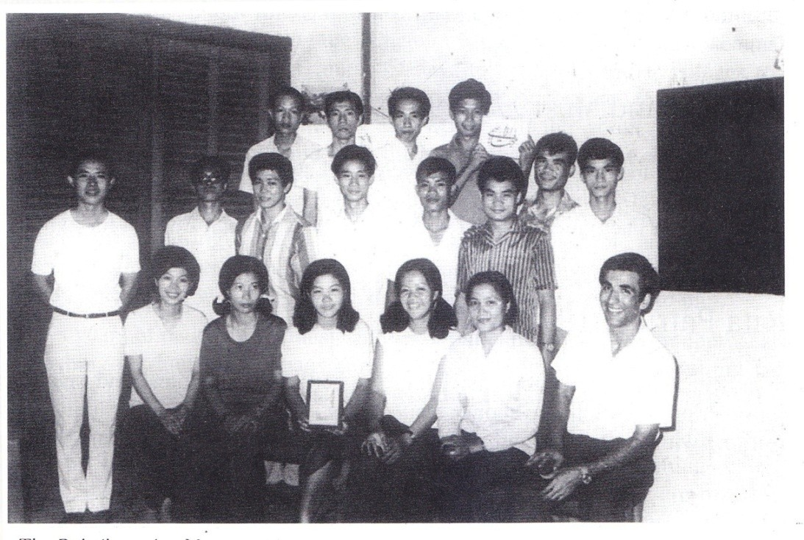
Bahá'í Centre, Savanakhet, 1967. Bahá’í youth. Mr Faridian seated far right.

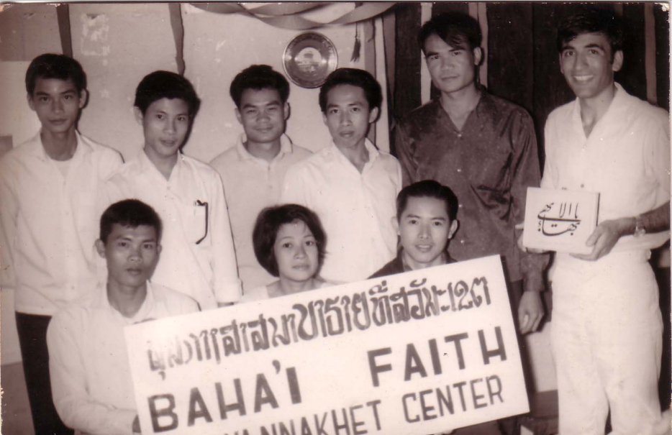
First Local Spiritual Assembly of the Bahá’ís of Suwanaket.
Chusiri sitting in middle, Faridian standing on far right.

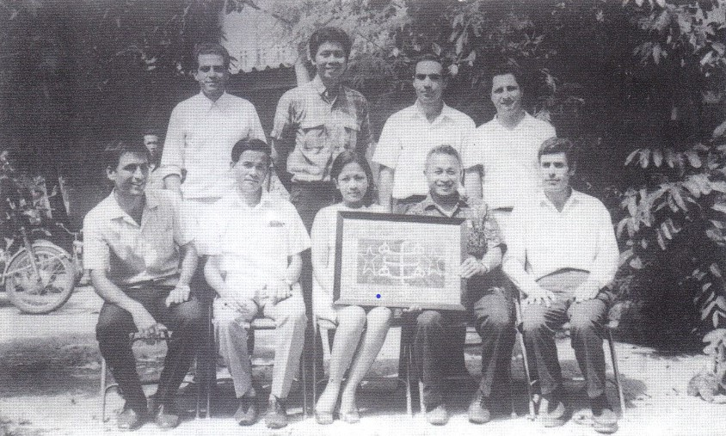
NSA of Bahá’ís of Laos, Riḍván, 1970
Front: L-R: Faridian, Bouaphanh, Chusiri, Shong-Leng, Firouz Aqdasi
Back: L-R: Faiz Yagan3gi, Paul Antipolo, Dawood Saadati, Firaydun

In the 1970s the Communists became stronger and more powerful, and the people felt sure that the doors would be closed to tourists soon. Indeed, many local people left Laos to go to Thailand as refugees. In 1970 Air America in Suwanaket closed down and we were told to return to Vientiane. We knew that Laos would soon become Communist, and that all foreigners would have to leave the country. In spite of this, the airline continued to operate in Vientiane, and I moved to Vientiane to continue working with Air America. Chusiri, however, moved to Bangkok to stay with her mother, soon again she could get a job as airline ticketing agent with GSA TWA in Bangkok.

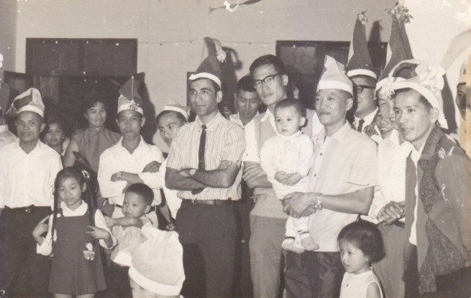
1967, Vientiane. Air America’s New Year’s eve party.
Faridian (Centre with tie) with his staff

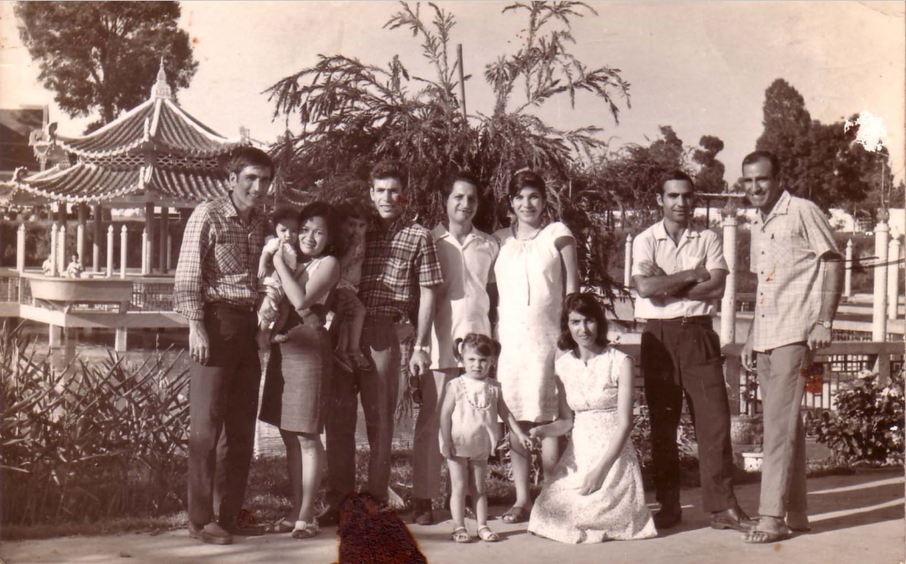
Vientiane, 1967, Nasser (far right) visiting pioneers
L-R: Faridian, Chusiri & Badi, Firouz Aghdacy & Fruzan, Firaydun & Giti Mithaq, Dawood Saadati, Nasser
Seated: Mautureh Aghdacy holding hand of Ladan

As time passed, the situation in Laos became more and more difficult. Except our Filipino pioneer Mr Pol Antipolo, and Faiz Yaganagi and family, all of the pioneers left Laos. For those who remained it was not easy to travel, and so the Bahá’í work was left to the local believers with almost no support from the pioneers.

On his next trip Dr Muhájir once again told me about the importance of teaching on both sides of the Mekong River, and he said that he would like me to do so until the doors closed completely. He stressed that we should hurry because we had to prepare the Lao believers to stand on their own feet. Fortunately, I had a permanent visa for both Thailand and Laos so I was able to do as he requested. I left Air America and started traveling teaching full time. My first priority was visiting and deepening friends in over forty villages in Thakek until I could no longer travel into Laos.

I remember that my first trip took forty days. When I returned to Bangkok to visit my family, Dr Mohajir was there. I was very happy to see him and I gave him a report about my trip. He said to me, “Faridian, for the last six months I did not see my daughter Gisso. We don’t know when Laos will close its doors to tourists. Go back and Bahá’u’lláh will look after your family. When you go traveling try to get the whole village or at least most of the villagers to accept the Faith.

” I continued travel teaching in Thakek. The number of villages increased to 47. When Laos became Communist it closed its doors to foreigners. Then I had to return to Thailand.

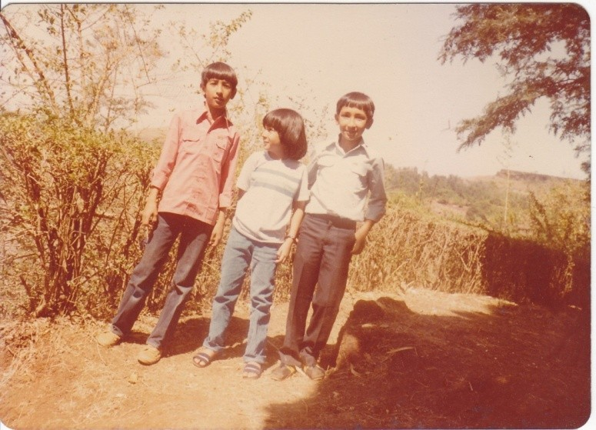
New Era High School, Panchgani India
L-R: Faridian’s children Roshan, Alisa & Badi

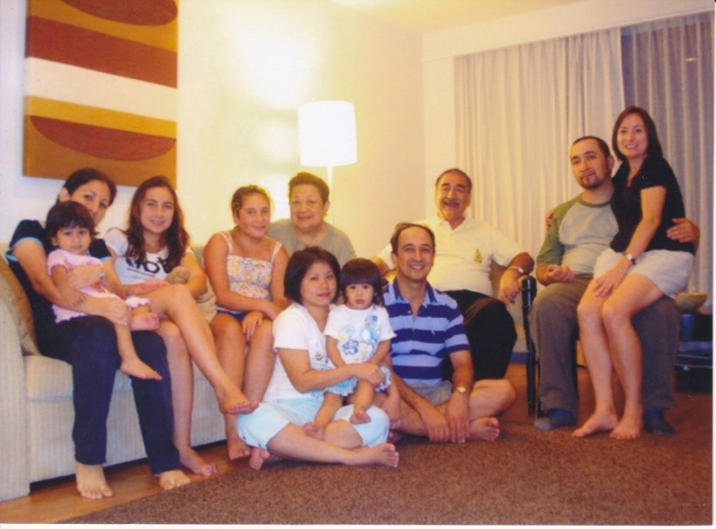
Abhasakun (Faridian) family
L-R: Alisa Das (née Abhasakun) & daughter Nara Das, Tara Abhasakun, Narisa Abhasakun, Chusiri, Faridian, Badi & Michelle Abhasakun.
Sitting on floor: L-R: Pornpimol Abhasakun with daughter Monsicha (Shirin) & Roshan Abhasakun.

Universal House of Justice

19 March 1986

The Local Spiritual Assembly of the Bahá’ís of Bangkok

Dear Bahá’í Friends,

As you requested in your letter of 19 February, the Universal House of Justice has requested us to assure you that it will offer prayers in the Holy Shrines for the progress of the soul of Mrs Bisharat Faridian. Her loving devotion to the Cause, so clearly evidenced by her sacrifices to enables her son and his family to pioneer over many years, is lovingly remembered.

With loving Bahá’í greetings
For Department of the Secretarial

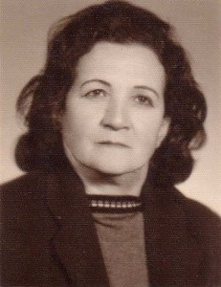
Mrs Bisharat Faridian, mother of Mr Faridian

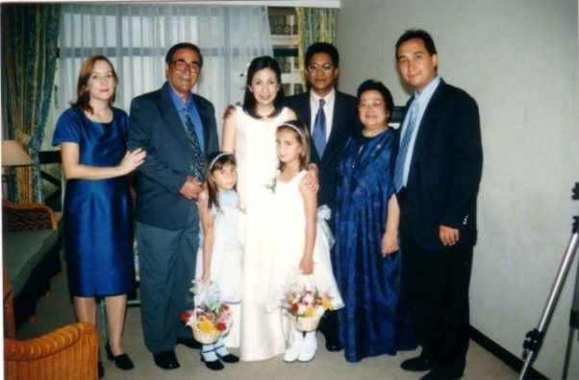
Wedding of Alisa Abhasakun & Shehab Das
Melaka, Malaysia, 10 Aug 2002
Back: L-R: Michelle Abhasakun, Faridian, Alisa, Shehab, Chusiri, Badi
Front: L-R: Narisa & Nara Abhasakun

Recollection of Compiler’s Kenya travel teaching trip

On 25th June 1972 Dr Muhájir called me and told me that he was in Bangkok and he would like me to go to his hotel with my wife Chusiri. Usually Dr Muhájir travelled alone but this time he came with his wife, Iran Khanum, and his daughter, Gisso. We were so happy to see them.

After a few minutes he asked Chusiri, if TWA flew to Kenya”. Chusiri said yes. He wanted to know if she could get a stopover in Tel Aviv. Chusiri said it is possible. Then Dr Mohajir asked if she could get a free ticket for me to go to Nairobi. She said yes. Dr Mohajir asked her how long the ticket would be valid. She says that a free ticket is valid only for three months. Then he told me, “Faridian I would like to send you travel teaching to Kenya for three months”. Again he asked Chusiri if she could get the ticket that day, Chusiri replied, “I will try but tomorrow is sure”. Then he told Chusiri not to forget to make a stopover in Tel Aviv. Dr Muhájir told me before going to Kenya to stopover in Tel Aviv and to go to Haifa for Pilgrimage. I had less than 24 hours’ time to arrange my trip. Dr Muhájir called the Bahá’í Centre for my credentials. Mrs Fozdar took the phone and told him the secretary was out of Bangkok. However the next day I was on board TWA going toward Tel Aviv when suddenly I noticed that I did not have a credential letter for the NSA of Kenya and no invitation for my Pilgrimage and I did not have enough money for my trip.

Finally I reached Haifa, and when I entered the garden of the Shrine of the Báb it was early morning. I saw that nine members of the Universal House of Justice gathered to go to the shrine to pray. Although I had seen their photos and I could remember their names, it was the first time that I had come for pilgrimage, and the first time I had seen members of the Universal House of Justice and witnessed the Kingdom of God on Earth. On the one hand I was overjoyed to be in Heaven and on the other hand I felt I had entered the garden of God without permission. I could not move my feet to go any farther. I stood there, not knowing what to do, from afar I greeted the members of the Universal House of Justice. Mr Fatheazam came toward me and said, “we would like to congratulate you, your wife has been appointed as Auxiliary Board member”

I was told that I was the guest of the Universal House of Justice and I was booked into the hotel and I was requested to go to the office of the Universal House of Justice, where I was given a letter of introduction for the NSA of Kenya and another letter for the British Embassy in Tel Aviv to get a visa for Kenya. After our return I was told that usually visitors can stay for only three days but I could stay longer if I wanted. Also I was given an envelope and told it is the decision of the Universal House of Justice to provide some money for expenses during my travel teaching in Kenya. I spend three unforgettable days and nights in prayers and meditation in the Bahá’í Holy places in the Holy Land.

Upon my arrival in Nairobi the National Spiritual Assembly of the Bahá’ís of Kenya arranged for someone to take me to the place of my destination for this trip. It was early morning when we reached it. I could hear the voice of a woman crying loudly from a distance in the village. I asked my companion what had happened. He then told me that the Kisomo tribe had just come and stolen cows from the village and, sadly, many people from both side had lost their lives during the fight.

Coming from a totally different part of the world I told myself, I am not the right person for travel teaching in this area. In my heart I questioned Dr Muhájir’s decision to send me to this area. Then I felt happy for being obedient to the Institution of Bahá’u’lláh and at least I had tried. I told to myself leave the rest in the hand of Bahá’u’lláh.

One evening soon afterwards when it was almost midnight my host woke me up and told me that the house was surrounded by Kisomo tribesmen. He then took his bow and arrow and prepared to shoot the intruders who came on horseback, but I stopped him. I told him that we were not going to kill anyone. It is better to die than to kill. He replied “How about my cows”? I told him that we trust in Bahá’u’lláh and He will protect us. Then he asked “what should we do”? For few moments I could not say anything then I invited him and his family to sit together for a prayer.

I started chanting “The Tablet of Ahmad”. I remembered that the night was very quiet except for the sound of the intruders and I chanted the prayer very loudly. It was with absolute detachment and I sincerely begged Bahá’u’lláh to aid us. My voice could probably be heard over the hills and valleys nearby. Astonishingly, when the prayer was over, the mounted intruders, without taking any cows or harming anyone just left the Village.

This incident astonished the family with whom I stayed. They ran out to the nearby houses to see if they had lost their cows. Everyone was happy for what had happened, no bloodshed, no lose of cows.

The next day the chief called for a meeting and in the morning he sent someone to take me to a meeting. When I reached there, hundreds of people were gathering. When I met him he came to me with open arms and hugged me saying that he had heard all about what had happened the night before. He said that the Bahá’í Faith is the only remedy for their problems and asked me to tell his people about the Bahá’í Faith. I told them that the Bahá’í Faith is a Universal Religion to establish Peace love and unity in the word. Bahá’u’lláh says that mankind, all of us are like “The fruits of one tree and the leaves of one branch”, “The flowers of one garden,” “the beauty of the garden depends on the diversity of its flowers”…. In the Bahá’í Faith we don’t have priests. The Bahá’ís spread all over the world to give this good news to all the people. The chief of the village told the people, “…the Bahá’í Faith is a religion of love and unity. I hope all my people can recognize the Station of Bahá’u’lláh and the return of Jesus Christ.” On that day hundreds of people accepted Bahá’u’lláh. During the next two months we were busy with deepening and forming five LSAs and one hundred and five local groups.

I heard that Dr Mohajir had arrived in Nairobi to attend the teaching conference. Few people from the Kisomo area attended the meeting. In the meeting the news of what had happened and the number of new believers was announced. Dr Muhájir asked me how many localities were formed I told him there were 105 and he asked me how many LSAs were formed and I told him 5. Then Dr Muhájir told me. “Faridian go back to the Kisomo area to have LSAs in all new areas which have been opened.” We tried and found we were able form 21 LSAs and after three months I returned to Thailand.

Report of Compiler to the NSA of Kenya

I am happy to give you a brief report of activities of the friends and local teachers during my visit to the Kisii area.

With the grace of Bahá’u’lláh, during this short time we were able to have 511 new believers, two teaching conferences, two deepening classes and also weekend deepening for new believers, 21 L.S.As formed and 118 new localities were opened to the Coues of God.

The Message was given to Mr Stephen Keane, Chief of Nyanbari Masimba. He was so attracted to the teaching of Bahá’u’lláh that he himself translated our Message to a group of people and many of them declared. The District Education Officer in Kisii also visited and happily he allowed us to extend the Message of Bahá’u’lláh in all School in the Kisii area.

The L.S.A of Masimba is now actively working with weekly gatherings, all out for teaching, youth activities, and recently extension of Bahá’í Education to the Children’s. We are very thankful to the N.S.A for sending Mr Juliva Mokanda and Christopher Musamber to visit us. They also assisted us in our deepening classes.

Mr Festus Mukalama made a 3 day visit to Kisii and was a great help in school teaching.

I am returning to Thailand and I am so happy with wonderful experience which I learned from you. I wish to come back and serve you again.[]

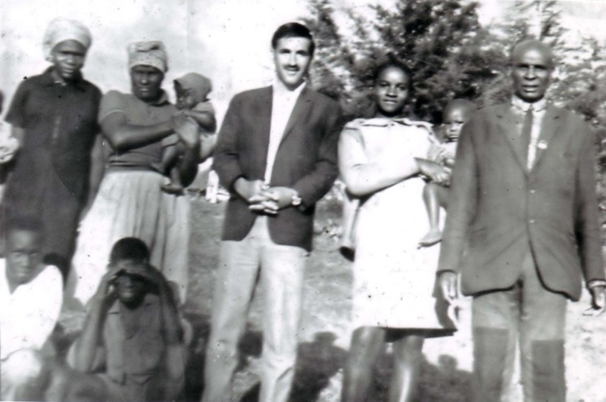
Mr Faridian with his host family in Kisii area.

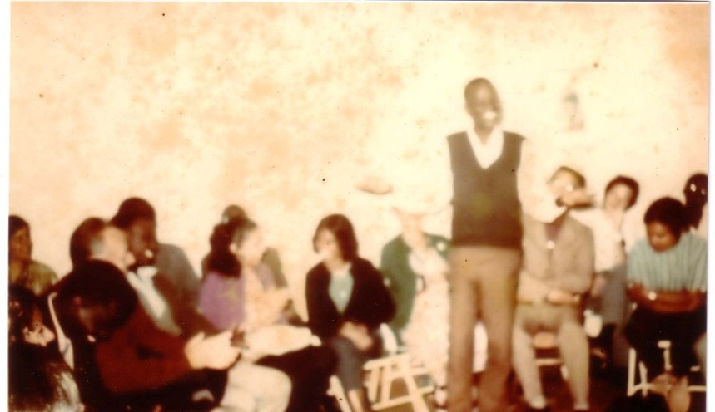
Dr Mohajir at Teaching Conference in Nairobi. Faridian’s host telling the audience about our Teaching activities.

Compiler’s return to Thailand

After my return from Africa I received the following letter from NSA of Kenya:

“Thank you so very much for your wonderful letter of 21 October 1972, giving the report of your extensive teaching work in Kenya.

The Universal House of Justice has written us expressing how pleased they were to learn of your highly successful teaching efforts in the field. They wish to convey to you their deep and loving appreciation for your devoted services.

We look forward to you returning one day to Kenya. We feel your love, devotion to God, and the tremendous sacrifices you render to Bahá’u’lláh and His Cause, are an example to be set for all our Bahá’ís in Kenya….”[]

Appointment to Auxiliary Board

“…The Continental Board of Counsellors had decided to appoint you to the important role of a member of the Auxiliary Board for Protection…”[]

With loving greetings

The Continental Board of Counsellors in Asia

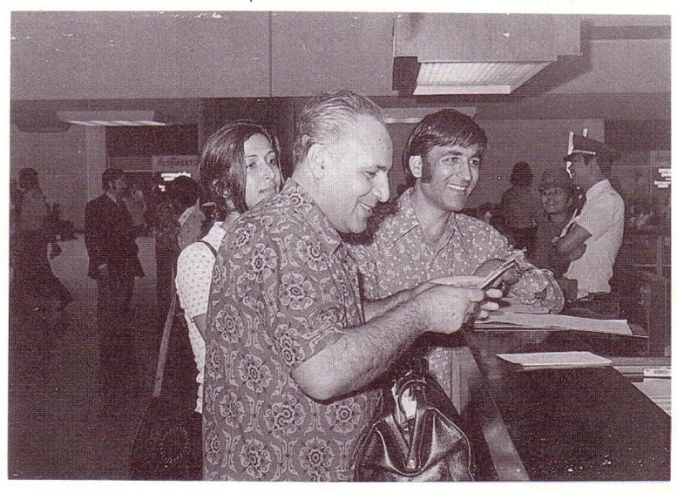
Dr Muhájir with Camelia &
Faridian at Bangkok Don Muang Airport

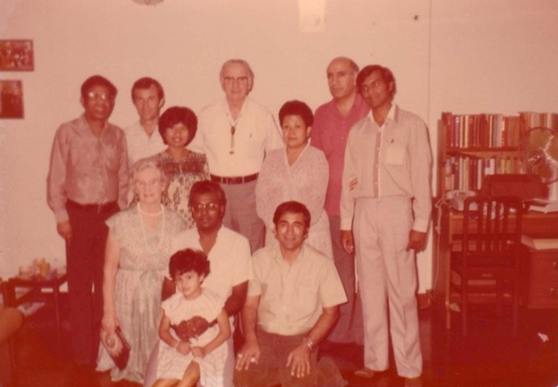
Mr Featherstone & Dr Sundram with ABMs
Standing L-R: Dr Sundrum, Mark Starrs, Montha Greenspoon, Mr Featherstone, Chusiri, Nasser, Kanna
Sitting: L-R: Mrs Featherstone, Élan & Jessada Govindasamy, Mr Faridian

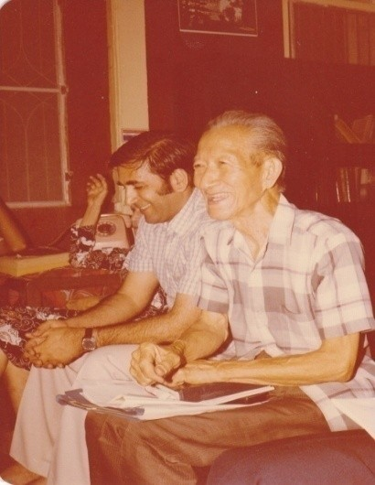
Bahá'í Centre, Bangkok. R-L: Faridian, Yankee Leong

Nongkhai Activities

First Visit to Nongkhai[]

Instructions from NSA

“….During the recent Joint meeting in Kuala Lumpur regarding assisting Laos, it was decided that two strategic bases from Laos; Nongkhai and Mukdahan have to be developed immediately. In line with this goal, we would like to request you[Sukhum Abhasakun (Faridian)] to co-ordinate, facilitate and follow-up all teaching activities related to this project. Also assisting those travel teachers from Malaysia and Singapore who will be coming ….”[]

Faridian and Sammi decided to go to Nongkhai, to start looking at what could be done at the border, following consultation with Dr Arbab and the National Spiritual Assembly.

On the way there , they attended a Feast in Nakhon Sawan – 3 friends attended and for the first time contributed to the Arc Fund. Also on the final stretch of the journey from Udon Thani to Nongkhai a young girl-Thon – was taught the Faith. Other than being very interested, she sat and read all the prayers and Hidden Words in the small prayer book aloud on the bus, non – stop. She took more literature and a declaration card and said she would read and think about enrolling.

In Nongkhai they stayed at Niyana’s guesthouse. Faridian has known Niyana for many years. The opportunity arose to teach her. She was very excited about the teaching concerning the role and status of women. She also said she wanted to read before deciding to enrol.

On the grounds of a temple, Faridian spoke of the Faith at length to a small group (6-7) of monks and laymen. One said he wished to join but the monk teacher stopped him, saying the Faith sounds good, but he should think about it first. The monk accepted books including one for the instruction of children, as many boys are educated at the temple.

They visited Mekong guesthouse several times over the weekend in the hope of meeting Mr Charoen who was a Bahá’í working at the restaurant there; however he was away at a temple, making charcoal. The temple was far from the city. But they befriended the staff at the guesthouse and spoke at length on the Faith to one of the young women-Nok- who spoke of her lake of hope and unhappiness. They told her of the Bahá’í attitude to work and how to turn to the holy words for guidance and support.

In spite of meeting many people there was still a feeling of not having achieved enough. They turned once again to prayer and asked that whatever is His will, would happen. Neither felt pulled strongly in any direction. The words that sprang to mind were being “light and untrammelled as the breeze”. Not knowing where they were going, or which road to turn, they just followed intuition. On the last afternoon after much prayer Faridian[remembering the instruction of Dr Muhájir to teach the monks] just felt it right to walk into another temple compound. There, a group of young monks asked if they wanted to meet the Abbot. This was the Buddhist centre for cultural exchange and the study of philosophy. The Abbot was very hospitable, offered refreshments and a book on finding inner peace. They told him a few words about the Bahá’í view of inner transformation and how similar the Bahá’í idea of struggle is with that of Buddhism. He was presented with the peace statement, a proclamation book, and “The New Garden”. These he accepted and said that since their intentions were good they could go and see the school where 500 students study. They could go and share some words with them. So Faridian and Sammi found their way to a classroom full of young monks. The teacher came out and spoke in English and asked immediately if they wanted to speak to the students as this was an English class and the experience would be good for the students who had never met foreigners. So for the next hour Sammi taught an English class to 50 or so monks aged 15-30. They asked the purpose of our visit to Nongkhai.

The teacher immediately said “tell them the meaning of Bahá’í, they don’t know it.” When the words “Bahá’í” and “Bahá’u’lláh” were written on the blackboard, they all repeated them and many wrote them down. The teacher then asked that some of the principles of the Faith be written on the board so that they would be able to compare them to Buddhist principles. This was done and followed by a short discussion on the meaning of each one. One young monk who had been taking in everything from the beginning cried out “I agree with the principles.” Several were very responsive. Some small prayer books and one history of the Faith for children were left for them. A copy of “Words of God” was given to the enthusiastic young monk. They hoped to correspond with the Bahá’ís. This really was a tremendous opportunity as it opened doors for future visitors to go and give lectures on all sorts of issues.
Finally just before leaving for Bangkok, Faridian met a retired soldier, who invited him to his house. He lived alone and was delighted to have visitors. He asked about the Faith, accepted some literature and invited the Bahá’ís back.

Nongkhai Bahá’í Centre

The compiler did not return to Bangkok but stayed in Nongkhai to fulfil the request of the Beloved NSA. Early in the morning I started to search for a small room. I saw a small one room house near the road and I felt it was a good location to invite friends for Bahá’í activities. So I went to see the owner and she said that the night before I came she had dreamed of a big white snake in the room. “In Thailand we believe this is a sign of good luck, happiness and prosperity. This morning you have and come I consider you to be a good luck. So I told her, “it is true. I have a message from Bahá’u’lláh for the prosperity and happiness of the people of the world.” She asked many questions about the Bahá’í Faith. After I answered her question she told me, “you can take the house and you pay me any amount for it”. I got the house on a one year contract at a very cheap price and I made a sign “Bahá’í Centre” for the house.

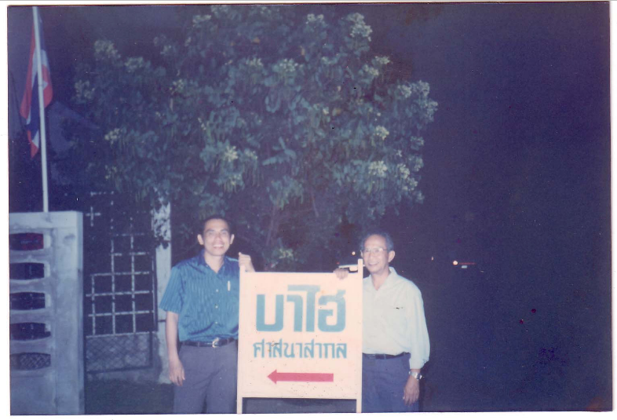
Dr Tawatchai, NSA member & Vic Samaniego visited our Bahá’í Centre

Teaching Activities in Nongkhai

After a few days I met some girls[students]. They approached me and asked me if I could tell their fortune. I told them I didn’t know fortune telling but I could teach them meditation. They became very interested. We made an appointment for early the next day at 7 am. Seven of them came to the Bahá’í Centre and I give to each one a Hidden Word of Bahá’u’lláh and told them that each of them should maintain silence for 30 minutes and mediate on the writings of Bahá’u’lláh. That after 30 minutes we would come back together and tell everyone what Bahá’u’lláh had told us. Every morning and evening the youth came and we prayed together. Then they got the Hidden Words of Bahá’u’lláh for meditation and after half an hour of meditation came together and told each other What Bahá’u’lláh said. One morning a week later, one of them “Miss ANN” said, “my friends invited me to drink but I refused and told them I am a Bahá’í .I don’t drink.” Soon another girl, Dalin, whose house was next to the Bahá’í centre accepted the faith. And soon Miss Pom and the rest of the girls accepted the Faith. They knew that the moment they became Bahá’ís it became their moral obligation to teach the Faith.

At this time I remembered that Dr Muhájir had told me to teach all the villages around the Mekong River. The compiler made a plan to open up the following cities and villages around Nongkhai and establish LSAs : Nongkhai, Tabo, Sichiangmai, Sangkhom, Ponpisai, Korkam, Bung Kan[], Huaisiam, Nongdenta and Bungkla.

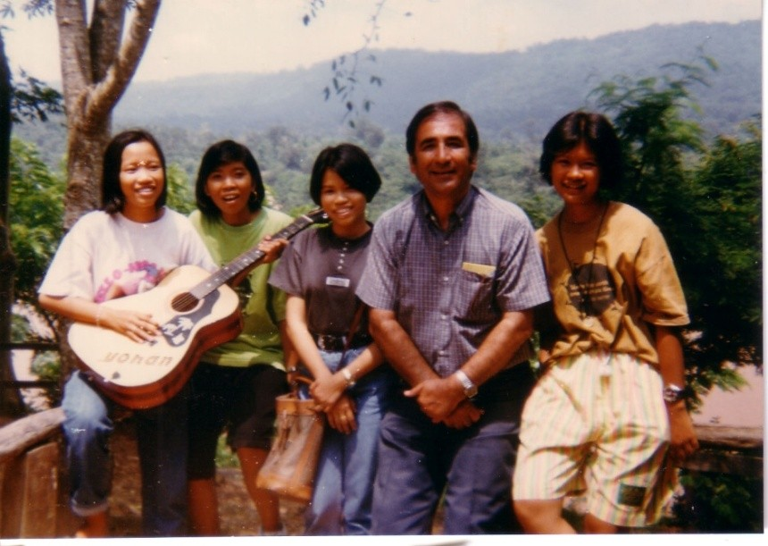
1st group accepted the Faith on a teaching trip.
L-R: Miss Pom, Miss An[our 1st believer], unk, Faridian & Miss Darin

Travel Teacher Miss Alice Ang

Counsellor Dr J. Fozdar sent Miss Alice Ang from Kuching, Sarawak, Malaysia to help with our teaching activities in Thailand. Below is her report to CBC with copy to the NSA and ABM Faridian.

28 November 1991 (Thursday)

We went to Pibun Managsahan to extend our stay for another week and received a letter from ABM Mr Faridian to meet with the Bahá’ís of Nongkhai. Nagen immediately contacted Lek to inform her we were going off. She volunteered to cook dinner (Thai dishes 0 for us. We had wonderful time with her and Nagen’s family.

29 November 1991 (Friday)

Left Ubon for Nongkhai by tour bus at 8 a.m. Arrived at about 3.45 p.m. at the Bahá’í Centre in Nongkhai. ABM Mr Sukhum gave us a warm welcome. Later 2 Bahá’í youths dropped by and met us. They were Darin and Unchally (The first believer in Nongkhai). Unchelly later brought her friend to meet us and she started teaching her the Faith. ABM Sukhum took us and Darin for dinner at a stall where a Bahá’í youth Suzy works. After dinner, we went to the house of Pom and her younger sister. Darin offered her place for us to sleep at night. Her house is next door to the Centre.

30 November 1991 (Saturday)

We had the privilege to observe how the Children’s Class was conducted. A total of 9 children attended. Ms. Unchaelly and Ms Pom were the teachers. After the children’s class Mr Sukhum took all the children and youth present to a temple park for teaching. ABM Mr Sukhum presented a book, Bahá’u’lláh and New Era (Thai), to the chief priest of the temple park. After we left the park, we stopped to buy lunch. A man who works nearby called Mr Sukhum.

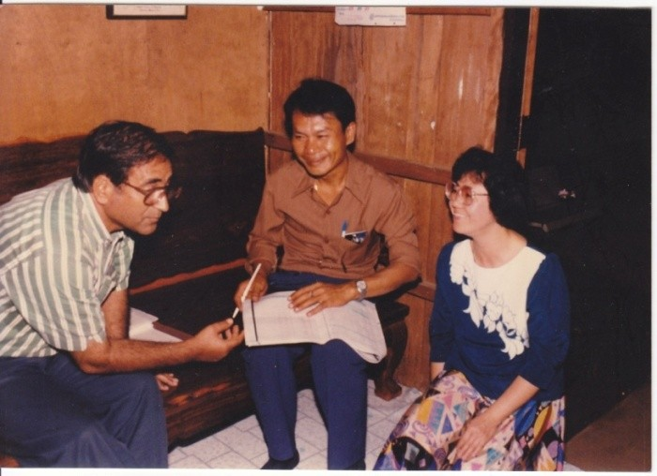
Nongkhai Bahá’í Centre, November 30, 1991
L-R: Faridian, Thanat Sontor, Alice Ang

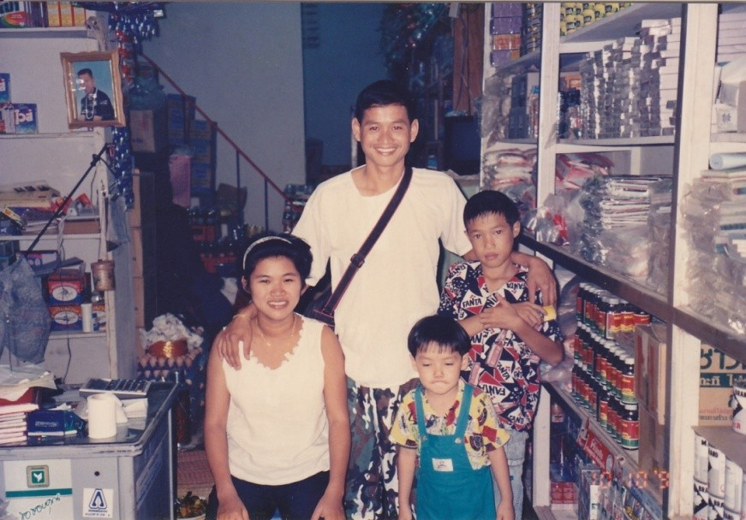
Bung Kan, December 1991. Shop of Noi’s sister & brother-in-law

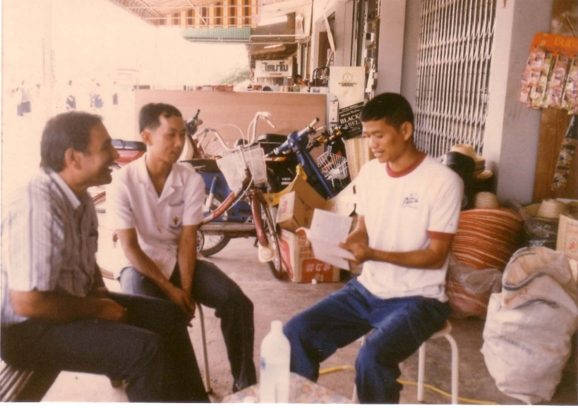
Bung Kan, December 1991. Teaching trip, home visit , shop of Noi’s brother-in-law

He is Thanat Sontor. This man was found earlier by Mr Sukhum lying on the floor (pathway of the street) drunk. Mr Sukhum had given him a prayer book then. Later he was given some Bahá’í books to read. Being a painter he had then rendered some services free of charge for the Bahá’í Centre like giving a signboard, etc. This afternoon he was calling Mr Sukhum because he had painted a portrait of the king to be put up at the Bahá’í Centre on the King’s birthday on 5th December. The portrait was well done. He said he would go to the centre that night. We gathered in Pom’s house for lunch. In the evening, Mr Thanat came and he declared. It is a wonder how waiting souls are found at odd circumstances. Mr Sukhum took us and some youths to a village, Nam khong, to visit 4 youths who have declared. He made arrangement with the Bahá’í youth to take us to Bun Kang the next day.

1 December 1991 (Sunday)

We had the opportunity to speak to the sheriff’s (Nong Khai) wife who is also the landlady of the centre. She was interested to know why we have become Bahá’í at heart. Though she has not declared yet, she says she is a Bahá’í at heart. Mr Sukhum then joined us. The landlady’s eldest daughter who is a Bahá’í dropped by to see us.

We waited for Nur in the morning but she did not turn up. In the afternoon, Darin and her sister joined Mr Sukhum and us to present some Bahá’í books to the former sheriff of the town. Mr Sukhum discussed the Faith with him. It is interesting to know how this request came about. Mr Sukhum could not go teaching outstation because of a backache. He went to the post office and received a cable from Nagen about our arrival to Nongkhai on that day. While coming out of the post office a man who saw the Bahá’í van approached him. He told Mr Sukhum he wants to know more about the Bahá’í Faith. He then scribbled his name and address on a piece of paper and gave to Mr Sukhum. Mr Sukhum learnt later that he was the former sheriff of Nong Khai. Back at the centre, Mr Thanat came to fetch Mr Sukhum to go to his place to bring the portrait to the centre. In the evening Mr Sukhum brought us, some youth and 2 children to Nan Kong to meet Nur again. Mr Sukhum and Darin persuaded her to accompany us to Bung Kan the next day.

2 December 1991 (Monday)

We, with Mr Sukhum, left early morning for Bung Kan with the 2 Thai- Chinese Bahá’í youths. Nur did not turns up. Later we learnt that she had mistook the time and waited for a few hours at the bus station. When we reached Bun Kang at about 10.30 a.m., we went to look for Mr Anuwat, an x- ray technician at the hospital. He took us to the shop house of Ms. Apson, the Thai-Chinese youth. She and her mother cooked a sumptuous lunch for us. Mr Anuwat purposely took a half day off so he could be with us for the rest of the day. Another Thai –Chinese Bahá’í youth, Ms. Rungnapa (Noi) Joined us for lunch. They have so much love for us.

In the afternoon we went to the shop of Noi’s sister and brother in in-law.

Noi’s sister could speak good Teochiew and we had a long talk and told her about the Faith. She would translate to her husband who is a Thai. Mr Sukhum and Mr Anuwat brought us along to visit their contact who has been very helpful to them for village teaching nearby. A few individuals were also taught the Faith at their shop. Noi invited us to her house for dinner. We taught the Faith to Noi’s father who speaks very good teochiew. He is very open about religion even though he is a Buddhist. He had heard about the Faith from his daughter. But he preferred to read Bahá’í books in Mandarin for himself. We promised to send him some books. Mr Sukhum had a deepening session with the 3 Bahá’ís. Later we were joined by Noi’s sister. Half way through listening to Mr Sukhum, she started teaching the Faith to her brother-in-law who came in to join us. We were in Apson’s house for the night.

3 December 1991

We left early for Nongkhai upon arrival Mr Sukhum had to go and fetch Mr Kannabran and ABM Mr Faiz Yeganegi to go to Sakonnakhon. We took this opportunity to go and buy the train tickets to Bangkok.

Comment: Nongkhai is a very receptive area. One has to be there to experience and feel it for oneself. In addition, Mr Sukhum‘s love for all and his reliance on the power of prayer has attracted many to the Faith. Mr Sukhum’s practice of taking local believers with him for teaching and proclamation activities is highly commendable.

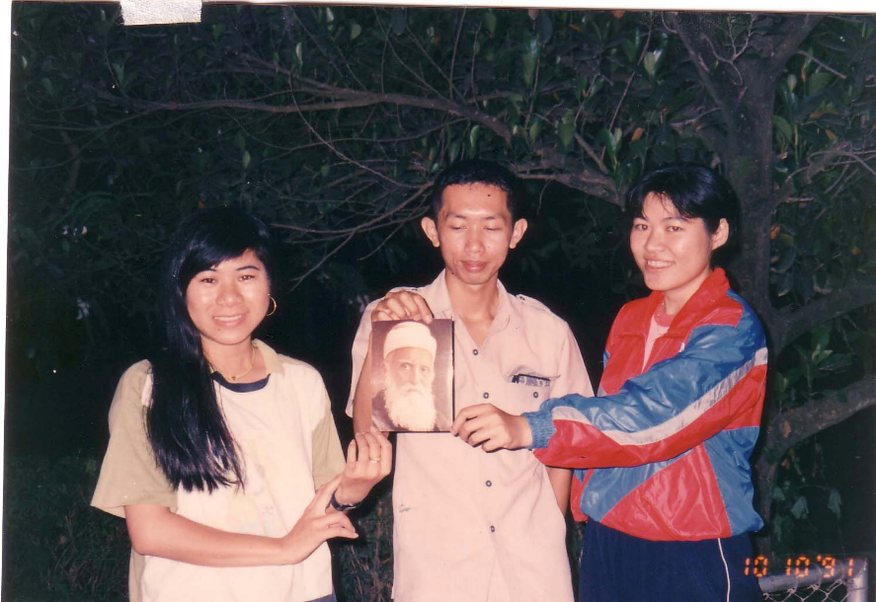
Bunkan, Oct 1991 in Bunkan
L-R: Ms. Apson, Mr Anuwat, Ms. Rungnapa (Noi)

CBC Fozdar letter to compiler (7 January 1992)

“Thank you for your letter of 14 December giving me the interesting news of progress around Nongkhai and your visit accompanying Faiz and others to Chiang Khan, adjacent to Sarakham. You are aware that teaching activities in that part of Thailand / Laos is of great interest to the World Centre and they are keen that this work progresses as rapidly as possible. We are also encouraging the National Assemblies of Thailand and Malaysia to be actively involved in this project and to give all the help and encouragement to you all.”

ITC letter to Counsellor Shantha Sundram (23 September 1991)

“...The Supreme Body was pleased to receive the exciting news about recent teaching success in Nongkhai and has asked that we assure you of its prayers that your assistance to the friends and Institution in Thailand will receive divine blessing and confirmation...”

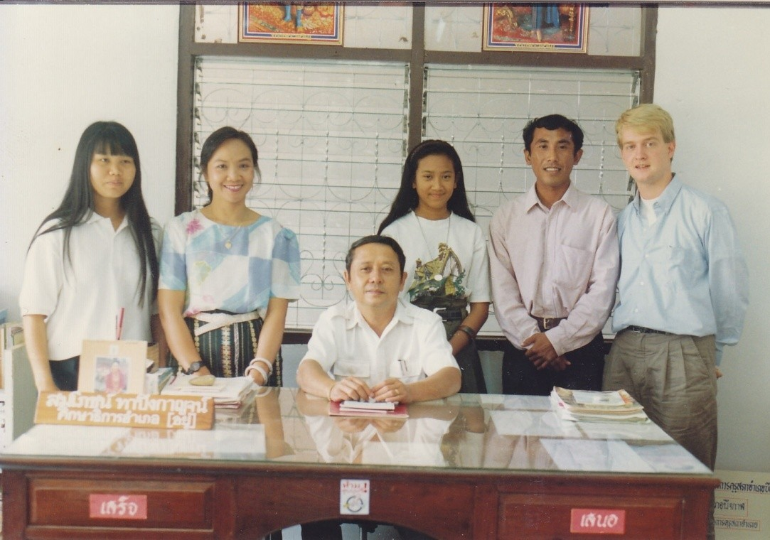
Standing L-R: Pau, ABM Chanchai, Riḍván, Peh, & Adrian Kielhorn
Seated: Than Suksa Amphur of Bung Kan

Compiler’s Cable to CBC with cc: NSA

JOYFULLY ANNOUNCE THE FORMATION OF THE FIRST LOCAL SPIRITUAL ASSEMBLY OF NONG KHAI PROVINCE 15/12/91 REQUEST INTERNATIONAL TEACHING CENTRE BESEECH HOLY SHRINES CONFIRMATION POTENTIAL NONGKHAI THAILAND GATEWAY TO VIENTIANE AND LAOS

“We are very thankful to Bahá’u’lláh that the Local Spiritual Assembly of Nongkhai was formed on 15 December 1991 and they have their first meeting with 8 members present.

The members are as follows:

1. Mrs Dai Thong Supanta
2. Mrs Lamduan Potisen
3. Mr Kampan Kraipon
4. Mr Tanat Sontan
5. Mr Tianq Batanikun
6. Mrs Apandi Nadichun
7. Miss Cheree Namvat
8. Mr Jalan Tantiseree
9. Miss Kanita Tunake[]

ITC letter to Dr Jabbar Eidelkhani (18 October 1992)

...We further acknowledge receipt of a copy of your letter dated 27 August 1992 to Mr Sukhum Abhasakun, Auxiliary Board member, regarding “The Assistant’s Newsletter” It is a fine and informative report that illustrates the progress of the Muhájir Mekong Project, This will assist both national communities of Thailand and Laos to emblazon the name of Bahá’u’lláh beyond human borders and bring harmony and understanding to peoples willing to listen to His call.

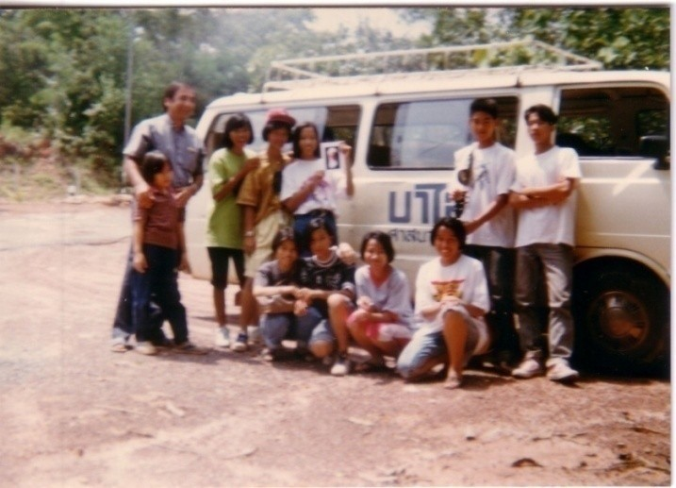
Teaching team in Nongkhai province

One morning some of our Bahá’í youth came to the Bahá’í Centre and told the compiler that they would like to go teaching and asked him to get permission from their parents. I went to see the parents all they said they trust the Bahá’ís. I was allowed to take them but had to return before dark.

We started from Nongkhai toward Bung Kan visiting villages. We had a very good time and were very successful in teaching. Suddenly we noticed it was getting dark and we had run out of our gasoline. We were told that in the village there was gasoline for sale but we should be careful because sometimes it was not pure. We had no alternative way as we needed to fill the tank.

On the way we were very happy, we had had a good day teaching and we are returning the youth to their families as we promised. But unexpectedly the van stopped. I looked around and found that we were in the middle of nowhere. I was very fearful that something might happen to the children. I suggest we pray. After praying I tried again but the van did not start. I don’t know what happened but suddenly I shout loudly “Yá Bahá'u'l-Abhá!” Suddenly the car started and we reach home at 8 P.M. It was not too late. For months the youth were taking about what had happened to us and the power of saying “Yá Bahá'u'l-Abhá!” and they were teaching their friends and their families to say “Yá Bahá'u'l-Abhá!” in time of difficulties.

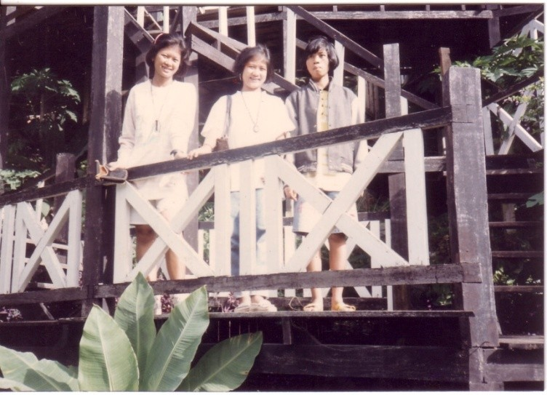
L-R: Miss Darin, Cheree Namvat, Miss An. They were among the first group to become Bahá’ís in Nongkhai. In this picture they are on a teaching trip in Bung Kan

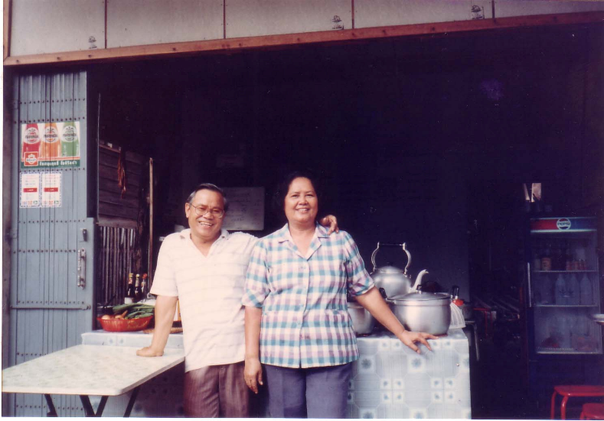
Mr & Mrs Jalan Tantiseree outside their shop, Nongkhai, 1991

Teaching Student Monks

One night two student monks came to the Bahá’í Centre and said the youths had told them about Bahá’u’lláh. They wanted to know more. I asked them in and after serving them some refreshments, I said, “The Bahá’ís believe that there is one Creator or (“Causeless Cause”) which is called by deferent names, and we believe religion is one and humanity is one family. My purpose in coming here is to invite people to work together we work toward world unity and the betterment and happiness of mankind.

They stayed up until midnight. After all their questions were answered with reference to Buddha teaching’s, one of them wanted to become a Bahá’í. I told him that our purpose is not to change the religion of the people because we believe religion is one. Buddha says that “Tama” (moral law) of religion will not change. Our purpose is to serve mankind to replace love with hatred, to establish the unity of mankind and build a new world civilization. The next morning he returned with his friend and told us they would like to go with our team to tell people about Bahá’u’lláh.

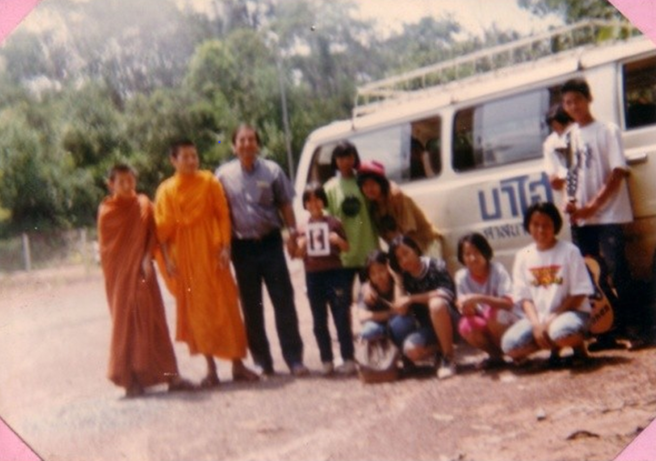
Two student monks join our team

Teaching experience at The Buddhist College in Nongkhai

One of the high ranking monks came to our Bahá’í Centre and approached me saying that he would like to invite me to the college to give a talk on the Bahá’í Faith. I told him that I would like to request that he issue an official invitation. The next day I received the invitation for May 31, 1991.

At the appointed time I went to the Srisaket Temple meeting place. There were more than 400 high ranking monks and their students from different temples in Nongkhai who came to hear about the Bahá’í Faith.

I started by thanking them for their invitation. I said that I didn’t know when Buddhism reached this part of the world because different opinions exist about the matter. Some believe that Buddhism was introduced to Thailand during the reign of Asoka, the great Indian emperor who sent Buddhist missionaries to deferent countries.

Others believe Thailand received Buddhism much later. I told them that Thai people are pure hearted and ready to accept spiritual truth. When the missionaries reached Siam the Thai people listened to the beautiful teaching of Buddha they accepted and practiced the wonderful teachings and the whole country became Buddhist.

They did not say that this is not our religion, they did not say that Buddha was not a Thai, they did not say that this is an Indian religion, before they said anything they practiced it and they found wonderful.

Buddha has said that “Tama” (moral teaching) never changes. Bahá’u’lláh the founder of the Bahá’í Faith teaches us that religion is one, man is one and the world is but one country.

The Bahá’ís believe every Buddha (i.e. the enlightened ones) have two kinds of teachings, spiritual, which, as Buddha has said will not change, and social, which can change. That is why Buddha says “I am not the first Buddha who came upon the earth, nor shall I be the last, in due time another Buddha will arise in the world. A Holy one, a supremely enlightened one...He will be known as Maitreya”,

At this time I requested that they close their eyes and imagine that they were taken back to the time of Buddha. He encountered questions like how in India the King, the Queen and the people believed in the Hindu religion and were happy with their religion and asked why he told the people not to worship material. They asked why he told people not to worship the Hindu gods and why he created disunity in the country. Buddha replied that to investigate the truth. The ordinary people after practicing his teaching whole heartedly believed in him but the religious leaders tried to prevent people from believing in Buddha because they were afraid of losing their incomes, their comfort and their positions. I said that The only suggestion I had for them is to investigate the truth. Maitreya Buddha came to establish peace, unity and love among the people of the world.

The monks asked me many questions and it seemed to me that they were finally satisfied with my answers to their questions. After some time I was requested to teach English conversation to BA (Bachelor of Arts) students using religious subjects.

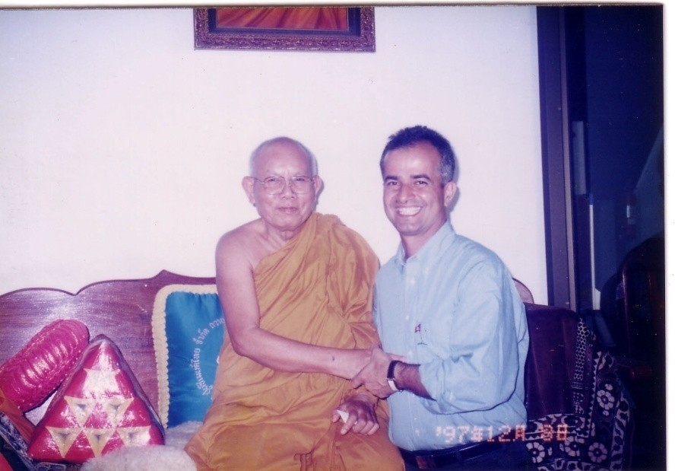
Srisaket Temple, Nongkhai 1972.
Masoud Sobhani, a Bahá’í visiting from Japan, with the Abbot

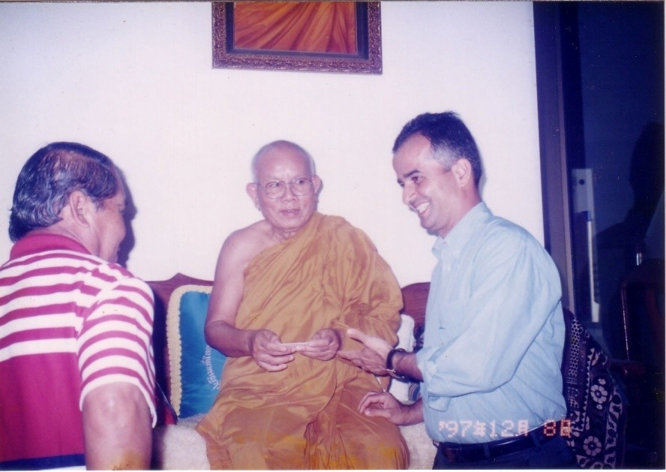
Srisaket Temple, Nongkhai, 1972. Masoud Sobhani, a Bahá'í visiting from Japan, accompanied by Mr Somai Nanongkhai, the vice governor, a close friend of the Bahá’ís as translator, with the Abbot

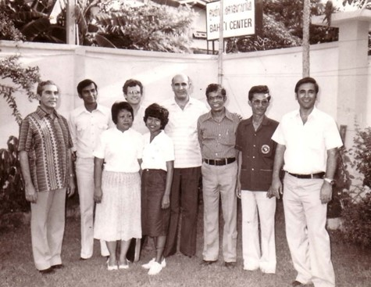
Duplicate?? Check later

Bangkok Bahá’í Centre, Thai ABMs with Counsellors:
L-R: Dr John Fozdar, Kanna, Chusiri, Vaughan, Montha, Nasser, Dr Sundram, Suwai Thongsuk, Sukhum Abhasakun (Faridian)

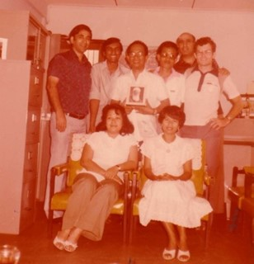
Duplicate?
Counselor Vicente Samaniego with Auxiliary Board members in Thailand
Standing: from left to right Sukhum Abhasakun, Kanna Bran, Counselor Vicente Samaniego, Suway Thongsuk, Nasser, Vaughn Smith
Seated: Chusiri & Montha Greenspoon

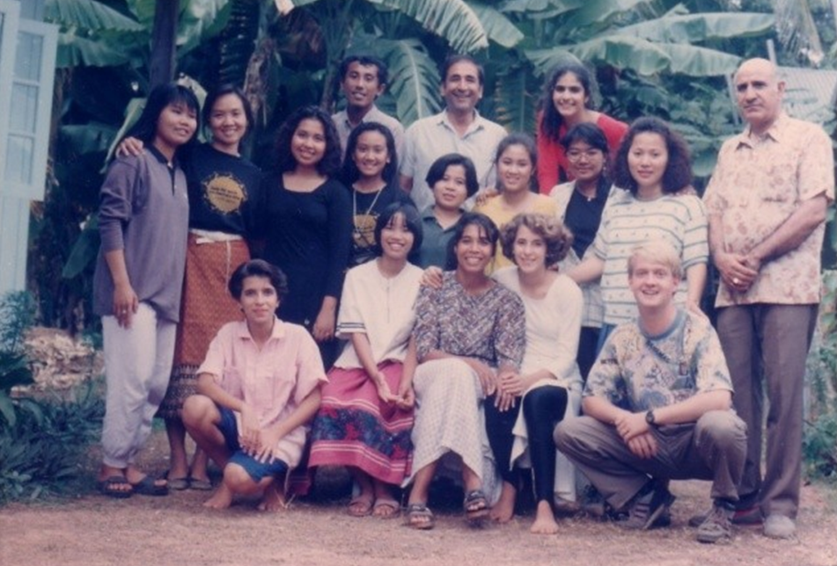

The news of teaching activities in Nongkhai was encouraging for all of us the friends from deferent part of Thailand North, South, Central and visitors from neighbouring countries Singapore, Malaysia, Laos even as far as America were coming to Nongkhai to assist in our teaching activities.

I would like to share with you the feelings of our beloved pioneer from Chiangmai Mr Nasser Jafari he says “The spirit of Dr Muhájir is definitely around the area as in one night in Nongkhai he dreamed of Bahá’u’lláh, Dr Muhájir and Collis Featherstone.

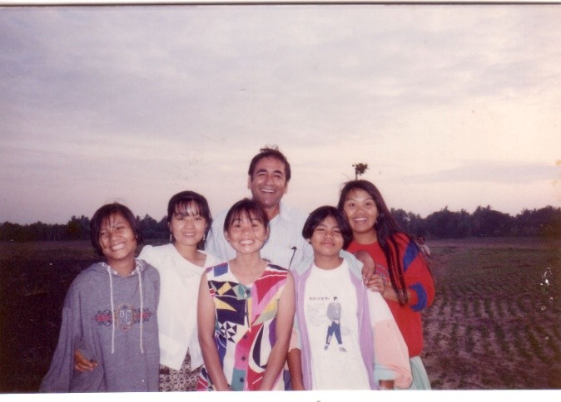
Sangkhom, Nongkhai, Nov 1992, Teaching team
L-R: unk, Toi, unk, Faridian, Nootky (from Laos), unk

“…The Supreme Body was very pleased to receive the exciting news about recent teaching successes in Nongkhai and has asked that we assure you of its prayers that your assistance to the friends and institutions in Thailand will receive divine blessings and confirmation…”[]

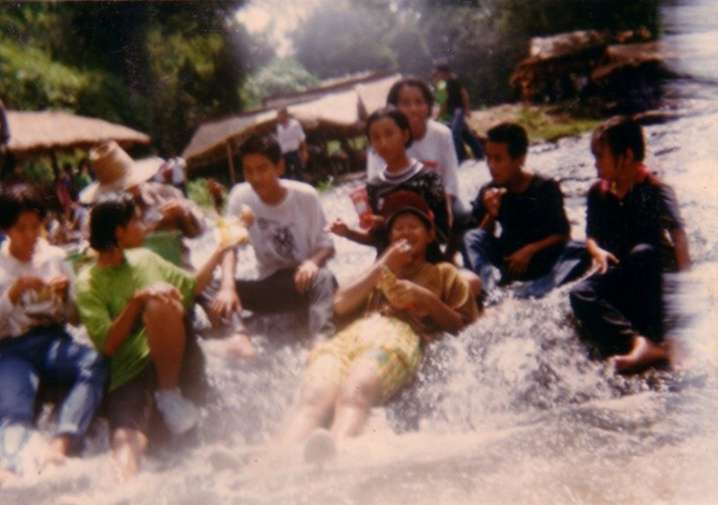
Our happy teaching team

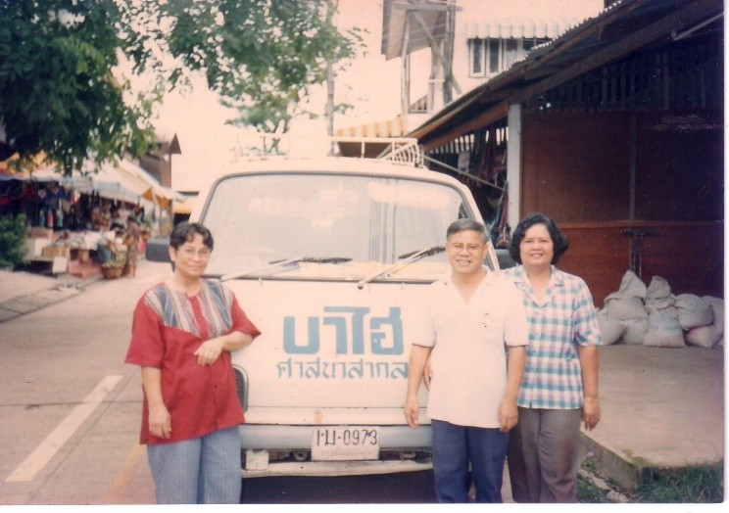
L-R: Mrs Maliwan, Mr & Mrs Jalan; three members of Nongkhai LSA

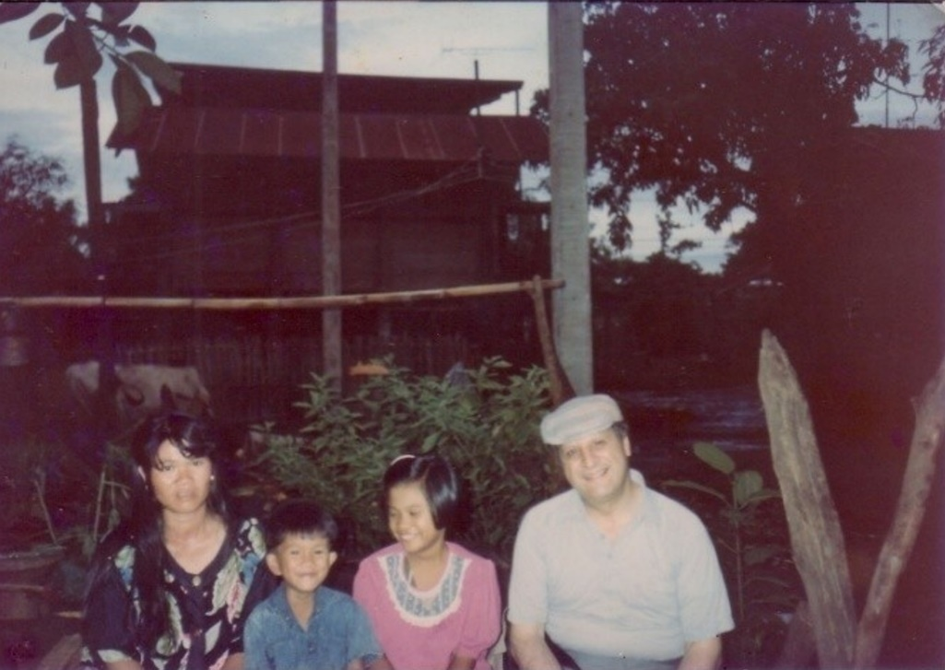
Baan Dong Charoen, Nongkhai. Firaydun visited
Mrs Nang & her two children, Chart & Pui

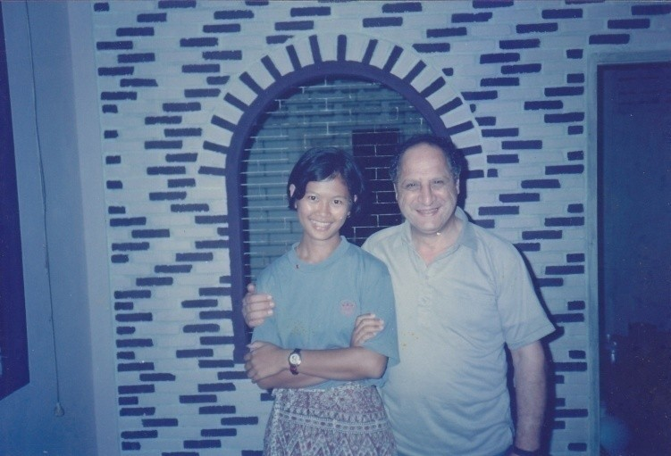
Bung Kan, Nongkhai. L-R: Miss Darin, Firaydun

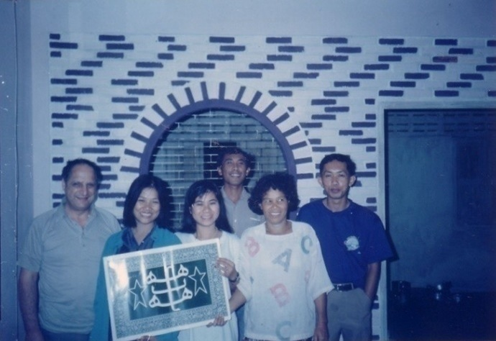
Bahá’í Centre, Bung Kan, Firaydun with group of youth

Mekong Project report from Firaydun dated to the Compiler (16 Aug 1992)

An outstanding feature of the above nine day teaching and consolidation work was the strong sense of unity and cooperation that emanated like a sweet fragrance from the teaching team which, at a high level, captured the hearts and made the audience from the Teaching team which, at a high level captured hearts and led the audience to bow in submission to the countenance of Bahá’u’lláh in whose teachings they could recognize the glory of the Promised Maitrya-the fifth Buddha. in fact reportedly, an old man cried upon hearing that the promised Maitrya had at last come.

The Teaching Team varied between four and ten members including four youths (travel teachers) from Laos, one full-time Thai teacher, two local youths, an Auxiliary Board Members and the compiler.

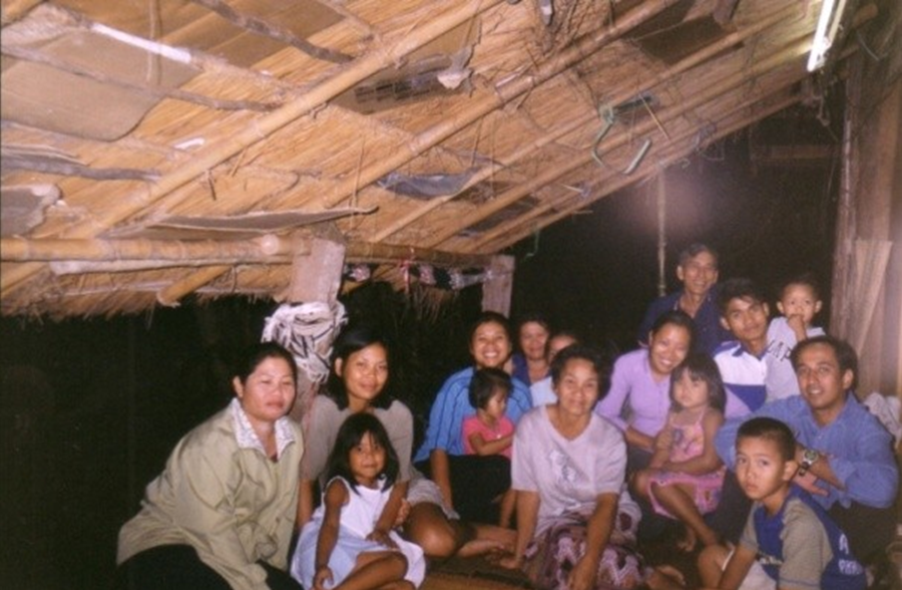
Baan Dong Charone, Nongkhai.
Devotional meeting at Mrs Nang’s house

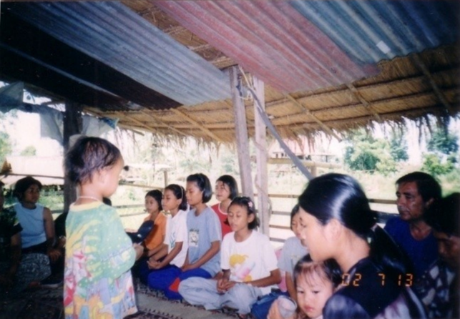
Most of our believers before becoming Bahá’ís began by making home visits, travelling teaching, participating in study & devotional meetings, e.g, in this picture you can see Ms Jiab

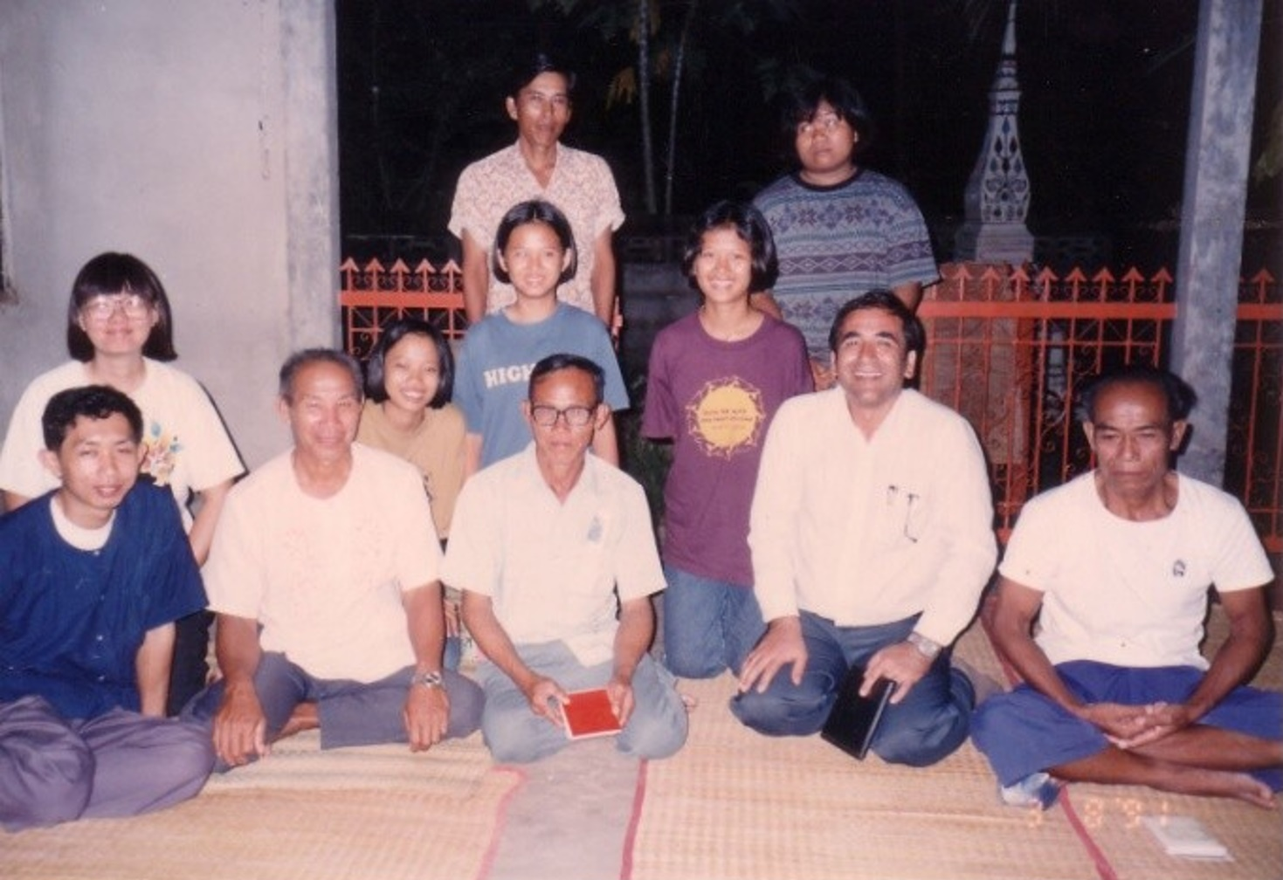
ABM Sunapa (Yai) visiting to help our teaching in villages

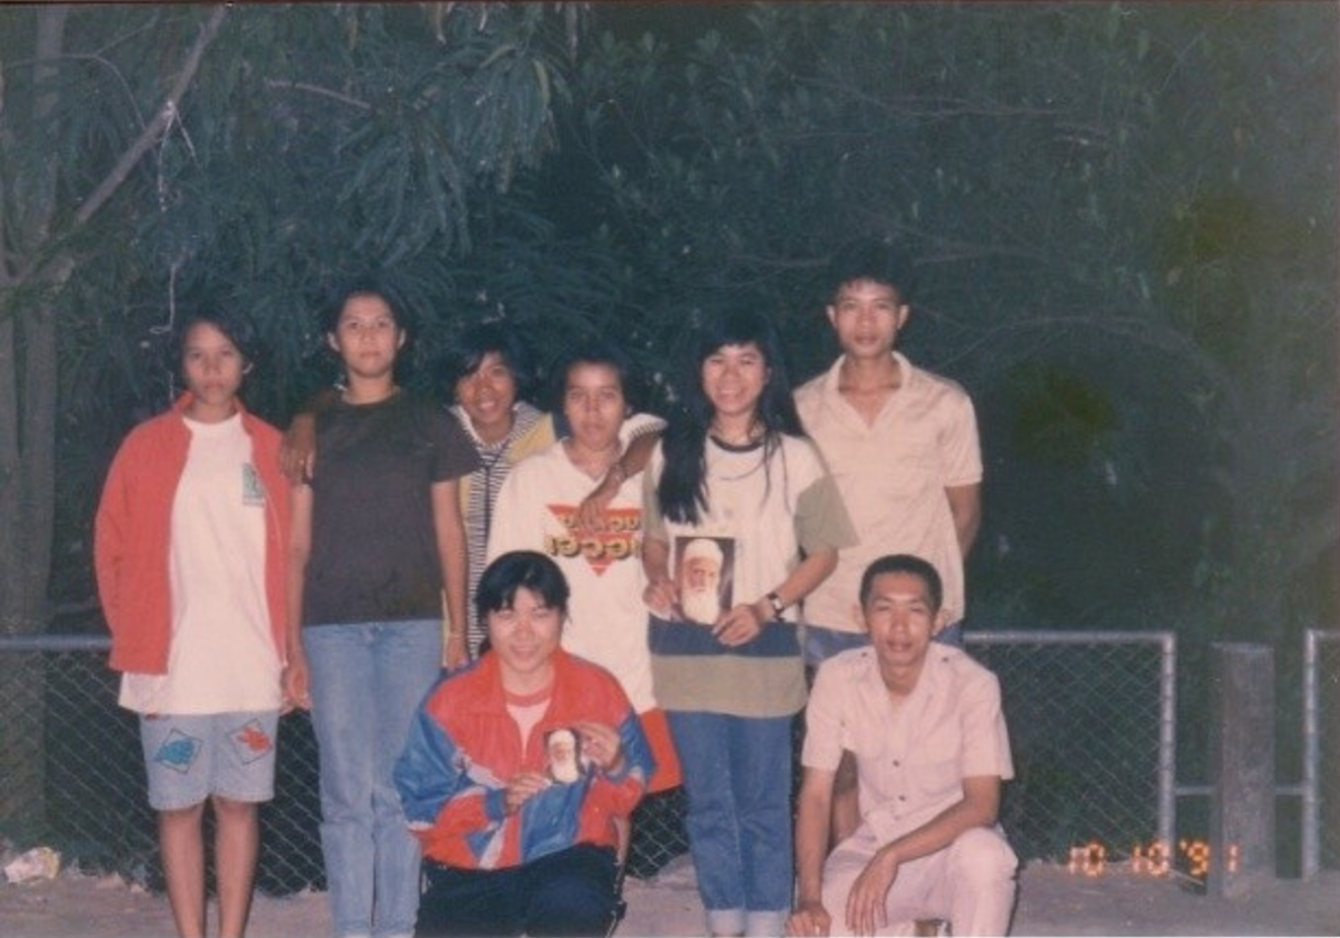
Bung Kan, Nongkhai. Youth teaching activities
3rd from left is Miss Ann, our first believer in Nongkhai

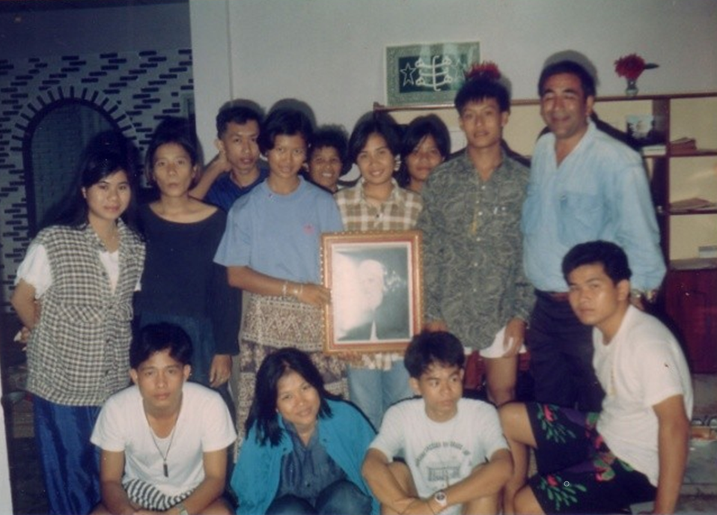
Bung Kan “Bahá’í Centre”. A house was rented for activities
of our teaching team. A few friends from Laos joined us

Repetition?
Nongkhai at house of Mr & Mrs Jalan.
L-R: Miss Darin, Mr Jalan, Mr Peh, ABM Chanchai, Faridian

CBC letter from Dr Edelkhani to Faridian w/cc to NSA Thailand & Laos (13 Jul 1992)

... In the last meeting of a group of Counsellors it was decided that you shall also be considered an Auxiliary Board member whenever travelling in Lao PDR. ABMs Mr Faiz Yaganegi and Mrs Chanchai Baran are already informed verbally that they shall have similar status while travelling along the Mekong River on the Thailand side.

This shall provide all of you a better opportunity to accelerate your border teaching activates.

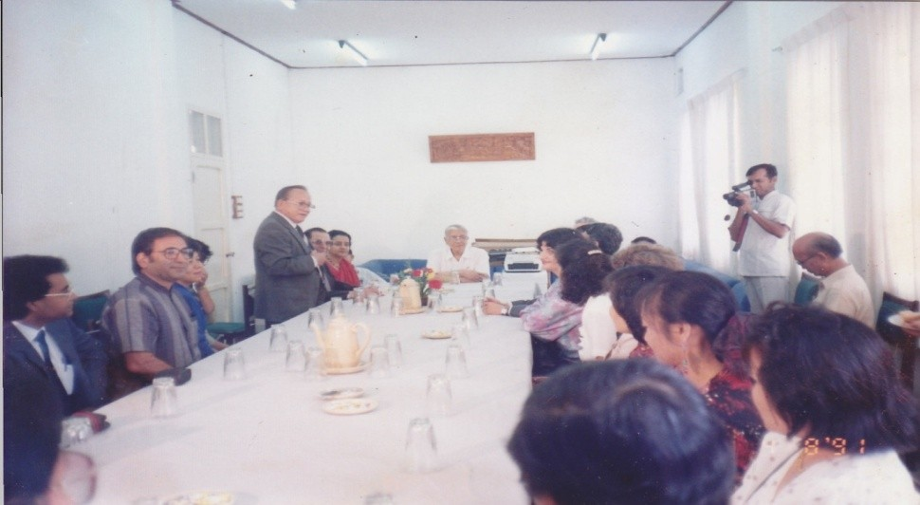
NSA of Laos arranged a courtesy meeting of friends from Laos, Thailand &
Malaysia to meet His Excellency the Chairman of the Lao PDR

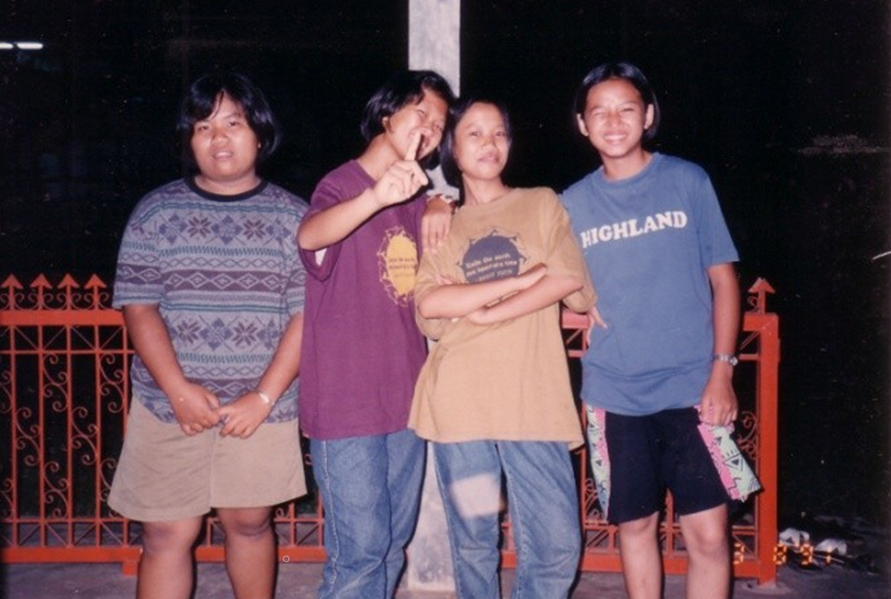
Some youth in Nongkhai. In the middle are Darin & Pom

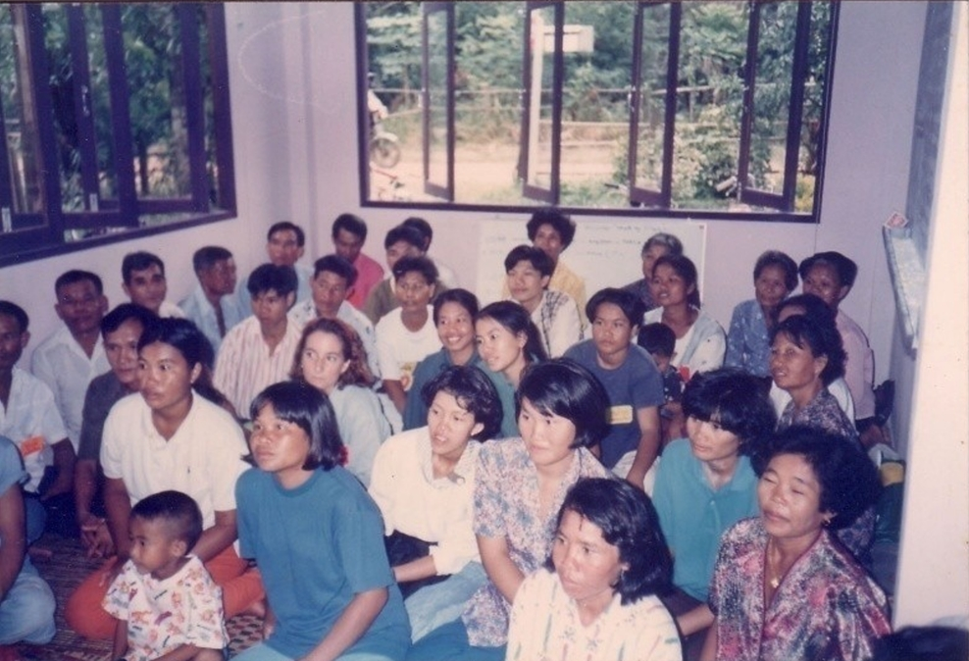
Deepening believers in the Faith at a rented house in Bung Kan

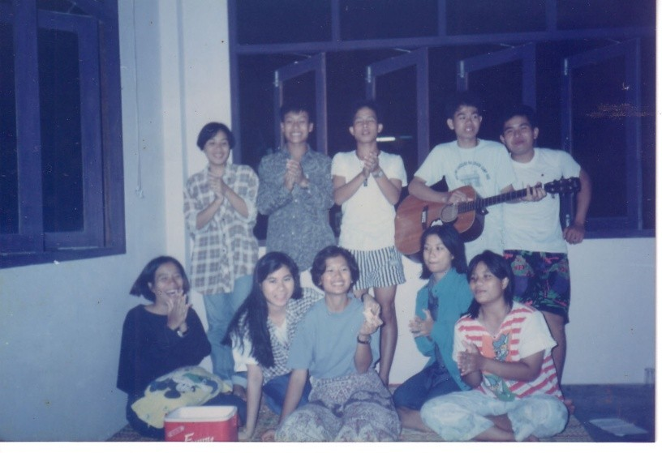
Bahá’í songs performed by the youth in Bung Kan

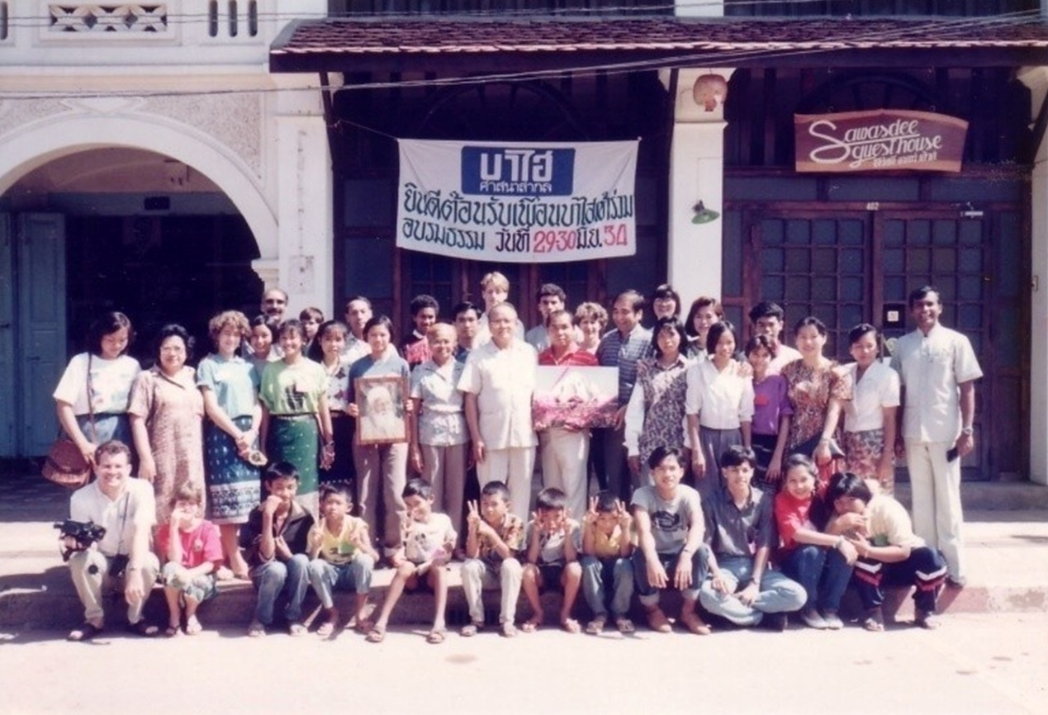
First Thai-Lao deepening institute on 29-30 June 1991

The Deputy Governor Mr Samai Na Nongkhai was invited to the first Thai-Lao deepening institute on 29-30 June 1991. He spoke for more than one hour and said this heart brought him to this meeting. He wished for the progress of the Faith in Nongkhai, and sent his best wishes to Shirin Fozdar, whom he had met before.
[NB: This is a work in progress: people still missing, order may not be correct. VS]
Back: L-R: Chanchai Baran, Chusiri, Soraya Mottahedeh, Rizwan Baran, Pethlumphan (Node) Yaganagi, Soheyl & Vahid Mottahedeh, Mr. Chantana, Vantui (from Vietnam), Hushman Yaganagi, Mr Samai Na Nongkhai (Deputy Governor), Bopan, Monique Mottahedeh, Faridian, Yai, Somlak, Pom, Elaheh Mottahedeh, Muongma Yaganagi, Veerapa, Kanna Baran,
Front: L-R: Vaughan, Fariba Mottahedeh, Santi Baran, Bay Yaganagi, Wirongwrong,

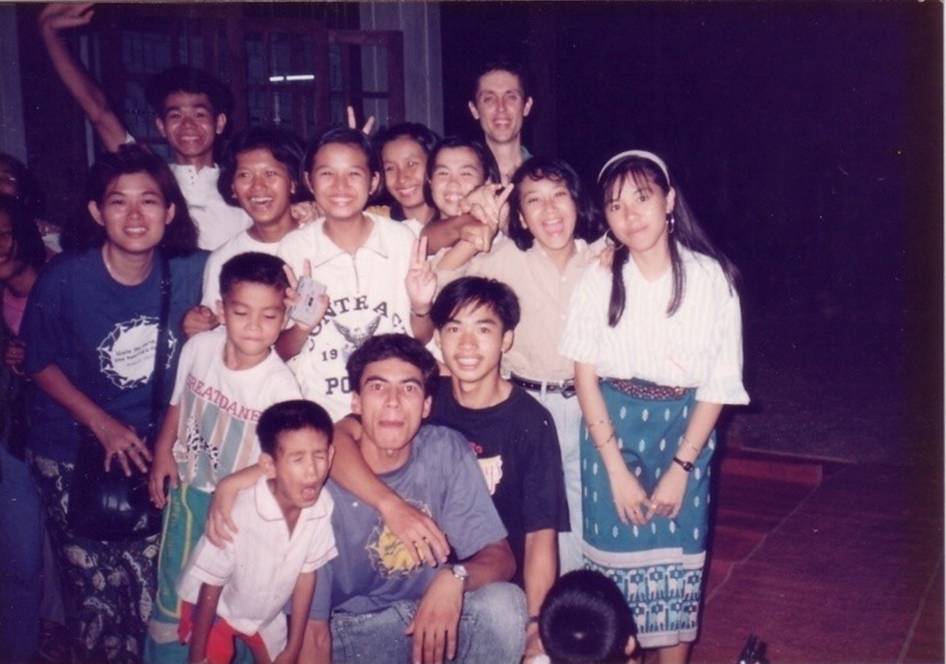
Some Thai Lao youths serving in the Border teaching project

Many thanks to the Laotian friends who regularly assisted our project; we received great help from friends in Laos. The Thais in the north-eastern border area are ethnic Lao and when the Laotians cross the river into Thailand for teaching activities, they are not strangers. You can see in the faces of the youth how happy they are.

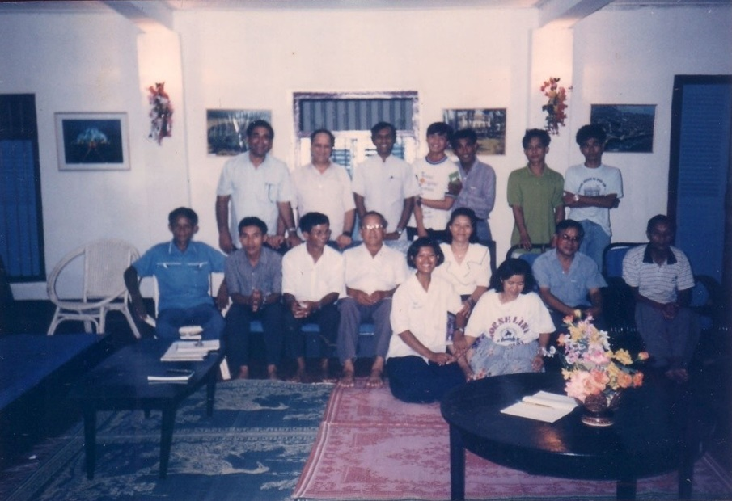
Bahá'í Centre, Vientiane, 20 Oct 1991: Members of the Muhájir Mekong Teaching Project Committee, the compiler & members of Thai & Lao National Assemblies. They met to share the progress of the Faith.

Mekong Teaching Project: A Report[]

Dear John,

A meeting was held in Vientiane between ABM Faizollah Yeganegi, Mr Sukhum Abhasakun (Teaching Coordinator Thai/Lao Border), Mr Kanna Baran and Mr Soheyl Mottahedeh Assistants, launching of a vast teaching activity along the Thai and Lao borders.

Mr Sukhum was accompanied by 6 believers from Thailand (4 new) who were invited to attend the celebration of the Birth of the Báb in Vientiane. A good opportunity was given to consult with the friends in Laos.

Background & Context of the suggested Mekong Teaching Project:

- 10 million people of Lao origin live in Thailand and 3 million in Laos. Most are direct relatives and have continuous relationships with each other.
- Borders are open to them for trade purposes in remote areas at least once a week. In bigger towns like Nongkhai the borders are open 6 days a week.
- Experience has shown that when the new believers cross the borders their teaching efforts are much more successful than[they are] among their own relatives.
- Dr Muhájir, beloved Hand of the Cause, often referred to the area between Thailand and Laos.
- In 1969-71 a number of pioneers were encouraged by Dr Muhájir to teach the border villages along the Mekong River. One of them Mr Sukhum was assisted to do this border teaching activity on full time basis. Due to the changes of the regime in Laos this programme was postponed for the future.

Due to favourable conditions now existing in Thailand and developing in Laos, and improvements in transport and communication now under consideration or construction between these two countries (3 major bridges over the Mekong) , it is suggested to the Counsellors, if agreeable, to endorse this Teaching Project and get the blessing and approval of the 2 NSAs involved.

In the past 6 months, 8 localities on the Thai side have been opened and more than 80 believers have entered the Faith. On the Lao side teaching activities in the past allowed the establishment of the Faith in 6 border towns. As people on each side of the border are relatives, a special opportunity is now being given to teach families on both sides.

A number of villages at the Lao border are still inaccessible for the Bahá’ís of Laos. Those villages can be very easily approached from the Thai side, when borders are opened weekly. The towns that are on each side of the border and that can be matched for teaching purposes are:

 | Thai side | Lao side
1. | Chiangkhan | Salakhan
2. | Srichiangmai | Vientiane
3. | Nongkhai | Thadeua
4. | Boungkang | Paksane
5. | Nakorn Phanom | Thakek
6. | Mukdahan | Savannakhet
7 | Tahuthin | Himboun (near Takhek)

CBC letter to Compiler[]

Mr Sukhum Abhasakun
Thailand

Thank you for your letter of 14 December giving me the interesting news of progress around Nongkhai and also your visit accompanying Faiz and others to Chiang Khan, adjacent to Sarakham. You are aware that the teaching activities in that part of Thailand /Laos are of great interest to the World Centre and they are keen that this work progress as rapidly as possible....

The work that you are doing is truly praiseworthy and a source of much inspiration and encouragement to all of us. I was particularly pleased to see the adventurous spirit that you are using to open up Laos from the Mekong to the west and east, making sure that all obstacles are overcome, to ensure that this receptive people receive the message as soon as possible.
John Fozdar

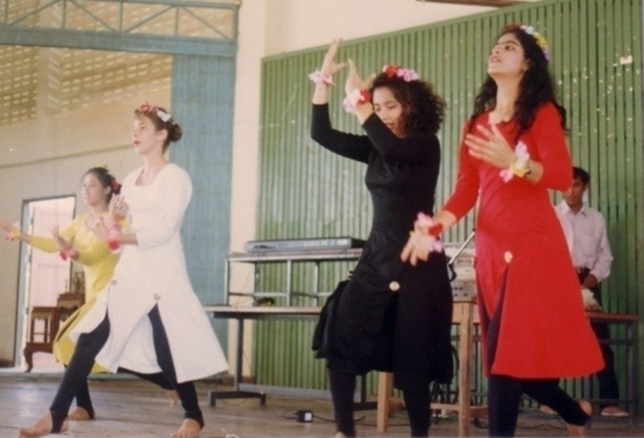
Performance at Pathumthep Wittaya school, Nongkhai
L-R: Wilairat (Yasothon), Soraya (Laos), Sulee (Bangkok) & Golbang from Chiangmai

A performance at Pathumthep Wittaya school in Nongkhai where 1,000 students were able to enjoy the performance but more importantly learn about Bahá’u’lláh, Darine who studied at the Pathumthep Wittaya school introduced herself as a Bahá’í after the performance and invited anyone who was interested in learning more about the Bahá’í Faith to contact the Bahá’í Centre or herself.

The group also performed at the village of Bungla. The community of Bungla gave them a warm welcome and prepared a feast for them. The performance, which attracted more people than it usually would at the village, was held at the house of one of the LSA members. The crowed enjoyed the performance very much and many stayed behind to ask about the Faith.

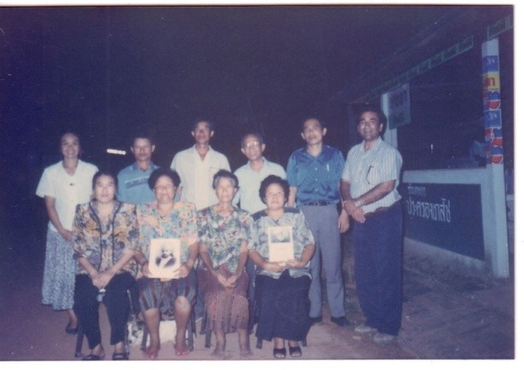
Counsellor Vic, Dr Tawatchai (Thai NSA rep), & compiler visit the
LSA of Bungla (one of most active Assemblies in Nongkhai)

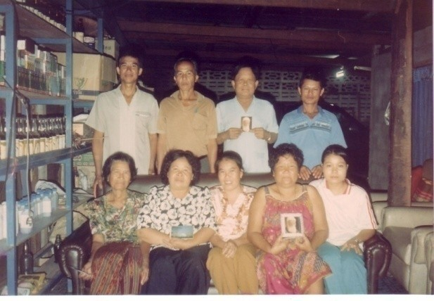
LSA of Bungla, Nongkhai

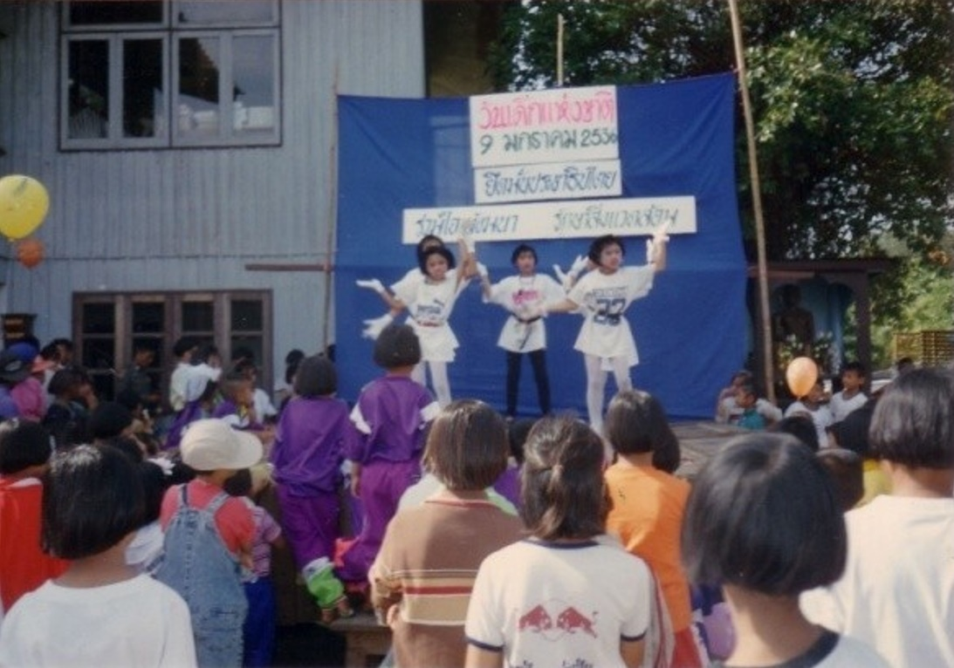
Bahá’í children win dance contest

On the occasion of Children’s Day on 9 Jan 1993 the Bahá’í children of Sangkhom participated in a dance contest organized by the local authorities. They emerged as winners of the contest and received prizes from the chief of police. They also publicly identified themselves as Bahá’ís. They give the message that they believe in the oneness of mankind, the oneness of religion and expressed love for all. Many thanks to Bahá’í youth, Miss Corrine Smith, who took time off to help them with the dance.

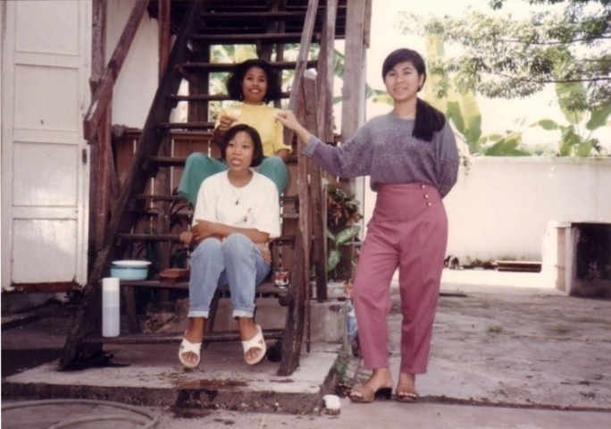
Sitting above: Sulee (Tim),
Sitting below: Miss Pom, Miss Apson (standing)

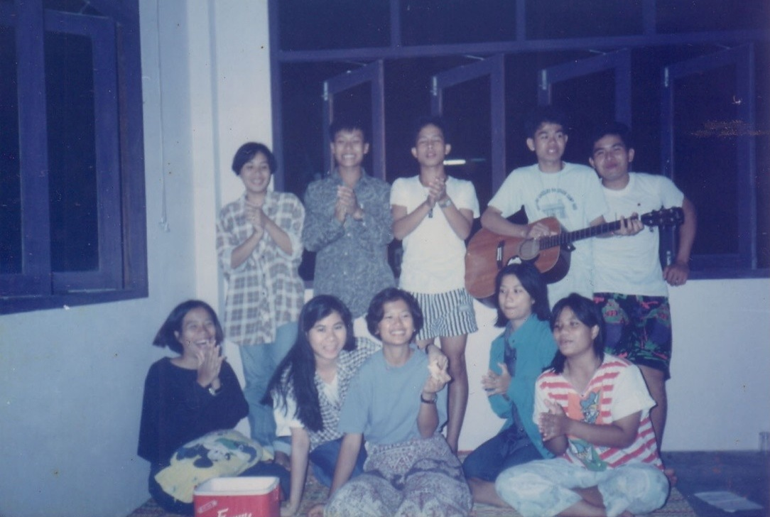
Lao & Thai youth singing at deepening session in Bung Kan

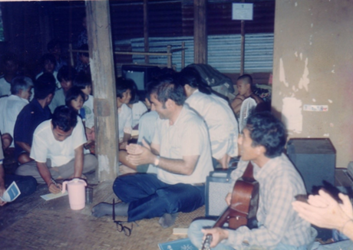
Village after village around Mekong River were embracing the Faith

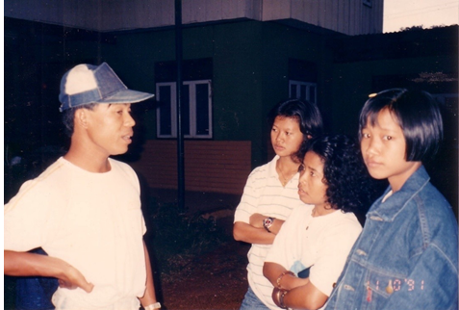
L-R: Miss Pom, Miss Tim & Miss Darling visited a radio announcer & gave him a Bahá’í pamphlet. The next day he read the whole pamphlet on the radio

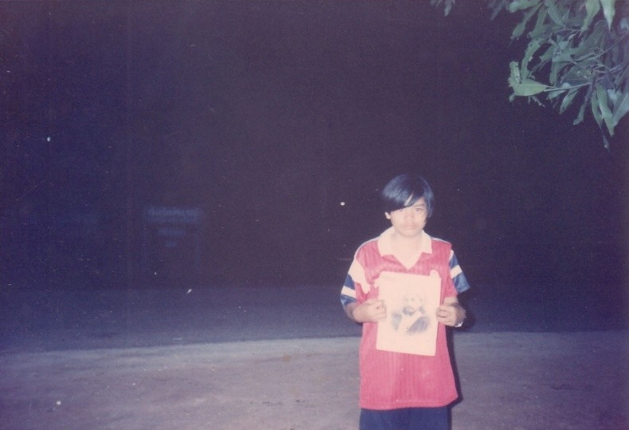
Assistant to ABM, Miss Toi of Sangkom

In October 1992, the compiler received a report from a 15 years old youth who was his assistant for Sangkhom offering service to Bahá’u’lláh for the Holy Year. Her personal teaching resulted in more than 70 youths embracing the Faith of Bahá’u’lláh. The compiler was greatly touched by the courage of the young girl. He went to see her personally. She informed him that over 226 youths had accepted the Faith. Although she has a quiet and shy nature, she was not prevented from teaching as she has learned to draw strength from the concourse on High and relies completely on prayer.

Before doing anything else, she prays. She then gathers her friends to read and meditate on the Holy Writings together. When asked if they feel happy and like it, she asks, “do you want to serve Bahá’u’lláh by teaching and telling people that the 5th Buddha has appeared and His name is Bahá’u’lláh. He has brought happiness and prosperity for the people of the world. They then say they want to be a Bahá’ís.”

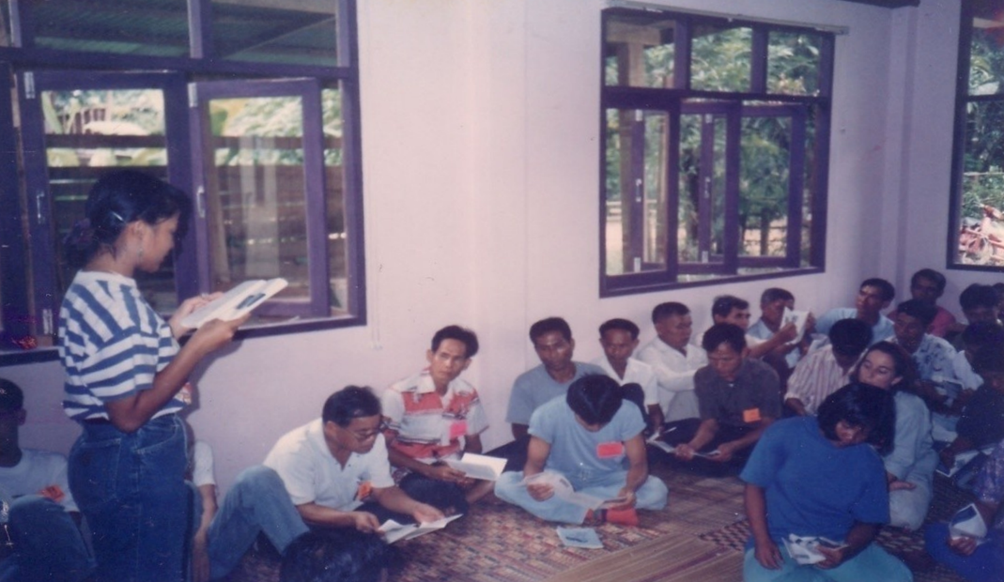
Bahá’í Centre, Bung Kan. Miss Pom tutoring part of deepening programme

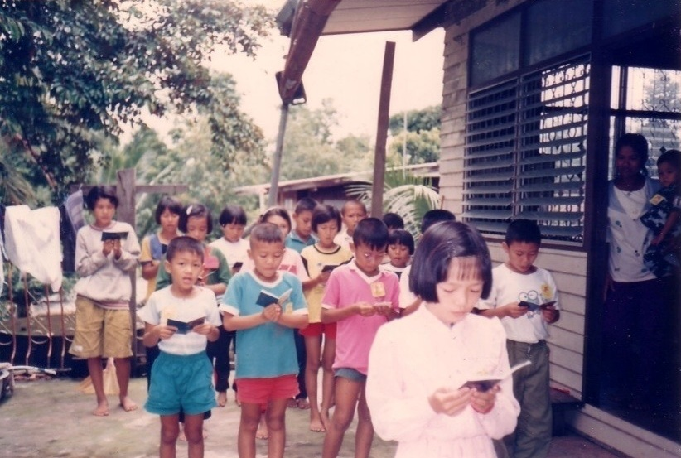
Bung Kan, temporary Bahá’í Centre. Children learning Bahá’í prayers by heart.

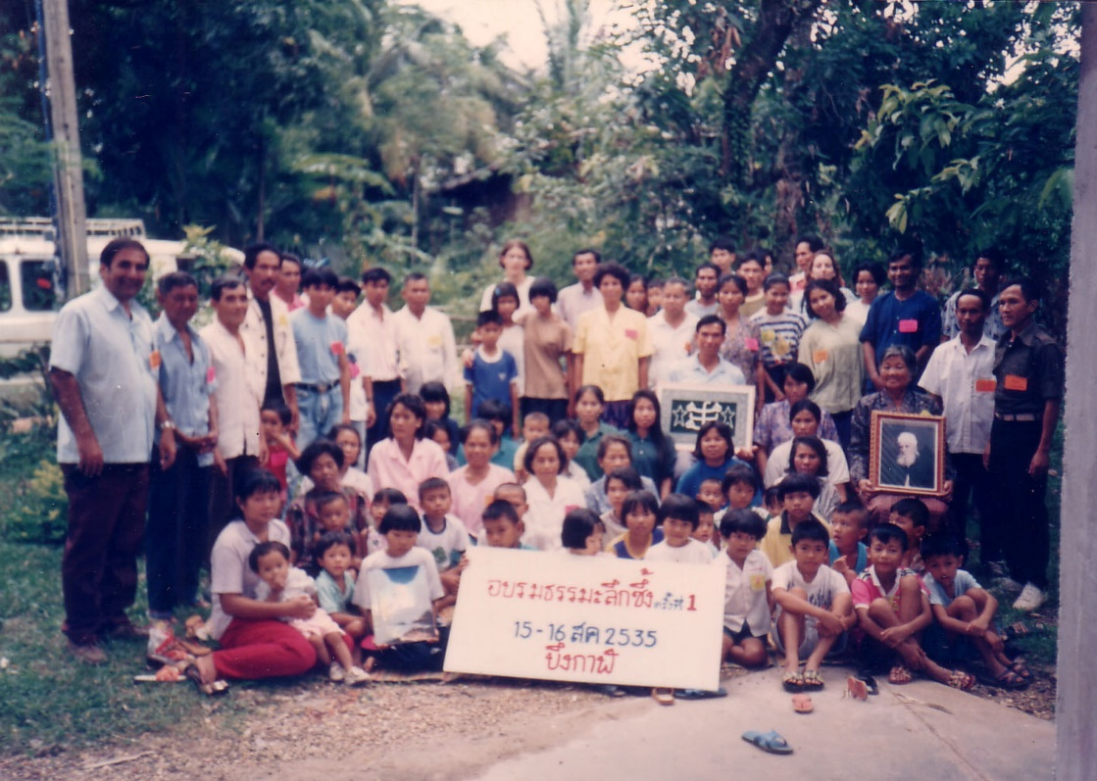
Bung Kan Bahá’í Centre, 1992, Bahá’í friends & families from
villages along Mekong River during 2-day deepening conference.

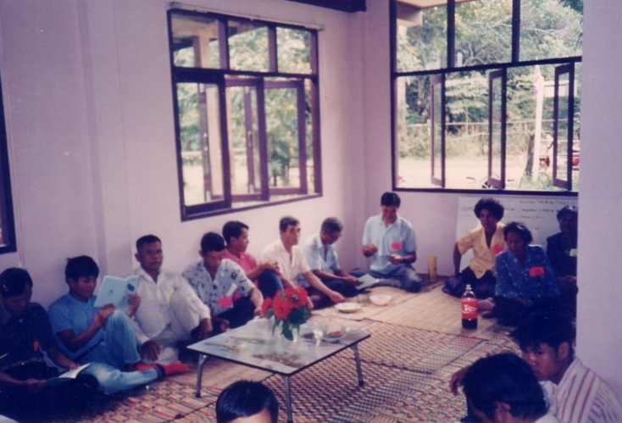
Bung Kan Bahá’í centre, 1992. Deepening class

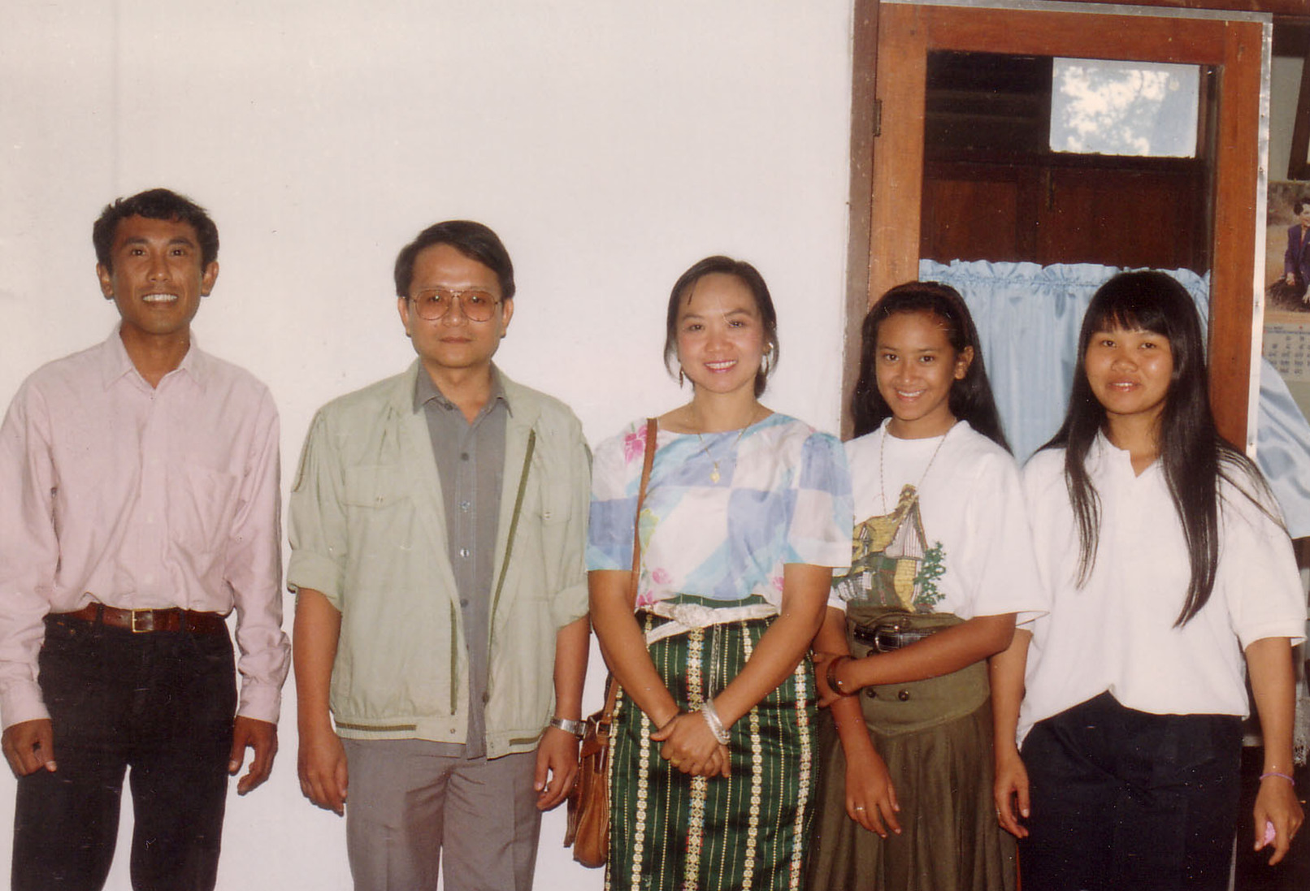
Delegation of 5 friends went to see the Seksatikan Amphur of Bung Kan (District officer for Education) & the Palat Amphur of Bung Kan (Asst. Sheriff)
L-R: Peh, Palat Amphur of Bung Kan, Chanchai, Ridwan and Pau

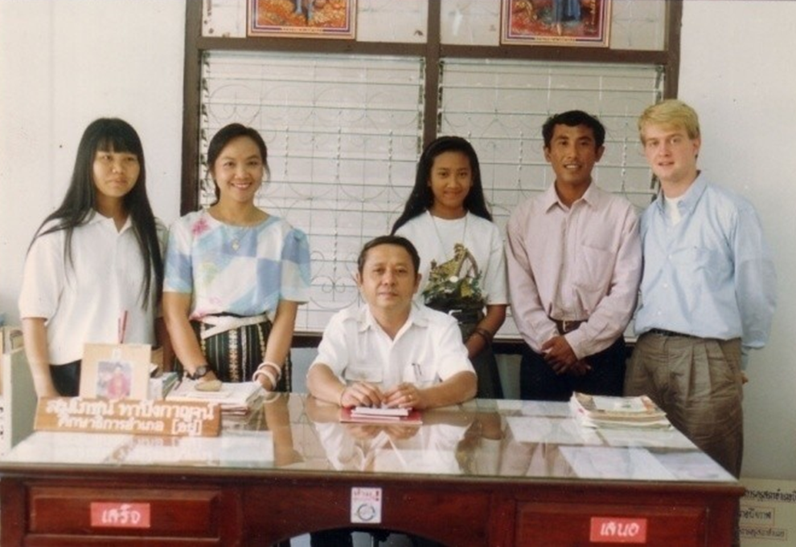
Standing: R-L: Pau, ABM Chanchai, Rizwan, Peh & Adrian.
Seated: the Than Seksa Amphur of Bung Kan

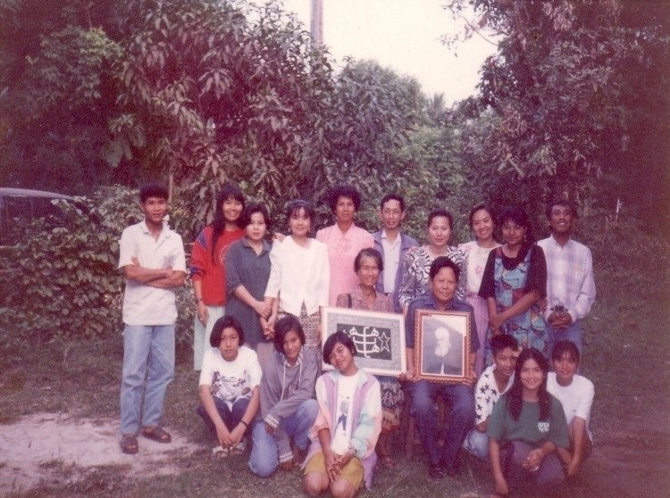
Institute in Bung Kan was conducted by ABMs Chanchai
from Laos & Mrs Veerapa from Thailand (31 Oct 1992)

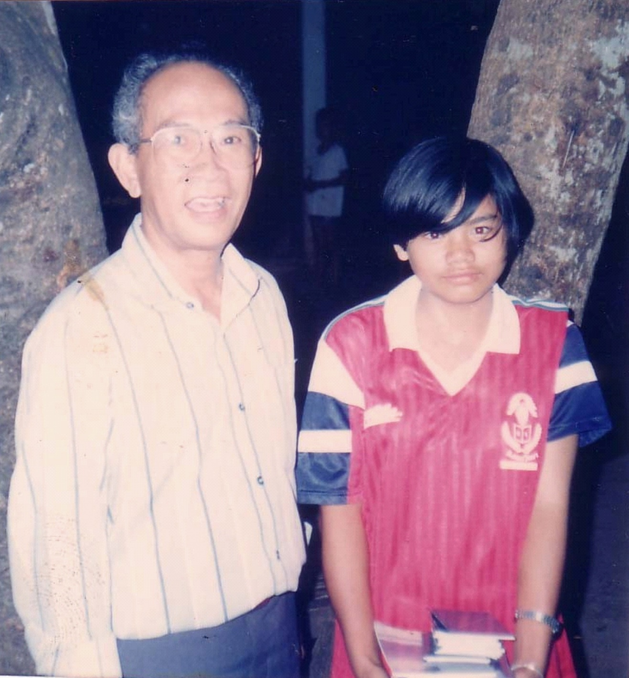
Nongkhai. Counsellor Vic with Miss Daoi from Sangkom. Her personal
teaching campaign resulted in more than 70 youth embracing the Faith

The END

[] Email dated March 23, 2009 from the Secretary of the Spiritual Assembly of the Bahá’ís of Thailand to compiler
[] Hand of the Cause of God Dr ‘Alí Mohammad Varqá in his letter dated November 22, 1976 addressed to the National Spiritual Assembly of the Bahá’ís of Thailand mentioned “…The Universal House of Justice instructed me to communicate with all the National Assemblies and pioneers throughout the world, and gather together these documents which will serve to study and put in writing the history of the Faith during the Formative Age in future.”
[] Mr Vicente Samaniego usually called Counsellor Vic.
[] Continental Board of Counsellor Mr Vicente Samaniego in his letter dated June 5, 1996 wrote “I am very happy to see that somebody has initiated writing about the early history of the Faith in Thailand.”
[] The Spiritual Assembly of the Bahá’ís of Laos in their letter dated June 1, 1990 mentioned “One of the things needed for our National Archives is the written experiences of the former pioneers like you.”
[] The Spiritual Assembly of the Bahá’ís of Thailand in their letter dated July 10, 1996 mentioned “To our knowledge this is the first attempt to compile and print a comprehensive history of our beloved Faith in Thailand. We urge you to continue this important work by expanding the history of this early period….that you had written would be circulated to the NSA members for their study.”
[] The Spiritual Assembly of the Bahá’ís of Thailand in their email dated October 2, 2006 mentioned “I would like to share with you the pleasure of the National Assembly when it learnt that you had revised the first chapter of the history of the Faith in Thailand.”
[] Mr Charles Duncan in his email dated October 30, 2006 wrote “It is certain that you have rendered a great service to future historians of our Faith. You have gathered information from the participants themselves as Nabil did in The Dawnbreakers.
[] Mrs Sammireh Nagaratnam (ex Smith, née Anwar) usually called Sammi.
[] Herald of the South, Jan-Mar 1991, Pg 30
[] https://bahai-library.com/momen_jamal_effendi#N_41_, Rúmí, op. cit. C:26-7.
[] https://bahai-library.com/momen_jamal_effendi#N_42_, In a letter of Rúmí cited in Sulaymání, Masábíh-i Hidáyat 8:233.
[] Bahá'í Studies Review, Volume 9, 1999/2000 Moojan Momen, https://bahai-library.com/momen_jamal_effendi
[] Jewel Among Nations ISBN983-41519-09 Published by Splendour publications 79-M, Lorong Momanda. 1, Ampang point, 68000 Ampang, Selang, Malaysia
[] The Anarchist Encyclopaedia, Vasily Eroshenko 1890-1952)
[] Tablets of the Divine Plan, pages 39-46:gr10, Bahá’í Reference Library)
[] Messages of Shoghi Effendi to the Indian Subcontinent 1923-1957, May 4, 1948, Page 292
[] Messages of Shoghi Effendi to the Indian Subcontinent 1923-1957, April 9, 1949 page 297
[] Messages of Shoghi Effendi to the Indian Subcontinent 1923-1957, page 321
[] From a one and a half page The History of the Faith in Thailand by Mrs Shirin Fozdar, written for the Singapore Oceanic Conference, January 1971.
[] From a letter dated July 22, 1996 written by Mr Jamshed K Fozdar to the Spiritual Assembly of the Bahá’ís of Thailand copied to the compiler.
[] From a Letter dated September 15, 1990 written by Mr R.N. Shah, Secretary of the National Spiritual Assembly of the Bahá’ís of India to the compiler.
[] From a letter dated June 1, 1953 written on behalf of the Guardian addressed to Mr C.P.M. Anwer Cadir.
[] From a one and a half page The History of the Faith in Thailand by Mrs Shirin Fozdar, written for the Singapore Oceanic Conference, January 1971.
[] From a letter dated July 22, 1996 written by Mr Jamshed K Fozdar to the Spiritual Assembly of the Bahá’ís of Thailand copied to the compiler.
[] Story of My Pioneering written by Mr Charles Duncan at the request of Hand of the Cause, Dr A.M. Varqá, with a copy to the compiler dated December 20, 1978
[] The Columbia Encyclopaedia, Sixth Edition, and 2004 Encyclopaedia Articles indicate that Thailand had a crisis in 1953 due to the Communist movement.
[] From a letter dated August 05, 1996 written by Mrs B.A. Cadir[The wife of Mr Anwer Cadir] to the compiler.
[] From a one and a half page The History of the Faith in Thailand, by Mrs Shirin Fozdar, written for the Singapore Oceanic Conference, January 1971.
[] From an article The History and Progress of the Faith in Sarawak, Vietnam, Cambodia, Laos and Thailand, by Mr Jamshed Fozdar, April 10, 1957
[] From the booklet The Dynamic Power of Faith – that Promising Country Laos, by Dr Heshmat Ta’eed, June 2000
[] From an email from Charles Duncan addressed to the compiler, September 30, 2006.
[] From an email from Marjorie Lighthall Fozdar addressed to the compiler, October 11, 2006.
[] Currently spelt Thonburi
[] From a one and a half page The History of the Faith in Thailand, by Mrs Shirin Fozdar, written for the Singapore Oceanic Conference, January 1971
[] From an article The History and Progress of the Faith in Sarawak, Vietnam, Cambodia, Laos and Thailand, by Mr Jamshed Fozdar, April 10, 1957
[] Story of My Pioneering written by Mr Charles Duncan at the request of Hand of the Cause, Dr A.M. Varqá, with a copy to the compiler dated December 20, 1978.
[] Story of My Pioneering written by Mr Charles Duncan at the request of Hand of the Cause, Dr A.M. Varqá, with a copy to the compiler dated December 20, 1978, and subsequently edited by Mr Charles Duncan, October 11, 2006.
[] From an email from Mr Charles Duncan to the compiler, September 30, 2006, and revised by him on October 19, 2006.
[] From a one and a half page The History of the Faith in Thailand by Mrs Shirin Fozdar, written for the Singapore Oceanic Conference, January 1971.
[] From an email from Mr Charles Duncan to the compiler, September 30, 2006, and revised by him on October 19, 2006.
[] From an email from Mr Charles Duncan to the compiler, September 30, 2006, and revised by him on October 19, 2006.
[] From The Dynamic Power of Faith by Dr Heshmat Ta’eed, June 2000.
[] Story of My Pioneering written by Mr Charles Duncan at the request of Hand of the Cause, Dr A.M. Varqá, with a copy to the compiler dated December 20, 1978, and partially revised by him on October 19, 2006.
[] From a letter written by Mr Charles Duncan to Vaughan Smith, September 22, 1992, and revised by him on October 20, 2006.
[] Story of My Pioneering written by Mr Charles Duncan at the request of Hand of the Cause, Dr A.M. Varqá, with a copy to the compiler dated December 20, 1978, and revised by him on October 20, 2006.
[] From an attachment to an email dated September 30, 2006 from Charles Duncan to the compiler.
[] From an article The History and Progress of the Faith in Sarawak, Vietnam, Cambodia, Laos and Thailand by Mr Jamshed Fozdar, April 10, 1957.
[] Story of My Pioneering written by Mr Charles Duncan at the request of Hand of the Cause, Dr A.M. Varqá, with a copy to the compiler dated December 20, 1978, and revised by him on October 20, 2006.
[] From a letter written by Mr Charles Duncan to Vaughan Smith, September 22, 1992, and revised by him on October 20, 2006.
[] Story of My Pioneering written by Mr Charles Duncan at the request of Hand of the Cause, Dr A.M. Varqá, with a copy to the compiler dated December 20, 1978.
[] Wikipedia: Bahá’í Faith in Laos
[] From a letter dated 22 July 1996 written by Mr Jamshed K. Fozdar to the NSA Thailand with a copy to the compiler
[] Mrs Chusiri Faridian (née Roobsoong), aka Chusiri Abhasakun
[] Firaydun Mithaq
[] From a one and a half page The History of the Faith in Thailand by Mrs Shirin Fozdar, written for the Singapore Oceanic Conference, January 1971.)
[] Dr Firaydun Missaghian aka Firaydun Mithaq usually called Feri or Firaydun
[] Mr Victor Greenspoon
[] Mr Sawai Thongsoot usually called Sawai
[] Ms Sunapa de Leon (née Dechatattanon) usually called Yai
[] Mrs Laddawan Kalai (née Chantatul)
[] Mrs Pensri Thongsoot usually called Pensri
[] Dr Tawatchai Wisootimak
[] From Dr John Fozdar dated March 22, 1992 to the compiler.
[] From an attachment to an email dated September 30, 2006 from Charles Duncan to the compiler.
[] From an attachment to an email dated September 30, 2006 from Charles Duncan to the compiler.
[] From The Dynamic Power of Faith by Dr Heshmat Ta’eed, June 2000.
[] Mr Nasser Jafari
[] Dr Chavalit Manjikul: he brought these 3 youth to the Centre
[] Mr George was from Hong Kong. He later he had mental problem & used to go to Sathorn road near Immigration & help traffic police all day
[] Mr Perumal (Malaysian pioneer)
[] Mr Phillips: working with US military in Bangkok
[] Mr Sanya Pholprasit, a lawyer, 1st translator of Hidden Words into Thai, husband of Dawn Edwards (pioneer from USA)
[] Mr Aldham Robarts (aka Aldi): son of Hand of the Cause John Robarts, was Marketing Director of the Bangkok Post.
[] Mr Boonrod Wongsali (aka Noi)
[] Mr Tien: Husband of Thanya. Nasser wrote: “This couple invited Manoochehr Tahmasebian (Nasser’s brother-in-law) and me to a big & nice Chinese restaurant in Sukhumvit for a nice dinner”
[] Mrs. Avril Robarts: wife of Aldi
[] Mrs Tanya Anaparitra (née Abhichartbutr): NSA secretary
[] Mrs Phillips: wife of Mr Phillips
[] Mrs Sunantha Smith (née Pornprasit)
[] Kannabran Rajagopal (official) aka Kanna Baran, usually called Kanna
[] Mrs Maliheh Jafari (née Tahmassebian)
[] Mr Elangovan Govindasamy (official) usually called Elan
[] Mrs Waraporn Yawwapapong (née Attirattanachai) usually called Dui
[] Miss Wilairat Thongsoot nickname Wi
[] Story of My Pioneering written by Mr Charles Duncan at the request of Hand of the Cause, Dr A.M. Varqá, with a copy to the compiler dated December 20, 1978.
[] Mrs Camelia Ma’ani
[] Mrs Shirin Fozdar
[] Machakalai Chandran (official) aka Kalai Perumal aka P.M. Kalai usually called Kalai
[] Mr ? Nat? Nathan? Yogachandran (official) usually called Yoga (waiting for input from Yoga)
[] Dr Muhájir by Irán Furútan Muhájir, p. 323
[] From a letter dated June 5, 1996 written by Counsellor Vicente Samaniego to the compiler.)
[] Firaydun Mithaq
[] Marimuthu Shanmugampillay (official) aka Nagen Pillay usually called Nagen
[] Miss Sulee Kaewprasert aka “Tim”
[] Mrs Somlak Wilson (née Manakulissara). Married Thom Wilson in 1992.
[] Mr Badi Abhasakun
[] Dr Chellie Sundram
[] Mr Khudarahm H Payman
[] Maha Boonsong Indrawooth aka Maha Boonsong
[] Mr Jayabalan Krishnan usually called Jaya
[] Mr. Boonkong Somjit
[] Malaysian Bahá’í News Vol:8 No.2, July-August 1972 Page 6
[] Yankee Leong
[] Faridian’s personal notes.
[] Malaysian Bahá’í News Vol:8 No.2, July-August 1972, Page 30
[] Yankee Leong the first Bahá’í in Malaysia, Web site of Ampang
[] Letter dated June 19, 1967 from Universal House of Justice to the National Spiritual Assembly of the Bahá’ís of Thailand.
[] Malaysian Bahá’í News, Vol:3 Nos. 2&3 Pages 3-7
[] Mr Nawarat Wongsopa aka Pout
[] Mr David Lyon
[] Saovanee Lyon (née Photisu) usually called Lek
[] Report from Faridian to CBC Dr John Fozdar dated September 18, 1983
[] A letter written by Victor Greenspoon, Secretary of the National Spiritual Assembly, to the Counsellor Payman with copy to the writer dated November 17, 1983.
[] Firaydun Mithaq
[] From an email dated 16 February 2007 send by Dr Utairat to Mr Faridian.
[] Dr Nardrudee Jiannilkulchai (née Jitpreecharn)
[] From an email dated 16 February 2007 send by Dr Utairat to Mr Faridian.
[] She was performing her duties as an Auxiliary Board Member for propagation in the northern Thailand.
[] This van served the Faith for nearly 15 years. It was used for transport all over the country for every teaching campaign and finally ended its life in Nongkhai after Dr Muhájir’s Teaching campaign along the Mekong River.
[] Now we see the fruits of the big socio-economic project with Karen’s in Omkoi district where hundreds of children have become active Bahá’ís and are serving as tutors, animators and children class teachers
[] Letter of Sukhum Abhasakun dated October 21, 1978 to the NSA of Kenya with copy to The Universal House of Justice)
[] Letter dated December 8, 1972 to Mr Faridian
[] Letter dated December 5, 1991 from the Continental Board of Counsellors to Mr Faridian
[] Reported by Mrs Sammi Smith
[] From a letter written by Mrs Sunantha Smith, Secretary of NSA to Mr Sukhum Abhasakun[Faridian], March 22, 1991
[] Bung Kan aka Bueng Kan was a district of Nongkhai, but became 76th province of Thailand in 2011
[] From a letter dated 19 January, 1992 written by the Compiler to CBC Shantha Sundram with cc to CBC, Dr John Fozdar & NSA
[] From letter dated 23 September 1991 from International Teaching Centre to CBC. Shantha Sundram forwarded copy to Faridian
[] Report from ABM Faiz Yeganegi to CBC John Fozdar with cc to compiler (20 October 1991)
[] Letter dated 7 Jan 1992 from CBC Dr John Fozdar to the compiler

