Art Activities:
Marriage Preparation Course

- Drawing a Fortress for Wellbeing:

Baha’u’llah described the institution of marriage as a “fortress for wellbeing and salvation”. It is a powerful and rich analogy !!

“And when He desired to manifest grace and beneficence to men, and to set the world in order, He revealed observances and created laws; among them He established the law of marriage, made it as a fortress for well-being and salvation…”

Questions and Task: In what ways is marriage like a fortress for well-being? Please draw your “fortress for well-being” on the large paper: (Hint: Be creative!!!) Please include the following by drawing and or writing.

- What things some positive things in your fortress right now?
- What things do you want to keep out of your fortress? Draw these outside of your fortress.
- In what new additions do you want to build in your fortress? Draw these inside your fortress.
- What kind of things do you need to defend your fortress from? In what ways will you defend your fortress from these negative forces? Draw (or write down) what you will do to defend against these things.
- How will you bring positive forces inside your fortress? Draw (or write down) what you will do to bring positive forces into your fortress.

- Drawing your Virtues Flower & Putting on New Glasses

Objectives:
- To recognize the purpose of life as explained by ‘Abdu’l-Baha
- To practice looking for the good in each other.
- To practice acknowledging virtues seen in others.

Time: 90 minutes

Materials / Preparation:

- Handouts:
- List of Virtues
- Virtues Spotting Form
- Virtue Acknowledgement Examples
- Flower Sheet
- Quotes on Looking for the Good in Each Other
- Seven sets of six leaves
- Coloured paper
- PowerPoint quot

Steps:

[1] Share Quotes

- Share and discuss quotes (Make posters to post around room)

“What is the purpose of life?” จุดมุ่งหมายของชีวิตคืออะไร
Abdu’l-Baha responded: “To acquire virtues”.
เพื่อพัฒนาคุณลักษณะทางธรรม
NOTE: (Can give different views on understanding on what virtues means)

“To look always at the good and not at the bad. If a man has ten good qualities and one bad one, to look at the ten and forget the one; and if a man has ten bad qualities and one good one, to look at the one and forget the ten.”
- ‘Abdu’l-Bahá

จงมองดูในสิ่งที่ดีเสมออย่ามองดู แต่สิ่งที่ไม่ดีถ้าผู้ใดมีความดีสิบอย่าง แต่มีความไม่ดีอยู่อย่างหนึ่งจงมองดูที่ความดีทั้งสิบของเขานั้นและละลืมความไม่ดีเพียงอย่างเดียวของเขาเสียและถ้าเขามีความไม่ดีอยู่สิบส่วน แต่มีความดีเพียงส่วนเดียวก็จงมองดูที่ความดีส่วนเดียวนั้นและลืมความไม่ดีสิบส่วนของเขาเสีย
- พระอับดุลบาฮา

The friends must overlook their shortcomings and faults and speak only of their virtues and not their defects.
- ‘Abdu'l-Baha

มิตรสหายต้องมองข้ามข้อบกพร่องและข้อด้อยของพวกเขา และพูดแต่คุณความดีไม่ใช่ข้อเสียของพวกเขา
- พระอับดุลบาฮา

[2] Flowers of One Garden

Introduction:

- The purpose of life is to develop our spiritual qualities, our virtues. The development of our virtues has impact on every aspect of our life. Our studies, work, marriage, children, and community.

- Today we are going to become more aware of the virtues in ourselves and in others so we can learn to work together and bring out the best in each other.

- Each of us is like a beautiful flower in the garden of humanity. Each of us has unique talents and qualities. Some of our qualities are developed more than others. Some virtues are developed more naturally than others. We can call these our strength virtues. Others qualities we will want to spend more time develop and polishing. We can call these our growth virtues.

Making a Virtues Flower:

- Have participants choose a color piece of paper to make a flowerhead to represent themselves. They can cut the flowerhead into any shape they wish. Then have each person stick their flowerhead onto a sheet of paper and draw a stem. Show an example.

- Explain other people will give them the leaves later which they can glue on to their virtues flower.

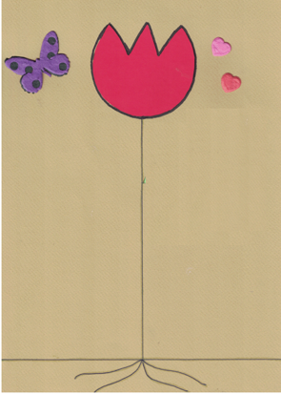
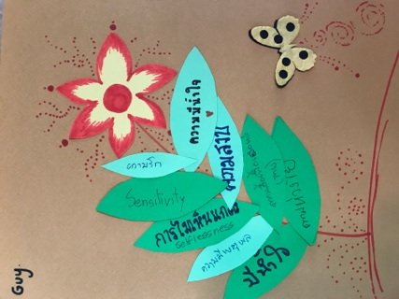

[3] Putting on our “Virtue Glasses” to Look for the Virtues in each other.

- Now we will practice looking for the best qualities in each other as ‘Abdu’l-Baha advised us to do.

- Everyone will need to slip on “special virtue glasses” to help us look for each other’s strength virtues. Facilitator exaggerates pretending to put on his/her own virtues glasses.

- Facilitator says, “Everyone was born with virtues glasses, but sometimes people don’t know that they have them.” Facilitator asks everyone to reach into their pockets and pull out their own special virtues glasses and put them on.

- Did you know that these virtues glasses block out shortcomings? They are really powerful glasses. These glasses have the power to focus on people’s strength virtues. But we must make sure we wipe them clean first so we can see clearly.

